20.
a) $8^{2}=8∙8=64$
b) ${17}^{2}=17∙17=289$
c) ${(-4)}^{2}=-4∙(-4)=16$
d)${(-12)}^{2}=-12∙(-12)=144$
e) ${25}^{2}=25∙25=625$
f)${\left(-32\right)}^{2}=-32∙\left(-32\right)=1024$
g) $0^{2}=0∙0=0$
h)${(-20)}^{2}=-20∙(-20)=400$

21.
a) ${\left(\frac{7}{9}\right)}^{2}=\frac{7}{9}∙\frac{7}{9}=\frac{49}{81}$
b)${\left(\frac{14}{15}\right)}^{2}=\frac{14}{15}∙\frac{14}{15}=\frac{196}{225}$
c)${\left(-\frac{5}{18}\right)}^{2}=-\frac{5}{18}∙\left(-\frac{5}{18}\right)=\frac{25}{324}$
d)${\left(-\frac{23}{38}\right)}^{2}=-\frac{23}{38}∙\left(-\frac{23}{38}\right)=\frac{529}{1444}$
e) ${\left(1\frac{4}{7}\right)}^{2}={\left(\frac{11}{7}\right)}^{2}=\frac{11}{7}∙\frac{11}{7}=\frac{121}{49}$
f) ${\left(5\frac{2}{3}\right)}^{2}={\left(\frac{17}{3}\right)}^{2}=\frac{17}{3}∙\frac{17}{3}=\frac{289}{9}$
g)${\left(-3\frac{1}{4}\right)}^{2}={\left(-\frac{13}{4}\right)}^{2}=-\frac{13}{4}∙\left(-\frac{13}{4}\right)=\frac{169}{16}$
h)${\left(-6\frac{2}{3}\right)}^{2}={\left(-\frac{20}{3}\right)}^{2}=-\frac{20}{3}∙\left(-\frac{20}{3}\right)=\frac{400}{9}$

22.
a) ${\left(-5\right)}^{2}=-5∙(-5)=25$
b) $-3^{2}=-3∙3=-9$
c) $-{(4)}^{2}=-4∙4=-16$
d) $-{\left(-2\right)}^{2}=-(-2)∙(-2)=-4$
e) $-{\left(-6\right)}^{2}=-(-6)∙(-6)=-36$

23.
a) ${\left(-8\right)}^{2}=-8∙(-8)=64$
b)${-8}^{2}=-8∙8=-64$
c) ${\left(-13\right)}^{2}=-13∙(-13)=169$
d)${-13}^{2}=-13∙13=-169$
e) ${\left(\frac{4}{7}\right)}^{2}=\frac{4}{7}∙\frac{4}{7}=\frac{16}{49}$
f)$\frac{4^{2}}{7}=\frac{4∙4}{7}=\frac{16}{7}$
g) $\frac{4}{7^{2}}=\frac{4}{7∙7}=\frac{4}{49}$
h)${\left(-\frac{3}{8}\right)}^{2}=-\frac{3}{8}∙\left(-\frac{3}{8}\right)=\frac{9}{64}$
i) $-\frac{3}{8^{2}}=-\frac{3}{8∙8}=-\frac{3}{64}$
j)$-\frac{3^{2}}{8}=-\frac{3∙3}{8}=-\frac{9}{8}$

24.
a) ${\left(-\frac{-5}{11}\right)}^{2}=-\frac{-5}{11}∙\left(-\frac{-5}{11}\right)=\frac{25}{121}$
b) $- \frac{(-{5)}^{2}}{11}=-\frac{-5∙\left(-5\right)}{11}=-\frac{25}{11}$
c) $- \frac{-5^{2}}{11}=-\frac{-5∙5}{11}=\frac{25}{11}$
d) $-\frac{-5}{{11}^{2}}=-\frac{-5}{11∙11}=\frac{5}{121}$
e) ${-\left(\frac{-5}{11}\right)}^{2}=-\frac{-5}{11}∙\left(\frac{-5}{11}\right)=-\frac{25}{121}$

25.
a) ${\left(-3\right)}^{2}=-3∙\left(-3\right)=9$
b) $-3^{2}=-3∙3=-9$
c)$-{\left(-3\right)}^{2}=-\left(-3\right)∙\left(-3\right)=-9$
d) $-\left({-3}^{2}\right)=-(-3∙3)=9$
e) ${\left(-3^{2}\right)}^{2}={\left(-3∙3\right)}^{2}={\left(-9\right)}^{2}=-9∙\left(-9\right)=81$

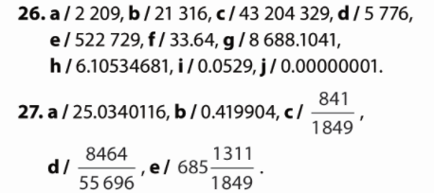
28.
a) $2^{2}-2=4-2=2$
b) ${3-2}^{2}=3-4=-1$
c) $3∙7^{2}+7=3∙49+7=147+7=154$

29.
a) $6^{2}-{\left(-6\right)}^{2}=36-36=0$
b) $6^{2}-\left(-6^{2}\right)=36-\left(-36\right)=36+36=72$
c) $-{12}^{2}-{\left(-12\right)}^{2}=-144-144=-288$

30.
a) ${(3-2}^{2})∙4=\left(3-4\right)∙4=-1∙4=-4$
b) ${-5∙(4}^{2}-5)+4=-5∙(16-5)+4=-5∙9+4=-45+4=-41$
c) ${\left(7-3∙4\right)}^{2}-3^{2}={\left(7-12\right)}^{2}-3^{2}={\left(-5\right)}^{2}-3^{2}=25-9=16$
31.
a) ${\left(\frac{5}{6}\right)}^{2}-\frac{5^{2}}{6}=\frac{25}{36}-\frac{25}{6}=\frac{25-150}{36}=\frac{-125}{36}$
b) ${\left(\frac{-4}{13}\right)}^{2}-{\left(\frac{4}{13}\right)}^{2}=\frac{16}{169}-\frac{16}{169}=0$
c) $\frac{2^{2}}{3}-\frac{2}{3^{2}}=\frac{4}{3}-\frac{2}{9}=\frac{12-2}{9}=\frac{10}{9}$

32.
a) ${1.2}^{2}-2=1.44-2=-0.56$
b) ${2.3}^{2}-3:2=5.29-3:2=5.29-1.5=3.79$
c) $-18 :{1.5}^{2}+2∙{1.5}^{2}=-18:2.25+2∙2.25=-8+4.5=-3.5$

33.
a) $7^{2}=7∙7=49$
b)${14}^{2}=14∙14=196$
c) $(-{5)}^{2}=-5∙(-5)=25$
d) ${(-17)}^{2}=-17∙(-17)=289$
e) ${25}^{2}=25∙25=625$

34.
a) ${\left(\frac{7}{10}\right)}^{2}=\frac{7}{10}∙\frac{7}{10}=\frac{49}{100}$
b) ${\left(-\frac{6}{17}\right)}^{2}=-\frac{6}{17}∙\left(-\frac{6}{17}\right)=\frac{36}{289}$
c)${\left(2\frac{3}{7}\right)}^{2}=\frac{17}{7}∙\frac{17}{7}=\frac{289}{49}$
d) ${\left(4\frac{1}{3}\right)}^{2}=\frac{13}{3}∙\frac{13}{3}=\frac{169}{9}$
e) ${\left(-5\frac{1}{4}\right)}^{2}=-\frac{21}{4}∙\left(-\frac{21}{4}\right)=\frac{441}{16}$
35.
a) ${\left(-9\right)}^{2}=-9∙(-9)=81$
b) ${-9}^{2}=-9∙9=-81$
c)${\left(-16\right)}^{2}=-16∙(-16)=256$
d) ${-16}^{2}=-16∙16=-256$
e)${\left(\frac{3}{5}\right)}^{2}=\frac{3}{5}∙\frac{3}{5}=\frac{9}{25}$

36.
a)$\frac{3^{2}}{5}=\frac{3∙3}{5}=\frac{9}{5}$
b) $\frac{2}{7^{2}}=\frac{2}{7∙7}=\frac{2}{49}$
c)${\left(-\frac{4}{9}\right)}^{2}=-\frac{4}{9}∙\left(-\frac{4}{9}\right)=\frac{16}{81}$
d) $-\frac{3}{7^{2}}=-\frac{3}{7∙7}=-\frac{3}{49}$
e)$-\frac{3^{2}}{7}=-\frac{3∙3}{7}=-\frac{9}{7}$

37.
a) ${\left(-\frac{-15}{19}\right)}^{2}=-\frac{-15}{19}∙\left(-\frac{-15}{19}\right)=\frac{225}{361}$
b) $-\frac{{\left(-15\right)}^{2}}{19}=-\frac{-15∙\left(-15\right)}{19}=-\frac{225}{19}$
c) $-\frac{{-15}^{2}}{19}=-\frac{-15∙15}{19}=\frac{225}{19}$
d) $-\frac{-15}{{19}^{2}}=-\frac{-15}{19∙19}=\frac{15}{361}$
e) $-{\left(\frac{15}{-19}\right)}^{2}=-\frac{15∙15}{-19∙\left(-19\right)}=-\frac{225}{361}$

38.
a) ${\left(-6\right)}^{2}=-6∙\left(-6\right)=36$
b) $-6^{2}=-6∙6=-36$
c) $-{\left(-6\right)}^{2}=-\left(-6\right)∙\left(-6\right)=-36$
d) $-\left(-6^{2}\right)=-\left(-6∙6\right)=36$
e) ${\left(-6^{2}\right)}^{2}={\left(-6∙6\right)}^{2}={\left(-36\right)}^{2}=-36∙\left(-36\right)=1296$

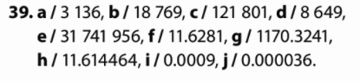
40.
a) $3^{2}-2∙5=9-2∙5=9-10=-1$
b) $4:2^{2}+5^{2}=4:4+25=1+25=26$
c) $-7^{2}∙2+3.2:{\left(-2\right)}^{2}=-49∙2+3.2 :4=-98+0.8=-97.2$

41.
a) ${\left(3-5\right)}^{2}+{\left(-1\right)}^{2}={\left(-2\right)}^{2}+{\left(-1\right)}^{2}=4+1=5$
b) $2∙\left(3-2^{2}:2\right)-6^{2}=2∙\left(3-4:2\right)-36=2∙\left(3-2\right)-36=2∙1-36=2-36=-34$
c) ${0.2}^{2}∙{\left(-5\right)}^{2}+\left(3∙2^{2}-{\left(-2\right)}^{2}\right)={0.2}^{2}∙{\left(-5\right)}^{2}+\left(3∙4-4\right)=0.04∙25+8=1+8=9$

42.
a) ${\left(\frac{3}{4}\right)}^{2}-\frac{3^{2}}{6}=\frac{9}{16}-\frac{9}{6}=\frac{27-72}{48}=\frac{-45}{48}=\frac{-15}{16}$
b) ${\left(-\frac{2}{3}\right)}^{2}-{\left(\frac{7}{12}\right)}^{2}=\frac{4}{9}-\frac{49}{144}=\frac{64-49}{144}=\frac{15}{144}$
c) $\frac{3^{2}}{5}-\frac{3}{5^{2}}=\frac{9}{5}-\frac{3}{25}=\frac{45-3}{25}=\frac{42}{25}$
d) ${\left(\frac{3}{4}\right)}^{2}:\frac{5^{2}}{8}-\frac{7}{10}=\frac{9}{16}:\frac{25}{8}-\frac{7}{10}=\frac{9}{16}∙\frac{8}{25}-\frac{7}{10}=\frac{9}{50}-\frac{7}{10}=\frac{9-35}{50}=\frac{-26}{50}=\frac{-13}{25}$
e)${\left(\frac{2}{3}\right)}^{2}-9∙{\left(1\frac{5}{6}\right)}^{2}=\frac{4}{9}-9∙\frac{121}{36}=\frac{4}{9}-\frac{121}{4}=\frac{16-1089}{36}=\frac{-1073}{36}$
f) ${\left(1\frac{3}{5}\right)}^{2}∙{\left(-5\right)}^{2}-{\left(-0.8\right)}^{2}=\frac{64}{25}∙25-0.64=64-0.64=63.36$

43.
a) ${1.3}^{2}-1.3=1.69-1.3=0.39$
b) $4:3^{2}-4^{2}:3=4:9-16:3=\frac{4}{9}-\frac{16}{3}=\frac{4-48}{9}=\frac{-44}{9}$
c) $5-0.28:{0.2}^{2}+{1.2}^{2}:3=5-0.28:0.04+1.44:3=5-7+0.48=-1.52$
d) ${\left(0.3-{0.4}^{2}∙5\right)}^{2}-{\left(1-2.1:3\right)}^{2}={\left(0.3-0.16∙5\right)}^{2}-{\left(1-0.7\right)}^{2}={\left(0.3-0.8\right)}^{2}-{\left(0.3\right)}^{2}={\left(-0.5\right)}^{2}-0.09=0.25-0.09=0.16$
e) $6:5 {-0.5}^{2}∙{1.2}^{2}+0.6:{0.5}^{2}=6:5-0.25∙1.44+0.6:0.25=1.2-0.36+2.4=3.24$
f) ${\left({0.5}^{2}+2\right)}^{2}-3+6^{2}={\left(0.25+2\right)}^{2}-{3+6}^{2}={2.25}^{2}-3+6^{2}=5.0625-3+36=38.0625$

44.
a) ${\left(-\frac{2^{2}}{15}+\frac{3}{-5}∙3^{2} \right)}^{2}:17={\left(-\frac{4}{15}+\frac{27}{-5}\right)}^{2}:17={\left(\frac{-4-81}{15}\right)}^{2}:17={\left(-\frac{17}{15}\right)}^{2}:17=\frac{289}{15}∙\frac{1}{17}=\frac{17}{15}$
b) $\left({1.2}^{2}-\frac{-2}{5^{2}}\right)+\frac{{\left(-3\right)}^{2}}{2}∙4^{2}=\left(1.44+\frac{4}{25}\right)+\frac{9}{2}∙16=1.6+72=73.6$
c) $0.5∙\frac{4}{-20}+{\left(\frac{3}{-2^{2}}-\frac{-5}{8}\right)}^{2}=\frac{1}{2}∙\frac{4}{-20}+{\left(\frac{3}{-4}-\frac{-5}{8}\right)}^{2}=-\frac{1}{10}+{\left(\frac{-6+5}{8}\right)}^{2}=-\frac{1}{10}+{\left(\frac{-1}{8}\right)}^{2}=-\frac{1}{10}+\frac{1}{64}=\frac{-32+5}{320}=\frac{-27}{320}$

45.
a)$\frac{\left(\frac{3^{2}}{4}-\frac{-5}{2^{2}}\right)+{1.25}^{2}}{{\left(-\frac{5}{3}\right)}^{2}-2}∙2=\frac{\left(\frac{9}{4}+\frac{5}{4}\right)+{\left(\frac{5}{4}\right)}^{2}}{\frac{25}{9}-2}∙2=\frac{\frac{14}{4}+\frac{25}{16}}{\frac{25-18}{9}}∙2=\frac{\frac{81}{16}}{\frac{7}{9}}∙2=\frac{81∙9}{16∙7}∙2=\frac{729}{112}∙2=\frac{729}{56}$

b)$3.2-\frac{-\frac{5}{2}∙{\left(-0.2\right)}^{2}}{-\frac{3^{2}}{8}}=3.2-\frac{-\frac{5}{2}∙\frac{1}{25}}{-\frac{9}{8}}=\frac{16}{5}-\frac{-\frac{1}{10}}{-\frac{9}{8}}=\frac{16}{5}-\frac{4}{45}=\frac{144-4}{45}=\frac{140}{45}=\frac{28}{9}$

c) $1.5+\frac{-\frac{5^{2}}{4}}{{\left(\frac{3}{-2^{2}}\right)}^{2}}∙{1.8}^{2}=1.5+\frac{-\frac{25}{4}}{\frac{9}{16}}∙3.24=\frac{3}{2}-\frac{100}{9}∙\frac{81}{25}=\frac{3}{2}-36=-\frac{69}{2}$

46.
a) $5^{2}=5∙5=25$
b) ${11}^{2}=11∙11=121$
c) ${(-2)}^{2}=-2∙(-2)=4$
d)${-3}^{2}=-3∙3=-9$
e)${-(-2)}^{2}=-\left(-2\right)∙\left(-2\right)=-4$

47.
a) ${0.2}^{2}=0.2∙0.2=0.04$
b)${-1.4}^{2}=-1.4∙1.4=-1.96$
c)${(-0.03)}^{2}=-0.03∙(-0.03)=0.0009$
d) ${23.6}^{2}=23.6∙23.6=556.96$
e)${-1.002}^{2}=-1.002∙1.002=-1.004004$

48.
a) ${\left(\frac{2}{3}\right)}^{2}=\frac{2}{3}∙\frac{2}{3}=\frac{4}{9}$
b) ${\left(-\frac{3}{5}\right)}^{2}=-\frac{3}{5}∙\left(-\frac{3}{5}\right)=\frac{9}{25}$
c) ${\left(\frac{-5}{7}\right)}^{2}=\frac{-5}{7}∙\left(\frac{-5}{7}\right)=\frac{25}{49}$
d) ${\left(\frac{3}{-4}\right)}^{2}=\frac{3}{-4}∙\left(\frac{3}{-4}\right)=\frac{9}{16}$
e) ${-\left(\frac{7}{5}\right)}^{2}=-\frac{7}{5}∙\frac{7}{5}=-\frac{49}{25}$

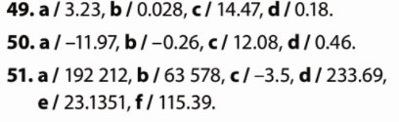

52.
a) ${\left(3∙9\right)}^{2}=3^{2}∙9^{2}=9∙81=729$
b) ${\left(2∙19\right)}^{2}=2^{2}∙{19}^{2}=4∙361=1444$
c)${\left(2a\right)}^{2}=2^{2}∙a^{2}=4∙a^{2}=4a^{2}$
d) ${\left(8x\right)}^{2}=8^{2}∙x^{2}=64∙x^{2}=64x^{2}$

53.
a) $4^{2}∙5^{2}={\left(4∙5\right)}^{2}={20}^{2}=400$
b) $8^{2}∙{13}^{2}={\left(8∙13\right)}^{2}={104}^{2}=10816$
c) $5^{2}∙8^{2}={\left(5∙8\right)}^{2}={40}^{2}=1600$
d) $9^{2}∙{10}^{2}={\left(9∙10\right)}^{2}={90}^{2}=8100$

54.
a) ${3.2}^{2}∙5^{2}={\left(3.2∙5\right)}^{2}={16}^{2}=256$
b)${0.21}^{2}∙{30}^{2}={\left(0.21∙30\right)}^{2}={6.3}^{2}=39.69$
c)$8^{2}∙{\left(\frac{13}{16}\right)}^{2}={\left(8∙\frac{13}{16}\right)}^{2}={\left(\frac{13}{2}\right)}^{2}=\frac{169}{4}$
d)${\left(\frac{3}{4}\right)}^{2}∙{12}^{2}={\left(\frac{3}{4}∙12\right)}^{2}=9^{2}=81$

55.
a) ${\left(30\right)}^{2}={\left(3∙10\right)}^{2}=3^{2}∙{10}^{2}=9∙100=900$
b)${\left(140\right)}^{2}={\left(14∙10\right)}^{2}={14}^{2}∙{10}^{2}=196∙100=19600$
c)${\left(700\right)}^{2}={\left(7∙100\right)}^{2}=7^{2}∙{100}^{2}=49∙10000=490000$
d) ${\left(1200\right)}^{2}={\left(12∙100\right)}^{2}={12}^{2}∙{100}^{2}=144∙10000=1440000$

56.
a)${\left(5ab\right)}^{2}=5^{2}∙a^{2}∙b^{2}=25∙a^{2}∙b^{2}=25a^{2}b^{2}$
b) ${\left(18xy\right)}^{2}={18}^{2}∙x^{2}∙y^{2}=324∙x^{2}∙y^{2}=324x^{2}y^{2}$
c) ${\left(13tzs\right)}^{2}={13}^{2}∙t^{2}∙z^{2}∙s^{2}=169∙t^{2}∙z^{2}∙s^{2}=169t^{2}z^{2}s^{2}$
d) ${\left(20ijk\right)}^{2}={20}^{2}∙i^{2}∙j^{2}∙k^{2}=400∙i^{2}∙j^{2}∙k^{2}=400i^{2}j^{2}k^{2}$

57.
a) ${\left(0.12xy\right)}^{2}={0.12}^{2}∙x^{2}∙y^{2}=0.0144x^{2}y^{2}$
b) ${\left(3.45cxz\right)}^{2}={3.45}^{2}∙c^{2}∙x^{2}∙z^{2}=11.9025c^{2}x^{2}z^{2}$
c) ${\left(632mat\right)}^{2}={632}^{2}∙m^{2}∙a^{2}∙t^{2}=399424m^{2}a^{2}t^{2}$
d) ${\left(0.07bond\right)}^{2}={0.07}^{2}∙b^{2}∙o^{2}∙n^{2}∙d^{2}=0.0049b^{2}o^{2}n^{2}d^{2}$

58.
a) ${\left(\frac{5}{8}\right)}^{2}=\frac{5^{2}}{8^{2}}=\frac{25}{64}$
b) ${\left(\frac{13}{16}\right)}^{2}=\frac{{13}^{2}}{{16}^{2}}=\frac{169}{256}$
c)${\left(-\frac{6}{17}\right)}^{2}=\frac{{(-6)}^{2}}{{17}^{2}}=\frac{36}{289}$
d) ${\left(-\frac{24}{37}\right)}^{2}=\frac{{\left(-24\right)}^{2}}{{37}^{2}}=\frac{576}{1369}$
e) ${\left(1\frac{4}{5}\right)}^{2}={\left(\frac{9}{5}\right)}^{2}=\frac{9^{2}}{5^{2}}=\frac{81}{25}$
f) ${\left(4\frac{1}{3}\right)}^{2}={\left(\frac{13}{3}\right)}^{2}=\frac{{13}^{2}}{3^{2}}=\frac{169}{9}$
g)${\left(-3\frac{2}{5}\right)}^{2}={\left(-\frac{17}{5}\right)}^{2}=\frac{(-{17)}^{2}}{5^{2}}=\frac{289}{25}$
h)${\left(-6\frac{3}{4}\right)}^{2}={\left(-\frac{27}{4}\right)}^{2}=\frac{{(-27)}^{2}}{4^{2}}=\frac{729}{16}$

59.
a) ${\left(\frac{x}{7}\right)}^{2}=\frac{x^{2}}{7^{2}}=\frac{x^{2}}{49}$
b) ${\left(\frac{a}{13}\right)}^{2}=\frac{a^{2}}{{13}^{2}}=\frac{a^{2}}{169}$
c)${\left(-\frac{y}{25}\right)}^{2}=\frac{{(-y)}^{2}}{{25}^{2}}=\frac{y^{2}}{625}$
d) ${\left(-\frac{b}{39}\right)}^{2}=\frac{{(-b)}^{2}}{{39}^{2}}=\frac{b^{2}}{1521}$
e)${\left(\frac{2}{d}\right)}^{2}=\frac{2^{2}}{d^{2}}=\frac{4}{d^{2}}$
f) ${\left(\frac{3x}{8}\right)}^{2}=\frac{3^{2}∙x^{2}}{8^{2}}=\frac{9x^{2}}{64}$
g) ${\left(-\frac{2a}{5b}\right)}^{2}=\frac{{(-2)}^{2}∙a^{2}}{5^{2}∙b^{2}}=\frac{{4a}^{2}}{25b^{2}}$
h) ${\left(-\frac{9x}{yz}\right)}^{2}=\frac{{(-9)}^{2}∙x^{2}}{y^{2}∙z^{2}}=\frac{{81x}^{2}}{y^{2}z^{2}}$

60.
a) ${27}^{2}:3^{2}={\left(27:3\right)}^{2}=9^{2}=81$
b) ${12}^{2}:3^{2}={\left(12:3\right)}^{2}=4^{2}=16$
c) ${56}^{2}:7^{2}={\left(56:7\right)}^{2}=8^{2}=64$
d) ${45}^{2}:{15}^{2}={\left(45:15\right)}^{2}=3^{2}=9$
e) ${3.2}^{2}:{0.8}^{2}={\left(3.2:0.8\right)}^{2}=4^{2}=16$
f) ${7.2}^{2}:{0.9}^{2}={\left(7.2:0.9\right)}^{2}=8^{2}=64$
g) $6^{2}:{0.3}^{2}={\left(6:0.3\right)}^{2}={20}^{2}=400$
h)${7.5}^{2}:{1.25}^{2}={\left(7.5:1.25\right)}^{2}=6^{2}=36$

61.
a) ${\left(\frac{3}{5}\right)}^{2}:{\left(\frac{3}{4}\right)}^{2}={\left(\frac{3}{5}:\frac{3}{4}\right)}^{2}={\left(\frac{3}{5}∙\frac{4}{3}\right)}^{2}={\left(\frac{4}{5}\right)}^{2}=\frac{16}{25}$
b) ${\left(\frac{4}{11}\right)}^{2}:{\left(1\frac{1}{11}\right)}^{2}={\left(\frac{4}{11}:\frac{12}{11}\right)}^{2}={\left(\frac{4}{11}∙\frac{11}{12}\right)}^{2}={\left(\frac{1}{3}\right)}^{2}=\frac{1}{9}$
c) ${\left(2\frac{2}{3}\right)}^{2}:{\left(3\frac{5}{9}\right)}^{2}={\left(\frac{8}{3}:\frac{32}{9}\right)}^{2}={\left(\frac{8}{3}∙\frac{9}{32}\right)}^{2}={\left(\frac{3}{4}\right)}^{2}=\frac{9}{16}$
d) ${\left(2.5\right)}^{2}:{\left(-\frac{1}{10}\right)}^{2}={\left(\frac{5}{2}:\frac{-1}{10}\right)}^{2}={\left(\frac{5}{2}∙\frac{-10}{1}\right)}^{2}={\left(\frac{-25}{1}\right)}^{2}=625$
e) $8^{2}:{\left(\frac{4}{5}\right)}^{2}={\left(8:\frac{4}{5}\right)}^{2}={\left(8∙\frac{5}{4}\right)}^{2}={\left(10\right)}^{2}=100$
f) ${\left(1\frac{5}{7}\right)}^{2}:6^{2}={\left(\frac{12}{7}:6\right)}^{2}={\left(\frac{12}{7}∙\frac{1}{6}\right)}^{2}={\left(\frac{2}{7}\right)}^{2}=\frac{4}{49}$

62.
a) ${\left(\frac{2}{3}\right)}^{2}∙{\left(\frac{3}{4}\right)}^{2}={\left(\frac{2}{3}∙\frac{3}{4}\right)}^{2}={\left(\frac{1}{2}\right)}^{2}=\frac{1}{4}$
b) ${\left(\frac{3}{5}\right)}^{2}∙{\left(\frac{7}{9}\right)}^{2}={\left(\frac{3}{5}∙\frac{7}{9}\right)}^{2}={\left(\frac{7}{15}\right)}^{2}=\frac{49}{225}$
c)${\left(\frac{4}{9}\right)}^{2}∙{\left(1\frac{2}{7}\right)}^{2}={\left(\frac{4}{9}∙\frac{9}{7}\right)}^{2}={\left(\frac{4}{7}\right)}^{2}=\frac{16}{49}$
d) ${\left(1\frac{1}{2}\right)}^{2}∙{\left(1\frac{1}{3}\right)}^{2}={\left(\frac{3}{2}∙\frac{4}{3}\right)}^{2}={\left(2\right)}^{2}=4$
e) ${\left(3\frac{1}{5}\right)}^{2}∙{\left(3\frac{3}{4}\right)}^{2}={\left(\frac{16}{5}∙\frac{15}{4}\right)}^{2}={\left(12\right)}^{2}=144$

63.
a) ${10}^{2}:{\left(\frac{5}{11}\right)}^{2}={\left(10:\frac{5}{11}\right)}^{2}={\left(10∙\frac{11}{5}\right)}^{2}={\left(22\right)}^{2}=484$
b) ${\left(\frac{3}{4}\right)}^{2}:{12}^{2}={\left(\frac{3}{4}:12\right)}^{2}={\left(\frac{3}{4}∙\frac{1}{12}\right)}^{2}={\left(\frac{1}{16}\right)}^{2}=\frac{1}{256}$
c) ${\left(\frac{8}{9}\right)}^{2}:6^{2}={\left(\frac{8}{9}:6\right)}^{2}={\left(\frac{8}{9}∙\frac{1}{6}\right)}^{2}={\left(\frac{4}{27}\right)}^{2}=\frac{16}{729}$
d) $9^{2}:{\left(1\frac{1}{2}\right)}^{2}={\left(9:\frac{3}{2}\right)}^{2}={\left(9∙\frac{2}{3}\right)}^{2}={\left(6\right)}^{2}=36$
e) ${\left(2\frac{1}{3}\right)}^{2}:{14}^{2}={\left(\frac{7}{3}:14\right)}^{2}={\left(\frac{7}{3}∙\frac{1}{14}\right)}^{2}={\left(\frac{1}{6}\right)}^{2}=\frac{1}{36}$

64.
a) ${\left(\frac{2}{5}\right)}^{2}:{\left(\frac{2}{4}\right)}^{2}={\left(\frac{2}{5}:\frac{2}{4}\right)}^{2}={\left(\frac{2}{5}∙\frac{4}{2}\right)}^{2}={\left(\frac{4}{5}\right)}^{2}=\frac{16}{25}$
b) ${\left(\frac{3}{5}\right)}^{2}:{\left(\frac{9}{10}\right)}^{2}={\left(\frac{3}{5}:\frac{9}{10}\right)}^{2}={\left(\frac{3}{5}∙\frac{10}{9}\right)}^{2}={\left(\frac{2}{3}\right)}^{2}=\frac{4}{9}$
c) ${\left(\frac{4}{9}\right)}^{2}:{\left(1\frac{1}{3}\right)}^{2}={\left(\frac{4}{9}:\frac{4}{3}\right)}^{2}={\left(\frac{4}{9}∙\frac{3}{4}\right)}^{2}={\left(\frac{1}{3}\right)}^{2}=\frac{1}{9}$
d) ${\left(1\frac{1}{2}\right)}^{2}:{\left(1\frac{1}{4}\right)}^{2}={\left(\frac{3}{2}:\frac{5}{4}\right)}^{2}={\left(\frac{3}{2}∙\frac{4}{5}\right)}^{2}={\left(\frac{6}{5}\right)}^{2}=\frac{36}{25}$
e) ${\left(3\frac{1}{3}\right)}^{2}:{\left(4\frac{1}{6}\right)}^{2}={\left(\frac{10}{3}:\frac{25}{6}\right)}^{2}={\left(\frac{10}{3}∙\frac{6}{25}\right)}^{2}={\left(\frac{4}{5}\right)}^{2}=\frac{16}{25}$

65.
a) ${\left(\frac{3}{5}\right)}^{2}∙{\left(\frac{5}{6}\right)}^{2}∙{\left(\frac{2}{3}\right)}^{2}={\left(\frac{3}{5}∙\frac{5}{6}∙\frac{2}{3}\right)}^{2}={\left(\frac{1}{3}\right)}^{2}=\frac{1}{9}$
b) ${\left(\frac{3}{4}\right)}^{2}∙{\left(\frac{28}{15}\right)}^{2}∙{\left(\frac{5}{7}\right)}^{2}={\left(\frac{3}{4}∙\frac{28}{15}∙\frac{5}{7}\right)}^{2}={\left(1\right)}^{2}=1$
c) ${\left(\frac{4}{9}\right)}^{2}:{\left(\frac{10}{21}\right)}^{2}:{\left(\frac{7}{15}\right)}^{2}={\left(\frac{4}{9}:\frac{10}{21}:\frac{7}{15}\right)}^{2}={\left(\frac{4}{9}∙\frac{21}{10}:\frac{7}{15}\right)}^{2}={\left(\frac{14}{15}:\frac{7}{15}\right)}^{2}={\left(\frac{14}{15}∙\frac{15}{7}\right)}^{2}={\left(2\right)}^{2}=4$

66.
a) ${\left(1\frac{1}{2}\right)}^{2}∙{\left(1\frac{1}{3}\right)}^{2}∙{\left(1\frac{1}{4}\right)}^{2}={\left(\frac{3}{2}∙\frac{4}{3}∙\frac{5}{4}\right)}^{2}={\left(\frac{5}{2}\right)}^{2}=\frac{25}{4}$
b)${\left(2\frac{1}{4}\right)}^{2}∙{\left(3\frac{1}{5}\right)}^{2}∙{\left(4\frac{1}{6}\right)}^{2}={\left(\frac{9}{4}∙\frac{16}{5}∙\frac{25}{6}\right)}^{2}={\left(30\right)}^{2}=900$
c) ${\left(1\frac{1}{9}\right)}^{2}:{\left(3\frac{1}{3}\right)}^{2}:{\left(1\frac{2}{3}\right)}^{2}={\left(\frac{10}{9}\right)}^{2}:{\left(\frac{10}{3}\right)}^{2}:{\left(\frac{5}{3}\right)}^{2}={\left(\frac{10}{9}∙\frac{3}{10}\right)}^{2}:{\left(\frac{5}{3}\right)}^{2}={\left(\frac{1}{3}\right)}^{2}:{\left(\frac{5}{3}\right)}^{2}={\left(\frac{1}{3}∙\frac{3}{5}\right)}^{2}={\left(\frac{1}{5}\right)}^{2}=\frac{1}{25}$

67.
x – neki broj $x^{2}-$ kvadrat broja
2x – broj povećan 2 puta
$${\left(2x\right)}^{2}=2^{2}∙x^{2}=4x^{2}$$
Kvadrat će se povećati 4 puta.

68.
x – neki broj $x^{2}-$ kvadrat broja
$\frac{x}{2}$– broj smanjen 2 puta
$${\left(\frac{x}{2}\right)}^{2}=\frac{x^{2}}{2^{2}}=\frac{x^{2}}{4}$$
Kvadrat će se smanjiti 4 puta.

69.
a) ${\left(\frac{2}{3}\right)}^{2}+2=\frac{4}{9}+2=\frac{4+18}{9}=\frac{22}{9}$
b) $\frac{5}{6}-{\left(\frac{3}{4}\right)}^{2}=\frac{5}{6}-\frac{9}{16}=\frac{40-27}{48}=\frac{13}{48}$
c) ${\left(\frac{4}{9}\right)}^{2}+1\frac{2}{9}=\frac{16}{81}+\frac{11}{9}=\frac{16+99}{81}=\frac{115}{81}$
d) $2\frac{1}{6}-{\left(1\frac{1}{3}\right)}^{2}=\frac{13}{6}-{\left(\frac{4}{3}\right)}^{2}=\frac{13}{6}-\frac{16}{9}=\frac{39-32}{18}=\frac{7}{18}$

70.
a) ${10}^{2}∙{\left(\frac{2}{5}\right)}^{2}-4={\left(10∙\frac{2}{5}\right)}^{2}-4=4^{2}-4=16-4=12$
b) $3-{\left(\frac{3}{4}\right)}^{2}∙6^{2}=3-\frac{9}{16}∙36=3-\frac{81}{4}=\frac{12-81}{4}=\frac{-69}{4}$
c) ${\left(\frac{1}{6}\right)}^{2}∙4^{2}-\frac{2}{9}=\frac{1}{36}∙16-\frac{2}{9}=\frac{4}{9}-\frac{2}{9}=\frac{2}{9}$
d) $\frac{3}{8}-9^{2}∙{\left(\frac{1}{12}\right)}^{2}=\frac{3}{8}-81∙\frac{1}{144}=\frac{3}{8}-\frac{9}{16}=\frac{6-9}{16}=\frac{-3}{16}$

71.
a) $1-{\left(\frac{3}{5}\right)}^{2}:{\left(\frac{3}{4}\right)}^{2}=1-{\left(\frac{3}{5}:\frac{3}{4}\right)}^{2}=1-{\left(\frac{3}{5}∙\frac{4}{3}\right)}^{2}=1-{\left(\frac{4}{5}\right)}^{2}=1-\frac{16}{25}=\frac{25-16}{25}=\frac{9}{25}$

b) ${\left(\frac{3}{4}\right)}^{2}:{\left(1\frac{1}{8}\right)}^{2}-\frac{3}{4}={\left(\frac{3}{4}:\frac{9}{8}\right)}^{2}-\frac{3}{4}={\left(\frac{3}{4}∙\frac{8}{9}\right)}^{2}-\frac{3}{4}={\left(\frac{2}{3}\right)}^{2}-\frac{3}{4}=\frac{4}{9}-\frac{3}{4}=\frac{16-27}{36}=\frac{-11}{36}$

c) ${\left(1\frac{1}{3}\right)}^{2}:{\left(\frac{4}{9}\right)}^{2}+1\frac{1}{2}={\left(\frac{4}{3}:\frac{4}{9}\right)}^{2}+\frac{3}{2}={\left(\frac{4}{3}∙\frac{9}{4}\right)}^{2}+\frac{3}{2}=3^{2}+\frac{3}{2}=9+\frac{3}{2}=\frac{18+3}{2}=\frac{21}{2}$

72.
a) $2∙{\left(\frac{2}{3}\right)}^{2}+{\left(\frac{3}{5}\right)}^{2}∙{\left(\frac{5}{6}\right)}^{2}=2∙\frac{4}{9}+{\left(\frac{3}{5}∙\frac{5}{6}\right)}^{2}=\frac{8}{9}+{\left(\frac{1}{2}\right)}^{2}=\frac{8}{9}+\frac{1}{4}=\frac{32+9}{36}=\frac{41}{36}$

b)${\left(\frac{28}{15}\right)}^{2}∙{\left(\frac{5}{7}\right)}^{2}-{\left(\frac{3}{4}\right)}^{2}∙2={\left(\frac{28}{15}∙\frac{5}{7}\right)}^{2}-\frac{9}{16}∙2={\left(\frac{4}{3}\right)}^{2}-\frac{9}{8}=\frac{16}{9}-\frac{9}{8}=\frac{128-81}{72}=\frac{47}{72}$

c) $1\frac{1}{3}∙{\left(1\frac{1}{2}\right)}^{2}-{\left(1\frac{1}{4}\right)}^{2}=\frac{4}{3}∙{\left(\frac{3}{2}\right)}^{2}-{\left(\frac{5}{4}\right)}^{2}=\frac{4}{3}∙\frac{9}{4}-\frac{25}{16}=3-\frac{25}{16}=\frac{48-25}{16}=\frac{23}{16}$

73.
a) ${\left(2∙3\right)}^{2}=6^{2}=36$
b)${\left(3∙6\right)}^{2}={18}^{2}=324$
c) ${\left(4∙5\right)}^{2}={20}^{2}=400$
d) ${\left(7∙2\right)}^{2}={14}^{2}=196$
e)${\left(2∙8\right)}^{2}={16}^{2}=256$

74.
a) ${\left(2∙3\right)}^{2}=2^{2}∙3^{2}=4∙9=36$
b)${\left(3∙6\right)}^{2}=3^{2}∙6^{2}=9∙36=324$
c) ${\left(4∙5\right)}^{2}=4^{2}∙5^{2}=16∙25=400$
d) ${\left(7∙2\right)}^{2}=7^{2}∙2^{2}=49∙4=196$
e)${\left(2∙8\right)}^{2}=2^{2}∙8^{2}=4∙64=256$

75.
a) $2^{2}∙4^{2}=4∙16=64$
b)$5^{2}∙3^{2}=25∙9=225$
c) $7^{2}∙4^{2}=49∙16=784$
d) $8^{2}∙3^{2}=64∙9=576$
e) $9^{2}∙2^{2}=81∙4=324$

76.
a) $2^{2}∙4^{2}={\left(2∙4\right)}^{2}=8^{2}=64$
b)$5^{2}∙3^{2}={\left(5∙3\right)}^{2}={15}^{2}=225$
c) $7^{2}∙4^{2}={\left(7∙4\right)}^{2}={28}^{2}=784$
d) $8^{2}∙3^{2}={\left(8∙3\right)}^{2}={24}^{2}=576$
e) $9^{2}∙2^{2}={\left(9∙2\right)}^{2}={18}^{2}=324$

77.
a) ${\left(6:3\right)}^{2}=2^{2}=4$
b)${\left(8:2\right)}^{2}=4^{2}=16$
c) ${\left(15:5\right)}^{2}=3^{2}=9$
d) ${\left(21:7\right)}^{2}=3^{2}=9$
e)${\left(25:5\right)}^{2}=5^{2}=25$

78.
x – neki broj $x^{2}-$ kvadrat broja
x + 20% od x = x +0.2x =1.2x – broj povećan 20%
$${\left(1.2x\right)}^{2}={1.2}^{2}∙x^{2}=1.44x^{2}$$
Kvadrat će se povećati za 44%.

79.
x – neki broj $x^{2}-$ kvadrat broja
$x-30\% od x=x-0.3x=0.7x$– broj smanjen 30%
$${\left(0.7x\right)}^{2}={0.7}^{2}∙x^{2}=0.49x^{2}$$
Razlika je 1 – 0.49 = 0.51.
Kvadrat će se smanjiti 51%.

80.
a) $10∙10∙10∙10∙10∙10={10}^{6}$
b) $3∙3∙3∙3∙3∙3∙3∙3∙3=3^{9}$
c) $7∙7∙7∙7∙7∙7∙7=7^{7}$
d)$22∙22∙22∙22∙22={22}^{5}$
e) $13∙13∙13∙13∙13∙13∙13∙13={13}^{8}$
f) $100∙100∙100∙100∙100∙100∙100={100}^{7}$

81.
a) $8∙7^{3}+4∙7^{3}=\left(8+4\right)∙7^{3}=12∙7^{3}$
b) $-3∙{\left(\frac{1}{2}\right)}^{7}+9∙{\left(\frac{1}{2}\right)}^{7}=\left(-3+9\right)∙{\left(\frac{1}{2}\right)}^{7}=6∙{\left(\frac{1}{2}\right)}^{7}$
c) ${0.6}^{5}+8∙{0.6}^{5}=\left(1+8\right)∙{0.6}^{5}=9∙{0.6}^{5}$

82.
a) $-{\left(\frac{5}{9}\right)}^{9}-7∙{\left(\frac{5}{9}\right)}^{9}+11∙{\left(\frac{5}{9}\right)}^{9}=\left(-1-7+11\right)∙{\left(\frac{5}{9}\right)}^{9}=3∙{\left(\frac{5}{9}\right)}^{9}$
b) $11∙{0.25}^{13}-6∙{0.25}^{13}-13∙{0.25}^{13}+14∙{0.25}^{13}=\left(11-6-13+14\right)∙{0.25}^{13}=6∙{0.25}^{13}$

83.
a) $6∙{100}^{5}+4∙{100}^{5}=\left(6+4\right)∙{100}^{5}=10∙{100}^{5}$
b) $-5∙{0.01}^{7}+9∙{0.01}^{7}=\left(-5+9\right)∙{0.01}^{7}=4∙{0.01}^{7}$
c)$3^{5}+6∙3^{5}=\left(1+6\right)∙3^{5}=7∙3^{5}$

84.
a) $5∙{10}^{3}+4∙{10}^{4}+3∙{10}^{3}+2∙{10}^{4}=\left(5+3\right)∙{10}^{4}+\left(4+2\right)∙{10}^{3}=8∙{10}^{4}+6∙{10}^{3}$
b)$2∙9^{7}+4∙9^{2}+3∙9^{7}-5{∙9}^{7}=\left(2+3-5\right)∙9^{7}+4∙9^{2}=0+4∙9^{2}=4∙9^{2}$
c) $5^{8}+6^{8}-2∙6^{8}+12∙5^{8}-6^{8}-9∙5^{8}=\left(1+12-9\right)∙5^{8}+\left(1-2-1\right)∙6^{8}=4∙5^{8}-2∙6^{8}$
d) $5∙3^{10}-4^{3}-2∙4^{3}+21∙3^{10}-3^{10}-8∙4^{3}=\left(5+21-1\right)∙3^{10}+\left(-1-2-8\right)∙4^{3}=25∙3^{10}-11∙4^{3}$

85.
a) ${10}^{5}∙{10}^{2}={10}^{5+2}={10}^{7}$
b) $2^{4}∙2^{7}=2^{4+7}=2^{11}$
c) ${3.7}^{6}∙{3.7}^{3}={3.7}^{6+3}={3.7}^{9}$
d) ${\left(\frac{9}{13}\right)}^{2}∙{\left(\frac{9}{13}\right)}^{11}={\left(\frac{9}{13}\right)}^{2+11}={\left(\frac{9}{13}\right)}^{13}$

86.
a) ${100}^{5}∙{100}^{3}={100}^{5+3}={100}^{8}$
b) ${0.1}^{2}∙{0.1}^{7}={0.1}^{2+7}={0.1}^{9}$
c) ${134}^{4}∙{134}^{3}={134}^{4+3}={134}^{7}$
d) ${\left(\frac{3}{8}\right)}^{21}∙{\left(\frac{3}{8}\right)}^{11}={\left(\frac{3}{8}\right)}^{21+11}={\left(\frac{3}{8}\right)}^{32}$

87.
a) $4^{5}∙4^{3}∙4^{8}=4^{5+3+8}=4^{16}$
b) ${50}^{3}∙{50}^{6}∙{50}^{11}={50}^{3+6+11}={50}^{20}$
c) ${\left(1\frac{3}{5}\right)}^{9}∙{\left(1\frac{3}{5}\right)}^{}∙{\left(1\frac{3}{5}\right)}^{6}={\left(1\frac{3}{5}\right)}^{9+1+6}={\left(1\frac{3}{5}\right)}^{16}$
d) ${0.003}^{7}∙{0.003}^{6}∙{0.003}^{5}={0.003}^{7+6+5}={0.003}^{18}$

88.
a) ${0.1}^{3}∙{0.1}^{4}={0.1}^{3+4}={0.1}^{7}=0.0000001$
b) ${100}^{2}∙{100}^{3}={100}^{2+3}={100}^{5}=10000000000$
c) $0.01∙{0.01}^{4}={0.1}^{1+4}={0.01}^{5}=0.0000000001$
d)${\left(\frac{1}{10}\right)}^{4}∙{\left(\frac{1}{10}\right)}^{5}={\left(\frac{1}{10}\right)}^{4+5}={\left(\frac{1}{10}\right)}^{9}=\frac{1}{1000000000}$

89.
a) ${\left(-10\right)}^{4}∙{\left(-10\right)}^{2}={\left(-10\right)}^{4+2}={\left(-10\right)}^{6}=1000000$
b) ${\left(-7\right)}^{3}∙{\left(-7\right)}^{2}={\left(-7\right)}^{3+2}={\left(-7\right)}^{5}=-16807$
c) ${\left(-11\right)}^{2}∙{\left(-11\right)}^{3}={\left(-10\right)}^{2+3}={\left(-11\right)}^{5}=-161051$
d) ${\left(-\frac{2}{3}\right)}^{5}∙{\left(-\frac{2}{3}\right)}^{3}={\left(-\frac{2}{3}\right)}^{5+3}={\left(-\frac{2}{3}\right)}^{8}=\frac{256}{6561}$

90.
a) $2^{5}∙2^{x}=2^{12}$
$$2^{5+x}=2^{12}$$
$$5+x=12$$
$$x=12-5$$
$$x=7$$

b) ${0.5}^{x}∙{0.5}^{9}={0.5}^{15}$
$${0.5}^{x+9}={0.5}^{15}$$
$$x+9=15$$
$$x=15-9$$
$$x=6$$

c) ${\left(-\frac{5}{13}\right)}^{2x }∙{\left(-\frac{5}{13}\right)}^{x}={\left(-\frac{5}{13}\right)}^{18}$
${\left(-\frac{5}{13}\right)}^{2x+x }={\left(-\frac{5}{13}\right)}^{18}$
$$2x+x=18$$
$3x=18$/:3
$$x=6$$

d) $20∙{20}^{x}={20}^{6}$
$${20}^{1+x}={20}^{6}$$
$$1+x=6$$
$$x=6-1$$
$$x=5$$

e) ${\left(\frac{4}{15}\right)}^{5 }∙{\left(\frac{4}{15}\right)}^{2x}={\left(\frac{4}{15}\right)}^{11}$
${\left(\frac{4}{15}\right)}^{5+2x }={\left(\frac{4}{15}\right)}^{11}$
$$5+2x=11$$
$2x=11-5$/:2
$$x=3$$

f) ${\left(2\frac{6}{7}\right)}^{x }∙{\left(2\frac{6}{7}\right)}^{x}={\left(2\frac{6}{7}\right)}^{8}$
${\left(2\frac{6}{7}\right)}^{x+x }={\left(2\frac{6}{7}\right)}^{8}$
$$x+x=8$$
$2x=8$/:2
$$x=4$$

91.
a) ${10}^{5}:{10}^{3}={10}^{5-3}={10}^{2}$
b) ${12}^{8}:{12}^{7}={12}^{8-7}={12}^{1}=12$
c) ${81}^{6}:{81}^{2}={81}^{6-2}={81}^{4}$
d) ${5.6}^{21}:{5.6}^{11}={5.6}^{21-11}={5.6}^{10}$

92.
a) ${100}^{5}:{100}^{3}={100}^{5-3}={100}^{2}$
b) ${0.1}^{9}:{0.1}^{2}={0.1}^{9-2}={0.1}^{7}$
c) ${\left(\frac{4}{9}\right)}^{7}:{\left(\frac{4}{9}\right)}^{3}={\left(\frac{4}{9}\right)}^{7-3}={\left(\frac{4}{9}\right)}^{4}$
d) ${\left(\frac{13}{10}\right)}^{13}:{\left(\frac{13}{10}\right)}^{7}={\left(\frac{13}{10}\right)}^{13-7}={\left(\frac{13}{10}\right)}^{6}$

93.
a) ${10}^{15}:{10}^{3}:{10}^{8}={10}^{15-3}:{10}^{8}={10}^{12}:{10}^{8}={10}^{12-8}={10}^{4}$
b) $2^{23}:2^{6}:2^{9}=2^{23-6}:2^{9}=2^{17}:2^{9}=2^{17-9}=2^{8}$
c) $5^{7}:\left(5^{6}:5^{5}\right)=5^{7}:5^{6-5}=5^{7}:5^{1}=5^{7-1}=5^{6}$
d) ${(43}^{14}:{43}^{8}):{(43}^{9}:{43}^{6})={43}^{14-8}:{43}^{9-6}={43}^{6}:{43}^{3}={43}^{6-3}={43}^{3}$

94.
a) ${10}^{7}:{10}^{4}={10}^{7-4}={10}^{3}=1000$
b) $2^{8}:2^{4}:2^{2}=2^{8-4}:2^{2}=2^{4}:2^{2}=2^{4-2}=2^{2}=4$
c) ${\left(\frac{1}{3}\right)}^{4}∙{\left(\frac{1}{3}\right)}^{8}:{\left(\frac{1}{3}\right):\left(\frac{1}{3}\right)}^{2}={\left(\frac{1}{3}\right)}^{4+8}:\left(\frac{1}{3}\right):{\left(\frac{1}{3}\right)}^{2}={\left(\frac{1}{3}\right)}^{12}:\left(\frac{1}{3}\right):{\left(\frac{1}{3}\right)}^{2}={\left(\frac{1}{3}\right)}^{12-1}:{\left(\frac{1}{3}\right)}^{2}={\left(\frac{1}{3}\right)}^{11}:{\left(\frac{1}{3}\right)}^{2}={\left(\frac{1}{3}\right)}^{11-2}={\left(\frac{1}{3}\right)}^{9}=\frac{1}{19683}$

95.
a) ${(-10)}^{7}:{(-10)}^{2}={(-10)}^{7-2}={(-10)}^{5}=-100000$
b) ${\left(-\frac{1}{10}\right)}^{7}:{\left(-\frac{1}{10}\right)}^{4}={\left(-\frac{1}{10}\right)}^{7-4}={\left(-\frac{1}{10}\right)}^{3}=-\frac{1}{1000}$
c) ${(0.5}^{3}∙{0.5}^{4}):{(0.5}^{12}:{0.5}^{9})={0.5}^{3+4}:{0.5}^{12-9}={0.5}^{7}:{0.5}^{3}={0.5}^{7-3}={0.5}^{4}=0.0625$

96.
a) ${10}^{15}:{10}^{x}={10}^{12}$
$${10}^{15-x}={10}^{12}$$
$$15-x=12$$
$$-x=12-15$$
$-x=-3$ /:-1
$$x=3$$

b) $5^{17}:5^{2x}=5^{11}$
$$5^{17-2x}=5^{11}$$
$$17-2x=11$$
$$-2x=11-17$$
$-2x=-6$ /:-2
$$x=3$$

c) ${(-6)}^{5x}:{(-6)}^{2x}={(-6)}^{18}$
$${(-6)}^{5x-2x}={(-6)}^{18}$$
$$5x-2x=18$$
$3x=18$ /:3
$$x=6$$

97.
a) ${\left({10}^{3}\right)}^{5}={10}^{3∙5}={10}^{15}$
b) ${\left({7.2}^{6}\right)}^{3}={7.2}^{6∙3}={7.2}^{18}$
c) ${\left({2.2}^{4}\right)}^{4}={2.2}^{4∙4}={2.2}^{16}$
d) ${\left({(-5)}^{8}\right)}^{3}={(-5)}^{8∙3}={(-5)}^{24}$
e) ${\left({\left(\frac{13}{22}\right)}^{9}\right)}^{6}={\left(\frac{13}{22}\right)}^{9∙6}={\left(\frac{13}{22}\right)}^{54}$
f) ${\left({\left(-5\frac{1}{3}\right)}^{13}\right)}^{4}={\left(-5\frac{1}{3}\right)}^{13∙4}={\left(-5\frac{1}{3}\right)}^{52}$

98.
a) ${\left({12}^{6}\right)}^{5}={12}^{6∙5}={12}^{30}$
b) ${\left({\left(1\frac{7}{11}\right)}^{9}\right)}^{3}={\left(1\frac{7}{11}\right)}^{9∙3}={\left(1\frac{7}{11}\right)}^{27}$
c) ${\left({-3.2}^{5}\right)}^{5}={(-3.2)}^{5∙5}={(-3.2)}^{25}$
d)${\left({\left(\frac{10}{101}\right)}^{4}\right)}^{3}={\left(\frac{10}{101}\right)}^{4∙3}={\left(\frac{10}{101}\right)}^{12}$
e)${\left({\left(-134\frac{1}{2}\right)}^{5}\right)}^{4}={\left(-134\frac{1}{2}\right)}^{5∙4}={\left(-134\frac{1}{2}\right)}^{20}$

99.
a) ${\left({10}^{3}\right)}^{5}:{\left({10}^{5}\right)}^{2}∙{10}^{5}={10}^{3∙5}:{10}^{5∙2}∙{10}^{5}={10}^{15}:{10}^{10}∙{10}^{5}={10}^{15-10}∙{10}^{5}={10}^{5}∙{10}^{5}={10}^{5+5}={10}^{10}$
b) ${2^{10}:\left(2^{3}\right)}^{3}∙2^{7}={2^{10}: 2}^{3∙3}∙2^{7}={2^{10}:2^{9}∙2}^{7 }=2^{10-9}∙2^{7}=2^{1}∙2^{7}=2^{1+7}=2^{8}$
c) ${{6.1}^{1} ∙\left({6.1}^{4}\right)}^{3}:{\left({6.1}^{3}\right)}^{3}∙{6.1}^{4}={6.1}^{1}∙{6.1}^{4∙3}:{6.1}^{3∙3}∙{6.1}^{4}={6.1}^{1}∙{6.1}^{12}:{6.1}^{9}∙{6.1}^{4}={6.1}^{1+12-9+4}={6.1}^{8}$

100.
a) ${\left({\left(\frac{6}{7}\right)}^{4}\right)}^{5}:{\left({\left(\frac{6}{7}\right)}^{5}\right)}^{4}∙{\left(\frac{6}{7}\right)}^{11}={\left(\frac{6}{7}\right)}^{20}:{\left(\frac{6}{7}\right)}^{20}∙{\left(\frac{6}{7}\right)}^{11}={\left(\frac{6}{7}\right)}^{0}∙{\left(\frac{6}{7}\right)}^{11}={\left(\frac{6}{7}\right)}^{11}$
b) ${\left(2\frac{2}{5}\right)}^{12}:{\left({\left(2\frac{2}{5}\right)}^{4}\right)}^{5}∙{\left(2\frac{2}{5}\right)}^{9}={\left(2\frac{2}{5}\right)}^{12}:{\left(2\frac{2}{5}\right)}^{20}∙{\left(2\frac{2}{5}\right)}^{9}={\left(2\frac{2}{5}\right)}^{-8}∙{\left(2\frac{2}{5}\right)}^{9}={\left(2\frac{2}{5}\right)}^{1}=2\frac{2}{5}$

c) ${\left({\left(-\frac{8}{13}\right)}^{2}\right)}^{4}∙{\left({\left(-\frac{8}{13}\right)}^{5}\right)}^{2}:{\left({\left(-\frac{8}{13}\right)}^{3}∙{\left(-\frac{8}{13}\right)}^{4}\right)}^{2}={\left(-\frac{8}{13}\right)}^{8}∙{\left(-\frac{8}{13}\right)}^{10}:{\left({\left(-\frac{8}{13}\right)}^{7}\right)}^{2}={\left(-\frac{8}{13}\right)}^{18}:{\left(-\frac{8}{13}\right)}^{14}={\left(-\frac{8}{13}\right)}^{4}$

101.
a) $7∙{10}^{3}+2∙{10}^{3}=\left(7+2\right)∙{10}^{3}=9∙{10}^{3}$
b) $-4∙5^{7}+11∙5^{7}=\left(-4+11\right)∙5^{7}=7∙5^{7}$
c) ${\left(\frac{5}{16}\right)}^{5}+13∙{\left(\frac{5}{16}\right)}^{5}=\left(1+13\right)∙{\left(\frac{5}{16}\right)}^{5}=14∙{\left(\frac{5}{16}\right)}^{5}$
d) $15∙{3.6}^{4}+{3.6}^{4}-11∙{3.6}^{4}=\left(15+1-11\right)∙{3.6}^{4}=5∙{3.6}^{4}$

102.
a) ${2.9}^{3}∙{2.9}^{2}={2.9}^{5}$
b) ${0.4}^{6}∙{0.4}^{7}={0.4}^{13}$
c) $\left(\frac{6}{17}\right)∙{\left(\frac{6}{17}\right)}^{4}={\left(\frac{6}{17}\right)}^{5}$
d) ${\left(-7\frac{4}{13}\right)}^{4}∙{\left(-7\frac{4}{13}\right)}^{11}={\left(-7\frac{4}{13}\right)}^{15}$

103.
a) $4^{7}∙4^{2}=4^{9}=262144$
b) ${(-8)}^{4}∙{\left(-8\right)}^{3}={\left(-8\right)}^{7}=-2097152$
c)$2^{8}∙2^{3}=2^{11}=2048$
d) ${\left(\frac{1}{3}\right)}^{3} ∙{\left(\frac{1}{3}\right)}^{6}={\left(\frac{1}{3}\right)}^{9}=\frac{1}{19683}$
104.
a) $3^{5}∙3^{4}=3^{9}=19638$
b) ${0.2}^{3}∙0.2={0.2}^{4}=0.0016$
c) ${\left(\frac{2}{3}\right)}^{3} ∙{\left(\frac{2}{3}\right)}^{2}∙{\left(\frac{2}{3}\right)}^{}={\left(\frac{2}{3}\right)}^{6}=\frac{64}{729}$
d)${0.1}^{3}∙{0.1}^{5}∙{0.1 ∙0.1}^{2}={0.1}^{11}=0.00000000001$

105.
a) ${10}^{9}:{10}^{3}={10}^{6}$
b) ${600}^{15}:{600}^{3}={600}^{12}$
c) ${0.333}^{9}:{0.333}^{5}={0.333}^{4}$
d) ${\left(\frac{8}{45}\right)}^{10}:{\left(\frac{8}{45}\right)}^{7}={\left(\frac{8}{45}\right)}^{3}$

106.
a) ${0.1}^{6}:{0.1}^{4}={0.1}^{2}=0.01$
b) ${100}^{6}:{100}^{3}={100}^{3}=1000000$
c) ${\left(\frac{4}{5}\right)}^{11}:{\left(\frac{4}{5}\right)}^{7}={\left(\frac{4}{5}\right)}^{4}=\frac{256}{625}$
d) ${\left(1\frac{1}{2}\right)}^{8}:{\left(1\frac{1}{2}\right)}^{3}={\left(1\frac{1}{2}\right)}^{5}={\left(\frac{3}{2}\right)}^{5}=\frac{243}{32}$

107.
a) ${\left({2.3}^{3}\right)}^{2}={2.3}^{3∙2}={2.3}^{6}$
b) ${\left({24.5}^{6}\right)}^{4}={24.5}^{6∙4}={24.5}^{24}$
c) ${\left({\left(\frac{11}{15}\right)}^{5}\right)}^{5}={\left(\frac{11}{15}\right)}^{5∙5}={\left(\frac{11}{15}\right)}^{25}$
d) ${\left((-{20)}^{8}\right)}^{6}={\left(-20\right)}^{8∙6}={\left(-20\right)}^{48}$

108.
a) ${{100}^{3}=\left({10}^{2}\right)}^{3}={10}^{2∙3}={10}^{6}$
b) ${{1000}^{2}=\left({10}^{3}\right)}^{2}={10}^{3∙2}={10}^{6}$
c) ${{100000}^{5}=\left({10}^{5}\right)}^{5}={10}^{5∙5}={10}^{25}$
d) ${{100000}^{9}=\left({10}^{5}\right)}^{9}={10}^{5∙9}={10}^{45}$

109.
a) ${\left({10}^{3}\right)}^{6}:{\left({10}^{2}\right)}^{4}∙{10}^{13}={10}^{18}:{10}^{8}∙{10}^{13}={10}^{10}∙{10}^{13}={10}^{23}$
b) ${\left(2^{5}\right)}^{5}:2^{15}∙{\left(2^{3}\right)}^{2}=2^{25}:2^{15}∙2^{6}=2^{10}∙2^{6}=2^{16}$
c) ${\left({\left(\frac{3}{10}\right)}^{5}\right)}^{5}:{\left(\frac{3}{10}\right)}^{21}∙{\left({\left(\frac{3}{10}\right)}^{4}\right)}^{3}={\left(\frac{3}{10}\right)}^{25}:{\left(\frac{3}{10}\right)}^{21}∙{\left(\frac{3}{10}\right)}^{12}={\left(\frac{3}{10}\right)}^{4}∙{\left(\frac{3}{10}\right)}^{12}={\left(\frac{3}{10}\right)}^{16}$
d) ${\left({4.2}^{3}\right)}^{4}∙{\left({4.2}^{4}\right)}^{2}:{\left({4.2}^{7}:{4.2}^{4}\right)}^{4}={\left({4.2}^{3}\right)}^{4}∙{\left({4.2}^{4}\right)}^{2}:{\left({4.2}^{3}\right)}^{4}={4.2}^{12}∙{4.2}^{8}:{4.2}^{12}={4.2}^{20}:{4.2}^{8}={4.2}^{12}$

110.
a) ${1000}^{5}:{100}^{4}∙{1000}^{6}={\left({10}^{3}\right)}^{5}:{\left({10}^{2}\right)}^{4}∙{\left({10}^{3}\right)}^{6}={10}^{15}:{10}^{8}∙{10}^{18}={10}^{7}∙{10}^{18}={10}^{25}$
b) ${100}^{12}:{1000}^{5}∙{10000}^{2}={\left({10}^{2}\right)}^{12}:{\left({10}^{3}\right)}^{5}∙{\left({10}^{4}\right)}^{2}={10}^{24}:{10}^{15}∙{10}^{8}={10}^{9}∙{10}^{8}={10}^{17}$
c) ${100}^{8}:{1000}^{2}∙{10000}^{3}={\left({10}^{2}\right)}^{8}:{\left({10}^{3}\right)}^{2}∙{\left({10}^{4}\right)}^{3}={10}^{16}:{10}^{6}∙{10}^{12}={10}^{10}∙{10}^{12}={10}^{22}$
d) ${\left({1000}^{4}∙{100}^{2}\right)}^{3}:{{(10}^{3}∙{100}^{4})}^{2}={\left({\left({10}^{3}\right)}^{4}∙{\left({10}^{2}\right)}^{2}\right)}^{3}:{\left({10}^{3}∙{\left({10}^{2}\right)}^{4}\right)}^{2}={\left({10}^{12}∙{10}^{4}\right)}^{3}:{\left({10}^{3}∙{10}^{8}\right)}^{2}={\left({10}^{16}\right)}^{3}:{\left({10}^{11}\right)}^{2}={10}^{48}:{10}^{22}={10}^{26}$

111.
a) $2 ∙3^{2}=2∙9=18$
b) $1^{9} ∙2^{3}=1∙8=8$
c) ${50}^{1}:5^{2}=50:25=2$
d) $6^{2}:9=36 :9=4$

112.
a) $3^{2}∙3^{4}=3^{2+4}=3^{6}$
b) $2^{2}∙2^{3}=2^{2+3}=2^{5}$
c) ${10}^{2}∙{10}^{5}={10}^{2+5}={10}^{7}$
d) $7∙7^{2}=7^{1+2}=7^{3}$

113.
a) $5^{6}:5^{2}=5^{6-2}=5^{4}$
b) $3^{5}:3^{2}=3^{5-2}=3^{3}$
c) ${11}^{10}:{11}^{4}={11}^{10-4}={11}^{6}$
d) ${10}^{8}:{10}^{2}={10}^{8-2}={10}^{6}$

114.
a) ${\left(3^{2}\right)}^{5}=3^{2∙5}=3^{10}$
b) ${\left(5^{3}\right)}^{2}=5^{3∙2}=5^{6}$
c) ${\left(7^{5}\right)}^{2}=7^{5∙2}=7^{10}$
d) ${\left({10}^{0}\right)}^{1}={10}^{0∙1}={10}^{0}=1$

115.
a) $2∙3^{2}+5∙3^{2}=\left(2+5\right)∙3^{2}=7∙3^{2}$
b) $7∙2^{5}-3∙2^{5}=\left(7-3\right)∙2^{5}=4∙2^{5}$
c) $4∙3^{5}+2∙3^{5}=\left(4+2\right)∙3^{5}=6∙3^{5}$
d) $5∙{10}^{3}-{10}^{3}=\left(5-1\right)∙{10}^{3}=4∙{10}^{3}$

116.
$$1+3=4=2^{2}$$
$$1+3+5=9=3^{2}$$
$$1+3+5+7=16=4^{2}$$
$$1+3+5+7+9=25=5^{2}$$
$$1+3+5+7+9+11=36=6^{2}$$
…

117.
n=1
$$1<2^{1}=2<100$$
n=2
$$1<2^{2}=4<100$$
n=3
$$1<2^{3}=8<100$$
n=4
$$1<2^{4}=16<100$$
n=5
$$1<2^{5}=64<100$$
n=6
$1<2^{6}=128<100$ Ne vrijedi.

$$n ϵ\{1,2,3,4,5\}$$

118.
n=1 $7^{1}=7>117649$ Ne vrijedi.
n=2 $7^{2}=49>117649$ Ne vrijedi.
n=3 $7^{3}=343>117649$ Ne vrijedi.
n=4 $7^{4}=2401>117649$ Ne vrijedi.
n=5 $7^{5}= 16807>117649$ Ne vrijedi.
n=6 $7^{6}=117649>117649$ Ne vrijedi.
n=7 $7^{7}=823543>117649$ Vrijedi.

119.
n=1 $\frac{80}{2^{n}}=\frac{80}{2^{1}}=\frac{80}{2}=40$
n=2 $\frac{80}{2^{n}}=\frac{80}{2^{2}}=\frac{80}{4}=20$
n=3 $\frac{80}{2^{n}}=\frac{80}{2^{3}}=\frac{80}{8}=10$
n=4 $\frac{80}{2^{n}}=\frac{80}{2^{4}}=\frac{80}{16}=5$
n=5 $\frac{80}{2^{n}}=\frac{80}{2^{5}}=\frac{80}{32}=2.5$ Ne vrijedi, a svaki veći nazivnik neće biti djelitelj broja 80.
$$n ∈\{1,2,3,4\}$$

120.
$$\frac{0.5 :3-{\left(\frac{2}{3}\right)}^{2}∙\frac{3}{4}}{{\left(\frac{7}{11}\right)}^{0}+{\left(\frac{1}{5}\right)}^{1}:0.3 }=\frac{\frac{1}{2}∙\frac{1}{3}-\frac{4}{9}∙\frac{3}{4}}{1+\frac{1}{5}:\frac{3}{10}}=\frac{\frac{1}{6}-\frac{1}{3}}{1+\frac{1}{5}∙\frac{10}{3}}=\frac{\frac{1-2}{6}}{1+\frac{2}{3}}=\frac{-\frac{1}{6}}{\frac{5}{3}}=\frac{-1}{10}$$

121.
a) $4^{3}={\left(2^{2}\right)}^{3}=2^{6}$
b) $2∙8^{3}=2∙{2^{3}}^{3}=2∙2^{9}=2^{10}$
c) $4^{3}+5∙2^{6}+2∙4^{3}={\left(2^{2}\right)}^{3}+5∙2^{6}+{2∙\left(2^{2}\right)}^{3}=2^{6}+5∙2^{6}+2{∙2}^{6}=\left(1+5+2\right)∙2^{6}=8∙2^{6}=2^{3}∙2^{6}=2^{9}$

122.
Ne, jer je broj 32.57 veći od 10.

123.
Ne jer je broj 0.0065 manji od 1.

124.
a) $576 400 000=5.764∙{10}^{8}$
b)$0.0000364=3.64∙{10}^{-5}$
c)$40 000=4∙{10}^{4}$
d) $-0.00012=-1.2∙{10}^{-4}$

125.
a) $3.85∙{10}^{11}=385 000 000 000$
b) $-1.5∙{10}^{2}=-150$
c) $2.89∙{10}^{-5}=0.0000289$
d) $-7.83∙{10}^{-11}=-0.0000000000783$

126.
a) $6.3∙{10}^{3}∙5.2∙{10}^{5}=\left(6.3∙5.2\right)∙\left({10}^{3}∙{10}^{5}\right)=32.76∙{10}^{8}=3.276∙{10}^{9}$
b) $1.45∙{10}^{-2}∙2.8∙{10}^{2}=\left(1.45∙2.8\right)∙\left({10}^{-2}∙{10}^{2}\right)=4.06∙{10}^{0}=4.06$
c) $2.8∙{10}^{-14}∙3.78∙{10}^{-23}=\left(2.8∙3.78\right)∙\left({10}^{-14}∙{10}^{-23}\right)=10.584∙{10}^{-37}=1.0584∙{10}^{-36}$

127.
a) $\frac{3.5∙{10}^{6}}{9.68∙{10}^{3}}=\left(3.5:9.68\right)∙\left({10}^{6}:{10}^{3}\right)=0.36157024∙{10}^{3}=3.6157024∙{10}^{2}$
b) $\frac{4.45∙{10}^{-3}}{1.42∙{10}^{-5}}=\left(4.45:1.42\right)∙\left({10}^{-3}:{10}^{-5}\right)=3.1338028∙{10}^{2}$
c) $\frac{9.98∙{10}^{12}}{5∙{10}^{-15}}=\left(9.98:5\right)∙\left({10}^{12}:{10}^{-15}\right)=1.996∙{10}^{27}$

128.
a) ${\left(7.23∙{10}^{-9}\right)}^{3}={7.23}^{3}∙{\left({10}^{-9}\right)}^{3}=377.933067∙{10}^{-27}=3.77933067∙{10}^{-25}$
b) ${\left(1.87∙{10}^{5}\right)}^{4}={1.87}^{4}∙{\left({10}^{5}\right)}^{4}=12.22830961∙{10}^{20}=1.222830961∙{10}^{21}$
c) ${\left(2.25∙{10}^{-6}\right)}^{6}={2.25}^{6}∙{\left({10}^{-6}\right)}^{6}=129,746337890625∙{10}^{-36}=1.29746337890625∙{10}^{-34}$

129.
a) $5∙{10}^{2}∙3.2∙{10}^{3}=\left(5∙3.2\right)∙\left({10}^{2}∙{10}^{3}\right)=16∙{10}^{5}=1.6∙{10}^{6}$
b) $3.3∙{10}^{9}∙1.1∙{10}^{-4}=\left(3.3∙1.1\right)∙\left({10}^{9}∙{10}^{-4}\right)=3.63∙{10}^{5}$

130.
a) $234 000 000 J=2.34∙{10}^{8}J=2.34∙{10}^{8}∙{10}^{-6}MJ=2.34∙{10}^{2}MJ$
b) $0.000067 km=6.7∙{10}^{-5}km=6.7∙{10}^{-5}∙{10}^{6}mm=6.7∙{10}^{1}mm$
c) $0.00000389 kN=3.89∙{10}^{-6}kN=3.89∙{10}^{-6}∙{10}^{3}N=3.89∙{10}^{-3}N$
d) $1013hPa=1.013∙{10}^{3}hPa=1.013∙{10}^{3}∙{10}^{2}Pa=1.013∙{10}^{5}Pa$
e) $2.4km^{2}=2.4∙{10}^{0}km^{2}=2.4∙{10}^{0}∙{10}^{12}mm^{2}=2.4∙{10}^{12}mm^{2}$
f) $3 890 000 mm^{2}=3.89∙{10}^{6}mm^{2}=3.89∙{10}^{6}∙{10}^{-6}m^{2}=3.89 m^{2}$
g) $5cm^{3}=5∙{10}^{0}cm^{3}=5∙{10}^{0}∙{10}^{-6}m^{3}=5∙{10}^{-6}m^{3}$
h) $2.8 L=2.8 dm^{3}=2.8∙{10}^{-3}m^{3}$

131.
$$4 900 000∙5 000 000=4.9∙{10}^{6}∙5∙{10}^{6}=24.5∙{10}^{12}=2.45∙{10}^{13}$$

132.
$$446 000 000 :\left(4∙{10}^{6}\right)=4.46∙{10}^{8}:\left(4∙{10}^{6}\right)=1.115∙{10}^{2}$$

133.
$$0.000009 m^{2}=9∙{10}^{-6}m^{2}=9∙{10}^{-6}∙{10}^{6}mm^{2}=9 mm^{2}$$

134.
a) $23 740 000=2.374∙{10}^{7}$
b)$0.000382=3.82∙{10}^{-4}$
c) $-0.000078123=-7.8123∙{10}^{-5}$
d) $50=5∙{10}^{1}$

135.
a) $6.9∙{10}^{6}=6 900 000$
b) $-2.54∙{10}^{3}=-2540$
c)$-3.811∙{10}^{4}=-38110$
d) $6∙{10}^{-6}=0.000006$

136.
a) $8.9∙{10}^{8}∙5.21∙{10}^{6}=\left(8.9∙5.21\right)∙{10}^{8+6}=46.369∙{10}^{14}=4.6369∙{10}^{15}$
b) $2.37∙{10}^{-7}∙6.1∙{10}^{5}=2.37∙6.1∙{10}^{-7+5}=14.457∙{10}^{-2}=1.4457∙{10}^{-1}$
c) $9∙{10}^{-6}∙3.2∙{10}^{-4}=9.2∙3.2∙{10}^{-6-4}=29.44∙{10}^{-10}=2.944∙{10}^{-9}$

137.
a) $\left(7.19∙{10}^{5}\right):\left(9.1∙{10}^{6}\right)=7.19:9.1∙{10}^{5-6}=0.7901098∙{10}^{-1}=7.901098∙{10}^{-2}$
b) $\left(1.9∙{10}^{8}\right):\left(5.2∙{10}^{-5}\right)=1.9:5.2∙{10}^{8-\left(-5\right)}=0.365384615∙{10}^{13}=3.65384615∙{10}^{12}$

c) $\frac{3.5∙{10}^{5}}{2∙{10}^{-7}}=3.5:2∙{10}^{5-\left(-7\right)}=1.75∙{10}^{12}$

138.
a) ${\left(2.5∙{10}^{8}\right)}^{3}={2.5}^{3}∙{10}^{8∙3}=15.625∙{10}^{24}=1.5625∙{10}^{25}$
b) ${\left(1.25∙{10}^{-2}\right)}^{3}={1.25}^{3}∙{10}^{-2∙3}=1.953125∙{10}^{-6}$
c) ${\left(6.3∙{10}^{-3}\right)}^{5}={6.3}^{5}∙{10}^{-3∙5}=9924.36543∙{10}^{-15}=9.92436543∙{10}^{-12}$

139.
a) $2 500 000 J=2.5∙{10}^{6}J=2.5∙{10}^{6}∙{10}^{-6}MJ=2.5 MJ$
b) $0.00057 mm=5.7∙{10}^{-4}mm=5.7∙{10}^{-4}∙{10}^{-2}dm=5.7∙{10}^{-6}dm$
c) $0.0089 N=8.9∙{10}^{-3}N=8.9∙{10}^{-3}∙{10}^{-3}kN=8.9∙{10}^{-6}kN$
d) $101 500 Pa=1.015∙{10}^{5}Pa=1.015∙{10}^{5}∙{10}^{-2}hPa=1.015∙{10}^{3}hPa$
e) $51.4km^{2}=5.14∙{10}^{1}km^{2}=5.14∙{10}^{1}∙{10}^{6}cm^{2}=5.14∙{10}^{7}cm^{2}$
f) $2 800 dm^{2}=2.8∙{10}^{3}dm^{2}=2.8∙{10}^{3}∙{10}^{-2}m^{2}=2.8∙{10}^{1}m^{2}$
g) $5.4cm^{3}=5.4∙{10}^{0}cm^{3}=5.4∙{10}^{0}∙{10}^{-3}{dm}^{3}=5.4∙{10}^{-3}m^{3}$
h) $1.8 L=1.8 dm^{3}=1.8∙{10}^{3}cm^{3}$

140.
$$8∙{10}^{6}μg=8∙{10}^{6}∙{10}^{-6}g=8∙{10}^{0}g=8g$$

141.
$$1.6726∙{10}^{-27}:9.10938∙{10}^{-31}=1.6726 :9.10938∙{10}^{-27-\left(-31\right)}=0.178635∙{10}^{4}=1.78635∙{10}^{3}$$
Masa protona je veća $1.78635∙{10}^{3}$.
142.
$$-1.602177∙{10}^{-19}C=-0.0000000000000000001602177$$

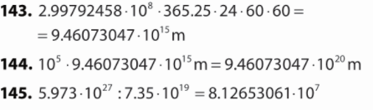

146.
$$P=duljina∙širina=5∙{10}^{4}∙6∙{10}^{3}=30∙{10}^{7}=3∙{10}^{8}m^{2}$$

147.
Promjer $4∙{10}^{2}∙2∙{10}^{-7}=8∙{10}^{-5} m$

148.
$$5∙{10}^{3}∙8∙{10}^{-4}kg=40∙{10}^{-1}=4 kg$$
Masa spajalica u kutiji je 4 kg.

149.
a) $P=16 {cm}^{2}$
a=?
$$P=a^{2}$$
$$a^{2}=16$$
$$a=\sqrt{16}$$
$$a=4 cm$$

b) $P=49 {cm}^{2}$
a=?
$$P=a^{2}$$
$$a^{2}=49$$
$$a=\sqrt{49}$$
$$a=7 cm$$

c) $P=81 m^{2}$
a=?
$$P=a^{2}$$
$$a^{2}=81$$
$$a=\sqrt{81}$$
$$a=9 m$$

d) $P=256 {dm}^{2}$
a=?
$$P=a^{2}$$
$$a^{2}=256$$
$$a=\sqrt{256}$$
$$a=16 dm$$

e) $P=121 {mm}^{2}$
a=?
$$P=a^{2}$$
$$a^{2}=121$$
$$a=\sqrt{121}$$
$$a=11 mm$$

f) $P=36 {cm}^{2}$
a=?
$$P=a^{2}$$
$$a^{2}=36$$
$$a=\sqrt{36}$$
$$a=6 cm$$

150.
a) $\sqrt{9}=3 jer je 3^{2}=9$
b) $\sqrt{144}=12 jer je {12}^{2}=144$
c)$\sqrt{36}=6 jer je 6^{2}=36$
d)$\sqrt{169}=13 jer je {13}^{2}=169$
e)$\sqrt{256}=16 jer je {16}^{2}=256$

151.
a) $\sqrt{100}=10 jer je {10}^{2}=100$
b) $\sqrt{900}=30 jer je {30}^{2}=900$
c)$\sqrt{1960000}=1400 jer je {1400}^{2}=1960000$
d)$\sqrt{4000000}=2000 jer je {2000}^{2}=4000000$
152.
a) $\sqrt{0.01}=0.1$
b) $\sqrt{0.04}=0.2$
c) $\sqrt{0.25}=0.5$
d) $\sqrt{2.25}=1.5$
e) $\sqrt{3.61}=1.9$

153.
a) $\sqrt{\frac{9}{16}}=\frac{3}{4}$
b) $\sqrt{\frac{25}{36}}=\frac{5}{6}$
c) $\sqrt{\frac{49}{81}}=\frac{7}{9}$
d) $\sqrt{\frac{121}{9}}=\frac{11}{3}$
e) $\sqrt{\frac{361}{36}}=\frac{19}{6}$

154.
a) $\sqrt{1\frac{9}{16}}=\sqrt{\frac{25}{16}}=\frac{5}{4}$
b) $\sqrt{1\frac{13}{36}}=\sqrt{\frac{49}{36}}=\frac{7}{6}$
c) $\sqrt{2\frac{2}{49}}=\sqrt{\frac{100}{49}}=\frac{10}{7}$
d) $\sqrt{1\frac{21}{100}}=\sqrt{\frac{121}{100}}=\frac{11}{10}$
e) $\sqrt{10\frac{1}{36}}=\sqrt{\frac{361}{36}}=\frac{19}{6}$
155.
a) $P=16 π {cm}^{2}$
r=?
$$P=r^{2}π$$
$$r^{2}π=16π$$
$$r=\sqrt{16}$$
$$r=4 cm$$

$$o=2rπ=2∙4π=8π cm$$

b)$P=49 π {cm}^{2}$
r=?
$$P=r^{2}π$$
$$r^{2}π=49π$$
$$r=\sqrt{49}$$
$$r=7 cm$$

$$o=2rπ=2∙7π=14π cm$$

c) $P=81 π {cm}^{2}$
r=?
$$P=r^{2}π$$
$$r^{2}π=81π$$
$$r=\sqrt{81}$$
$$r=9 cm$$

$$o=2rπ=2∙9π=18π cm$$
d) $P=256 π {cm}^{2}$
r=?
$$P=r^{2}π$$
$$r^{2}π=256π$$
$$r=\sqrt{256}$$
$$r=16 cm$$

$$o=2rπ=2∙16π=32π cm$$

e) $P=1.21 π {cm}^{2}$
r=?
$$P=r^{2}π$$
$$r^{2}π=1.21π$$
$$r=\sqrt{1.21}$$
$$r=1.1 cm$$

$$o=2rπ=2∙1.1π=2.2π cm$$

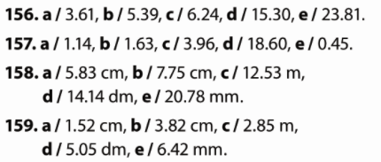
160.
a) $4=\sqrt{16}<\sqrt{17}<\sqrt{25}=5$ Između 4 i 5.
b) $24=\sqrt{576}<\sqrt{620}<\sqrt{625}=25$ Između 24 i 25.
c) $10=\sqrt{100}<\sqrt{115}<\sqrt{121}=11$ Između 10 i 11.
d) $1=\sqrt{1}<\sqrt{1.61}<\sqrt{4}=2$ Između 1 i 2.
e) $1=\sqrt{1}<\sqrt{2.35}<\sqrt{4}=2$ Između 1 i 2.

161.
a) $\sqrt{3.9}≈2$
b) $\sqrt{9.5}≈3$
c) $\sqrt{342}≈19$
d) $\sqrt{62.5}≈8$
e) $\sqrt{200}≈14$

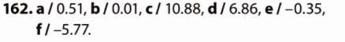
163.
a) $\sqrt{4}=2$
b) $\sqrt{49}=7$
c)$\sqrt{64}=8$
d)$\sqrt{225}=15$
e)$\sqrt{289}=17$

164.
a) $\sqrt{\frac{9}{25}}=\frac{3}{5}$
b) $\sqrt{\frac{25}{36}}=\frac{5}{6}$
c) $\sqrt{\frac{49}{64}}=\frac{7}{8}$
d) $\sqrt{\frac{121}{16}}=\frac{11}{4}$
e) $\sqrt{\frac{64}{81}}=\frac{8}{9}$

165.
a) $\sqrt{15}≈3.87$
b) $\sqrt{23}≈4.80$
c) $\sqrt{59}≈7.68$
d) $\sqrt{237}≈15.39$
e) $\sqrt{562}≈23.71$

166.
a) $\sqrt{1.23}≈1.1$
b) $\sqrt{2.345}≈1.53$
c) $\sqrt{35.31}≈5.94$
d) $\sqrt{3145.28}≈56.08$
e) $\sqrt{0.1}≈0.32$

167.
a) $0.95-\sqrt{2.67}=-0.68$
b) $2-\sqrt{3.6}=0.10$
c) $\sqrt{5}∙1.46=3.26$
d) $\sqrt{1.63}:2+5=5.64$
e) $\sqrt{5.19}-2.3:\sqrt{2.8}=0.90$

168.
a) $452- \sqrt{12092}=324.04$
b) $289-\sqrt{39886}:2=189.14$
c) $-18:\sqrt{{1.5}^{2}+2}∙1.5=-13.10$
d) ${0.7}^{2}∙3+\sqrt{4∙\left(3-2.2\right)}=3.26$

169.
a) $\sqrt{9}=3$
b)$\sqrt{16}=4$
c)$\sqrt{36}=6$
d)$\sqrt{100}=10$
e)$\sqrt{144}=12$

170.
a) $\sqrt{\frac{4}{25}}=\frac{2}{5}$
b) $\sqrt{\frac{16}{49}}=\frac{4}{7}$
c) $\sqrt{\frac{25}{64}}=\frac{5}{8}$
d) $\sqrt{\frac{9}{16}}=\frac{3}{4}$
e) $\sqrt{\frac{1}{64}}=\frac{1}{8}$

171.
a) $\sqrt{2}=1.41$
b)$\sqrt{3}=1.73$
c)$\sqrt{12}=3.46$
d)$\sqrt{20}=4.47$
e)$\sqrt{37}=6.08$

172.
a) $\sqrt{2.4}=1.55$
b)$\sqrt{0.5}=0.71$
c)$\sqrt{15.2}=3.90$
d)$\sqrt{25.2}=5.06$
e)$\sqrt{2.1}=1.45$

173.
$$P=64 {cm}^{2}$$
a=?
$$P=a^{2}$$
$$a^{2}=64$$
$$a=\sqrt{64}$$
$$a=8 cm$$

174.
$$P=7564 {mm}^{2}$$
$$P=a^{2}$$
$$a^{2}=7564$$
$$a=\sqrt{7564}$$
$$a=86.98 mm$$
$$o=4·a=4·86.98 mm=347.89 mm$$
175.
$$P=144 π {cm}^{2}$$
r=?
$$P=r^{2}π$$
$$r^{2}π=144π$$
$$r=\sqrt{144}$$
$$r=12 cm$$

176.
$$P=256 {mm}^{2}$$
r=?
$$P=r^{2}π$$
$$r^{2}π=256 : /π$$
$$r=\sqrt{81.49}$$
$$r=9.03 mm$$

$$o=2rπ=2∙9.02π=56.67 mm$$

177.
$P=a∙b=12∙75=900 {cm}^{2}$
a=?
$$P=a^{2}$$
$$a^{2}=900$$
$$a=\sqrt{900}$$
$$a=30 cm$$

178.
$$P=a∙b=36∙225=8100 {mm}^{2}$$
a=?
$$P=a^{2}$$
$$a^{2}=8100$$
$$a=\sqrt{8100}$$
$$a=90 mm$$

$$o=4a=4∙90mm=360 mm$$

179.
$$P=26 {cm}^{2}$$
$$P=a^{2}$$
$$a^{2}=26$$
$$a=\sqrt{26}$$
$$a=5.10 cm$$
$2r=a=5.10 cm$ /:2
$$r=2.55 cm$$

$$P=r^{2}π={2.55}^{2}π=20.41 cm^{2}$$

180.
$$P=50 m^{2}$$
$$P=a^{2}$$
$$a^{2}=50$$
$$a=\sqrt{50}$$
$a= 7.07 m$ Stranica kvadrata mora biti duga 7.07 m.
$o=4a=4∙ 7.07 m=28.28 m$ Mora kupiti 28.28 m ograde.

181.
$$P=a^{2}$$
$$a^{2}=1.6$$
$$a=\sqrt{1.6}$$
$a= 1.26 m$
duljina ruba $o=4a=4∙ 1.26 m=5.04 m$

$$P=r^{2}π$$
$$r^{2}π=1.6 : /π$$
$$r=\sqrt{0.51}$$
$$r=0.71 m$$
duljina ruba $o=2rπ=2∙ 0.71π m=4.46m$
Kvadratni stol je naručila.

182.
a) $\left(5.3-6\sqrt{2.8}\right)∙9.7=16.63$
b) $6-1.2∙{\left({0.33}^{2}-\sqrt{2.7}\right)}^{2}+{0.1}^{2}=3.19$
c) $\left(6.782+\sqrt{1.1-{0.77}^{2}}\right)-2.11:\sqrt{3}=6.28$
d) $\sqrt{2.6}:{\left( \sqrt{45.007-{4.52}^{2} :} 13.5\right)}^{2}=11.96$
e) $\sqrt{5-\left(\sqrt{20}-{\left(\sqrt{20}-5\right)}^{2}\right)}=0.90$
f) ${\left(\sqrt{{22.58}^{2}-{\left(3.28+4.5\right)}^{2}}-2\right)}^{2}=368.54$

183.
a) $\frac{222-\sqrt{32 071}}{222- \sqrt{39 886}:2}=0.35$
b) $\frac{28:\sqrt{{1.3}^{2}-1 }-1.5}{{1.3}^{2}∙7+ \sqrt{2∙(3-{1.2}^{2})}}=2.37$
c) $\frac{\sqrt{{0.3}^{2}∙3.1+{\left(2: 0.5\right)}^{2}}-1}{(1.2-\left(\sqrt{2.1}-1.9\right)):\sqrt{2.5}}=2.54$

184.
$$P=30 m^{2}$$
r=?
$$P=r^{2}π$$
$$r^{2}π=30 : /π$$
$$r=\sqrt{9.55}$$
$$r= 3.09 m$$

$$o=2rπ=2∙3.09 π=19.42m$$
Opseg moramo pomnožiti s dubinom da dobijemo površinu bočnog dijela.
$$P_{B}=1.8 ∙19.42=34.956 m^{2}$$

$\left(34.956+30\right):2.5=25.9824$

Potrebno je 26 limenki.
185.
a) $5\sqrt{2}-4\sqrt{2}+6\sqrt{2}=\left(5-4+6\right)\sqrt{2}=7\sqrt{2}$
b) $11\sqrt{11}-2\sqrt{11}=\left(11-2\right)\sqrt{11}=9\sqrt{11}$
c) $-2\sqrt{7}+\sqrt{7}=\left(-2+1\right)\sqrt{7}=-\sqrt{7}$
d) $4\sqrt{13}-3\sqrt{13}+8\sqrt{13}=\left(4-3+8\right)\sqrt{13}=9\sqrt{13}$
e) $6\sqrt{3}-1.4\sqrt{3}+2.6\sqrt{3}=\left(6-1.4+2.6\right)\sqrt{3}=7.2\sqrt{3}$
f) $3\sqrt{8}-2.4\sqrt{8}-\sqrt{8}+7.1\sqrt{8}=\left(3-2.4-1+7.1\right)\sqrt{8}=6.7\sqrt{8}$

186.
a) $5\sqrt{7}-4\sqrt{2}-3\sqrt{2}+6\sqrt{7}=\left(5+6\right)\sqrt{7}+\left(-4-3\right)\sqrt{2}=11\sqrt{7}-7\sqrt{2}$
b) $6\sqrt{14}-7\sqrt{14}-8\sqrt{14}+2\sqrt{8}=\left(6-7-8\right)\sqrt{14}+2\sqrt{8}=-9\sqrt{14}+2\sqrt{8}$
c) $\frac{1}{6}\sqrt{6}-\frac{3}{8}\sqrt{6}+2\frac{2}{3}\sqrt{7}-\frac{1}{4}\sqrt{7}=\left(\frac{1}{6}-\frac{3}{8}\right)\sqrt{6} +\left(\frac{8}{3}-\frac{1}{4}\right)\sqrt{7}=-\frac{5}{24}\sqrt{6}+\frac{29}{12}\sqrt{7}$
d) $4.21\sqrt{2}-3\sqrt{3}+2.5\sqrt{3}-2.7\sqrt{2}=\left(4.21-2.7\right)\sqrt{2}+\left(-3+2.5\right)\sqrt{3}=1.51\sqrt{2}-0.5\sqrt{3}$
e) $\frac{3}{5}\sqrt{3}-\frac{1}{2}\sqrt{5}+\frac{1}{2}\sqrt{3}-\frac{7}{10}\sqrt{5}=\left(\frac{3}{5}+\frac{1}{2}\right)\sqrt{3} +\left(-\frac{1}{2}-\frac{7}{10}\right)\sqrt{5}=\frac{11}{10}\sqrt{3}-\frac{6}{5}\sqrt{5}$
f) $1.8\sqrt{12}-2\sqrt{11}+0.71\sqrt{12}-1.7\sqrt{11}=\left(1.8+0.71\right)\sqrt{12}+\left(-2-1.7\right)\sqrt{11}=2.51\sqrt{12}-3.7\sqrt{11}$

187.
a) ${\left(\sqrt{5}\right)}^{2}=5$
b) ${\left(\sqrt{0.31}\right)}^{2}=0.31$
c) ${\left(\sqrt{17.94}\right)}^{2}=17.94$
d) ${\left(\sqrt{\frac{6}{11}}\right)}^{2}=\frac{6}{11}$
e) ${\left(\sqrt{3\frac{5}{11}}\right)}^{2}=3\frac{5}{11}$

188.
a) $\sqrt{6^{2}}=6$
b) $\sqrt{{(-17)}^{2}}=17$
c) $\sqrt{{(-4.8)}^{2}}=4.8$
d) $\sqrt{{\left(\frac{5}{8}\right)}^{2}}=\frac{5}{8}$
e) $\sqrt{{\left(-4\frac{1}{5}\right)}^{2}}=4\frac{1}{5}$

189.
a) ${\left(2\sqrt{6}\right)}^{2}=2^{2}∙{\sqrt{6}}^{2}=4∙6=24$
b) ${\left(4\sqrt{3}\right)}^{2}=4^{2}∙{\sqrt{3}}^{2}=16∙3=48$
c) ${\left(6\sqrt{2}\right)}^{2}=6^{2}∙{\sqrt{2}}^{2}=36∙2=72$
d) ${\left(1.2\sqrt{1.6}\right)}^{2}={1.2}^{2}∙{\sqrt{1.6}}^{2}=1.44∙1.6=2.304$
e) ${\left(0.5\sqrt{4}\right)}^{2}={0.5}^{2}∙{\sqrt{4}}^{2}=0.25∙4=1$

190.
a) ${\left(\frac{\sqrt{24}}{6}\right)}^{2}=\frac{{\sqrt{24}}^{2}}{6^{2}}=\frac{24}{36}=\frac{2}{3}$
b) ${\left(\frac{6}{\sqrt{12}}\right)}^{2}=\frac{6^{2}}{{\sqrt{12}}^{2}}=\frac{36}{12}=3$
c) ${\left(\frac{\sqrt{28}}{\sqrt{49}}\right)}^{2}=\frac{{\sqrt{28}}^{2}}{{\sqrt{49}}^{2}}=\frac{28}{49}=\frac{4}{7}$
d) $7\sqrt{{\left(\frac{5}{7}\right)}^{2}}=7∙\frac{5}{7}=5$
e) $\frac{\sqrt{{8.4}^{2}}}{2}=\frac{8.4}{2}=4.2$

191.
a)$\sqrt{12}∙\sqrt{3}=\sqrt{12∙3}=\sqrt{36}=6$
b) $\sqrt{2}∙\sqrt{18}=\sqrt{2∙18}=\sqrt{36}=6$
c) $\sqrt{20}∙\sqrt{5}=\sqrt{20∙5}=\sqrt{100}=10$

192.
a)$\sqrt{20}∙\sqrt{1.25}=\sqrt{20∙1.25}=\sqrt{25}=5$
b) $\sqrt{0.3}∙\sqrt{1.2}=\sqrt{0.3∙1.2}=\sqrt{0.36}=0.6$
c) $\sqrt{2.4}∙\sqrt{0.6}=\sqrt{2.4∙0.6}=\sqrt{1.44}=1.2$

193.
a)$\sqrt{\frac{10}{9}}∙\sqrt{\frac{1}{10}}=\sqrt{\frac{10}{9}∙\frac{1}{10}}=\sqrt{\frac{1}{9}}=\frac{1}{3}$
b) $\sqrt{20}∙\sqrt{\frac{5}{4}}=\sqrt{20∙\frac{5}{4}}=\sqrt{25}=5$
c) $\sqrt{1\frac{2}{3}}∙\sqrt{5\frac{2}{5}}=\sqrt{\frac{5}{3}∙\frac{27}{5}}=\sqrt{9}=3$

194.
a) $\sqrt{6}\left(\sqrt{6}+\sqrt{1.5}\right)=\sqrt{36}+\sqrt{9}=6+3=9$
b) $\sqrt{5}\left(\sqrt{45}+\sqrt{20}+\sqrt{80}\right)=\sqrt{225}+\sqrt{100}+\sqrt{400}=15+10+20=45$
c) $\sqrt{2}\left(\sqrt{2}+\sqrt{18}+\sqrt{32}\right)=\sqrt{4}+\sqrt{36}+\sqrt{64}=2+6+8=16$

195.
a) $\sqrt{49∙169}=\sqrt{49}∙\sqrt{169}=7∙13=91$
b) $\sqrt{3.24∙5.76}=\sqrt{3.24}∙\sqrt{5.76}=1.8∙2.4=4.32$
c) $\sqrt{6.25∙6.76}=\sqrt{6.25}∙\sqrt{6.76}=2.5∙2.6=6.5$

196.
a) $\sqrt{27}:\sqrt{3}=\sqrt{27:3}=\sqrt{9}=3$
b) $\sqrt{18}:\sqrt{2}=\sqrt{18:2}=\sqrt{9}=3$
c)$\sqrt{20}:\sqrt{5}=\sqrt{20:5}=\sqrt{4}=2$
d) $\sqrt{75}:\sqrt{3}=\sqrt{75:3}=\sqrt{25}=5$

197.
a) $\sqrt{20}:\sqrt{1.25}=\sqrt{20:1.25}=\sqrt{16}=4$
b) $\sqrt{1.8}:\sqrt{0.2}=\sqrt{1.8:0.2}=\sqrt{9}=3$
c)$\sqrt{2.4}:\sqrt{0.6}=\sqrt{2.4:0.6}=\sqrt{4}=2$
d) $\sqrt{15}:\sqrt{0.6}=\sqrt{15:0.6}=\sqrt{25}=5$

198.
a) $\sqrt{144:36}=\sqrt{144}:\sqrt{36}=12 :6=2$
b) $\sqrt{225:25}=\sqrt{225}:\sqrt{25}=15 :5=3$
c) $\sqrt{256:16}=\sqrt{256}:\sqrt{16}=16 :4=4$
d) $\sqrt{324:9}=\sqrt{324}:\sqrt{9}=18 :3=6$

199.
a) $\sqrt{784:49}=\sqrt{784}:\sqrt{49}=28 :7=4$
b) $\sqrt{29.16:3.24}=\sqrt{29.16}:\sqrt{3.24}=5.4 :1.8=3$
c) $\sqrt{2.56:0.64}=\sqrt{2.56}:\sqrt{0.64}=1.6 :0.8=2$
d) $\sqrt{484:16}=\sqrt{484}:\sqrt{16}=22 :4=5.5$

200.
a) $\sqrt{\frac{16}{25}}=\frac{\sqrt{16}}{\sqrt{25}}=\frac{4}{5}$
b) $\sqrt{\frac{64}{225}}=\frac{\sqrt{64}}{\sqrt{225}}=\frac{8}{15}$
c) $\sqrt{\frac{144}{169}}=\frac{\sqrt{144}}{\sqrt{169}}=\frac{12}{13}$
d) $\sqrt{\frac{841}{441}}=\frac{\sqrt{841}}{\sqrt{441}}=\frac{29}{21}$

201.
a) $\frac{\sqrt{18}}{\sqrt{2}}=\sqrt{\frac{18}{2}}=\sqrt{9}=3$
b) $\frac{\sqrt{12}}{\sqrt{3}}=\sqrt{\frac{12}{3}}=\sqrt{4}=2$
c) $\frac{\sqrt{75}}{\sqrt{12}}=\sqrt{\frac{75}{12}}=\sqrt{6.25}=2.5$
d) $\frac{\sqrt{125}}{\sqrt{45}}=\sqrt{\frac{125}{45}}=\sqrt{\frac{25}{9}}=\frac{5}{3}$
e) $\frac{\sqrt{8}}{\sqrt{18}}=\sqrt{\frac{8}{18}}=\sqrt{\frac{4}{9}}=\frac{2}{3}$

202.
a) $\frac{\sqrt{98}}{\sqrt{8}}=\sqrt{\frac{98}{8}}=\sqrt{\frac{49}{4}}=\frac{7}{2}$
b) $\frac{\sqrt{108}}{\sqrt{75}}=\sqrt{\frac{108}{75}}=\sqrt{\frac{36}{25}}=\frac{6}{5}$
c) $\frac{\sqrt{175}}{\sqrt{28}}=\sqrt{\frac{175}{28}}=\sqrt{\frac{25}{4}}=\frac{5}{2}$
d) $\frac{\sqrt{125}}{\sqrt{80}}=\sqrt{\frac{125}{80}}=\sqrt{\frac{25}{16}}=\frac{5}{4}$
e) $\frac{\sqrt{288}}{\sqrt{50}}=\sqrt{\frac{288}{50}}=\sqrt{\frac{144}{25}}=\frac{12}{5}$

203.
a) $\sqrt{8}=\sqrt{4∙2}=\sqrt{4}∙\sqrt{2}=2\sqrt{2}$
b) $\sqrt{12}=\sqrt{4∙3}=\sqrt{4}∙\sqrt{3}=2\sqrt{3}$
c) $\sqrt{50}=\sqrt{25∙2}=\sqrt{25}∙\sqrt{2}=5\sqrt{2}$
d) $\sqrt{32}=\sqrt{16∙2}=\sqrt{16}∙\sqrt{2}=4\sqrt{2}$
e) $\sqrt{75}=\sqrt{25∙3}=\sqrt{25}∙\sqrt{3}=5\sqrt{3}$

204.
a) $\sqrt{90}=\sqrt{9∙10}=\sqrt{9}∙\sqrt{10}=3\sqrt{10}$
b) $\sqrt{200}=\sqrt{100∙2}=\sqrt{100}∙\sqrt{2}=10\sqrt{2}$
c) $\sqrt{150}=\sqrt{25∙6}=\sqrt{25}∙\sqrt{6}=5\sqrt{6}$
d) $\sqrt{343}=\sqrt{49∙7}=\sqrt{49}∙\sqrt{7}=7\sqrt{7}$
e) $\sqrt{162}=\sqrt{81∙2}=\sqrt{81}∙\sqrt{2}=9\sqrt{2}$

205.
a) $\sqrt{1008}=\sqrt{144∙7}=\sqrt{144}∙\sqrt{7}=12\sqrt{7}$
b) $\sqrt{768}=\sqrt{256∙3}=\sqrt{256}∙\sqrt{3}=16\sqrt{3}$
c) $\sqrt{3750}=\sqrt{625∙6}=\sqrt{625}∙\sqrt{6}=25\sqrt{6}$
d) $\sqrt{2880}=\sqrt{576∙5}=\sqrt{576}∙\sqrt{5}=24\sqrt{5}$
e) $\sqrt{504}=\sqrt{36∙14}=\sqrt{36}∙\sqrt{14}=6\sqrt{14}$
206.
a) $\sqrt{\frac{5}{16}}=\frac{\sqrt{5}}{\sqrt{16}}=\frac{\sqrt{5}}{4}$
b) $\sqrt{1\frac{7}{25}}=\sqrt{\frac{32}{25}}=\frac{\sqrt{32}}{5}=\frac{\sqrt{16∙2}}{5}=\frac{4\sqrt{2}}{5}$
c) $\sqrt{1\frac{1}{4}}=\sqrt{\frac{5}{4}}=\frac{\sqrt{5}}{\sqrt{4}}=\frac{\sqrt{5}}{2}$
d) $\sqrt{4\frac{11}{16}}=\sqrt{\frac{75}{16}}=\frac{\sqrt{75}}{\sqrt{16}}=\frac{\sqrt{25∙3}}{4}=\frac{5\sqrt{3}}{4}$
e) $\sqrt{2\frac{22}{25}}=\sqrt{\frac{72}{25}}=\frac{\sqrt{72}}{\sqrt{25}}=\frac{\sqrt{36∙2}}{5}=\frac{6\sqrt{2}}{5}$

207.
a) $5\sqrt{3}-2\sqrt{27}+7\sqrt{48}=5\sqrt{3}-2∙3\sqrt{3}+7∙4\sqrt{3}=\left(5-6+28\right)\sqrt{3}=27\sqrt{3}$
b) $4\sqrt{32}-3\sqrt{8}+\sqrt{18}=4∙4\sqrt{2}-3∙2\sqrt{2}+3\sqrt{2}=\left(16-6+3\right)\sqrt{2}=13\sqrt{2}$
c) $2\sqrt{45}-11\sqrt{20}-6\sqrt{125}=2∙3\sqrt{5}-11∙2\sqrt{5}-6∙5\sqrt{5}=\left(6-22-30\right)\sqrt{5}=-46\sqrt{5}$
d) $\sqrt{80}+7\sqrt{45}+3\sqrt{180}=4\sqrt{5}+7∙3\sqrt{5}+3∙6\sqrt{5}=\left(4+21+18\right)\sqrt{5}=43\sqrt{5}$

208.
a) $3.7\sqrt{27}-2.1\sqrt{12}+5.2\sqrt{3}=3.7∙3\sqrt{3}-2.1∙2\sqrt{3}+5.2\sqrt{3}=\left(11.1-4.2+5.2\right)\sqrt{3}=12.1\sqrt{3}$
b) $1.7\sqrt{50}-5.2\sqrt{2}+\sqrt{72}=1.7∙5\sqrt{2}-5.2\sqrt{2}+6\sqrt{2}=\left(8.5-5.2+1\right)\sqrt{3}=9.3\sqrt{3}$
c) $3.2\sqrt{45}-1.33\sqrt{320}-3.4\sqrt{125}=3.2∙3\sqrt{5}-1.33∙8\sqrt{5}-3.4∙5\sqrt{5}=\left(9.6-10.64-17\right)\sqrt{5}=-18.04\sqrt{5}$

d) $\frac{3}{4}\sqrt{75}-\frac{5}{8}\sqrt{147}-\frac{1}{2}\sqrt{243}=\frac{3}{4}∙5\sqrt{3}-\frac{5}{8}∙7\sqrt{3}-\frac{1}{2}∙9\sqrt{3}=\left(\frac{15}{4}-\frac{35}{8}-\frac{9}{2}\right)\sqrt{3}=\frac{-41}{8}\sqrt{3}$

209.
a) $\frac{1}{\sqrt{2}}=\frac{1}{\sqrt{2}}∙\frac{\sqrt{2}}{\sqrt{2}}=\frac{\sqrt{2}}{{\sqrt{2}}^{2}}=\frac{\sqrt{2}}{2}$
b) $\frac{1}{\sqrt{5}}=\frac{1}{\sqrt{5}}∙\frac{\sqrt{5}}{\sqrt{5}}=\frac{\sqrt{5}}{{\sqrt{5}}^{2}}=\frac{\sqrt{5}}{5}$
c)$\frac{1}{\sqrt{7}}=\frac{1}{\sqrt{7}}∙\frac{\sqrt{7}}{\sqrt{7}}=\frac{\sqrt{7}}{{\sqrt{7}}^{2}}=\frac{\sqrt{7}}{7}$
d) $\frac{1}{\sqrt{10}}=\frac{1}{\sqrt{10}}∙\frac{\sqrt{10}}{\sqrt{10}}=\frac{\sqrt{10}}{{\sqrt{10}}^{2}}=\frac{\sqrt{10}}{10}$
e)$\frac{1}{\sqrt{15}}=\frac{1}{\sqrt{15}}∙\frac{\sqrt{15}}{\sqrt{15}}=\frac{\sqrt{15}}{{\sqrt{15}}^{2}}=\frac{\sqrt{15}}{15}$

210.
a) $\frac{3}{\sqrt{3}}=\frac{3}{\sqrt{3}}∙\frac{\sqrt{3}}{\sqrt{3}}=\frac{3\sqrt{3}}{{\sqrt{3}}^{2}}=\frac{3\sqrt{3}}{3}=\sqrt{3}$
b) $\frac{10}{\sqrt{5}}=\frac{10}{\sqrt{5}}∙\frac{\sqrt{5}}{\sqrt{5}}=\frac{10\sqrt{5}}{{\sqrt{5}}^{2}}=\frac{10\sqrt{5}}{5}=2\sqrt{5}$
c)$\frac{12}{\sqrt{2}}=\frac{12}{\sqrt{2}}∙\frac{\sqrt{2}}{\sqrt{2}}=\frac{12\sqrt{2}}{{\sqrt{2}}^{2}}=\frac{12\sqrt{2}}{2}=6\sqrt{2}$
d) $\frac{6}{\sqrt{12}}=\frac{6}{\sqrt{12}}∙\frac{\sqrt{12}}{\sqrt{12}}=\frac{6\sqrt{12}}{{\sqrt{12}}^{2}}=\frac{6\sqrt{4∙3}}{12}=\frac{6∙2\sqrt{3}}{12}=\sqrt{3}$
e)$\frac{5}{\sqrt{10}}=\frac{5}{\sqrt{10}}∙\frac{\sqrt{10}}{\sqrt{10}}=\frac{5\sqrt{10}}{{\sqrt{10}}^{2}}=\frac{5\sqrt{10}}{10}=\frac{\sqrt{10}}{2}$

211.
a) $\frac{\sqrt{21}}{\sqrt{14}}=\sqrt{\frac{21}{14}}=\sqrt{\frac{3}{2}}=\frac{\sqrt{3}}{\sqrt{2}}=\frac{\sqrt{3}}{\sqrt{2}}∙\frac{\sqrt{2}}{\sqrt{2}}=\frac{\sqrt{6}}{{\sqrt{2}}^{2}}=\frac{\sqrt{6}}{2}$
b) $\frac{\sqrt{10}}{\sqrt{35}}=\sqrt{\frac{10}{35}}=\sqrt{\frac{2}{7}}=\frac{\sqrt{2}}{\sqrt{7}}=\frac{\sqrt{2}}{\sqrt{7}}∙\frac{\sqrt{7}}{\sqrt{7}}=\frac{\sqrt{14}}{{\sqrt{7}}^{2}}=\frac{\sqrt{14}}{7}$
c) $\frac{2\sqrt{18}}{\sqrt{12}}=2\sqrt{\frac{18}{12}}=2\sqrt{\frac{3}{2}}=\frac{2\sqrt{3}}{\sqrt{2}}=\frac{2\sqrt{3}}{\sqrt{2}}∙\frac{\sqrt{2}}{\sqrt{2}}=\frac{2\sqrt{6}}{{\sqrt{2}}^{2}}=\frac{2\sqrt{6}}{2}=\sqrt{6}$
d) $\frac{8\sqrt{6}}{\sqrt{8}}=8\sqrt{\frac{6}{8}}=8\sqrt{\frac{3}{4}}=\frac{8\sqrt{3}}{2}=4\sqrt{3}$
e) $\frac{2\sqrt{5}}{\sqrt{15}}=2\sqrt{\frac{5}{15}}=2\sqrt{\frac{1}{3}}=\frac{2\sqrt{1}}{3}=\frac{2}{\sqrt{3}}∙\frac{\sqrt{3}}{\sqrt{3}}=\frac{2\sqrt{3}}{{\sqrt{3}}^{2}}=\frac{2\sqrt{3}}{3}$

212.
a) $\frac{36}{4\sqrt{6}}=\frac{9}{\sqrt{6}}=\frac{9}{\sqrt{6}}∙\frac{\sqrt{6}}{\sqrt{6}}=\frac{9\sqrt{6}}{{\sqrt{6}}^{2}}=\frac{9\sqrt{6}}{6}=\frac{3\sqrt{6}}{2}$
b) $\frac{6}{2\sqrt{12}}=\frac{6}{4\sqrt{3}}=\frac{3}{2\sqrt{3}}∙\frac{\sqrt{3}}{\sqrt{3}}=\frac{3\sqrt{3}}{{2\sqrt{3}}^{2}}=\frac{3\sqrt{3}}{6}=\frac{\sqrt{3}}{2}$
c) $\frac{5\sqrt{10}}{\sqrt{15}}=5\sqrt{\frac{10}{15}}=5\sqrt{\frac{2}{3}}=\frac{5\sqrt{2}}{\sqrt{3}}∙\frac{\sqrt{3}}{\sqrt{3}}=\frac{5\sqrt{6}}{{\sqrt{3}}^{2}}=\frac{5\sqrt{6}}{3}$
d) $\frac{9\sqrt{3}}{\sqrt{18}}=9\sqrt{\frac{3}{18}}=9\sqrt{\frac{1}{6}}=\frac{9}{\sqrt{6}}∙\frac{\sqrt{6}}{\sqrt{6}}=\frac{9\sqrt{6}}{{\sqrt{6}}^{2}}=\frac{9\sqrt{6}}{6}=\frac{3\sqrt{6}}{2}$
e) $\frac{\sqrt{5}}{\sqrt{12}}=\frac{\sqrt{5}}{2\sqrt{3}}=\frac{\sqrt{5}}{2\sqrt{3}}∙\frac{\sqrt{3}}{\sqrt{3}}=\frac{\sqrt{15}}{{2\sqrt{3}}^{2}}=\frac{\sqrt{15}}{6}$

213.
a) $5\sqrt{2}-3\sqrt{2}=\left(5-3\right)\sqrt{2}=2\sqrt{2}$
b) $16\sqrt{11}-7\sqrt{11}-8\sqrt{11}=\left(16-7-8\right)\sqrt{11}=\sqrt{11}$
c) $\sqrt{6}-5\sqrt{6}+5\sqrt{7}-9\sqrt{7}=\left(1-5\right)\sqrt{6} +\left(5-9\right)\sqrt{7}=-4\sqrt{6}-4\sqrt{7}$
d) $5\sqrt{2}-3\sqrt{3}+9\sqrt{3}-2\sqrt{2}=\left(5-2\right)\sqrt{2}+\left(-3+9\right)\sqrt{3}=3\sqrt{2}+6\sqrt{3}$

214.
a) $\sqrt{5^{2}}=5$
b) $\sqrt{{(-15)}^{2}}=15$
c) $\sqrt{{(-3.4)}^{2}}=3.4$
d) $\sqrt{{0.65}^{2}}=0.65$
e) $\sqrt{{0.2}^{2}}=0.2$

215.
a)$\sqrt{18}∙\sqrt{2}=\sqrt{18∙2}=\sqrt{36}=6$
b) $\sqrt{3}∙\sqrt{75}=\sqrt{3∙75}=\sqrt{225}=15$
c) $\sqrt{20}∙\sqrt{5}=\sqrt{20∙5}=\sqrt{100}=10$
d) $\sqrt{5}∙\sqrt{80}=\sqrt{5∙80}=\sqrt{400}=20$
e) $-\sqrt{32}∙\sqrt{2}=-\sqrt{32∙2}=-\sqrt{64}=-8$

216.
a) $\sqrt{12}:\sqrt{3}=\sqrt{12:3}=\sqrt{4}=2$
b) $\sqrt{18}:\sqrt{2}=\sqrt{18:2}=\sqrt{9}=3$
c)$\sqrt{45}:\sqrt{5}=\sqrt{45:5}=\sqrt{9}=3$
d) $\sqrt{300}:\sqrt{3}=\sqrt{300:3}=\sqrt{100}=10$
e) $\sqrt{50}:\sqrt{2}=\sqrt{50:2}=\sqrt{25}=5$

217.
a) $5\sqrt{2}∙3\sqrt{2}=5∙3\sqrt{2^{2}}=15∙2=30$
b) $8\sqrt{5}∙5\sqrt{5}=8∙5\sqrt{5^{2}}=40∙5=200$
c) $4\sqrt{11}∙13\sqrt{11}=4∙13\sqrt{{11}^{2}}=52∙11=572$
d) $0.3\sqrt{15}∙1.6\sqrt{15}=0.3∙1.6\sqrt{{15}^{2}}=0.48∙15=7.2$
e) $1.2\sqrt{20}∙0.8\sqrt{20}=1.2∙0.8\sqrt{{20}^{2}}=0.96∙20=19.2$
f) $4.4\sqrt{7}∙1.6\sqrt{7}=4.4∙1.6\sqrt{7^{2}}=7.04∙7=49.28$
218.
a) $\sqrt{2}\left(4+\sqrt{2}\right)=\sqrt{2}∙4+\sqrt{2}∙\sqrt{2}=4\sqrt{2}+\sqrt{2^{2}}=4\sqrt{2}+2$
b) $\sqrt{5}\left(3\sqrt{5}-5\right)=3\sqrt{5}∙\sqrt{5}-\sqrt{5}∙5=3\sqrt{5^{2}}-5\sqrt{5}=15-5\sqrt{5}$
c) $\sqrt{11}\left(4\sqrt{11}-1\right)=4\sqrt{11}∙\sqrt{11}-\sqrt{11}∙1=4\sqrt{{11}^{2}}-\sqrt{11}=44-\sqrt{11}$
d) $4\sqrt{12}\left(2-11\sqrt{12}\right)=4\sqrt{12}∙2-4∙11\sqrt{12}∙\sqrt{12}=8\sqrt{12}-44\sqrt{{12}^{2}}=8\sqrt{12}-528$
e) $2\sqrt{3}\left(2-\sqrt{3}-11\sqrt{3}\right)=2\sqrt{3}∙2-2\sqrt{3}∙\sqrt{3}-2∙11\sqrt{3∙3}=4\sqrt{3}-6-66=4\sqrt{3}-72$
f) $6\sqrt{10}\left(2\sqrt{10}-7\sqrt{10}-11\right)=-6∙5\sqrt{{10}^{2}}-6∙11\sqrt{10}=-300-66\sqrt{10}$

219.
a) $\sqrt{50}=\sqrt{25∙2}=\sqrt{25}∙\sqrt{2}=5\sqrt{2}$
b) $\sqrt{72}=\sqrt{36∙2}=\sqrt{36}∙\sqrt{2}=6\sqrt{2}$
c) $\sqrt{150}=\sqrt{25∙6}=\sqrt{25}∙\sqrt{6}=5\sqrt{6}$
d) $\sqrt{1000}=\sqrt{100∙10}=\sqrt{100}∙\sqrt{10}=10\sqrt{10}$
e) $\sqrt{96}=\sqrt{16∙6}=\sqrt{16}∙\sqrt{6}=4\sqrt{6}$

220.
a) $12\sqrt{128}=12\sqrt{64∙2}=12∙8∙\sqrt{2}=96\sqrt{2}$
b) $10\sqrt{147}=10\sqrt{49∙3}=10\sqrt{49}∙\sqrt{3}=70\sqrt{3}$
c) $12\sqrt{200}=12\sqrt{100∙2}=12\sqrt{100}∙\sqrt{2}=120\sqrt{2}$
d) $5\sqrt{405}=5\sqrt{81∙5}=5\sqrt{81}∙\sqrt{5}=45\sqrt{5}$
e) $9\sqrt{12}=9\sqrt{4∙3}=9\sqrt{4}∙\sqrt{3}=18\sqrt{3}$

221.
a) $\sqrt{2}+\sqrt{2}-\sqrt{32}=\sqrt{2}+\sqrt{2}-\sqrt{16∙2}=2\sqrt{2}-4\sqrt{2}=-2\sqrt{2}$
b) $10\sqrt{6}+7\sqrt{54}=10\sqrt{6}+7\sqrt{9∙6}=10\sqrt{6}+21\sqrt{6}=31\sqrt{6}$
c) $-2\sqrt{11}+13\sqrt{44}=-2\sqrt{11}+13\sqrt{4∙11}=-2\sqrt{11}+26\sqrt{11}=24\sqrt{11}$

222.
a) $8\sqrt{27}-2\sqrt{48}+9\sqrt{108}=8\sqrt{9∙3}-2\sqrt{16∙3}+9\sqrt{36∙3}=24\sqrt{3}-8\sqrt{3}+54\sqrt{3}=70\sqrt{3}$
b) $11\sqrt{50}-3\sqrt{18}+\sqrt{98}=11\sqrt{25∙2}-3\sqrt{9∙2}+\sqrt{49∙2}=55\sqrt{2}-9\sqrt{2}+7\sqrt{2}=53\sqrt{2}$
c) $2\sqrt{45}-13\sqrt{80}-\sqrt{245}=2\sqrt{9∙5}-13\sqrt{16∙5}-\sqrt{49∙5}=6\sqrt{5}-52\sqrt{5}-7\sqrt{5}=-53\sqrt{5}$
d) $3\sqrt{40}-7\sqrt{90}-3\sqrt{250}=3\sqrt{4∙10}-7\sqrt{9∙10}-3\sqrt{25∙10}=6\sqrt{10}-21\sqrt{10}-15\sqrt{10}=-30\sqrt{10}$
e) $3\sqrt{60}+9\sqrt{135}-20\sqrt{240}=3\sqrt{4∙15}+9\sqrt{9∙15}-20\sqrt{16∙15}=6\sqrt{15}+27\sqrt{15}-80\sqrt{15}=-47\sqrt{15}$
f) $13\sqrt{126}-3\sqrt{350}+4\sqrt{224}=13\sqrt{9∙14}-3\sqrt{25∙14}+4\sqrt{16∙14}=39\sqrt{14}-15\sqrt{14}+16\sqrt{14}=40\sqrt{14}$

223.
a)$-6∙\sqrt{48}∙\sqrt{8}=-6∙\sqrt{16∙3}∙\sqrt{4∙2}=-6∙4∙2∙\sqrt{3∙2}=-48\sqrt{6}$
b) $-\sqrt{20}∙4\sqrt{176}=-\sqrt{4∙5}∙4∙\sqrt{16∙11}=-32\sqrt{5∙11}=-32\sqrt{55}$
c) $-4\sqrt{8}∙\left(-3\sqrt{80}\right)=4\sqrt{4∙2}∙3\sqrt{16∙5}=96\sqrt{2∙5}=96\sqrt{10}$

224.
a) $\sqrt{8}∙\left(\sqrt{63}+\sqrt{48}\right)=2\sqrt{2}∙\left(3\sqrt{7}+4\sqrt{3}\right)=6\sqrt{14}+8\sqrt{6}$
b) $\sqrt{18}∙\left(\sqrt{44}-\sqrt{48}\right)=3\sqrt{2}∙\left(2\sqrt{11}-4\sqrt{3}\right)=6\sqrt{22}-12\sqrt{6}$
c) $2\sqrt{20}∙\left(3\sqrt{99}-5\sqrt{32}\right)=4\sqrt{5}∙\left(9\sqrt{11}-20\sqrt{2}\right)=36\sqrt{55}-80\sqrt{10}$

225.
a) $8\sqrt{2}-5\sqrt{2}=\left(8-5\right)\sqrt{2}=3\sqrt{2}$
b) $6\sqrt{6}-9\sqrt{6}-8\sqrt{6}=\left(6-9-8\right)\sqrt{6}=-11\sqrt{6}$
c) $\sqrt{13}-4\sqrt{13}+5\sqrt{13}=\left(1-4+5\right)\sqrt{13}=2\sqrt{13}$

226.
a) $\sqrt{2^{2}}=2$
b) $\sqrt{{12}^{2}}=12$
c) $\sqrt{{\left(-3\right)}^{2}}=3$
d) $\sqrt{3^{2}}=3$
e) $\sqrt{{\left(-1\right)}^{2}}=1$

227.
a)$\sqrt{2}∙\sqrt{8}=\sqrt{2∙8}=\sqrt{16}=4$
b) $\sqrt{3}∙\sqrt{12}=\sqrt{3∙12}=\sqrt{36}=6$
c) $\sqrt{5}∙\sqrt{20}=\sqrt{5∙20}=\sqrt{100}=10$
d) $\sqrt{5}∙\sqrt{5}=\sqrt{5∙5}=\sqrt{25}=5$
e) $\sqrt{3}∙\sqrt{27}=\sqrt{3∙27}=\sqrt{81}=9$

228.
a) $\sqrt{18}:\sqrt{2}=\sqrt{18:2}=\sqrt{9}=3$
b) $\sqrt{24}:\sqrt{6}=\sqrt{24:6}=\sqrt{4}=2$
c)$\sqrt{75}:\sqrt{3}=\sqrt{75:3}=\sqrt{25}=5$
d) $\sqrt{32}:\sqrt{2}=\sqrt{32:2}=\sqrt{16}=4$
e) $\sqrt{72}:\sqrt{2}=\sqrt{72:2}=\sqrt{36}=6$

229.
a) $\sqrt{12}=\sqrt{4∙3}=\sqrt{4}∙\sqrt{3}=2\sqrt{3}$
b) $\sqrt{18}=\sqrt{9∙2}=\sqrt{9}∙\sqrt{2}=3\sqrt{2}$
c) $\sqrt{32}=\sqrt{16∙2}=\sqrt{16}∙\sqrt{2}=4\sqrt{2}$
d) $\sqrt{28}=\sqrt{4∙7}=\sqrt{4}∙\sqrt{7}=2\sqrt{7}$
e) $\sqrt{80}=\sqrt{16∙5}=\sqrt{16}∙\sqrt{5}=4\sqrt{5}$

230.
$$P_{1}=a_{1}^{2}$$
$P_{2}=a_{2}^{2}={9a}_{1}^{2}$
Korjenujemo da dobijemo stranicu.
$a_{2}^{2}={9a}_{1}^{2}$ /:
$$a_{2}=3a_{1}$$
Stranica se povećala 3 puta.

231.
$$P_{1}=a_{1}^{2}$$
$P_{2}=a_{2}^{2}=\frac{a_{1}^{2}}{2}$
Korjenujemo da dobijemo stranicu.
$a_{2}^{2}=\frac{a_{1}^{2}}{2}$ /:
$$a_{2}=\frac{a_{1}}{\sqrt{2}}∙\frac{\sqrt{2}}{\sqrt{2}}=\frac{\sqrt{2}a_{1}}{2}$$
Stranica se smanjila $\frac{\sqrt{2}}{2}$ puta.

232.
$$P_{1}=r_{1}^{2}π$$
$P_{2}=r_{2}^{2}π=\frac{r_{1}^{2}π}{5}$
Korjenujemo da dobijemo stranicu.
$r_{2}^{2}π=\frac{r_{1}^{2}π}{5}$ /:
$$r_{2}=\frac{r_{1}}{\sqrt{5}}∙\frac{\sqrt{5}}{\sqrt{5}}=\frac{\sqrt{5}r_{1}}{5}$$
Polumjer se smanjio $\frac{\sqrt{5}}{5}$ puta.

233.
$$P_{1}=a_{1}^{2}$$
$P_{2}=a_{2}^{2}={3a}_{1}^{2}$
Korjenujemo da dobijemo stranicu.
$a_{2}^{2}={3a}_{1}^{2}$ /:
$$a_{2}={\sqrt{3}a}_{1}$$
Stranica se povećala $\sqrt{3}$puta.

234.
a) $\frac{\sqrt{5x^{4}y^{4}}}{\sqrt{8x^{5}y^{4}}}=\sqrt{\frac{5}{8}x^{4-5}y^{4-4}}=\sqrt{\frac{5}{8}x^{-1}y^{0}}=\sqrt{\frac{5}{8x}}=\frac{\sqrt{5}}{2\sqrt{2x}}∙\frac{\sqrt{2x}}{\sqrt{2x}}=\frac{\sqrt{10x}}{4x}$
b) $\frac{\sqrt{35x}}{\sqrt{28x^{2}}}=\sqrt{\frac{35}{28}x^{1-2}}=\sqrt{\frac{5}{4}x^{-1}}=\sqrt{\frac{5}{4x}}=\frac{\sqrt{5}}{2\sqrt{x}}∙\frac{\sqrt{x}}{\sqrt{x}}=\frac{5\sqrt{x}}{2x}$
c) $\frac{7\sqrt{15x}}{\sqrt{35x^{2}}}=7\sqrt{\frac{15}{35}x^{1-2}}=7\sqrt{\frac{3}{7}x^{-1}}=7\sqrt{\frac{3}{7x}}=\frac{7\sqrt{3}}{\sqrt{7x}}∙\frac{\sqrt{7x}}{\sqrt{7x}}=\frac{7\sqrt{21x}}{7x}=\frac{\sqrt{21x}}{x}$
d) $\frac{\frac{3}{2}\sqrt{3a}}{\sqrt{27a^{2}}}=\frac{3}{2}\sqrt{\frac{3}{27}a^{1-2}}=\frac{3}{2}\sqrt{\frac{1}{9}a^{-1}}=\frac{3}{2}\sqrt{\frac{1}{9a}}=\frac{3}{2}∙\frac{1}{3\sqrt{a}}=\frac{1}{2\sqrt{a}}∙\frac{\sqrt{a}}{\sqrt{a}}=\frac{\sqrt{a}}{2a}$

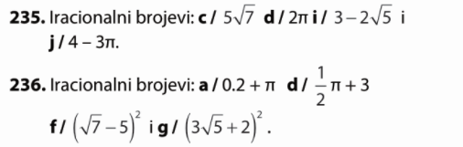
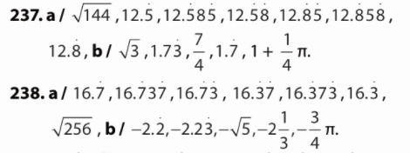
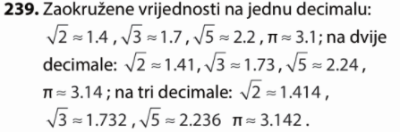
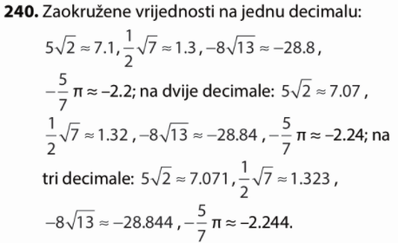
241.
a) nije
b) $\sqrt{\frac{4}{49}}=\frac{2}{7}$ nije
c) $-4\sqrt{5}$ je
d) $-5π$ je
e) $4.\dot{1}$ nije

242.
a) $0.8π+5$iracionalan
b) $2-\sqrt{\frac{1}{36}+\frac{2}{3}}=2-\sqrt{\frac{1+24}{36}}=2-\sqrt{\frac{25}{36}}=2-\frac{5}{6}=\frac{7}{6}$ nije iracionalan
c) $-{\left(-7\sqrt{5}\right)}^{2}+13=-49∙5+13$ nije iracionalan
d) $-\frac{5}{7}π+8$ iracionalan
e) $3.\dot{7}\dot{2}=3.7272727…$ nije iracionalan

243.
a) $\left(\sqrt{2}+5\right)\left(\sqrt{2}-5\right)=\sqrt{2^{2}}+5\sqrt{2}-5\sqrt{2}-25=2-25=-23$
b) $\sqrt{4-\frac{7}{9}}=\sqrt{\frac{36-7}{9}}=\frac{\sqrt{29}}{3}$ iracionalan
c) $-{\left(2\sqrt{11}\right)}^{2}+10π=-44+10π$ iracionalan
d) ${\left(5\sqrt{3}\right)}^{2}-(4{\sqrt{2)}}^{2}=75-32=43$
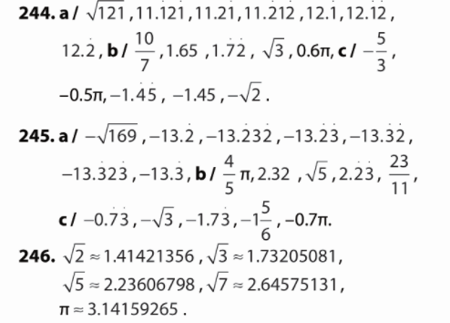

247.
$$3\sqrt{2}, 5π,π+3$$

248.
$$o=2rπ=2∙5π=10πcm$$
$$P=r^{2}π=5^{2}π=25πcm^{2}$$
a) opseg iracionalan
b) površina iracionalan

249.
$$2r=1.25 m→ r=0.625 m=62.5 cm$$
$$P=r^{2}π={62.5}^{2}π=12271.85 cm^{2}$$
$$12271.85 :400=30.67$$
Može se zasaditi 30 sadnica.

250.
a) $o=3+4+5=12 cm$
$$P=3∙4=12 cm^{2}$$

$$o=\sqrt{3}+2\sqrt{3}+\sqrt{15}=3\sqrt{3}+\sqrt{15} cm$$
$$P=\sqrt{3}∙2\sqrt{3}=2\sqrt{3^{2}}=6 cm^{2}$$

$$o=(\sqrt{11}+\sqrt{5}+4) cm$$
$$P=\sqrt{11}∙\sqrt{5}=\sqrt{55} cm^{2}$$

b) drugom i trećem
c) trećem
251.
$$o=4∙2\sqrt{2}=8\sqrt{2} cm$$
$$P=2\sqrt{2}∙2\sqrt{2}=4\sqrt{2^{2}}=8 cm^{2}$$

$$o=3∙5.5=16.5 cm$$
$$P=\frac{5.5∙5.5\sqrt{3}}{4}=7.5625\sqrt{3} cm^{2}$$

$$o=2rπ=2∙2π=4πcm$$
$$P=r^{2}π=2^{2}π=4πcm^{2}$$

b) prvom i trećem
c) drugom i trećem

252.
plavi dio
$$P=6∙\frac{2∙\sqrt{3}}{2}=6\sqrt{3} cm^{2}$$
žuti dio
$$P=6∙\frac{4∙2\sqrt{3}}{2}-6∙\frac{2∙\sqrt{3}}{2}=\left(24-6\right)\sqrt{3}=18\sqrt{3} cm^{2}$$
Površine su iracionalni brojevi.
opseg vanjskog ruba
$$o=6∙4 m=24 m$$
Opseg je racionalan broj.

253.
a) $2.5+\frac{5}{2}=2.5+2.5=5 ∈N$
b) $3.85-5.85= -2 ∈Z$
c) $\left(-\frac{3}{2}\right)∙\left(-\frac{8}{3}\right)=\frac{4}{1}=4∈N$
d) $\frac{4}{-3}:\frac{2}{5}-1.2=\frac{4}{-3}∙\frac{5}{2}-\frac{6}{5}=\frac{-10}{3}-\frac{6}{5}=\frac{-50-18}{15}=-\frac{68}{15}∈Q$

254.
a) $\frac{3.4+\frac{8}{5}}{\frac{1}{2}∙(-2)}=\frac{3.4+1.6}{-1}=\frac{5}{-1}=-5∈Z$
b) $1-\frac{\frac{2}{5}∙\left(-4.5\right)}{\frac{8}{15}:2}=1-\frac{\frac{2}{5}∙\left(-\frac{9}{2}\right)}{\frac{8}{15}∙\frac{1}{2}}=1-\frac{-\frac{9}{5}}{\frac{4}{15}}=1-\frac{-27}{4}=\frac{31}{4}∈Q$
c) $\frac{3}{8}∙\left(-\frac{4}{15}\right)-\frac{2.8}{\frac{4}{5}}=-\frac{1}{10}-\frac{7}{2}=\frac{-1-35}{10}=-\frac{36}{10}=\frac{-18}{5}∈Q$
d) $10.8+\frac{-\frac{7}{5}}{\frac{14}{25}}=\frac{54}{5}+\frac{-5}{2}=\frac{108-25}{10}=\frac{83}{10}∈Q$

255.
a) $\frac{84}{12}=84 :12=7=7.0$
$-\frac{135}{9}=-135 :9=-15=-15.0$
$-\frac{476}{17}=-476 :17=-28=-28.0$
$$\frac{275}{25}=275 :25=11=11.0$$

b)
$\frac{15}{4}=15:4=3.75$
$$-\frac{13}{16}=-13:16=-0.8125$$
$\frac{77}{50}=77:50=1.54$
$-\frac{111}{200}=-111:200=-0.555$

c) $\frac{14}{3}=14:3=4.6666…=4.\dot{6}$
$-\frac{25}{7}=-25 :7=-3.571428571428…=-3.\dot{5}7142\dot{8}$
$\frac{36}{11}=36:11=3.27272727…=3.\dot{2}\dot{7}$
$-\frac{11}{21}=-11:21=-0.523809523809…=-0.\dot{5}2380\dot{9}$

d) $-\frac{37}{12}=-37:12=-3.083333….=-3.08\dot{3}$
$\frac{43}{15}=43:15=2.866666…=2.8\dot{6}$
$\frac{9}{26}=9:26= 0.3461538461538…=0.3\dot{4}6153\dot{8}$
$-\frac{24}{35}=-24:35=-0,6857142857142….=-0.6\dot{8}5714\dot{2}$

256.
a) $2.3\dot{4}=2.34444.. >2.\dot{3=2.3333}$
b) $-\frac{27}{12}=-2.25=-2.25$
c) $\frac{1}{11}=0.0999…>0.09$
d) $\frac{4}{13}=0.307692…<4.13$

257.
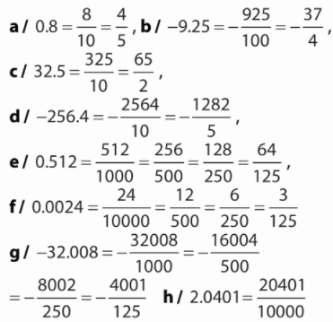

258.
Iracionalni brojevi su: $2\sqrt{7}, -π∙\frac{5}{8}+\frac{1}{3}, -π∙1.2+9.6$
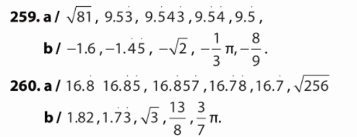

261.
a) $4^{2}=4∙4=16$
b) ${13}^{2}=13∙13=169$
c)${(-3)}^{2}=-3∙(-3)=9$
d) $(-{15)}^{2}=-15∙(-15)=225$
e) ${22}^{2}=22∙22=484$

262.
a) ${\left(\frac{5}{9}\right)}^{2}=\frac{5}{9}∙\frac{5}{9}=\frac{25}{81}$
b) ${\left(\frac{11}{16}\right)}^{2}=\frac{11}{16}∙\frac{11}{16}=\frac{121}{256}$
c) ${\left(-\frac{7}{18}\right)}^{2}=-\frac{7}{18}∙\left(-\frac{7}{18}\right)=\frac{49}{324}$
d) ${\left(-\frac{13}{38}\right)}^{2}=-\frac{13}{38}∙\left(-\frac{13}{38}\right)=\frac{169}{1444}$
e) ${\left(1\frac{2}{7}\right)}^{2}={\left(\frac{9}{7}\right)}^{2}=\frac{9}{7}∙\frac{9}{7}=\frac{81}{49}$

263.
a) ${\left(-8\right)}^{2}=-8∙(-8)=64$
b) ${-8}^{2}=-8∙8=-64$
c) ${-\left(-8\right)}^{2}=-\left(-8∙\left(-8\right)\right)=-64$
d) $-(-8^{2})=-(-8∙8)=64$
e) ${\left(-8^{2}\right)}^{2}={\left(-8∙8\right)}^{2}={\left(-64\right)}^{2}=4096$

264.
a) ${23}^{2}≈500 {23}^{2}=529$
b) ${35}^{2}≈1000 {23}^{2}=1225$
c) ${6.74}^{2}≈48 {6.74}^{2}=45.4276$
d) ${(-10.4)}^{2}≈110 {\left(-10.4\right)}^{2}=108.16$
e) ${432}^{2}≈180000 {432}^{2}=186 624$

265.
a) $7^{2}—{\left(-7\right)}^{2}=49-49=0$
b) $3∙{\left(-15\right)}^{2}—\left(-{13}^{2}\right)∙6=3∙225+169∙6=675+1014=1689$
c) ${\left(36-5^{2}\right)}^{2}-54:\left(6^{2}-9\right)={\left(36-25\right)}^{2}-54:\left(36-9\right)={11}^{2}-54:27=121-2=119$

266.
a) ${452}^{2}-12092=204304-12092=192 212$
b) ${289}^{2}-39 886:2=83 521-19 943=63 578$
c) $-18 :{1.5}^{2}+2∙{1.5}^{2}=-18:2.25+2∙2.25=-8+4.5=-3.5$

267.
a=5 cm
$$P=a^{2}$$
$$P=5^{2}$$
$$P=25 {cm}^{2}$$

268.
$P=144 {cm}^{2}$
a=?
$$P=a^{2}$$
$$a^{2}=144$$
$$a=\sqrt{144}$$
$$a=12 cm$$

269.
r=9 cm
$$P=r^{2}π$$
$$P=9^{2}π$$
$$P=81πcm^{2}$$

270.
$$P=121 π {cm}^{2}$$
r=?
$$P=r^{2}π$$
$$r^{2}π=121π$$
$$r=\sqrt{121}$$
$$r=11 cm$$

271.
a) ${\left(3∙9\right)}^{2}=3^{2}∙9^{2}=9∙81=729$
b) ${\left(2∙19\right)}^{2}=2^{2}∙{19}^{2}=4∙361=1444$
c) ${\left(7∙10\right)}^{2}=7^{2}∙{10}^{2}=49∙100=4900$
d) ${\left(2a\right)}^{2}=2^{2}∙a^{2}=4∙a^{2}=4a^{2}$
e) ${\left(8x\right)}^{2}=8^{2}∙x^{2}=64∙x^{2}=64x^{2}$

272.
a) $4^{2}∙5^{2}={\left(4∙5\right)}^{2}={20}^{2}=400$
b) $8^{2}∙{13}^{2}={\left(8∙13\right)}^{2}={104}^{2}=10 816$
c) $5^{2}∙8^{2}={\left(5∙8\right)}^{2}={40}^{2}=1600$
d) ${30}^{2}=900$
e) ${140}^{2}=19600$

273.
a) ${\left(\frac{x}{7}\right)}^{2}=\frac{x^{2}}{7^{2}}=\frac{x^{2}}{49}$
b) ${\left(\frac{a}{13}\right)}^{2}=\frac{a^{2}}{{13}^{2}}=\frac{a^{2}}{169}$
c) ${\left(-\frac{y}{25}\right)}^{2}=\frac{{\left(-y\right)}^{2}}{{25}^{2}}=\frac{y^{2}}{625}$
d) ${\left(-\frac{b}{39}\right)}^{2}=\frac{{(-b)}^{2}}{{39}^{2}}=\frac{b^{2}}{1521}$
e) ${\left(\frac{2}{d}\right)}^{2}=\frac{2^{2}}{d^{2}}=\frac{4}{d^{2}}$

274.
a) $3∙3∙3∙3∙3∙3=3^{6}$
b)$\left(-1\right)∙\left(-1\right)∙\left(-1\right)∙\left(-1\right)={\left(-1\right)}^{4}$
c) $2.5∙2.5∙2.5={2.5}^{3}$
d) $-0.1∙\left(-0.1\right)∙\left(-0.1\right)∙\left(-0.1\right)∙\left(-0.1\right)={\left(-0.1\right)}^{5}$
e) $\frac{1}{2}∙\frac{1}{2}∙\frac{1}{2}∙\frac{1}{2}∙\frac{1}{2}∙\frac{1}{2}={\left(\frac{1}{2}\right)}^{6}$
f) $\left(-\frac{1}{50}\right)∙\left(-\frac{1}{50}\right)={\left(-\frac{1}{50}\right)}^{2}$

275.
a) $8∙{10}^{3}+4∙{10}^{3}=\left(8+4\right)∙{10}^{3}=12∙{10}^{3}$
b) $-3∙3^{7}+9∙3^{7}=\left(-3+9\right)∙3^{7}=6∙3^{7}$
c) $5^{5}+8∙5^{5}=\left(1+8\right)∙5^{5}=9∙5^{5}$
d) $1.8∙{1.8}^{4}+{1.8}^{4}-6∙{1.8}^{4}=\left(1.8+1-6\right)∙{1.8}^{4}=-3.2∙{1.8}^{4}$
e) $-a^{9}-7∙a^{9}+11∙a^{9}=\left(-1-7+11\right)∙a^{9}=3∙a^{9}$
f) $x^{-2}+9∙x^{-2}-3∙x^{-2}=\left(1+9-3\right)∙x^{-2}=7∙x^{-2}$

276.
a) ${10}^{-5}=\frac{1}{{10}^{5}}=\frac{1}{100000}=0.00001$
b) ${10}^{-6}=\frac{1}{{10}^{6}}=\frac{1}{1000000}=0.000001$
c)${10}^{-9}=\frac{1}{{10}^{9}}=\frac{1}{1000000000}=0.000000001$
d) ${10}^{-14}=\frac{1}{{10}^{14}}=\frac{1}{100000000000000}=0.00000000000001$
e)${10}^{-7}=\frac{1}{{10}^{7}}=\frac{1}{10000000}=0.0000001$

277.
a) $2^{5}∙2^{2}=2^{5+2}=2^{7}$
b) $5^{4}∙5^{7}=5^{4+7}=5^{11}$
c) $3^{7}:3^{4}=3^{7-4}=3^{3}$
d) ${1.4}^{11}:{1.4}^{9}={1.4}^{11-9}={1.4}^{2}$
e) ${(-11)}^{5}:{(-11)}^{1}={(-11)}^{5-1}={(-11)}^{4}$

278.
a) ${\left({10}^{3}\right)}^{5}={10}^{3∙5}={10}^{15}$
b) ${\left(3^{6}\right)}^{3}=3^{6∙3}=3^{18}$
c) ${\left(2^{2}\right)}^{3}=2^{2∙3}=2^{6}$
d) ${\left(7^{3}\right)}^{5}=7^{3∙5}=7^{15}$
c) ${\left({3.5}^{1}\right)}^{12}={3.5}^{1∙12}={3.5}^{12}$

279.
a) $782 300 000=7.823∙{10}^{8}$
b)$0.0000034657=3.4657∙{10}^{-6}$
c) $2 538 256=2.538256∙{10}^{6}$

280.
a)$5.7564∙{10}^{13}=57 564 000 000 000$
b)$3.543∙{10}^{-7}=0.0000003543$
c) )$2.89∙{10}^{3}=2890$

281.
a)$\left(4.87∙{10}^{3}\right)∙\left(3∙{10}^{5}\right)=4.87∙3∙{10}^{3+5}=14.61∙{10}^{8}=1.461∙{10}^{9}$
b) $\left(4∙{10}^{-2}\right)∙\left(7.88∙{10}^{-7}\right)=4∙7.88∙{10}^{-2-7}=31.52∙{10}^{-9}=3.152∙{10}^{-8}$
c) $\left(2.56∙{10}^{-8}\right)∙\left(5.78∙{10}^{5}\right)=2.56∙5.78∙{10}^{-8+5}=14.7968∙{10}^{-3}=1.47968∙{10}^{-2}$

282.
a) $\frac{2.2∙{10}^{4}}{6.22∙{10}^{5}}=2.2:6.22∙{10}^{4-5}=0.35∙{10}^{-1}=3.5∙{10}^{-2}$
b) $\frac{3∙{10}^{-2}}{8.23∙{10}^{-6}}=3:8.23∙{10}^{-2-(-6)}=0.36∙{10}^{4}=3.6∙{10}^{3}$
c) $\frac{5.63∙{10}^{12}}{4.2∙{10}^{-14}}=5.63:4.2∙{10}^{12-(-14)}=1.34∙{10}^{26}$

283.
a) ${\left(3.56∙{10}^{6}\right)}^{3}={3.56}^{3}∙{\left({10}^{6}\right)}^{3}=45.118016∙{10}^{18}=4.5118016∙{10}^{19}$
b) ${\left(5.8∙{10}^{-23}\right)}^{2}={5.8}^{2}∙{\left({10}^{-23}\right)}^{2}=33.64∙{10}^{-46}=3.364∙{10}^{-45}$
c) ${\left(2.89∙{10}^{-8}\right)}^{3}={2.89}^{3}∙{\left({10}^{-8}\right)}^{3}=24.137569∙{10}^{-24}=2.4137569∙{10}^{-23}$

284.
a) $\sqrt{9}=3 jer je 3^{2}=9$
b) $\sqrt{144}=12 jer je {12}^{2}=144$
c)$\sqrt{0.01}=0.1 jer je {0.1}^{2}=0.01$
d)$\sqrt{0.04}=0.2 jer je {0.2}^{2}=0.04$
e)$\sqrt{2.25}=1.5 jer je {1.5}^{2}=2.25$

285.
a) $\sqrt{\frac{9}{16}}=\frac{3}{4}$
b) $\sqrt{\frac{25}{36}}=\frac{5}{6}$
c) $\sqrt{1\frac{9}{16}}=\sqrt{\frac{25}{16}}=\frac{5}{4}$
d)$\sqrt{1\frac{13}{36}}=\sqrt{\frac{49}{36}}=\frac{7}{6}$
e)$\sqrt{2\frac{41}{64}}=\sqrt{\frac{169}{64}}=\frac{13}{8}$

286.
a) $\sqrt{13} procjena ≈4 \sqrt{13}≈3.61$
b) $\sqrt{29} procjena ≈5 \sqrt{29}≈5.39$
c)$\sqrt{39} procjena ≈6 \sqrt{13}≈6.24$
d) $\sqrt{234} procjena ≈15 \sqrt{13}≈15.30$
e)$\sqrt{567} procjena ≈24 \sqrt{13}≈23.81$

287.
a) $3.45-\sqrt{8.6703}=3.45-2.94=0.51$
b) $\sqrt{3}∙1.42+{\left(-2.902\right)}^{2}=1.73∙1.42+8.42=2.46+8.42=10.88$
c) $\sqrt{0.329}∙0.5-{1.2}^{2}:\sqrt{2.5}=0.57∙0.5-1.44:1.58=0.29-0.91=-0.62$

288.
a) $5\sqrt{7}-4\sqrt{2}-3\sqrt{2}+6\sqrt{7}=\left(5+6\right)\sqrt{7}+\left(-4-3\right)\sqrt{2}=11\sqrt{7}-7\sqrt{2}$
b) $6\sqrt{14}-7\sqrt{14}-8\sqrt{14}+2\sqrt{8}=\left(6-7-8\right)\sqrt{14}+2\sqrt{8}=-9\sqrt{14}+2\sqrt{8}$
c) $4.21\sqrt{2}-3\sqrt{3}+2.5\sqrt{3}=4.21\sqrt{2}+\left(-3+2.5\right)\sqrt{3}=4.21\sqrt{2}-0.5\sqrt{3}$

289.
a) ${\left(\sqrt{5}\right)}^{2}=5$
b) ${\left(\sqrt{17}\right)}^{2}=17$
c) ${\left(2\sqrt{6}\right)}^{2}=24$
d) ${\left(6\sqrt{2}\right)}^{2}=72$
e) ${\left(\sqrt{\frac{6}{11}}\right)}^{2}=\frac{6}{11}$

290.
a) $\sqrt{6}\left(\sqrt{6}+2\sqrt{1.5}\right)=\sqrt{36}+2\sqrt{9}=6+6=12$
b) $\left(\sqrt{7}+6\sqrt{2})(2\sqrt{7}-11\sqrt{2}\right)=2\sqrt{49}+12\sqrt{14}-11\sqrt{14}-66\sqrt{4}=14+\sqrt{14}-132=-118+\sqrt{14}$
c) ${\left(4\sqrt{7}-3\sqrt{5}\right)}^{2}=\left(4\sqrt{7}-3\sqrt{5}\right)\left(4\sqrt{7}-3\sqrt{5}\right)=16\sqrt{49}-12\sqrt{35}-12\sqrt{35}+9\sqrt{25}=112-24\sqrt{35}+45=157-24\sqrt{35}$

291.
a) $\sqrt{200}=\sqrt{100∙2}=\sqrt{100}∙\sqrt{2}=10\sqrt{2}$
b)$\sqrt{1008}=\sqrt{144∙7}=\sqrt{144}∙\sqrt{7}=12\sqrt{7}$
c) $\sqrt{80}+7\sqrt{45}+3\sqrt{180}=4\sqrt{5}+7∙3\sqrt{5}+3∙6\sqrt{5}=\left(4+21+18\right)\sqrt{5}=43\sqrt{5}$
d) $5\sqrt{24}+7\sqrt{54}-10\sqrt{96}=5\sqrt{4∙6}+7\sqrt{9∙6}-10\sqrt{16∙6}=10\sqrt{6}+21\sqrt{6}-40\sqrt{6}=-9\sqrt{6}$

Priprema za ispit znanja
1.
a) $5^{2}=25$
b) ${\left(-8\right)}^{2}=64$
c) ${\left(-15\right)}^{2}=225$
d) ${\left(\frac{3}{11}\right)}^{2}=\frac{9}{121}$
e) ${\left(-1\frac{7}{12}\right)}^{2}={\left(-\frac{19}{12}\right)}^{2}=\frac{361}{144}$

2.
a) $3^{2}-{\left(-2\right)}^{2}=9-4=5$
b) $1\frac{1}{9}:5^{2}-{\left(1-\frac{3}{5}\right)}^{2}=\frac{10}{9}:25-{\left(\frac{2}{5}\right)}^{2}=\frac{10}{9}∙\frac{1}{25}-\frac{4}{25}=\frac{10}{225}-\frac{4}{25}=\frac{10-36}{225}=-\frac{26}{225}$

3.
r=9 cm
$$P=r^{2}π$$
$$P=9^{2}π$$
$$P=81πcm^{2}$$

4.
a) $-1∙(-1)∙(-1)∙(-1)={\left(-1\right)}^{4}$
b)$10∙10∙10∙10∙10∙10∙10={10}^{7}$

5.
a)$2∙{10}^{9}-7∙{10}^{9}+{10}^{9}=\left(2-7+1\right)∙{10}^{9}=-4∙{10}^{9}$
b) $2^{6}∙2^{5}=2^{6+5}=2^{11}$
c) $5^{17}:5^{4}=5^{17-4}=5^{13}$
d) ${\left(3^{3}\right)}^{7}=3^{3∙7}=3^{21}$

6.
a) $54 560 000=5.456∙{10}^{7}$
b) $0.00032564=3.2564∙{10}^{-4}$

7.
a) $2.45798∙{10}^{11}=245 798 000 000$
b) $4.1213∙{10}^{-5}=0.000041213$

8.
a) $\sqrt{64}=8$
b) $\sqrt{0.09}=0.3$
c) $\sqrt{\frac{36}{25}}=\frac{6}{5}$
d) $\sqrt{5\frac{1}{16}}=\sqrt{\frac{81}{16}}=\frac{9}{4}$

9.
a) $8\sqrt{5}-4\sqrt{2}-3\sqrt{2}+4\sqrt{5}=\left(8+4\right)\sqrt{5}+\left(-4-3\right)\sqrt{2}=12\sqrt{5}-7\sqrt{2}$
b) $\sqrt{3}∙\sqrt{12}=\sqrt{36}=6$
c) $\sqrt{98}:\sqrt{2}=\sqrt{49}=7$

10.
a) $\sqrt{700}=\sqrt{100∙7}=\sqrt{100}∙\sqrt{7}=10\sqrt{7}$
b) $4\sqrt{80}+\sqrt{45}-2\sqrt{180}=4∙4\sqrt{5}+3\sqrt{5}-2∙6\sqrt{5}=\left(16+3-12\right)\sqrt{5}=7\sqrt{5}$

11.
$\frac{3}{4}=3:4=0.75$
$-\frac{9}{50}=-9:50=-0.18$
$\frac{17}{200}=17 :200=0.085$

12.
$0.89=\frac{89}{100}$
$2.175=\frac{2175}{1000}=\frac{87}{40}$
$-0.0732=-\frac{732}{10000}=-\frac{183}{2500}$

13.
$$\frac{7}{9}=7:9=0.777…=0.\dot{7}$$
$$-\frac{8}{15}=-8:15=0.5333…=0.5\dot{3}$$
$$\frac{13}{22}=13:22=0.590909090…=0.5\dot{9}\dot{0}$$

14.
a) $\sqrt{49}=7<7.\dot{1}=7.1111…$
b) $-4.7777…<-4.72222$
c) $1\frac{7}{9}=1.77777…=1.77777…$

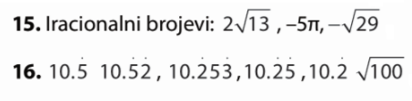

1.
$$a-0.25b=\frac{5}{2}-0.25∙2=2.5-0.5=2$$

2.
a) $5a+8b-4+3.8a-2b=\left(5+3.8\right)a+\left(8-2\right)b-4=8.8a+6b-4$
b) $3xy+1.5-xy+2x^{2}y=\left(3-1\right)xy+1.5+2x^{2}y=2xy+1.5+2x^{2}y$
c) $\frac{2}{5}c-2d-0.8c+5cd=\left(\frac{2}{5}-\frac{4}{5}\right)c-2d+5cd=-\frac{2}{5}c-2d+5cd$

3.
a) $7\left(8x-9y\right)=7∙8x-7∙9y=56x-63y$
b) $-6a\left(5a+4b\right)=-6a∙5a-6a∙4b=-30a^{2}-24ab$
c) $11\left(-2a+19-13b\right)=11∙\left(-2a\right)+11∙19+11∙\left(-13b\right)=-22a+209-143b$

4.
a)$3\left(2a-1\right)-5a=3∙2a-3∙1-5a=6a-3-5a=a-3$
b)$3\left(2-3b\right)+10b=3∙2-3∙3b+10b=6-9b+10b=6+b$
c)$2\left(3c-2\right)-3\left(2c-3\right)=2∙3c-2∙2-3∙2c-3∙\left(-3\right)=6c-4-6c+9=5$

5.
a) $\left(7x-3y\right)\left(5x-11y\right)=7x∙5x-7x∙11y-3y∙5x-3y∙\left(-11y\right)=35x^{2}-77xy-15xy+33y^{2}=35x^{2}-92xy+33y^{2}$
b) $\left(12x+y\right)\left(8x-y\right)=12x∙8x+y∙8x-12x∙y-y∙y=96x^{2}+8xy-12xy-y^{2}=96x^{2}-4xy-y^{2}$
c) $\left(a+3b\right)\left(8b-13a\right)=a∙8b-a∙13a+3b∙8b-3b∙13a=8ab-13a^{2}+24b^{2}-39ab=-31ab-13a^{2}+24b^{2}$

6.
a) $2a+2b=2(a+b)$
b) $2a-2b=2(a-b)$
c) $-2a+8=-2a+2∙4=2(-a+4)$
d)$-3a-9=-3a-3∙3=-3(a+3)$
e) $2a-4b+6c=2a-2∙2b+2∙3c=2(a-2b+3c)$
f) $9a+6b-3c=3∙3a+3∙2b-3∙c=3(3a+2b-c)$

7.
a) $a^{2}+a=a∙a+a∙1=a(a+1)$
b) $a^{2}-a=a∙a-a∙1=a(a-1)$
c) $3a^{2}-2a=a∙3a-a∙2=a(3a-2)$
d) $3a^{2}b+15ab=3a∙a∙b+5∙3∙a∙b=3ab(a+5b)$
e) $3a^{2}-2ab+4a=3∙a∙a-2∙a∙b+4∙a=a(3a-2b+4)$
f) $3a^{2}b+15a-ab=3a∙a∙b+15a-a∙b=a(3ab+15a-b)$

8.
a) $2ab+4ac=2ab+2∙2ac=2a(b+2c)$
b) $3a^{2}b+6a=3a∙ab+3∙2a=3a(ab+2)$
c) $12a^{2}b+14ac-2a^{2}=2∙6a∙a∙b+2∙7ac-2a∙a=2a(6ab+7c-a)$
d) $3a^{2}b-6a+3ab=3a∙a∙b-3∙2a+3ab=3a(ab-2+b)$
e) $\frac{3}{10}c+\frac{7}{10}d+\frac{3}{10}=\frac{1}{10}(3c+7d+3)$
f) $\frac{a}{12}-\frac{d}{12}+\frac{1}{12}=\frac{1}{12}(a-d+1)$

9. a) b)
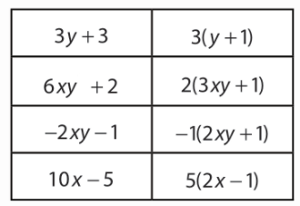
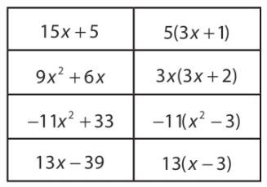

10.
a) ${\left(-2\right)}^{2}+2∙\left(-2\right)+5=4-4+5=5$
b) $5∙{\left(-\frac{2}{3}\right)}^{2}+3∙\left(-\frac{2}{3}\right)-1=5∙\frac{4}{9}-2-1=\frac{20}{9}-\frac{27}{9}=-\frac{7}{9}$
c) $\frac{{0.1}^{2}}{2}+0.1=0.005+0.1=0.105$
d) $\frac{4}{{\left(-2.5\right)}^{2}}+2∙\left(-2.5\right)-3=\frac{4}{6.25}-5-3=0.64-5-3=-7.36$

11.
a) $3\left(x+2\right)=3∙x+3∙2=3x+6$
b) $2x\left(3x-7\right)=2x∙3x-2x∙7=6x^{2}-14x$
c) $\left(3-x\right)\left(5+2x\right)=3∙5+3∙2x-x∙5-x∙2x=15+6x-5x-2x^{2}=15+x-2x^{2}$
d) $\left(6a-1\right)\left(5x+2\right)=6a∙5x-1∙5x+6a∙2-1∙2=30ax-5x+12a-2$
e) $\left(3a-2b\right)\left(5a+4b\right)=3a∙5a-2b∙5a+3a∙4b-2b∙4b=15a^{2}-10ab+12ab-8b^{2}=15a^{2}+2ab-8b^{2}$
f) $\left(11x-7y\right)\left(8x-9y\right)=11x∙8x-11x∙9y-7y∙8x+7y∙9y=88x^{2}-99xy-56xy+63y^{2}=88x^{2}-155xy+63y^{2}$

12.
a) $3a+3=3\left(a+1\right)$
b) $4a-4=4(a-1)$
c) $5a+5=5\left(a+1\right)$
d) $7a-7=7(a-1)$

13.
a) $2b^{2}-7b=2b∙b-7b=b(2b-7b)$
b) $6b^{2}a+5ba=6b∙ba+5ba=ba(6b+5)$
c) $b^{2}-ab=b∙b-ab=b(b-a)$
d) $8b^{2}-9ab=8b∙b-9ab=b(8b-9a)$
e) $4b-15b^{2}=4b-15b∙b=b(4-15b)$
f) $19b^{2}a-11ab=19b∙ab-11ab=ab(19b-11)$
g) $24a^{2}+8a=3∙8∙a∙a+8a=8a(3a+1)$
h) $36a^{2}b+9ab=9∙4∙a∙a∙b+9ab=9ab(4a+1)$
i) $45a^{2}b-9a=9∙5∙a∙a∙b-9a=9a(5ab-1)$
j) $35ad-7a^{2}=7∙5ad-7∙a∙a=7a(5d-a)$
k) $26a^{2}-13ab=13∙2a∙a-13∙ab=13a(2a-b)$
l) $48a^{2}b-12a=12∙4∙a∙a∙b-12a=12a(4ab-1)$

14.
a) $\frac{1}{2}x+\frac{1}{2}y=\frac{1}{2}(x+y)$
b) $\frac{1}{2}a+\frac{1}{4}=\frac{1}{2}a+\frac{1}{2}∙\frac{1}{2}=\frac{1}{2}\left(a+\frac{1}{2}\right)$
c) $\frac{2x}{5}-\frac{2y}{5}=\frac{2}{5}(x-y)$
d) $-\frac{4a}{3}-\frac{4}{9}b=-\frac{4a}{3}-\frac{4b}{3}∙\frac{1}{3}=-\frac{4}{3}\left(a+\frac{1}{3}b\right)$

15.
a) $a\left(a+b\right)+3\left(a+b\right)=(a+b)(a+3)$
b) $a\left(b-2\right)-3\left(b-2\right)=(b-2)(a-3)$
c) $b\left(a+1\right)-2\left(a+1\right)=(a+1)(b-2)$
d) $b\left(2a+b\right)-a\left(2a+b\right)=\left(2a+b\right)(b-a)$
e) $a\left(a-2b\right)-b\left(a-2b\right)=(a-2b)(a-b)$
f) $b\left(2a-1\right)-a\left(1-2a\right)=b\left(2a-1\right)-a∙\left(-1\right)\left(2a-1\right)=\left(2a-1\right)(b+a)$

16.
a) $5\left(x-3\right)=5∙x-5∙3=5x-15$
b)$4\left(3a+4\right)=4∙3a+4∙4=12a+16$
c) $8\left(2+x\right)=8∙2+8∙x=16+8x$
d) $-7\left(6+3x\right)=-7∙6-7∙3x=-42-21x$
e)$-3\left(5-9a\right)=-3∙5-3∙\left(-9a\right)=-15+27a$

17.
a) $3a+15=3a+3∙5=3(a+5)$
b) $2a+18=2a+2∙9=2(a+9)$
c) $4a-16=4a-4∙4=4(a-4)$
d) $5a+20=5a+5∙4=5(a+4)$
e) $6a-12=6a-6∙2=6\left(a-2\right)$
f) $7a+21=7a+7∙3=7(a+3)$

18.
$$6∙\left(\frac{a∙v}{2}\right)=3av$$

19.
a) $16-\left(5-8x\right)+5=7+3\left(2x-1\right)-2$
$$16-5+8x+5=7+6x-3-2$$
$$16+8x=6x+2$$
$$8x-6x=2-16$$
$2x=-14$ /:2
$x=-7∈Z$

b) $\frac{5}{3}x-\frac{1}{6}-\frac{3}{5}x=\frac{7}{5}x-\frac{3}{2}$
$\frac{5}{3}x-\frac{3}{5}x-\frac{7}{5}x=\frac{1}{6}-\frac{3}{2}$ /$∙30$
$$50x-18x-42x=5-45$$
$-10x=-40$ /:-10
$$x=4∈N$$

c) $\frac{12}{5}-\frac{6}{5}x-\frac{x}{4}=1-\frac{5}{2}x$ /$∙20$
$$48-24x-5x=20-50x$$
$$-24x-5x+50x=20-48$$
$21x=-28$ /:21
$x=-\frac{4}{3}$

d) $\frac{5}{2}+2\left(\frac{3}{4}-x\right)=\frac{2}{3}-\left(\frac{2}{3}x-2\right)$
$\frac{5}{2}+\frac{3}{2}-2x=\frac{2}{3}-\frac{2}{3}x+2$ $/∙6$$$15+9-12x=4-4x+12$$
$$-12x+4x=-24+4+12$$
$-8x=-8$ /:-8
$$x=1∈N$$
20.
put = $\frac{19}{60}∙12=3.8 km$
brzina vraćanja kući $v=3.8 :\frac{20}{60}=\frac{19}{5}∙\frac{3}{1}=11.4 km/h$

21.
$$F=\frac{W}{s}$$

22.
$r=\frac{o}{2π}$

23.
a) $28-15x=12-23x$
$$-15x+23x=12-28$$
$8x=-16$/:8
$$x=-2 ∈Z$$

b) $$5x-4-2\left(5-3x\right)=6x-(2+7x)$$
$$5x-4-10+6x=6x-2-7x$$
$$5x+6x-6x+7x=14-2$$
$12x=12$ /:12
$x=1 ∈N$

c)
$\frac{1}{6}x-\frac{x}{8}+\frac{5}{3}=\frac{3}{2}+\frac{x}{2}-\frac{1}{6}$ /24
$$4x-3x+40=36+12x-4$$
$$x-12x=32-40$$
$-11x=-8$ /:-11
$x=\frac{8}{11}∈Q$

d) $\frac{2x+2}{2}-\frac{3x-3}{3}=\frac{4x+4}{4}-\frac{6x-6}{6}$
$$x+1-x+1=x+1-x+1$$
$$0x=0$$
Jednadžba ima beskonačno mnogo rješenja.

e)
$5-\frac{7}{6}\left(3x+2\right)=\frac{3}{4}x-\left(\frac{11}{6}+\frac{x}{2}\right)$
$5-\frac{7}{2}x-\frac{7}{3}=\frac{3}{4}x-\frac{11}{6}-\frac{x}{2}$ /12
$$60-42x-28=9x-22-6x$$
$$-42x-3x=-22-32$$
$-45x=-54$ /:-45
$x=\frac{6}{5}∈Q$

f) $\frac{6}{5}\left(\frac{10}{3}-5x\right)+\frac{7x}{4}=\frac{3}{2}\left(4-\frac{x}{2}\right)-\frac{2x+1}{2}$
$4-6x+\frac{7x}{4}=6-\frac{3x}{4}-x-\frac{1}{2}$ /4
$$16-24x+7x=24-3x-4x-2$$
$$-17x+7x=22-16$$
$-10x=-6$/:-10
$$x=-\frac{3}{5}∈Q$$

24.
Marko x koševa
Ante x+8 koševa

x + (x+8)=22
2x=22-8
2x=14 / :2
x= 7

Ante je postigao 15 koševa.

25.
x – Andrejine godine
x + 5 - Andrejine godine za 5 godina
x - 5 - Andrejine godine prije 5 godina

x+5 = 2(x-5)
x + 5 = 2x – 10
x-2x=-5-10
-x=-15
x=15

Andreja ima 15 godina.

26.
1. dan $\frac{1}{3}x$ ostane mu $\frac{2}{3}x$
2. dan $\frac{1}{4}od \frac{2}{3}x=\frac{1}{4}∙\frac{2}{3}x=\frac{1}{6}x$
3. dan $\frac{1}{3}x-5$
4.dan 50 km

$$\frac{1}{3}x+\frac{1}{6}x+\frac{1}{3}x-5+30=x$$
$$2x+x+2x+150=6x$$
$$5x-6x=-270$$
$$-x=-150$$
$$x=150$$
Put do mora je 150 km.

27.
1. broj x
2. broj x + 20%x = 1.2x
3. broj 1.2x + 20% od 1.2% = 1.2x + 0.24x=1.44x

x +1.2x+1.44x=2002
3.64x=2002 /:3,64
x=550
Prvi broj je 550, drugi 660, a treći 792.

28.x – ukupan broj cipela
60% od x ženske cipele – 0.6x
15% od 0.6x = 36
0.15·0.6x=36
0.09x=36 /:0.09
x=400 Ima 400 cipela.
29.
x – početna cijena
x + 8% od x = 1.08x
100% - 15%=85%
85% od 1.08x=0.85·1.08=0.918x

0.918x=459 /:0.918
x=500
Cijena prije promjene bila je 500 kn.

30.
Slavko 16 k = 16·150=2400 kn
Mirko 12 k =12·150= 1800 kn

16k + 12k = 4200
28k=4200/ : 28
k=150

Slavko će dobiti 2400 kn, a Mirko 1800 kn.

31.
x – broj djevojaka na početku
45 – x broj dječaka na početku
(45-x +5) : ( x – 2) = 3:5
5(50-x)= 3(x-2)
250 – 5x =3x – 6
-8x =-256 /:-8
x=32
Na početku je bilo 32 djevojke i 13 dječaka.

32.
$$a_{1}=8 cm m_{1}=35 dag=350g$$
$$a_{2}=2 cm m_{2}=?g$$

$$ρ_{1}=ρ_{2}$$
$$\frac{m_{1}}{V_{1}}=\frac{m_{2}}{V_{2}}$$
$$m_{2}=\frac{m_{1}V_{2}}{V_{1}}=\frac{2^{3}∙350}{8^{3}}≈5.5 g$$

33.
$$\frac{m_{1}}{V_{1}}=\frac{m_{2}}{V_{2}}$$
$$V_{1}=\frac{m_{1}V_{2}}{m_{2}}=\frac{42∙18}{14}=54 cm^{3}$$

34.
dužina a – 3x
širina b – x
o = 2a + 2b=6x+2x
$8x=\sqrt{768}$ /:8
$$x=2\sqrt{3}$$
širina $2\sqrt{3} cm$
duljina $6\sqrt{3} cm$

35.
a – x $2\sqrt{5}cm$
b – 5x $10\sqrt{5}cm$
$$P=\frac{ab}{2}$$
$$50=\frac{ab}{2}$$
$$ab=100$$
$x∙5x=100$ /:5
$$x∙x=20$$
$$x∙x=2∙2∙5$$
$$x∙x=2∙2∙\sqrt{5}\sqrt{5}$$
$$x=2\sqrt{5}$$

36.
a) $masa \left(sastojka\right)=w∙masa(smjese)$
b) $masa\left(smjese\right)=m\left(sastojka\right):w$

37.
a) x+2=5
x=5-2
x=3

b) 2x=8 /:2
x=4

c) 3x – 5 = 9
3x = 9+5
3x=14 /:3
$x=\frac{14}{3}$

d) 8 + 5x=x
5x-x=-8
4x=-8 /:4
x=-2

38.
x – nepoznati broj
x+7=10
x=10-7
x=3
Taj broj je 3.

39.
x – broj stranica koje Ivan mora pročitati
30 + x=200
x= 200 – 30
x=170
Ostalo mu je 170 stranica.

40.
a) $\left|2x-\frac{1}{2}\right|=\frac{5}{6}$
$2x-\frac{1}{2}=\frac{5}{6}$
$2x=\frac{5}{6}+\frac{1}{2}$
$2x=\frac{8}{6}$ /:2
$x_{1}=\frac{2}{3}$

$-2x+\frac{1}{2}=\frac{5}{6}$
$-2x=\frac{5}{6}-\frac{1}{2}$
$2x=\frac{2}{6}$ /:-2
$x_{2}=-\frac{1}{6}$

b) $\left|1.2x+4\right|=0.8$
1.2x+4=0.8
1.2x=0.8 – 4
1.2x=-3.2 /:1.2
x= $-\frac{8}{3}$

-1.2x-4=0.8
-1.2x=0.8+4
-1.2x=4.8 /:-1.2
x=-4

c) $\left|4x+5\right|-6=7$
$$4x+5-6=7$$
$4x=8$/:4
$$x_{1}=2$$

$$-4x-5-6=7$$
$-4x=4$/:-4
$$x_{2}=-1$$

41.
a) $2-2\left(2x+2\right)-2x<2-2x$
$$2-4x-4-2x<2-2x$$
$$-4x-2x+2x<-2+4+2$$
$-4x<4$/:-4
$$x>-1$$

b) $\frac{1}{6}-4\left(\frac{7}{6}x+\frac{1}{2}\right)≥\frac{5x-5}{5}+2$
$\frac{1}{6}-\frac{14}{3}x-2≥x-1+2$ / 6
$$1-28x-12≥6x+6$$
$$-28x-6x≥12-1+6$$
$-34x≥17$ /:-34
$x≤-\frac{1}{2}$

42.
a) $\frac{1-2ab}{1-a}=1+b$
$$1-2ab=\left(1+b\right)\left(1-a\right)$$
$$1-2ab=1+b-a-ab$$
$$-ab+a=b$$
$a\left(-b+1\right)=b$ /(-b+1)
$$a=\frac{b}{-b+1}$$

b) $\frac{1-2ab}{1-a}=1+b$
$$1-2ab=\left(1+b\right)\left(1-a\right)$$
$$1-2ab=1+b-a-ab$$
$$-ab-b=-a$$
$b\left(-a-1\right)=-a$ /(-a-1)
$$b=\frac{a}{a+1}$$

43.
$$\frac{1}{1+\frac{1}{1-x}}=3$$

$\frac{1}{\frac{1-x+1}{1-x}}=3$
$\frac{\frac{1}{1}}{\frac{2-x}{1-x}}=3$
$\frac{1-x}{2-x}=3$/(2-x)
$$1-x=3(2-x)$$
$$1-x=6-3x$$
$$-x+3x=6-1$$
$$2x=5$$
$x=\frac{5}{2}$

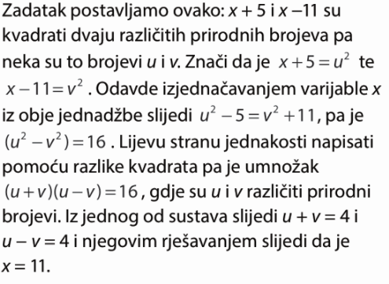
44.

45.
dječaci : djevojčice = 2k : 5k
2k + 5k =98
7k=98 /:7
k=14

Dječaka je 28, a djevojčica 70.

46.
1.kut : 2.kut: 3.kut = 2k:3k:5k
Zbroj 3 unutarnja kuta u trokutu je 180°.
2k + 3k +5k =180°
10k=180° /:10
k=18°
1.kut = 36°
2.kut = 54°
3.kut = 90°
Najveći kut ima 90°.

47.
1.p: 2.p: 3.p = 11k:9k:16k
11k + 9k +16k =18 000
36k=18 000 /:36
k=500
1.prijatelj = 5500 kn
2. prijatelj = 4500 kn
3. prijatelj = 8000 kn
48. a) $x :6=2:1$
$$x∙1=6∙2$$
$$x=12$$

b) $2 :c=1:2$
$$c∙1=2∙2$$
$$c=4$$

c) $5 :4=10:x$
$$5∙x=4∙10$$
$5x=40$/:5
$$x=8$$

d) $2 :5=x:15$
$$5∙x=2∙15$$
$5x=30$ /:5
$$x=6$$

e) $3 :4=x:8$
$$4∙x=3∙8$$
$4x=24$ /:4
$$x=6$$

f) $4 :7=12:x$
$$4∙x=7∙12$$
$$4x=84$$
$$x=21$$
49.
a)$0.3 :0.5=9:x$
$$0.3∙x=0.5∙9$$
$0.3x=4.5$ /:0.3
$$x=15$$

b) $1.2:0.4=0.1:x$
$$1.2∙x=0.4∙0.1$$
$1.2x=0.04$ /:1.2
$x=\frac{1}{25}:\frac{6}{5}=\frac{1}{25}∙\frac{5}{6}=\frac{1}{30}$

c) $x:0.9=5:3$
$$x∙3=0.9∙5$$
$3x=4.5$ /:3
$$x=1.5$$

50.
a) $x:(x+1)=7:8$
$$x∙8=(x+1)∙7$$
$8x=7x+7$
$8x-7x=7$
$$x=7$$

b) $(x-1):3=x:12$
$$(x-1)∙12=3∙x$$
$$12x-12=3x$$
$12x-3x=12$
$9x=12$ /:9
$x=\frac{12}{9}=\frac{4}{3}$

c)$(2x-3):7=x:5$
$$(2x-3)∙5=7∙x$$
$$10x-15=7x$$
$10x-7x=15$
$3x=15$ /:3
$$x=5$$

51.a) $\frac{4}{2x-3}=\frac{2.2}{5.5}$
$\frac{4}{2x-3}=\frac{2}{5}$ unakrsno množimo
$$(2x-3)∙2=4∙5$$
$$4x-6=20$$
$4x=20+6$
$4x=26$ /:4
$x=\frac{26}{4}=\frac{13}{2}=6.5$

b) $\frac{2x+1}{7}=\frac{x-3}{2}$ unakrsno množimo
$$(2x+1)∙2=(x-3)∙7$$
$$4x+2=7x-21$$
$4x-7x=-21-2$
$-3x=-23$ /: -3
$x=\frac{23}{3}$
c) $\frac{4}{5}=\frac{x-1}{x}$ unakrsno množimo
$$4∙x=5∙(x-1)$$
$$4x=5x-5$$
$4x-5x=-5$
$-x=-5$ /:-1
$x=5$

52.
y … masa vode 1000 y
x… volumen vode 1 0.005
$$\frac{1000}{1}=\frac{y}{0.005}$$
$y=1000∙0.005$
$$y=5$$
Masa 5 L vode je 5 kg.

53.
y … vrijednost u SEK 1 825
x… vrijednost u kn 0.749 x
$$\frac{1}{0.749}=\frac{825}{x}$$
$$x=825∙0.749$$
$$x=618.53kn$$
Za 825 SEK dobije 618.53 kuna.

54.a)
y … vrijednost u eurima 1 20
x… vrijednost u kn 7.50 x
$$\frac{1}{7.50}=\frac{20}{x}$$
$$x=20∙7.50$$
$$x=150 kn$$
Za 20 € dobije 150 kuna.

b) y … vrijednost u eurima 1 100
x… vrijednost u kn 7.50 x
$$\frac{1}{7.50}=\frac{100}{x}$$
$$x=100∙7.50$$
$$x=750 kn$$
Za 100 € dobije 750 kuna.

c) y … vrijednost u eurima 1 150
x… vrijednost u kn 7.50 x
$$\frac{1}{7.50}=\frac{150}{x}$$
$$x=150∙7.50$$
$$x=1125 kn$$
Za 150 € dobije 1125 kuna.

55.
A mjenjačnica
y … vrijednost u eurima 1 70
x… vrijednost u kn x 516.6
$$\frac{1}{x}=\frac{70}{516.6}$$
$70x=516.6$ /:70
$$x=7.38 kn$$
Za 1 € dobije 7.38 kuna.

B mjenjačnica
y … vrijednost u eurima 1 50
x… vrijednost u kn x 378
$$\frac{1}{x}=\frac{50}{378}$$
$50x=378$ /:70
$$x=7.56 kn$$
Za 1 € dobije 7.56 kuna.
Povoljnije je mijenjati u B mjenjačnici.

56.
y … put km 435 644
x… gorivo L 14 x
$$\frac{435}{14}=\frac{644}{x}$$
$435x=644∙14$ /:435
$$x=20.72$$
Za 644 km treba 20.72 litara.

57.
y … broj radnika 3 5
x… broj dana 7 x
$$3∙7=5∙x$$
$5x=21$ /:2
$x=4.2$ Završit će posao za 4.2 dana.
58.
vrijeme = put : brzina
y … vrijeme $\frac{2}{3}h$ y
x… brzina 14 19
$$\frac{2}{3}∙14=y∙19$$
$19y=\frac{28}{3}$
$$y=0.49 ∙60=29.49 min$$
Trebalo bi mu 29.49 minuta.

59.
y … promjer 61 81
x… broj okreta 100 x
$$61∙100=81∙x$$
$81x=6100$/:81
$$x=75.30$$
Napravi 75.30 okreta.

60.
y … broj radnika 5 5+x
x… dani 24 15
$$5∙24=(5+x)∙15$$
$$15x=120-75$$
$15x=45$ /:3
x = 3
Treba zaposliti još 3 radnika.

61.
1. d : 2. d : 3. d = 3k : 5k : 8 k
3k+5k+8k=2400
16k = 2400 /:16
k=150
1. dio je 450, 2. dio 750, a treći 1200

62.
a) $\frac{x}{7}=\frac{11}{14}$
$$14∙x=7∙11$$
$$14x=77$$
$x=\frac{77}{14}=\frac{11}{2}=5.5$

b) $\frac{12}{25}=\frac{4}{5x}$
$$12∙5x=4∙25$$
$$60x=100$$
$x=\frac{100}{60}=\frac{5}{3}$

c) $\left(b+2\right):40=7:5$
$$(b+2)∙5=7∙40$$
$$5b+10=280$$
$5b=280-10$ /:5
$$b=54$$

d) $1.5 :b=6.3:2.1$
$$b∙6.3=1.5∙2.1$$
$6.3b=3.15$ /:6.3
$$b=0.5$$

e) $5:6=\left(b+4\right):b$
$$b∙5=6∙(b+4)$$
$$5b=6b+24$$
$$5b-6b=24$$
$$-b=24$$
$$b=-24$$

f) $125:375=1.5:x$
$$125∙x=375∙1.5$$
$125x=562.5$ /:125
$$x=4.5$$

g) $(1+3x):5=\left(2x+3\right):1$
$$(1+3x)∙1=5∙(2x+3)$$
$$1+3x=10x+15$$
$$3x-10x=15-1$$
$-7x=14$ /:-7
$$x=-2$$

h) $\frac{x}{2}:2=\frac{7x+1}{2}:3$
$\frac{x}{2}∙3=2∙\frac{7x+1}{2}$
$$\frac{3x}{2}=7x+1$$
$$\frac{3x}{2}-7x=1$$
$-\frac{11x}{2}=1$ /:-$-\frac{11}{2}$
$x=1 :\left(-\frac{11}{2}\right)=1∙\frac{-2}{11}=-\frac{2}{11}$

i) $x :3=4:15$
$$x∙15=3∙4$$
$15x=12$ /:15
$x=\frac{12}{15}=\frac{4}{5}$

j) $72 :9=x:3$
$$9∙x=72∙3$$
$9x=216$ /:9
$$x=26$$

k) $8 :3=40:x$
$$8∙x=3∙40$$
$8x=120$ /:8
$$x=15$$

l) $1 :(x+3)=2:7$
$$(x+3)∙2=1∙7$$
$2x+6=7$
$$2x=7-6$$
$2x=1$ /:2
$x=\frac{1}{2}$
m) $1 :4=(x-1):12$
$$(x-1)∙4=1∙12$$
$4x-4=12$
$$4x=12+4$$
$4x=16$ /:4
$$x=4$$

n) $3 :(x-1)=2:(x+5)$
$$(x+5)∙3=(x-1)∙2$$
$3x+15=2x-2$
$$3x-2x=-2-15$$
$x=-17$

o) $(2x-8) :6=x:9$
$$(2x-8)∙9=6∙x$$
$18x-72=6x$
$$18x-6x=72$$
$12x=72$ /:12
$$x=6$$

p) $\frac{3x-2}{5}=\frac{x}{3}$
$$(3x-2)∙3=x∙5$$
$9x-6=5x$
$$9x-5x=6$$
$4x=6$ /:4
$x=\frac{6}{4}=\frac{3}{2}$

r) $\frac{5}{2x-1}=\frac{2}{x-3}$
$$\left(2x-1\right)∙2=(x-3)∙5$$
$4x-2=5x-15$
$$4x-5x=-15+2$$
$-x=-13$ /:-1
$$x=13$$

s) $\frac{x-3}{4}=\frac{2x+3}{12}$
$$(x-3)∙12=(2x+3)∙4$$
$12x-36=8x+12$
$$12x-8x=36+12$$
$4x=48$ /:4
$$x=12$$

63.
a) $3 :5=x:15$
$$5∙x=3∙15$$
$5x=45$ /:5
$$x=9$$

b) $5 :x=3:16$
$$3∙x=5∙16$$
$3x=80$ /:3
$x=\frac{80}{3}$

c) $4 :x=12:7$
$$x∙12=4∙7$$
$12x=28$ /:12
$x=\frac{28}{12}=\frac{7}{3}$

d) $x :7=4:21$
$$x∙21=7∙4$$
$21x=28$ /:21
$x=\frac{28}{21}=\frac{4}{3}$

64.
a) $(x+1) :6=(x-5):9$
$$(x+1)∙9=6∙(x-5)$$
$9x+9=6x-30$
$$9x-6x=-30-9$$
$3x=-39$ /:3
$$x=-13$$

b) $(x-3) :2=14:3$
$$(x-3)∙3=2∙14$$
$3x-9=28$
$$3x=28+9$$
$3x=37$ /:3
$x=\frac{37}{3}$

c) $8 :7=4:(x+2)$
$$(x+2)∙8=7∙4$$
$8x+16=28$
$$8x=28-16$$
$8x=12$ /:8
$x=\frac{12}{8}=\frac{3}{2}$

d) $1 :4=(x-1):12$
$$(x-1)∙4=1∙12$$
$4x-4=12$
$$4x=12+4$$
$4x=16$ /:4
$$x=4$$

65.
a) sirup : voda = k : 6k
k + 6k = 0.7
7k = 0.7 / : 7
k= 0.1
sirup : 0.1 L, a voda 0.6 L

b) sirup : voda = k : 6k
k + 6k = 4
7k = 4 / : 7
k= $\frac{4}{7}$
sirup : $\frac{4}{7}$ L, a voda $\frac{24}{7}$ L

66.
a : b = k : 2k
o = 2a+2b
2a+2b=2k+4k=6k

6k = 72 /:6
k=12

a = k = 12 cm
b= 2k= 24 cm

67.
brat g : sestra g = 14k : 11k
14k+11k=300
25k =300 /:25
k=12
brat – 14k = 168 marke
sestra 11k = 132 maraka

68.
zaražen : nezaražen = 1:11
k + 11k=4 300 000
12k = 4 300 000 /:12
k= 358 333

Zaraženih je 358 333.

69.
y … vrijednost u eurima 1 136
x… vrijednost u kn 7.54 x
$$\frac{1}{7.54}=\frac{136}{x}$$
$$x=136∙7.54$$
$$x=1025.45 kn$$
Za 136 € dobije 1025.45 kuna.

70.
y … vrijednost u eurima 1 150
x… vrijednost u kn 7.59 x
$$\frac{1}{7.59}=\frac{150}{x}$$
$$x=150∙7.59$$
$$x=1137.83kn$$
Za 150 € treba pripremiti 1137.83 kn.

71.
velika pločica P = 30·30 = 900 cm²
mala pločica P = 20·20 = 400 cm²
y … površina pločice 900 400
x… broj komada 2600 x
$$900·2600=400·x$$
$$400x=900·2600$$
$$x=5850$$

Treba kupiti 5 850 pločica.
72.
y … masa 20 90
x… udaljenost od oslonca 1.8 x
$$20∙1.8=90∙x$$
$90x=36$ /:90
$$x=0.4$$
Tata treba sjesti 0.4 m od oslonca.

73.
y … površina stola 2400 2000
x… cijena 450 x
$$\frac{2400}{450}=\frac{2000}{x}$$
$$2400x=2000·450$$
$$x=375$$
Stol će platiti 375 kn.

74.
y … broj hektara 12 8
x… sati 6 x
$\frac{12}{6}=\frac{8}{x}$
$$12∙x=8∙6$$
$$12x=48$$
$$x=4$$
Trebat će 4 sata.

75. a) y … broj tenisica 216 y
x… sati 8 1
$\frac{216}{8}=\frac{y}{1}$
$$8∙y=216∙1$$
$$y=27$$
Proizvede se 27 komada.

b) y … broj tenisica 216 180
x… sati 8 x
$\frac{216}{8}=\frac{180}{x}$
$$216∙x=180∙8$$
$$y=6.66…=6\frac{2}{3}$$
Za 6 h i 40 minuta.

c) y … broj tenisica 216 18
x… sati 8 x
$\frac{216}{8}=\frac{18}{x}$
$$216∙x=18∙8$$
$$y=0.66…=\frac{2}{3}=40 minuta$$

76.
a) y … količina boje 5 y
x… površina 7 170
$\frac{5}{7}=\frac{y}{170}$
$$7∙y=170∙5$$
$$y=121.43$$
Potrebna je 121.43 L boje.

b) y … broj radnika 4 y
x… dani 7 2
$$4∙7=y∙2$$
$$2y=28$$
$$y=14$$
Trebat će im 14 radnika.

77.
1. poduzeće : 2. poduzeće : 3. poduzeće = 36 : 26 : 40 = 18 : 13 : 20
1. poduzeće $x_{1}=18k=82 746 kn$
2. poduzeće $x_{2}=13k=59 762 kn$
3. poduzeće $x_{2}=20k=91 940 kn$
$$18k+13k+20k=234 452$$
$51 k=234 452$/:51
$$k=4597.09$$

78.
Ante za 5.5 h oboji sobu za 1 h oboji $\frac{1}{5.5}$ sobe
Mira za 4.9 h oboji sobu za 1 h oboji $\frac{1}{4.9}$ sobe
za 1 sat zajedno oboje $\frac{1}{5.5}+\frac{1}{4.9}=\frac{2}{11}+\frac{10}{49}=\frac{98+110}{539}=\frac{208}{539}$ sobe
$\frac{208}{539}x=1$ / : $\frac{208}{539}$
$$x=1:\frac{208}{539}=1∙\frac{539}{208}=2.591 h$$
Zajedno im je potrebno 2.6 h.
79.
x – put koji je prošla Tea
182 + x – put koji je prošla Mira
$$t_{1}=t_{2}$$
$$\frac{x}{v_{1}}=\frac{182+x}{v_{2}}$$
$$1.4x=1.2(182+x)$$
$$1.4x=218.4+1.2x$$
$$1.4x-1.2x=218.4$$
$0.2x=218.4$ /:0.2
$$x=1092$$
Tea je prešla put od 1092 m, a Mira 1274 m.
Susrele su se nakon $\frac{1092}{1.2}=910 sekundi.$

80.
g = 12 000 kn
v = 1 god
s=0.35%
k=?
g+k =?
$$k=g∙s∙v$$
$k=12000∙0.0035∙1=42$ kn
$$g+k=12042 kn$$

81.
g = 40 000 kn
v = 2 god
s=9%
k=?
mj.rata =?
$$k=g∙s∙v$$
$k=40000∙0.09∙2=7200$ kn
Ukupno treba platiti 47 200 kn, a mjesečno 47200 : 24 = 1966.67 kn.

82. a)
g = 2 400 kn
v = 1 god
s=0.3%
k=?
g+k =?
$$k=g∙s∙v$$
$k=2400∙0.003∙1=7.2$ kn
Raspolagat će sa 2407.20 kn.

b) g = 2 400 kn
v = 5 god
s=0.3%
k=?
g+k =?
$$k=g∙s∙v$$
$k=2400∙0.003∙5=36$ kn
Raspolagat će sa 2436 kn.

c) g = 2 400 kn
v = 10 god
s=0.3%
k=?
g+k =?
$$k=g∙s∙v$$
$k=2400∙0.003∙10=72$ kn
Raspolagat će sa 2472 kn.

83.
k=30 kn
v = 3 mj=$\frac{3}{12}=\frac{1}{4}$ god
s=0.3%
g=?
$$k=g∙s∙v$$
$g=\frac{k}{s∙v}=\frac{30}{0.003∙\frac{1}{4}}=40 000$ kn

84.
g = 1200 kn
k=90 kn
s=0.3%
v=?
$$k=g∙s∙v$$
$v=\frac{k}{g∙s}=\frac{90}{1200∙0.003}=25$ godina
Treba 25 godina.

85.
g = 11 500 kn
v = 36 mj =3 god
s=12%
k=?
g+k =?
$$k=g∙s∙v$$
$k=11 500∙0.12∙3=4140$ kn
Moraju se vratiti kamate u iznosu 4140 kn.

86.
k=240 kn
v = 3 mj=$\frac{3}{12}=\frac{1}{4}$ god
s=0.4%
g=?
$$k=g∙s∙v$$
$g=\frac{k}{s∙v}=\frac{240}{0.004∙\frac{1}{4}}=240 000$ kn

87.
g = 13 000 kn
k=1875 kn
s=0.8%
v=?
$$k=g∙s∙v$$
$v=\frac{k}{g∙s}=\frac{1875}{13000∙0.008}=18.02$ godina
Treba 18.02 godina.

88.
k=504 kn
v = 6 mj=$\frac{6}{12}=\frac{1}{2}$ god
s=0.35%
g=?
$$k=g∙s∙v$$
$g=\frac{k}{s∙v}=\frac{504}{0.0035∙\frac{1}{2}}=288 000$ kn

89.
g=180 000 kn
v = 4 mj=$\frac{4}{12}=\frac{1}{3}$ god
k=45
s=?
$$k=g∙s∙v$$
$s=\frac{k}{g∙v}=\frac{45}{180000∙\frac{1}{3}}=0.00075$
$$s=0.075\%$$

90.
k=640.80 kn
v = 3 god
s=0.9%
g=?
$$k=g∙s∙v$$
$g=\frac{k}{s∙v}=\frac{640.80}{0.009∙3}=23 700$ kn

91.
g=140 000 kn
v = 20 god
k=14 000 kn
s=?
$$k=g∙s∙v$$
$s=\frac{k}{g∙v}=\frac{14000}{140000∙20}=0.005$
$$s=0.5\%$$

92.
g = 20 000 kn
k=3000 kn
s=6.5%
v=?
$$k=g∙s∙v$$
$v=\frac{k}{g∙s}=\frac{3000}{20000∙0.0065}=3$ godina
Treba 3 godina.

93.
k=2700 kn
v = 36 mj= 3 god
s=0.5%
g=?
$$k=g∙s∙v$$
$g=\frac{k}{s∙v}=\frac{2700}{0.005∙3}=25 000$ kn

94.
g = 3 600 kn
v = 1 god
s=0.5%
k=?
g+k =?
$$k=g∙s∙v$$
$k=3600∙0.005∙1=18$ kn
Nakon 1 god imat će 3618 kn.

95.
g = 6 000 kn
v = 10 god
s=0.23%
k=?
g+k =?
$$k=g∙s∙v$$
$k=6000∙0.0023∙10=138$ kn
Nakon 1 god imat će 6138 kn.

96.
g = 80 000 kn
v = 60 mj = 5 god
s=5%
k=?
g+k =?
$$k=g∙s∙v$$
$k=80000∙0.05∙5=20 000$ kn
Platit će 20 000 kn kamata.

g = 80 000 kn
v = 36 mj = 3 god
s=7%
k=?
g+k =?
$$k=g∙s∙v$$
$k=80000∙0.07∙3=16 800$ kn
Platit će 16 800 kn kamata.
Povoljniji je drugi kredit jer su manje kamate.

97.
g = 30 000 kn
v = 3 god
s=4.5%
k=?
g+k =?
$$k=g∙s∙v$$
$k=30000∙0.045∙3=4050$ kn
Ukupno treba platiti 34 050 kn.
Mjesečno 34 050 : 36 = 945.83 kn.

98.
g = 30 000 kn
v = 36 mj =3 god
s=6.8%
k=?
g+k =?
$$k=g∙s∙v$$
$k=30000∙0.068∙3=6120$ kn
Ukupno treba platiti 36 120 kn.
Mjesečno 36 120 : 36 = 1003.33 kn.
c) za onu iz zadatka 97, odgoda i manja mjesečna rata

99.
a) g = 2 650 kn
v = 3 god
s=6.5%
k=?
$$k=g∙s∙v$$
$k=2650∙0.065∙3=516.75$ kn

b) g = 700 kn
v = 5 god
s=7.8%
k=?
g+k =?
$$k=g∙s∙v$$
$k=700∙0.078∙5=273$kn

100.
g = 36 000 kn
k=7200 kn
s=0.5%
v=?
$$k=g∙s∙v$$
$v=\frac{k}{g∙s}=\frac{7200}{36000∙0.005}=40$ godina
Na 40 godina.

101.
g=14 024 kn
v = 6 mj=$\frac{6}{12}=\frac{1}{2}$ god
k=350.60
s=?
$$k=g∙s∙v$$
$s=\frac{k}{g∙v}=\frac{350.60}{14024∙\frac{1}{2}}=0.05$
$$s=5\%$$

102.
k=1988 kn
v = 5 god
s=0.2%
g=?
$$k=g∙s∙v$$
$g=\frac{k}{s∙v}=\frac{1988}{0.002∙5}=198 800$ kn

103.
$$k_{1}=k_{2}$$
$$g_{1}∙s_{1}∙v_{1}=g_{2}∙s_{2}∙v_{2}$$
$$15000∙s_{1}∙\frac{3}{4}=15000∙0.006∙1.5$$
$$s_{1}=0.009 :\frac{3}{4}=0.012$$
$$s_{1}=1.2\%$$

104.
$$k_{1}=k_{2}$$
$$g_{1}∙s_{1}∙v_{1}=g_{2}∙s_{2}∙v_{2}$$
$$6000∙s_{1}∙v_{1}=36000∙s_{1}∙\frac{5}{4}$$
$6000v_{1}=45000$ /:6000
$$v_{1}=7.5$$
Za 7.5 godina.
105.
a) palo je pismo, pala je glava
b) izvukli smo plavu čarapu, izvukli smo smeđu čarapu, izvukli smo crvenu čarapu

106.
a) vjerojatan događaj
b) malo vjerojatan događaj

107.
a) $P\left(pala je glava\right)=\frac{1}{2}$
b) $P\left(pao je broj manji od 3\right)=\frac{2}{6}=\frac{1}{3}$
c) $P\left(pao je broj 7\right)=\frac{0}{6}=0$

108.
a) $P\left(prezime počinje slovom A\right)=\frac{0}{24}=0$
b) $P\left(prezime počinje slovom C\right)=\frac{2}{24}=\frac{1}{12}$
c) $P\left(prezime počinje slovom F ili G\right)=\frac{5}{24}$
d) $P\left(prezime počinje slovom K ili M\right)=\frac{4}{24}=\frac{1}{6}$
e) $P\left(prezime počinje slovom poslije N\right)=\frac{8}{24}=\frac{1}{3}$
f) $P\left(prezime počinje slovom prije H\right)=\frac{8}{24}=\frac{1}{3}$

109.
a) $P\left(progođeno je crveno područje\right)=\frac{3}{12}=\frac{1}{4}$
b) $P\left(progođeno je plavo područje\right)=\frac{5}{12}$
c) $P\left(progođeno je žuto područje\right)=\frac{2}{12}=\frac{1}{6}$
d) $P\left(progođeno je zeleno područje\right)=\frac{2}{12}=\frac{1}{6}$
e) $P\left(progođeno je plavo ili zeleno područje\right)=\frac{7}{12}$
f) $P\left(progođeno je crveno ili žuto područje\right)=\frac{5}{12}$

110.
ukupno ovaca = 40+15 = 55
$$P\left(crna ovca\right)=\frac{15}{55}=\frac{3}{11}$$
$$P\left(bijela ovca\right)=\frac{40}{55}=\frac{8}{11}$$

111.
ukupno kuglica = 5+4+1=10
a) $P\left(žuta kuglica\right)=\frac{5}{10}=\frac{1}{2}$
b) $P\left(plava kuglica\right)=\frac{1}{10}$
c) $P\left(žuta ili plava kuglica\right)=\frac{6}{10}=\frac{3}{5}$
d) $P\left(žuta ili crvena kuglica\right)=\frac{9}{10}$

112.
a) $P\left(broj manji od 5\right)=\frac{4}{15}$
b) $P\left(broj djeljiv s 5\right)=\frac{3}{15}=\frac{1}{5}$
c) $P\left(paran broj veći od 10\right)=\frac{2}{15}$
d) $P\left(prost broj \right)=\frac{6}{15}=\frac{2}{5}$

113.
1. meta
a) $P\left(obojen dio crvenom bojom \right)=\frac{5}{12}$
b)$P\left(obojen dio plavom bojom \right)=\frac{3}{12}=\frac{1}{4}$
c) $P\left(obojen dio zelenom bojom \right)=\frac{1}{12}$
d) $P\left(obojen dio plavom ili crvenom bojom \right)=\frac{8}{12}=\frac{2}{3}$
e) $P\left(obojen dio žutom ili zelenom bojom \right)=\frac{4}{12}=\frac{1}{3}$
f) $P\left(obojen dio bijelom bojom \right)=\frac{0}{12}$
2. meta
a) $P\left(obojen dio crvenom bojom \right)=\frac{2}{12}=\frac{1}{6}$
b)$P\left(obojen dio plavom bojom \right)=\frac{2}{12}=\frac{1}{6}$
c) $P\left(obojen dio zelenom bojom \right)=\frac{3}{12}=\frac{1}{4}$
d) $P\left(obojen dio plavom ili crvenom bojom \right)=\frac{4}{12}=\frac{1}{3}$
e) $P\left(obojen dio žutom ili zelenom bojom \right)=\frac{6}{12}=\frac{1}{2}$
f) $P\left(obojen dio bijelom bojom \right)=\frac{2}{12}=\frac{1}{6}$

114.
ukupno 3+6+1+4+2+2=18 olovaka
a) $P\left(odabrana je zelena bojica \right)=\frac{4}{18}=\frac{2}{9}$
b)$P\left(odabrana je kemijska\right)=\frac{2}{18}=\frac{1}{9}$
c) $P\left(odabrana je ljubičasta bojica \right)=\frac{0}{18}=0$
d) $P\left(odabrana je drvena bojica \right)=\frac{14}{18}=\frac{7}{9}$
e) $P\left(odabrana je grafitna olovka \right)=\frac{2}{18}=\frac{1}{9}$

115.
ukupno knjiga = 6+4+3+2+1=16
a) $P\left(odabrana je knjiga iz fizike \right)=\frac{4}{16}=\frac{1}{4}$
b) $P\left(odabrana je beletristika \right)=\frac{6}{16}=\frac{3}{8}$
c) $P\left(odabrana je knjiga o filmu \right)=\frac{0}{16}=0$
d) $P\left(odabrana je strip \right)=\frac{1}{16}$
e) $P\left(odabrana je povijesna knjiga\right)=\frac{2}{16}=\frac{1}{8}$

116.
OTORINOLARINGOLOGIJA – 20 SLOVA
a) $P\left(odabrano slovo je samoglasnik\right)=\frac{10}{20}=\frac{1}{2}$
b) $P\left(odabrano slovo je suglasnik\right)=\frac{10}{20}=\frac{1}{2}$
c) $P\left(odabrano slovo je O\right)=\frac{5}{20}=\frac{1}{4}$
d) $P\left(odabrano slovo je R\right)=\frac{2}{20}=\frac{1}{10}$
e) $P\left(odabrano slovo je G\right)=\frac{2}{20}=\frac{1}{10}$
f) $P\left(odabrano slovo je N\right)=\frac{2}{20}=\frac{1}{10}$
Najvjerojatniji ishod je pod a i b.

117.
broj korisnika = 135
a) $P\left(odabran je korsnik mreže 091\right)=\frac{32}{135}$
b) $P\left(odabran je korsnik mreže 092\right)=\frac{10}{135}=\frac{2}{27}$
c) $P\left(odabran je korsnik mreže 095\right)=\frac{25}{135}=\frac{5}{27}$
d) $P\left(odabran je korsnik mreže 098\right)=\frac{28}{135}$
e) $P\left(odabran je korsnik mreže 095\right)=\frac{15}{135}=\frac{1}{9}$

118.
8. a – 25 učenika
8. b – 20 učenika
8. c – 24 učenika
a) $P\left(odabran je učenik 8.a s ocjenom vrlo dobar\right)=\frac{6}{25}$
b) $P\left(odabran je učenik s ocjenom dobar\right)=\frac{18}{69}=\frac{6}{23}$
c) $P\left(odabran je učenik 8.b s ocjenom dobar\right)=\frac{7}{20}$
d) $P\left(odabran je učenik s ocjenom odličan\right)=\frac{11}{69}$
e) $P\left(odabran je učenik s ocjenom većom od 3\right)=\frac{29}{69}$

119.
a) $P\left(odabran je učenik bavi se košarkom\right)=7\%=0.07$
b) $P\left(odabran je učenik bavi se rukometom\right)=33\%=0.33$
c) $P\left(odabran je učenik bavi se plivanjem\right)=13\%=0.13$
d) $P\left(odabran je učenik bavi se nogometom ili atletikom\right)=47\%=0.47$
e)$P\left(odabran je učenik bavi se rukometom ili plivanjem\right)=46\%=0.46$

120.
a) $P\left(odabrana je ispravna žarulja\right)=88\%=0.88$
b) $P\left(odabrana je neispravna žarulja\right)=12\%=0.12$

121.
a) $P\left(dobitak je novac\right)=\frac{40}{20000}=\frac{1}{500}$
b) $P\left(dobitak je automobil\right)=\frac{1}{20000}$
c) $P\left(dobitak je putovanje\right)=\frac{10}{20000}=\frac{1}{2000}$

122.
$$P\left(solist je ženska osoba\right)=\frac{60}{90}=\frac{2}{3}$$

123.
ukupno učenika : 2+2+1+4+5+1+2+4=21

$P\left(učeniku prezime počinje na B, L, M ili K\right)=\frac{11}{21}$

124.
$$P\left(planinar je ženska osoba\right)=40\%=0.4$$

125.
$$P\left(izbran je pravi izlaz\right)=\frac{1}{6}$$

126.
$P\left(poraz u igri\right)=1-\frac{1}{4}=\frac{3}{4}$

127.
25+40+30+5 = 100 bojica
a) $P\left(izbran je flomaster\right)=\frac{25}{100}=\frac{1}{4}$
b) $P\left(izbrana je drvena bojica\right)=\frac{40}{100}=\frac{2}{5}$
c) $P\left(izbran je flomaster\right)=\frac{30}{100}=\frac{3}{10}$
d) $P\left(izbran je tuš\right)=\frac{5}{100}=\frac{1}{20}$
Najvjerojatniji je događaj b.

128.
a)
p : b= 2:3
3p = 2b /:3
$p=\frac{2}{3}b=24$
b : c = 2 : 5
2c = 5b /:2
c$=\frac{5}{2}b=90$

p + b + c =150
$\frac{2}{3}b+b+\frac{5}{2}b=150$
$$\frac{4+6+15}{6}b=150$$
$\frac{25}{6}b=150$ /:$\frac{25}{6}$
$b=\frac{150}{1}∙\frac{6}{25}=36$

Plavih je 24, bijelih 36, a crveni 90.

b) $P\left(izvučena je plava kuglica\right)=\frac{24}{150}=\frac{4}{25}$
c) $P\left(izvučena je crvena kuglica\right)=\frac{90}{150}=\frac{3}{5}$
d) $P\left(izvučena je bijela kuglica\right)=\frac{36}{150}=\frac{6}{25}$

129.
a) $x^{2}=16$
Brojevi koje kad kvadriramo dobijemo 16 su 4 i -4.
$$x_{1}=4 i x_{2}=-4$$

b) $x^{2}=25$
Brojevi koje kad kvadriramo dobijemo 16 su 5 i -5.
$$x_{1}=5 i x_{2}=-5$$

c) $x^{2}=49$
Brojevi koje kad kvadriramo dobijemo 16 su 7 i -7.
$$x_{1}=7 i x_{2}=-7$$

d) $x^{2}=169$
Brojevi koje kad kvadriramo dobijemo 169 su 13 i -13.
$$x_{1}=13 i x_{2}=-13$$

e) $x^{2}=256$
Brojevi koje kad kvadriramo dobijemo 256 su 16 i -16.
$$x_{1}=16 i x_{2}=-16$$

f) $x^{2}=361$
Brojevi koje kad kvadriramo dobijemo 361 su 19 i -19.
$$x_{1}=19 i x_{2}=-19$$

130.
a) $x^{2}=20$ /
$$x_{1}=\sqrt{20}=2\sqrt{5}$$
$$x_{2}=-\sqrt{20}=-2\sqrt{5}$$

b) $x^{2}=50$ /
$$x_{1}=\sqrt{50}=5\sqrt{2}$$
$$x_{2}=-\sqrt{50}=-5\sqrt{2}$$

c) $x^{2}=48$ /
$$x_{1}=\sqrt{48}=4\sqrt{3}$$
$$x_{2}=-\sqrt{48}=-4\sqrt{3}$$

d) $x^{2}=160$ /
$$x_{1}=\sqrt{160}=4\sqrt{10}$$
$$x_{2}=-\sqrt{160}=-4\sqrt{10}$$

e) $x^{2}=252$ /
$$x_{1}=\sqrt{252}=6\sqrt{7}$$
$$x_{2}=-\sqrt{252}=-6\sqrt{7}$$

f) $x^{2}=360$ /
$$x_{1}=\sqrt{360}=6\sqrt{10}$$
$$x_{2}=-\sqrt{360}=-6\sqrt{10}$$

131.
a) $x^{2}=3.61$ /
$$x_{1}=\sqrt{3.61}=1.9$$
$$x_{2}=-\sqrt{3.61}=-1.9$$

b)$x^{2}=0.01$ /
$$x_{1}=\sqrt{0.01}=0.1$$
$$x_{2}=-\sqrt{0.01}=-0.1$$

c) $x^{2}=12.25$ /
$$x_{1}=\sqrt{12.25}=3.5$$
$$x_{2}=-\sqrt{12.25}=-3.5$$

d) $x^{2}=6.76$ /
$$x_{1}=\sqrt{6.76}=2.6$$
$$x_{2}=-\sqrt{6.76}=-2.6$$

e) $x^{2}=4.41$ /
$$x_{1}=\sqrt{4.41}=2.1$$
$$x_{2}=-\sqrt{4.41}=-2.1$$

132.
a) $x^{2}=\frac{36}{49}$ /
$x_{1}=\sqrt{\frac{36}{49}}=\frac{6}{7}$
$x_{2}=-\sqrt{\frac{36}{49}}=-\frac{6}{7}$

b) $x^{2}=\frac{1}{81}$ /
$x_{1}=\sqrt{\frac{1}{81}}=\frac{1}{9}$
$x_{2}=-\sqrt{\frac{1}{81}}=-\frac{1}{9}$

c) $x^{2}=\frac{64}{121}$ /
$x_{1}=\sqrt{\frac{64}{121}}=\frac{8}{11}$
$x_{2}=-\sqrt{\frac{64}{121}}=-\frac{8}{11}$

d) $x^{2}=\frac{169}{196}$ /
$x_{1}=\sqrt{\frac{169}{196}}=\frac{13}{14}$
$x_{2}=-\sqrt{\frac{169}{196}}=-\frac{13}{14}$

e) $x^{2}=\frac{225}{256}$ /
$x_{1}=\sqrt{\frac{225}{256}}=\frac{15}{16}$
$x_{2}=-\sqrt{\frac{225}{256}}=-\frac{15}{16}$

133.
a) $x^{2}=45$ /
$$x_{1}=\sqrt{45}=3\sqrt{5}$$
$$x_{2}=-\sqrt{45}=-3\sqrt{5}$$

b) $x^{2}=-100$
$Nema$rješenja jer kvadrat broja je nenegativan.

c) $x^{2}=-234$
$Nema$rješenja jer kvadrat broja je nenegativan.

d) $x^{2}=200$ /
$$x_{1}=\sqrt{200}=10\sqrt{2}$$
$$x_{2}=-\sqrt{200}=-10\sqrt{2}$$

e) $x^{2}=564$ /
$$x_{1}=\sqrt{564}=2\sqrt{141}$$
$$x_{2}=-\sqrt{564}=-2\sqrt{141}$$

134.
a) ${5x}^{2}=45$ /:5
$x^{2}=9$/
$$x_{1}=\sqrt{9}=3$$
$$x_{2}=-\sqrt{9}=-3$$

b) ${3x}^{2}=45$ /:3
$x^{2}=25$/
$$x_{1}=\sqrt{25}=5$$
$$x_{2}=-\sqrt{25}=-5$$

c) ${2.4x}^{2}=240$ /:2.4
$x^{2}=100$/
$$x_{1}=\sqrt{100}=10$$
$$x_{2}=-\sqrt{100}=-10$$

d) ${0.7x}^{2}=2.8$ /:0.7
$x^{2}=4$/
$$x_{1}=\sqrt{4}=2$$
$$x_{2}=-\sqrt{4}=-2$$

e) ${2.8x}^{2}=0.7$ /:2.8
$x^{2}=0.25$/
$$x_{1}=\sqrt{0.25}=0.5$$
$$x_{2}=-\sqrt{0.25}=-0.5$$

135.
a - duljina
b = $\frac{2}{3}a$ – širina
$P=a∙b=a∙\frac{2}{3}a=\frac{2}{3}a^{2}$
$\frac{2}{3}a^{2}=294$ /:$\frac{2}{3}$
$a^{2}=294 :\frac{2}{3}=294 ∙\frac{3}{2}=441$
$$a_{1}=\sqrt{441}=21 cm$$
$a_{2}=-\sqrt{441}=-21 cm$ Ne može.
b = $\frac{2}{3}a=\frac{2}{3}∙21=14 cm$
Dimenzije $21cm×14 cm$

136.
a) $x^{2}=900$/
$$x_{1}=\sqrt{900}=30$$
$$x_{2}=-\sqrt{900}=-30$$

b) $x^{2}=4900$/
$$x_{1}=\sqrt{4900}=70$$
$$x_{2}=-\sqrt{4900}=-70$$

c) $x^{2}=1.96$/
$$x_{1}=\sqrt{1.96}=1.4$$
$$x_{2}=-\sqrt{1.96}=-1.4$$

d) $x^{2}=3.61$/
$$x_{1}=\sqrt{3.61}=1.9$$
$$x_{2}=-\sqrt{3.61}=-1.9$$

e) $x^{2}=3.24$/
$$x_{1}=\sqrt{3.24}=1.8$$
$$x_{2}=-\sqrt{3.24}=-1.8$$

f) $x^{2}=0.04$/
$$x_{1}=\sqrt{0.04}=0.2$$
$$x_{2}=-\sqrt{0.04}=-0.2$$

g) $x^{2}=20.25$/
$$x_{1}=\sqrt{20.25}=4.5$$
$$x_{2}=-\sqrt{20.25}=-4.5$$

h) $x^{2}=4.84$/
$$x_{1}=\sqrt{4.84}=2.2$$
$$x_{2}=-\sqrt{4.84}=-2.2$$

137.
a) $x^{2}=\frac{16}{49}$ /
$x_{1}=\sqrt{\frac{16}{49}}=\frac{4}{7}$
$x_{2}=-\sqrt{\frac{16}{49}}=-\frac{4}{7}$

b) $x^{2}=\frac{1}{36}$ /
$x_{1}=\sqrt{\frac{1}{36}}=\frac{1}{6}$
$x_{2}=-\sqrt{\frac{1}{36}}=-\frac{1}{6}$

c) $x^{2}=\frac{4}{121}$ /
$x_{1}=\sqrt{\frac{4}{121}}=\frac{2}{11}$
$x_{2}=-\sqrt{\frac{4}{121}}=-\frac{2}{11}$

d) $x^{2}=\frac{196}{169}$ /
$x_{1}=\sqrt{\frac{196}{169}}=\frac{14}{13}$
$x_{2}=-\sqrt{\frac{196}{169}}=-\frac{14}{13}$

e) $x^{2}=\frac{50}{121}$ /
$x_{1}=\sqrt{\frac{50}{121}}=\frac{5\sqrt{2}}{11}$
$x_{2}=-\sqrt{\frac{50}{121}}=-\frac{5\sqrt{2}}{11}$

f) $x^{2}=7\frac{1}{5}$
$x^{2}=\frac{36}{5}$ /
$x_{1}=\sqrt{\frac{36}{5}}=\frac{6\sqrt{5}}{5}$
$x_{2}=-\sqrt{\frac{36}{5}}=-\frac{6\sqrt{5}}{5}$

g) $x^{2}=1\frac{3}{49}$
$x^{2}=\frac{52}{49}$ /
$x_{1}=\sqrt{\frac{52}{49}}=\frac{2\sqrt{13}}{7}$
$x_{2}=-\sqrt{\frac{52}{49}}=-\frac{2\sqrt{13}}{7}$

h) $x^{2}=2\frac{7}{16}$
$x^{2}=\frac{39}{16}$ /
$x_{1}=\sqrt{\frac{39}{16}}=\frac{\sqrt{39}}{4}$
$x_{2}=-\sqrt{\frac{39}{16}}=-\frac{\sqrt{39}}{4}$

138.
a) $x^{2}=9$/
$$x_{1}=\sqrt{9}=3$$
$$x_{2}=-\sqrt{9}=-3$$

b) $x^{2}=36$/
$$x_{1}=\sqrt{36}=6$$
$$x_{2}=-\sqrt{36}=-6$$

c) $x^{2}=196$/
$$x_{1}=\sqrt{196}=14$$
$$x_{2}=-\sqrt{196}=-14$$

d) $x^{2}=361$/
$$x_{1}=\sqrt{361}=19$$
$$x_{2}=-\sqrt{361}=-19$$

139.
a) $x^{2}=\frac{1}{4}$ /
$x_{1}=\sqrt{\frac{1}{4}}=\frac{1}{2}$
$x_{2}=-\sqrt{\frac{1}{4}}=-\frac{1}{2}$

b) $x^{2}=\frac{4}{9}$ /
$x_{1}=\sqrt{\frac{4}{9}}=\frac{2}{3}$
$x_{2}=-\sqrt{\frac{4}{9}}=-\frac{2}{3}$

c) $x^{2}=\frac{9}{16}$ /
$x_{1}=\sqrt{\frac{9}{16}}=\frac{3}{4}$
$x_{2}=-\sqrt{\frac{9}{16}}=-\frac{3}{4}$

d) $x^{2}=\frac{4}{25}$ /
$x_{1}=\sqrt{\frac{4}{25}}=\frac{2}{5}$
$x_{2}=-\sqrt{\frac{4}{25}}=-\frac{2}{5}$

140.
$$a^{2}=144 cm^{2} \sqrt{}$$
$a_{1}=\sqrt{144}=12$
$a_{2}=-\sqrt{144}=-12$ Ne može.
Duljina stranice je 12 cm.

141.
$$r^{2}π=64π cm^{2}$$
$$r^{2}=64 cm^{2}/\sqrt{}$$
$r_{1}=\sqrt{64}=8$
$r_{2}=-\sqrt{64}=-8$ Ne može.
Polumjer je 8 cm.

142.
$$a=2v_{a}$$
$$P=\frac{av_{a}}{2}=\frac{2v_{a}∙v_{a}}{2}=v_{a}^{2}$$

$v_{a}^{2}=25$ $/\sqrt{}$
$v_{a1}=\sqrt{25}=5$
$v_{a2}=-\sqrt{25}=-5$ Ne može.
Visina je 5 cm, a osnovica 10 cm.

143.
a - širina
b = $\frac{5}{7}a$ – visina
$P=a∙b=a∙\frac{5}{7}a=\frac{5}{7}a^{2}$
$\frac{5}{7}a^{2}=140$/:$\frac{5}{7}$
$a^{2}=140 :\frac{5}{7}=140 ∙\frac{7}{5}=196$
$$a_{1}=\sqrt{196}=14 cm$$
$a_{2}=-\sqrt{196}=-14 cm$ Ne može.
b = $\frac{5}{7}a=\frac{5}{7}∙14=10 cm$
Dimenzije $14cm×10 cm$

144.
${4x}^{2}-36=0$
${4x}^{2}=36$ /:4
$x^{2}=9$/
$$x_{1}=\sqrt{9}=3$$
$$x_{2}=-\sqrt{9}=-3$$

$x_{1}+x_{2}=3+\left(-3\right)=0$ d)

145.
${11x}^{2}-44=0$
${11x}^{2}=4$4 /:11
$x^{2}=4$/
$$x_{1}=\sqrt{4}=2$$
$$x_{2}=-\sqrt{4}=-2$$

${|x}_{1}|+{|x}_{2}|=2+2=4$ c)
146.
x – nepoznati broj
$$x=5∙x ∙x$$
$$x-5∙x ∙x=0$$
$x\left(1-5x\right)=0$ Umnožak je nula ako je barem 1 od faktora 0.
$$x_{1}=0$$
$$1-5x=0$$
$x=\frac{1}{5}$

147.
a) ${(x-14)}^{2}=4$/
$$x_{1}-14=\sqrt{4}$$
$$x_{1}=14+2$$
$$x_{1}=16$$
$$-x_{2}+14=\sqrt{4}$$
$$-x_{2}=-14+2$$
$$x_{2}=12$$

b) ${(x+6)}^{2}=1$/
$$x_{1}+6=\sqrt{1}$$
$$x_{1}=-6+1$$
$$x_{1}=-5$$
$$-x_{2}-6=\sqrt{1}$$
$$-x_{2}=6+1$$
$$x_{2}=-7$$

c) ${(5x-4)}^{2}=169$/
$${5x}_{1}-4=\sqrt{169}$$
$${5x}_{1}=4+13$$
$x_{1}=\frac{17}{5}$
$$-5x_{2}+4=\sqrt{169}$$
$$-5x_{2}=-4+13$$
$x_{2}=-\frac{9}{5}$

148.
a) $7\left(8x-9y\right)=7∙8x-7∙9y=56x-63y$
b) $-6a\left(5a+4b\right)=-6a∙5a-6a∙4b=-30a^{2}-24ab$
c) $11\left(-2a+19-13b\right)=11∙\left(-2a\right)+11∙19-11∙13b=-22a+209-143b$
d)$y\left(11x-3y\right)=y∙11x-y∙3y=11xy-3y^{2}$
e) $3\left(12a+3b\right)=3∙12a+3∙3b=36a+9b$
f) $-7y\left(5x+7y\right)=-7y∙5x-7y∙7y=-35xy-49y^{2}$

149.
a) $\left(7x-3y\right)\left(5x-8y\right)=7x∙5x-3y∙5x-7x∙8y+3y∙8y=35x^{2}-15xy-56xy+24y^{2}=35x^{2}-71xy+24y^{2}$
b)$\left(10x+y\right)\left(8x-y\right)=10x∙8x-10x∙y+y∙8x-y∙y=80x^{2}-10xy+8xy-y^{2}=80x^{2}-2xy-y^{2}$
c) $\left(a+3b\right)\left(8b-5a\right)=a∙8b+3b∙8b-a∙5a-3b∙5a=8ab+24b^{2}-5a^{2}-15ab=-7ab+24b^{2}-5a^{2}$

150.
a) $12x-4=4∙3x-4=4(3x-1)$
b) $-9y-6=-3∙3y-3∙2=-3(3y+2)$
c)$10-15x=5∙2-5∙3x=5(2-3x)$
d) $8y-12=4∙2y-4∙3=4(2y-3)$
e) $-4x+2=-2∙2x+2=2(-2x+1)$
f) $-8y+24=-8y+8∙3=8(-y+3)$

151.
a) $2a^{2}+2a=2∙a∙a+2∙a=2a(a+1)$
b) $3a^{2}+3ab=3∙a∙a+3∙a∙b=3a(a+b)$
c) $4a^{2}-4a=4∙a∙a-4∙a=4a(a-1)$
d) $15a-3a^{2}=3∙5∙a-3∙a∙a=3a(5-a)$
e) $6a^{2}-9a=3∙2∙a∙a-3∙3∙a=3a(2a-3)$
f) $8a^{2}-12a=4∙2∙a∙a-4∙3∙a=4a(2a-3)$

152.
a) b)
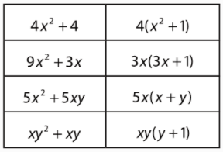
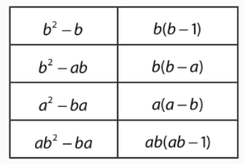

153.
a) $\left(2x+3\right)\left(3x+2\right)=2x∙3x+2x∙2+3∙3x+3∙2=6x^{2}+4x+9x+6=6x^{2}+13x+6$

b) $\left(3x+1\right)\left(2x+2\right)=3x∙2x+3x∙2+1∙2x+1∙2=6x^{2}+6x+2x+2=6x^{2}+8x+2$

c) $\left(3x+3\right)\left(2x+1\right)=3x∙2x+3x∙1+3∙2x+3∙1=6x^{2}+3x+6x+3=6x^{2}+9x+3$

d) $\left(1+4x\right)\left(3+2x\right)=1∙3+4x∙3+1∙2x+4x∙2x=3+12x+2x+8x^{2}=3+14x+8x^{2}$

e) $\left(3+5x\right)\left(2+2x\right)=3∙2+5x∙2+3∙2x+5x∙2x=6+10x+6x+10x^{2}=6+16x+10x^{2}$
154.
a) $b\left(a+2\right)+a\left(a+2\right)=(a+2)(b+a)$
b) $a\left(b+1\right)-b\left(b+1\right)=\left(b+1\right)\left(a-b\right)$
c) $a\left(b-1\right)-b\left(b-1\right)=\left(b-1\right)\left(a-b\right)$
d) $b\left(a+1\right)-a\left(1+a\right)=(a+1)(b-a)$
e) $a\left(b-1\right)-1\left(1-b\right)=a\left(b-1\right)+1\left(b-1\right)=(b-1)(a+1)$

155.
a) $a^{2}-2b+1 a=3, b=-1$
$$3^{2}-2∙1+1=9-2+1=7+1=8$$

b) ${3a}^{2}+4b^{2}-0.2 a=-1.1, b=0.5$
$$3∙{1.1}^{2}+4∙{0.5}^{2}-0.2=3.63+1-0.2=4.43$$

c) $\frac{4-a}{b^{2}} a=\frac{1}{2}, b=-0.25$

$$\frac{4-0.5}{{(-0.25)}^{2}}=\frac{3.5}{0.0625}=56$$

d) $1-\frac{2a^{2}}{b} a=-0.5, b=\frac{3}{2}=1.5$
$1-\frac{2a^{2}}{b}=1-\frac{2∙{\left(-0.5\right)}^{2}}{1.5}=\frac{0.5}{1.5}=\frac{\frac{1}{2}}{\frac{3}{2}}=\frac{1}{3}$

156.
a) $x^{2}=49$/
$$x_{1}=\sqrt{49}=7$$
$$x_{2}=-\sqrt{49}=-7$$
b) $x^{2}=\frac{50}{121}$ /
$x_{1}=\sqrt{\frac{50}{121}}=\frac{2\sqrt{5}}{11}$
$x_{2}=-\sqrt{\frac{50}{121}}=-\frac{2\sqrt{5}}{11}$

c) $x^{2}=1\frac{3}{49}$
$x^{2}=\frac{52}{49}$ /
$x_{1}=\sqrt{\frac{52}{49}}=\frac{2\sqrt{13}}{7}$
$x_{2}=-\sqrt{\frac{52}{49}}=-\frac{2\sqrt{13}}{7}$

157.
a) $9\left(x-2\right)=4x-3$
$$9x-18=4x-3$$
$$9x-4x=18-3$$
$5x=15$ /:5
$x=3∈N$

b) $2x-5\left(8-4x\right)=28-2(7-3x)$
$$2x-40+20x=28-14+6x$$
$$2x+20x-6x=28-14+40$$
$16x=54$ /:16
$x=\frac{54}{16}=\frac{27}{8}$ Nije iz N.

c) $-\frac{1}{2}:0.01+2\frac{1}{3}x+4=\frac{3}{4}x+5(x-1)$
$-50+\frac{7}{3}x+4=\frac{3}{4}x+5x-5$
$\frac{7}{3}x-\frac{3}{4}x-5x=50-4-5$ /12
$$28x-9x-60x=600-48-60$$
$-41x=492$ /:-41
$x=-12$ Nije iz N.

d) $\frac{x-3}{2}-\frac{2x-5}{4}=\frac{7x+4}{8}$ /8
$$4\left(x-3\right)-2\left(2x-5\right)=7x+4$$
$$4x-12-4x+10=7x+4$$
$$4x-4x-7x=12-10+4$$
$-7x=6$/:-7
$x=-\frac{6}{7}$ Nije iz N.

158.
a) $\left(0.4x-2\right)∙5+7=-0.3x+1.6$
$$2x-10+7=-0.3x+1.6$$
$$2x+0.3x=10-7+1.6$$
$2.3x=4.6$ :/2.3
$$x=2∈Z$$

b) $-3-5\left(2x+4\right)-7x=\left(x+7\right)\left(-4\right)-8\left(3x-5\right)+9$
$$-3-10x-20-7x=-4x-28-24x+40+9$$
$$-10x-7x+4x+24x=3+20-28+40+9$$
$11x=44$ /:11
$$x=4 ∈Z$$
c) $0.6x+1=-1-\frac{1}{2}x+3\left(\frac{2}{5}x+4\right)$
$0.6x+1=-1-\frac{1}{2}x+\frac{6}{5}x+12$
$0.6x+0.5x-1.2x=-1-1+12$
$-0.1x=10$ /:-0.1
$x=-100∈Z$

d) $\frac{x-4}{2}+\frac{3x-8}{5}=\frac{2}{15}-\frac{-2x+6}{3}$ /30
$$15x-90+18x-48=4+20x-60$$
$$15x+18x-20x=90+48+4-60$$
$13x=52$ /.13
$$x=4∈Z$$

159.
a) $x :2\frac{1}{2}=0.6:1\frac{1}{5}$
$x∙\frac{6}{5}=\frac{5}{2}∙\frac{3}{5}$
$\frac{6}{5}x=\frac{3}{2}$ /: $\frac{6}{5}$
$x=\frac{3}{2}:\frac{6}{5}=\frac{3}{2}∙\frac{5}{6}=\frac{5}{4}$

b) $7\frac{1}{5} :0.2x=4\frac{3}{4}:2\frac{3}{8}$
$\frac{1}{5}x∙\frac{19}{4}=\frac{36}{5}∙\frac{19}{8}$
$\frac{19}{20}x=\frac{171}{10}$ /: $\frac{19}{20}$
$x=\frac{171}{10}:\frac{19}{20}=\frac{171}{10}∙\frac{20}{19}=18$

c) $2\frac{1}{2}:x=1\frac{1}{4}:3$
$x∙\frac{5}{4}=\frac{5}{2}∙3$
$\frac{5}{4}x=\frac{15}{2}$ /: $\frac{5}{4}$
$x=\frac{15}{2}:\frac{5}{4}=\frac{15}{2}∙\frac{4}{5}=6$

d) $4\frac{2}{7} :\frac{3}{14}=3\frac{1}{3}x:15$
$\frac{10}{3}x∙\frac{3}{14}=\frac{30}{7}∙15$
$\frac{5}{7}x=\frac{450}{7}$ /: $\frac{5}{7}$
$x=\frac{450}{7}:\frac{5}{7}=\frac{450}{7}∙\frac{7}{5}=90$

e) $\left(x+3\right):6=(x-3):5$
$$(x+3)∙5=6∙(x-3)$$
$$5x+15=6x-18$$
$5x-6x=-15-18$
$-x=-33$ /:-1
$$x=33$$

f) $\left(5x-2\right):7=(3x+2):1$
$$(5x-2)∙1=7∙(3x+2)$$
$$5x-2=21x+14$$
$5x-21x=14+2$
$-16x=16$ /:16
$$x=-1$$

g) $\left(x+1\right):3=(x-1):1$
$$(x+1)∙1=3∙(x-1)$$
$$x+1=3x-3$$
$x-3x=-3-1$
$-2x=-4$ /:-2
$$x=2$$

h) $\left(5x+8\right):4=(2x-8):3$
$$(5x+8)∙3=4∙(2x-8)$$
$$15x+24=8x-32$$
$15x-8x=-24-32$
$7x=-56$ /:7
$$x=-8$$

i) $\frac{x}{x+8}=\frac{4}{3}$ unakrsno množimo
$$(x+8)∙4=x∙3$$
$$4x+32=3x$$
$4x-3x=-32$
$x=-32$

j) $\frac{1}{3}=\frac{2x-5}{3x+1}$ unakrsno množimo
$$(3x+1)∙1=(2x-5)∙3$$
$$3x+1=6x-15$$
$3x-6x=-15-1$
$-3x=-16$ /:-3
$x=\frac{16}{3}$
k) $\frac{2.5}{x+2}=\frac{7}{3x-4}$ unakrsno množimo
$$(3x-4)∙2.5=(x+2)∙7$$
$$7.5x-10=7x+14$$
$7.5x-7x=10+14$
$0.5x=24$ /:0.5
$x=48$

l) $\frac{3x+2}{5}=\frac{4x-25}{15}$ unakrsno množimo
$$(3x+2)∙15=(4x-25)∙5$$
$$45x+30=20x-125$$
$45x-20x=-125-30$
$25x=-155$ /:25
$x=-\frac{155}{25}=\frac{-31}{5}$

160.
a) $ρ_{1}=\frac{m_{1}}{V_{1}}=\frac{2kg}{5dm^{3}}$
$ρ_{2}=\frac{m_{2}}{V_{2}}=\frac{1}{\frac{19}{20}}=\frac{20 kg}{19 dm^{3}}$
Vosak jer je veća gustoća.

b) 1. čok $\frac{cijena}{pakiranje}=\frac{26kn}{500 g}=0.052\frac{kn}{g}$
2. čok $\frac{pakiranje}{cijena}=\frac{18kn }{250 g}=0.072\frac{kn}{g}$
Povoljnija je prva čokolada.

c) gepard $\frac{70km}{h}=70∙\frac{1000 m}{3600 s}=19.44\frac{m}{s}$
antilopa $20\frac{m}{s}$
Brža je antilopa.

d) jezero $\frac{masa soli}{količina vode}=\frac{350 g}{1L}=350\frac{g}{L}$
more $\frac{masa soli}{količina vode}=\frac{390 g}{1.5L}=260\frac{g}{L}$
Jezero.

161.
a) x : y =14k : 5k
x+y=361
14k+5k=361
19k =361 /:19
k=19

x=14·19=266
y=5·19=95

b) x : y =14k : 5k
x-y=234
14k-5k=234
9k =234 /:9
k=26

x=14·26=364
y=5·26=130

c) x : y =14k : 5k
x·y=280
14k·5k=280
70k² =280 /:70
k²=4
k=2 k =-2

x=14·2=28
y=5·2=10
x=14·(-2)=-28
y=5·(-2)=-10

162.
a) y … količina vode 32485 y
x… vrijeme dani 365 1
$$\frac{32485}{365}=\frac{y}{1}$$
$365y=32485$
$$y=89$$
U 1 danu se iscrpi 89 m³ vode.

b) y … količina vode 89 y
x… vrijeme dani 24 1
$$\frac{89}{24}=\frac{y}{1}$$
$24y=89$
$$y=3.71$$
U 1 satu se iscrpi 3.71 m³ vode.
163.
y … količina plina 1 y
x… cijena 2.80 722.05
$$\frac{1}{2.80}=\frac{y}{722.05}$$
$2.80y=722.05$
$$y=257.875$$
Potrošeno je 257.875 m³ plina.

164.
y …proteklo vrijeme 0.5 9
x… kašnjenje $2\frac{2}{3} min$ x
$$\frac{0.5}{2\frac{2}{3}}=\frac{9}{x}$$
$0.5x=9∙\frac{8}{3}$
$$0.5x=24$$
$$x=48$$
U 9 dana kasnit će 48 minuta.

165.
$$1:30 000 000$$
$1 cm :300 km$ 1 cm na karti predstavlja 300 km u prirodi
y … udaljenost u prirodi km 300 y
x… udaljenost na karti cm 1 1.3
$$\frac{300}{1}=\frac{y}{1.3}$$
$$y=300∙1.3=390$$
Udaljenost je 390 km.

166.
y … kombajni 3 5
x… broj sati rada 12 x
$$3∙12=5∙x$$
$5x=36$ /:5
$x=7.2$ Potrebno je 7.2 sati.

167.
y … radnici 54 y
x… broj dana 28 18
$$54∙28=y∙18$$
$18y=1512$ /:18
$y=84$ Potrebno je zaposliti još 84-54 = 30 radnika.

168.
Površine
manja = 20· 33 = 660 cm²
veća = 30· 33 = 990 cm²
y … površina 660 990
x… broj pločica 1800 x
$$660∙1800=x∙990$$
$990x=1188000$
$$x=1200$$
Treba 1200 komada većih pločica.
169.
a) y … broj radnika 60 42
x… dani 28 x
$$60∙28=42∙x$$
$42x=1680$ /:42
$$x=40$$
Završit će za 40 dana.

b) y … broj radnika 60 y
x… dani 28 20
$$60∙28=y∙20$$
$20y=1680$ /:20
$$x=84$$
Treba zaposliti još 84 – 60 = 24 radnika.

c) 60 radnika radilo je 10 dana. Ostalo je 18 dana posla.
y … broj radnika 60 72
x… dani 18 x
$$60∙18=72∙x$$
$72x=1080$ /:72
$$x=15$$
Podizanje nasipa trajalo je 10 + 15 = 25 dana.

170.
y … količina boje 10 y
x… površina 16 40
$\frac{10}{16}=\frac{y}{40}$
$$16∙y=10∙40$$
$y=\frac{400}{16}=25$
Potrebna je 25 L boje.

171.
a : b = 6k : 7k
o = 2a+2b
2a+2b=12k+14k=26k

26k = 78 /:26
k=3

a = 6k = 18 cm
b= 7k= 21 cm

172.
g = 20 000 kn
k=21000 – 20000 =1000 kn
s=0.3%
v=?
$$k=g∙s∙v$$
$v=\frac{k}{g∙s}=\frac{1000}{20000∙0.003}=16.67$ godina
Treba 16.67 godina.

173.
g = 7200 kn
v = 12 mj =1 god
s=1.9%
k=?
g+k =?
$$k=g∙s∙v$$
$k=7200∙0.019∙1=136.8$ kn
Platit će 7336.8 kn.

174.
a) $P\left(progođeno je plavo područje\right)=\frac{2}{12}=\frac{1}{6}$
b) $P\left(progođeno je crveno područje\right)=\frac{5}{12}$
c) $P\left(progođeno je zeleno područje\right)=\frac{2}{12}=\frac{1}{6}$
e) $P\left(progođeno je plavo ili crveno područje\right)=\frac{7}{12}$
f) $P\left(progođeno je žuto ili zeleno područje\right)=\frac{5}{12}$

175.
ukupno = 7+12+9+4=32 ribice
a) $P\left(izvučena je plava ribica\right)=\frac{7}{32}$
b) $P\left(izvučena je zlatna ribica\right)=\frac{9}{32}$
c) $P\left(izvučena je tigrasta ili crvena ribica\right)=\frac{16}{32}=\frac{1}{2}$

176.
a) 45% od 80 = 0.45 ·80 =36 plavih, a 80 – 36 = 44 crvene
b) $P\left(izvučena je crvena kuglica\right)=55\%=0.55$

177.
ukupno obuće = 4+30+8+6=48
a) $P\left(izvučene su papuče \right)=\frac{4}{48}=\frac{1}{12}$
b)$P\left(izvučene su cipele\right)=\frac{30}{48}=\frac{5}{8}$
c)$P\left(izvučene su čizme\right)=\frac{6}{48}=\frac{1}{8}$
d)$P\left(izvučene su tenisice\right)=\frac{8}{32}=\frac{1}{4}$

Priprema za ispit znanja
1.
a) $2\left(3x-5\right)=2∙3x-2∙5=6x-10$
b) $\left(4-3a\right)\left(6b+1.5a\right)=4∙6b+4∙1.5a-3a∙6b-3a∙1.5a=24b+6a-18ab-4.5a^{2}$

2.
a)$2x+16y=2x+2∙8y=2(x+8y)$
b) $25a^{2}-5a=5∙5∙a∙a-5a=5a(5a-1)$
c) $2\left(x-5x\right)+x(x-5y)$ Nema zajedničkog faktora osim 1.

3. $x^{2}=36$/
$$x_{1}=\sqrt{36}=6$$
$$x_{2}=-\sqrt{36}=-6$$

4.
$$-8+3\left(4x+5\right)=-2\left(-3x+7\right)+4\left(3x-6\right)-3$$
$$-8+12x+15=6x-14+12x-24-3$$
$$12x-6x-12x=8-15-14-24-3$$
$-6x=-48$ /:-6
$$x=8 ∈N$$

5.
$\frac{5x+2}{7}-\frac{6-3x}{4}=\frac{7x+4}{14}$ /28
$$4\left(5x+2\right)-7\left(6-3x\right)=2(7x+4)$$
$$20x+8-42+21x=14x+8$$
$$20x+21x-14x=-8+42++8$$
$$27x=42$$
$x=\frac{42}{27}=\frac{14}{9}$ Nije u Z.

6.
a)$8:\left(4x+3\right)=5:(2x-1)$
$$(2x-1)∙8=(4x+3)∙5$$
$$16x-8=20x+15$$
$16x-20x=15+8$
$-4x=23$ /:-4
$x=-\frac{23}{4}$

b) $\left(x-1\right):5=(2x+1):8$
$$(x-1)∙8=5∙(2x+1)$$
$$8x-8=10x+5$$
$8x-10x=8+5$
$-2x=13$ /:-2
$x=-\frac{13}{2}$

7.
y …broj automobila 8 12
x… vrijeme $35 min$ x
$$\frac{8}{35}=\frac{12}{x}$$
$8x=35∙12$
$8x=420$ /:8
$$x=52.5$$

Za 12 automobila treba im 52.5 minute.

8.
y … broj radnika 18 10
x… dani 35 x
$$18∙35=10∙x$$
$10x=630$ /:10
$$x=63$$
Trajao bi 63 dana.

9.
1. slučaj $\frac{cijena}{pakiranje}=\frac{28.39kn}{1.5g}=18.93\frac{kn}{kg}$
2. slučaj $\frac{cijena}{pakiranje}=\frac{32kg}{2kn}=16\frac{kn}{kg}$
Povoljnije je u 2. slučaju.

10.
a) g = 1 400 kn
v = 9 mj =$\frac{9}{12}=\frac{3}{4}$ god
s=0.5%
k=?
g+k =?
$$k=g∙s∙v$$
$k=1400∙0.005∙\frac{3}{4}=5.25$ kn
Kamate su 5.25 kn.

b) k=150 kn
v = 1 god
s=0.5%
g=?
$$k=g∙s∙v$$
$g=\frac{k}{s∙v}=\frac{150}{0.005∙1}=30 000$ kn
Treba uložiti 30 000 kn.

11.
ukupno čarapa = 6+5+9=20
a) $P\left(izvučena je plava čarapa\right)=\frac{6}{20}=\frac{3}{10}$
b) $P\left(izvučena je crna čarapa\right)=\frac{5}{20}=\frac{1}{4}$
c) $P\left(izvučena je smeđa čarapa\right)=\frac{9}{20}$

40.
a)
Odgovarajući kutovi
$∡\left|AED\right|=∡\left|CEB\right|$
$∡\left|A\right|=∡\left|B\right|$
$$∡\left|C\right|=∡\left|D\right|$$
odgovarajuće stranice
$$\overline{AE} i \overline{EB}, \overline{AD} i \overline{BC}, \overline{DE} i \overline{EC}$$

b) Odgovarajući kutovi
$∡\left|J\right|=∡\left|F\right|$
$∡\left|I\right|=∡\left|H\right|$
$$∡\left|F\right|=∡\left|G\right|$$
odgovarajuće stranice
$$\overline{FJ} i \overline{FG}, \overline{FI} i \overline{HG}, \overline{IJ} i \overline{FH}$$

41.
$$∡\left|X\right|=∡\left|A\right|$$
$∡\left|Y\right|=∡\left|B\right|$
$$∡\left|Z\right|=∡\left|C\right|$$
$$\frac{17.4}{8.7}=\frac{11.4}{5.7}=\frac{10}{5}=2$$
Odgovarajući kutovi su jednake veličine, a duljine odgovarajućih stranica su proporcionalne.
$$∆XYZ \sim ∆ABC$$

42.
$$∡\left|A\right|=∡\left|B\right|=\left(180°-38°\right):2=142°:2=71°$$
$$∡\left|C'\right|=180°-142°=38°$$
$$∡\left|A\right|=∡\left|A'\right|$$
$$∡\left|B\right|=∡\left|B^{'}\right|$$
$$∡\left|C\right|=∡\left|C^{'}\right|$$

$$\frac{7}{11.2}=\frac{7}{11.2}=\frac{5}{8}=0.625$$
Odgovarajući kutovi su jednake veličine, a duljine odgovarajućih stranica su proporcionalne.
$$∆ABC \sim ∆A'B'C'$$

b) $$∡\left|E\right|=90°-27°=63°$$
$$∡\left|G'\right|=90°-63°=27°$$
$$∡\left|E\right|=∡\left|E'\right|$$
$$∡\left|F\right|=∡\left|F^{'}\right|$$
$$∡\left|G\right|=∡\left|G^{'}\right|$$

$\frac{3}{2.1}=\frac{6}{4.2}=\frac{7}{4.9}=\frac{10}{7}$
Odgovarajući kutovi su jednake veličine, a duljine odgovarajućih stranica su proporcionalne.
$$∆EFG \sim ∆E'F'G'$$

43.
$$∡\left|FJG\right|=∡\left|HJI\right|$$
$∡\left|G\right|=∡\left|H\right|$
$$∡\left|F\right|=∡\left|I\right|$$
$\frac{18.9}{6.3}=3=k$
$\frac{x}{4.3}=\frac{3}{1}$
$$x=4.3∙3$$
$$x=12.9$$
$$\left|FG\right|=12.9$$

44.
$$o=9.6 cm$$
$$p=6.8 cm$$
$$r=11.4 cm$$
$$p^{'}=3.4 cm$$

$\frac{p}{p^{'}}=\frac{6.8}{3.4}=2=k$
$$\frac{r}{r^{'}}=k$$
$$\frac{11.4}{r^{'}}=\frac{2}{1}$$
$2r^{'}=11.4$ /:2
$r^{'}=5.7$ cm

$$\frac{o}{o^{'}}=k$$
$$\frac{9.6}{o^{'}}=\frac{2}{1}$$
$2o^{'}=9.6$ /:2
$o^{'}=4.8$ cm

45.
$$d=4 cm$$
$$e=5 cm$$
$$f=6 cm$$
$$k=1.4$$

$\frac{d}{d^{'}}=\frac{4}{d'}=\frac{1.4}{1}$
$1.4r^{'}=4$ /1.4
$d^{'}=5.6$ cm

$\frac{e}{e^{'}}=1.4$
$\frac{5}{e^{'}}=\frac{1.4}{1}$
$2e^{'}=9.6$ /:2
$e^{'}=4.8$ cm

$\frac{f}{f^{'}}=1.4$
$\frac{6}{f^{'}}=\frac{1.4}{1}$
$2f^{'}=9.6$ /:2
$f^{'}=4.8$ cm

46.
$\frac{\left|AB\right|}{\left|FG\right|}=\frac{\left|CD\right|}{\left|EH\right|}=\frac{12}{3}=4$
$\frac{\left|AD\right|}{\left|EF\right|}=\frac{\left|BC\right|}{\left|HG\right|}=\frac{8}{2}=4$
Odgovarajuće stranice su proporcionalne i svi kutovi jednaki.
Pravokutnici su slični. Koeficijent sličnosti je 4.

47.
$$\frac{|AB|}{|EF|}=\frac{3}{6}=0.5=k$$
$$\frac{x}{4}=\frac{0.5}{1}$$
$$x=0.5∙4$$
$$x=2$$

$$\frac{3.6}{y}=\frac{0.5}{1}$$
$0.5y=3.6$ /:0.5
$$y=7.2$$

$$\frac{3}{z}=\frac{0.5}{1}$$
$0.5z=3$ /:0.5
$$z=6$$

48.
$$\frac{|AD|}{|A'D'|}=\frac{10}{5}=2=k$$

$$\frac{21}{|A^{'}B^{'}|}=\frac{2}{1}$$
${2|A}^{'}B^{'}|=21$ /:2
$${|A}^{'}B^{'}|=10.5$$

$$o^{'}=2a^{'}+2b^{'}=2∙10.5+2∙5=21+10=31$$

49.
o=75 cm
a= 75 : 5 = 15 cm
$$\frac{a}{a^{'}}=\frac{15}{9}=\frac{5}{3}=k$$
$$\frac{24.3}{r^{'}}=\frac{5}{3}$$
$5r^{'}=24.3∙3$ /:5
$$r^{'}=14.58 cm$$

50.
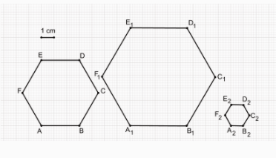
51.
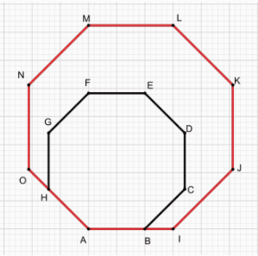
53.
x – visina stabla
$$\frac{4.2}{1.2}=\frac{10.7}{x}$$
$$4.2x=1.2∙10.7$$
$4.2x=12.84$ /:4.2
$x≈3.058$ m
Stablo je visoko približno 3.058 m.

54.
h – Markova visina
$$\frac{168}{45}=\frac{x}{40}$$
$45x=168∙40$ /:45
$$x=149.333…cm≈1.49 m$$
Josip je višlji.
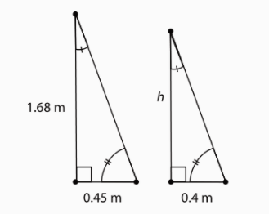

55.
$\frac{\left|AB\right|}{\left|DE\right|}=\frac{\left|AC\right|}{\left|DC\right|}$
$\frac{\left|AB\right|}{\left|DE\right|}=\frac{\left|AD\right|+\left|DC\right|}{\left|DC\right|}$
$\frac{25}{15}=\frac{5+\left|DC\right|}{\left|DC\right|}$
$$25\left|DC\right|=15\left(5+\left|DC\right|\right)$$
$$25\left|DC\right|=75+15\left|DC\right|$$
$$25\left|DC\right|-15\left|DC\right|=75$$
10$\left|DC\right|=75$/:10
$\left|DC\right|=7.5$ m
Širina jarka je 7.5 m.

56.
$\frac{10}{70}=\frac{2}{d}$
$$10d=2∙70$$
$10d=140$ /:10
$d=14$m
Dubina jezera je 14 m.

57.
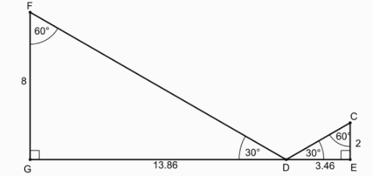
Udaljenost mornara od svjetionika je 13.86 + 3.46 = 17.32 cm.

U stvarnosti je to
$$\frac{1}{500}=\frac{17.32}{x}$$
$$x=500∙17.32=8660 cm$$
$$x=86.6 m$$

58.
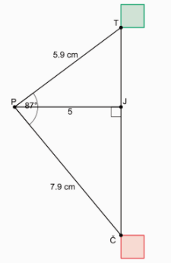
U stvarnosti je to
$$\frac{1}{5000}=\frac{5}{x}$$
$$x=5000∙5=25000 cm$$
$$x=250 m$$

59.
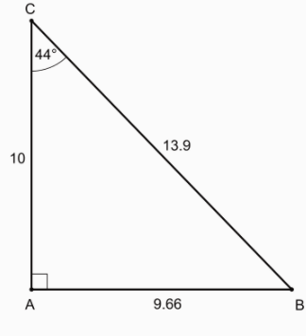
U stvarnosti je to
$\frac{1}{10}=\frac{9.66}{b}$
$b=10∙9.66$
$b=96.6 cm$

60. a)
$$∡\left|A\right|=∡\left|Y\right|$$
$∡\left|B\right|=∡\left|W\right|$
$$∡\left|C\right|=∡\left|X\right|$$
odgovarajuće stranice
$$\overline{AB} i \overline{YW}, \overline{BC} i \overline{WX}, \overline{AC} i \overline{YX}$$

b)
$$∡\left|P\right|=∡\left|T\right|$$
$∡\left|Q\right|=∡\left|U\right|$
$$∡\left|R\right|=∡\left|V\right|$$
odgovarajuće stranice
$$\overline{PQ} i \overline{TU}, \overline{QR} i \overline{UV}, \overline{PR} i \overline{RV}$$

61.
a)
$$∡\left|X\right|=∡\left|D\right|=45°$$
$∡\left|Y\right|=∡\left|E\right|=88°$
$$∡\left|Z\right|=∡\left|F\right|=47°$$
$$\frac{6}{12}=\frac{1}{2}=k$$
$\frac{5}{|EF|}=\frac{1}{2}$
$$\left|EF\right|=10$$
$\frac{|XY|}{8}=\frac{1}{2}$
$$2\left|XY\right|=8$$
$$\left|XY\right|=4$$

b)
$$∡\left|BAC\right|=∡\left|DBE\right|=32°$$
$∡\left|ABC\right|=∡\left|BDE\right|=63°$
$$∡\left|ACB\right|=∡\left|BED\right|=85°$$
$$\frac{8}{6}=\frac{4}{3}=k$$
$\frac{|BD|}{12}=\frac{4}{3}$
$3\left|BD\right|=48$ /:3
$$\left|BD\right|=16$$
$\frac{|BE|}{10}=\frac{4}{3}$
$$3\left|BE\right|=40$$
$\left|BE\right|=\frac{40}{3}$

c)
$$∡\left|O\right|=∡\left|B\right|=92°$$
$∡\left|R\right|=∡\left|C\right|=55°$
$$∡\left|P\right|=∡\left|A\right|=33°$$
$\frac{5}{9}=k$
$\frac{7.5}{|AB|}=\frac{5}{9}$
$5\left|AB\right|=67.5$ /:5
$$\left|AB\right|=13.5$$
$\frac{|RP|}{15}=\frac{5}{9}$
$$9\left|RP\right|=75$$
$\left|RP\right|=\frac{25}{3}$

62.
$$∡\left|A\right|=∡\left|P\right|=50°$$
$∡\left|B\right|=∡\left|Q\right|=90°$
$$∡\left|C\right|=∡\left|R\right|=40°$$
$\frac{4}{12}=\frac{1}{3}=k$
$\frac{5}{|QR|}=\frac{1}{3}$
$\left|QR\right|=15$
$\frac{|AC|}{19.2}=\frac{1}{3}$
$3\left|AC\right|=19.2$ /:3
$\left|AC\right|=6.4$

63.
$\frac{9}{6}=\frac{3}{2}=k$
$\frac{10}{|PQ|}=\frac{3}{2}$
$3\left|PQ\right|=20$ /:3
$\left|PQ\right|=\frac{20}{3}$
64.
a) $\frac{7.8}{7.8+7.2}=\frac{7.8}{15}=k$
$\frac{5.4}{x}=\frac{7.8}{15}$
$7.8x=5.4∙15$ /: 7.8
$x≈9.9$

b) $\frac{2}{8}=\frac{1}{4}=k$
$\frac{x}{10}=\frac{1}{4}$
$4x=10$ /: 4
$x=2.5$

65.
$\frac{5.2}{7.8}=k$
$\frac{6.6}{|DE|}=\frac{5.2}{7.8}$
$5.2\left|DE\right|=6.6∙7.8$ /: 5.2
$|DE|=9.9$

$\frac{3.4}{|EF|}=\frac{5.2}{7.8}$
$5.2\left|EF\right|=3.4∙7.8$ /: 5.2
$|DE|=5.1$

66.
a) $\frac{6}{7.2}=\frac{\frac{6}{1}}{\frac{36}{5}}=\frac{5}{6}=k$

b) $\frac{7.2}{6}=\frac{\frac{36}{5}}{\frac{6}{1}}=\frac{6}{5}=k$

67.
a) $\frac{a}{d}=\frac{b}{e}=\frac{c}{f}=k$
$$d=a: k=4.8 :4=1.2 cm$$
$$e=b: k=5.6 :4=1.4 cm$$
$$f=c: k=6.4 :4=1.6cm$$

b) $\frac{a}{d}=\frac{b}{e}=\frac{c}{f}=k$
$$d=a: k=4.8 :\frac{1}{4}=19.2 cm$$
$$e=b: k=5.6 :\frac{1}{4}=22.4cm$$
$$f=c: k=6.4 :\frac{1}{4}=25.6cm$$

c) $\frac{a}{d}=\frac{b}{e}=\frac{c}{f}=k$
$$d=a: k=4.8 :\frac{3}{4}=6.4 cm$$
$$e=b: k=5.6 :\frac{3}{4}=7.5 cm$$
$$f=c: k=6.4 :\frac{3}{4}=8.5 cm$$

d) ) $\frac{a}{d}=\frac{b}{e}=\frac{c}{f}=k$
$$d=a: k=4.8 :\frac{1}{3}=14.4 cm$$
$$e=b: k=5.6 :\frac{1}{3}=16.8cm$$
$$f=c: k=6.4 :\frac{1}{3}=19.2 cm$$

e) ) $\frac{a}{d}=\frac{b}{e}=\frac{c}{f}=k$
$$d=a: k=4.8 :\frac{3}{2}=3.2 cm$$
$$e=b: k=5.6 :\frac{3}{2}≈3.7 cm$$
$$f=c: k=6.4 :\frac{3}{2}≈4.3cm$$

68.
a)$\frac{1.5}{6}=k$
$\frac{1.5}{6}=\frac{1.8}{x}$
$1.5x=10.8$ /:1.5
$$x=7.2$$

$\frac{1.5}{6}=\frac{3}{y}$
$1.5y=18$ /:1.5
$$x=12$$

b) $\frac{3}{6}=\frac{1}{2}=k$
$\frac{1}{2}=\frac{1.5}{x}$
$x=2∙1.5$
$$x=3$$
$\frac{1}{2}=\frac{1.8}{y}$
$y=2∙1.8$
$$x=3.6$$
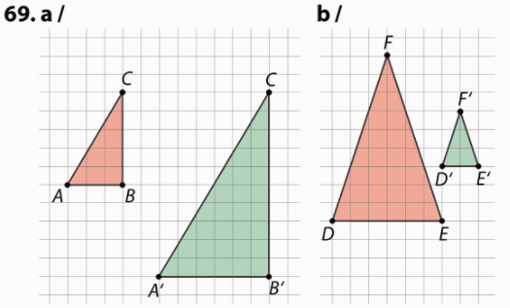
70.
$\frac{10.5}{73.5}=k$
$\frac{10.5}{73.5}=\frac{8}{x}$
$10.5x=73.5∙8$ /:10.5
$$x=56$$

71.
Vrijedi jer su to kutovi sa usporednim kracima koji su jednaki.
$\frac{13.5}{7.5}=k$
$\frac{13.5}{7.5}=\frac{18}{x}$
$13.5x=7.5∙18$ /:13.5
$$x=10$$

72. Svi odgovarajući kutovi su jednake veličine.
$\frac{24}{8}=3=k$
$\frac{x}{10.5}=3$
$x=10.5∙3$
$$x=31.5$$

73. Svi odgovarajući kutovi su jednake veličine.
$\frac{2.8}{4.2}=\frac{\frac{\frac{28}{10}}{42}}{10}=\frac{2}{3}=k$
$\frac{x}{1.8}=\frac{2}{3}$
$3x=1.8∙2$ /:3
$$x=1.2$$

74.
Ako znamo da su |AB| i |DE| paralelne.
$\frac{54}{18}=3=k$
$\frac{30}{x}=3$
$3x=30$ /:3
$$x=10mm$$

$\frac{y}{24}=3$
$y=24∙3$
$$x=72mm$$

75.
a) $\frac{6}{12}=\frac{1}{2}=k$
$\frac{4}{f}=\frac{1}{2}$
$f=4∙2$
$$f=8 cm$$

$\frac{7}{d}=\frac{1}{2}$
$d=7∙2$
$$d=14 cm$$

b) $\frac{4}{6}=\frac{2}{3}=k$
$\frac{5}{c}=\frac{2}{3}$
$2c=5∙3$
$$c=7.5 cm$$

$\frac{w}{9}=\frac{2}{3}$
$3w=9∙2$
$$w=6 cm$$

76.
a)
$$|∡B|=|∡E|=90°$$
$\left|∡BCA\right|=\left|∡DBE\right|-$ vršni
Ako su dva para kutova u trokutima sukladna, onda je i treći.
Trokuti su sukladni.
$\frac{16.2}{36.8}≈0.44=k$
$\frac{8.6}{x}=0.44$
$x≈19.5$

b)
$$|∡U|=|∡Q|=90°$$
$\left|∡UST\right|=\left|∡RSQ\right|-$ vršni
Ako su dva para kutova u trokutima sukladna, onda je i treći.
Trokuti su sukladni.
$\frac{6}{18}=\frac{1}{3}=k$
$\frac{x}{15}=\frac{1}{3}$
$3x=15$ /:3
x=5

77.
a) $\frac{70}{50}=\frac{7}{5}=k$
$\frac{11x-4}{60}=\frac{7}{5}$
$(11x-4)∙5=7∙60$
$$55x-20=420$$
$$55x=420+20$$
$55x=440$ / : 55
$$x=8$$

b) $\frac{77}{21}=\frac{11}{3}=k$
$\frac{11x+11}{30}=\frac{11}{3}$
$(11x+11)∙3=11∙30$
$$33x+33=330$$
$$33x=330-33$$
$33x=317$ / : 33
$$x=9$$

c) $\frac{36}{96}=\frac{3}{8}=k$
$\frac{4x-4}{64}=\frac{3}{8}$
$(4x-4)∙8=3∙64$
$$32x-32=192$$
$$32x=192+32$$
$32x=224$ / : 32
$$x=7$$

d) $\frac{88}{24}=\frac{11}{3}=k$
$\frac{5x+11}{18}=\frac{11}{3}$
$(5x+11)∙3=18∙11$
$$15x+33=198$$
$$15x=198-33$$
$15x=165$ / : 15
$$x=11$$

78.
a) $\frac{2.5}{5}=\frac{1}{2}=k$
$\frac{x}{9}=\frac{1}{2}$
$2x=9$ /:2
x=4.5
b) $\frac{6.8}{4}=1.7=k$
$\frac{x}{5}=1.7$
$x=1.7∙5$
x=8.5

79.
$\frac{\left|AE\right|}{\left|AF\right|}=\frac{4}{5}$
$\frac{\left|AB\right|}{\left|AD\right|}=\frac{4}{5}$
$4\left|AD\right|=5|AB|$ /:4
$\left|AD\right|=\frac{4}{5}|AB|$
$$o=2\left|AB\right|+2|AD|$$
$2\left|AB\right|+2∙\frac{4}{5}\left|AD\right|=54$
$\frac{18}{5}\left|AB\right|=54$ /:$\frac{18}{5}$
$\left|AB\right|=54:\frac{18}{5}=54∙\frac{5}{18}=15$ cm
$\left|AD\right|=\frac{4}{5}\left|AB\right|=\frac{4}{5}∙15=12$ cm

80.
o = 22 mm + 12 mm + 6 mm + 14 mm = 54 mm
$\frac{o}{o^{'}}=\frac{54}{189}=\frac{2}{7}=k$
$\frac{22}{a^{'}}=\frac{2}{7}$
$$a^{'}=22∙\frac{7}{2}=77 mm$$
$\frac{12}{b^{'}}=\frac{2}{7}$
$$b^{'}=12∙\frac{7}{2}=46 mm$$
$\frac{6}{c^{'}}=\frac{2}{7}$
$$c^{'}=6∙\frac{7}{2}=21 mm$$
$\frac{14}{d^{'}}=\frac{2}{7}$
$$d^{'}=14∙\frac{7}{2}=49 mm$$

81.
$\frac{14}{12}=\frac{7}{6}=k$
$\frac{28}{a^{'}}=\frac{7}{6}$
$$a^{'}=28∙\frac{6}{7}=24 mm$$
$\frac{12}{b^{'}}=\frac{2}{7}$
$$b^{'}=21∙\frac{6}{7}=18 mm$$
$\frac{6}{c^{'}}=\frac{2}{7}$
$$c^{'}=35∙\frac{6}{7}=30 mm$$
$\frac{14}{d^{'}}=\frac{2}{7}$
$$d^{'}=49∙\frac{6}{7}=42 mm$$

82.
o + o' = 165 cm
$$\frac{o}{o^{'}}=1.5$$
$$o=o'∙1.5$$
$$1.5o^{'}+o^{'}=165$$
$2.5o^{'}=165$ /:2.5
$$o^{'}=66$$
$o=o^{'}∙1.5=66∙1.5=99$ cm

83.
Kutovi sličnih mnogokuta su jednake veličine.
$$3y-9°=120°$$
$$3y=120°+9°$$
$3y=129°$ /:3
$$y=43°$$

$\frac{5x-25}{20}=\frac{9}{4}$
$$20x-100=180$$
$20x=280$ /:20
$$x=14$$

84.
a) $\frac{12x-4}{40}=\frac{4x+8}{25}$
$$300x-100=160x+320$$
$140x=420$ /:140
$$x=3$$

85.
1 cm na karti je 1000 cm u prirodi.
750 m = 75 000 cm 1 km = 100 000 cm 840 m = 84 000 cm
$$\frac{x}{75000}=\frac{1}{1000}$$
$1000x=75000$ /:1000
$$x=75 cm$$

$$\frac{y}{100000}=\frac{1}{1000}$$
$1000y=100000$ /:1000
$$y=100 cm$$

$$\frac{z}{84000}=\frac{1}{1000}$$
$1000x=84000$ /:1000
$$x=84 cm$$

86.
$$\frac{1.2}{3}=\frac{x}{5}$$
$3x=6$ /:3
$$x=2 m$$
Zid je visok 2 m.

87.
$$\frac{2.4}{3}=\frac{x}{8}$$
$3x=19.2$ /:3
$$x=6.4 m$$
Ljestve mogu doseći visinu 6.4 m.

88.
$$\frac{1.25}{6}=\frac{1.60}{x}$$
$1.25x=9.6$ /:1.25
$$x=7.68 m$$
Visina stabla je 7.68 m.

89.
$$\frac{152-57}{152}=\frac{x}{122}$$
$152x=11590$ /:152
$$x=76.25 cm$$
Visina potpornog stupa mora biti 76.25 cm.

90. a)
$$\frac{1.7}{x}=\frac{0.4}{14}$$
$0.4x=23.8$ /:0.4
$$x=59.5 m$$
Visina tornja je 59.5 m.

91.
$$\frac{9}{1.8}=\frac{x-1.8}{9}=k$$
$1.8x-3.24=81$
$1.8x= 84.24$ /1.8
$x=46.8$ m
Visina stijene je 46.8 m.

92.
$$\frac{15}{x}=\frac{22}{160}$$
$22x=2400$ /:22
$$x≈109.09 m$$
Širina pješčane doline je približno 109.09 m.

93.
$$\frac{15}{x}=\frac{17}{50}$$
$17x=750$ /:17
$$x≈44.1 m$$

94.
|AB| - širina rijeke
$$\frac{1}{|AB|}=\frac{2}{\left|AB\right|+26}$$
$\left|AB\right|+26=2|AB|$
$\left|AB\right|=26$m

U drugom slučaju
$$\frac{1}{|AB|}=\frac{2.5}{\left|AB\right|+30}$$
$\left|AB\right|+30=2.5|AB|$
$1.5\left|AB\right|=30$/:1.5
$\left|AB\right|=20$m

96.
visina trokuta u ind. zoni – x
$$\frac{3}{1}=\frac{x}{1.4}$$
$$x=3∙1.4=4.2 km$$
$$P=\frac{3∙4.2}{2}=6.3 km^{2}$$

97.
$$a=8.5 dm, b=10 dm, c=12.5 dm$$
$$c^{'}-a^{'}=6.4 dm$$
$$c^{'}=a^{'}+6.4$$
$$\frac{a}{a'}=\frac{c}{c^{'}}$$
$$\frac{8.5}{a^{'}}=\frac{12.5}{a^{'}+6.4}$$
$$8.5a^{'}+54.4=12.5a^{'}$$
${4.5a}^{'}=54.4$ /: 4
$a^{'}=13.6$ dm
$$c^{'}=a^{'}+6.4=13.6+6.4=20 dm$$
$$\frac{b}{b^{'}}=\frac{c}{c^{'}}$$
$$b^{'}=\left(10∙20\right):12.5=16 dm$$

98.
$$a=2 cm, b=3 cm, c=4 cm$$
najveći
$$\frac{a}{a^{'}}=\frac{2}{24}=\frac{1}{12}$$
$$\frac{3}{b^{'}}=\frac{1}{12}$$
$$b^{'}=3∙12=36 cm$$

$$\frac{4}{c^{'}}=\frac{1}{12}$$
$$c^{'}=4∙12=48 cm$$

$$o=24+36+48=108 cm$$

najmanji
$$\frac{c}{c^{'}}=\frac{4}{24}=\frac{1}{6}$$
$$\frac{2}{a^{'}}=\frac{1}{6}$$
$$a^{'}=2∙6=12 cm$$

$$\frac{3}{b^{'}}=\frac{1}{6}$$
$$b^{'}=3∙6=18 cm$$

$$o=12+18+24=54 cm$$

99.
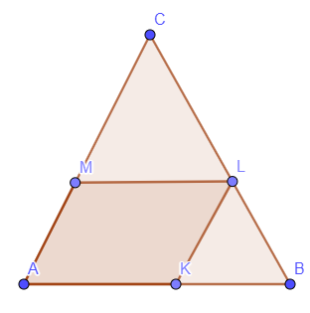
$\overline{AK} i \overline{ML} su paralelne$ - $∆ABC \sim ∆MLC$
$\frac{14}{|AC|}=\frac{7}{\left|AC\right|-8}$
$14 \left|AC\right|-112=7\left|AC\right|$
$7 \left|AC\right|=112$ /:7
$\left|AC\right|=16$ cm
100.
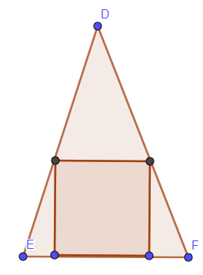

$$\frac{a}{24}=\frac{30-a}{30}$$
$$30a=720-24a$$
$54a=720$ /:54
$a=13\frac{1}{3}$ mm

$o=4a=4∙\frac{40}{3}=\frac{160}{3}$ mm

101.
$$\frac{3}{y'}=\frac{50}{10}$$
$50y'=30$ /:50
$$y^{'}=0.6 cm$$

1.
a) $\left|OA\right|:\left|OB\right|=2:5$
b) $\left|AB\right|:\left|OB\right|=3:5$
c) $\left|AA'\right|:\left|BB'\right|=\left|OA\right|:\left|OB\right|=2:5$
d) $\left|OA\right|:\left|AB\right|=2:3$
e) $\left|OA^{'}\right|:\left|A^{'}B^{'}\right|=\left|OA\right|:\left|AB\right|=2:3$

2.
a) $x:3=1.6:4$
$$x∙4=3∙1.6$$
$4x=4.8$ / :4
$$x=1.2$$

b) $3:x=5.1:6.8$
$$x∙5.1=3∙6.8$$
$5.1x=20.4$ / :5.1
$$x=4$$

c) $x:3.6=2.5:4.5$
$$x∙4.5=3.6∙2.5$$
$4.5x=9$ / :4.5
$$x=2$$

d) $3.6:(3.6+x)=6.6:7$
$$(3.6+x)∙6.6=3.6∙7$$
$23.76+6.6x=25.2$
$$6.6x=25.2-23.76$$
$$6.6x=1.44$$
$$x=0.22$$

e) $15:35=9:x$
$$15∙x=35∙9$$
$15x=315$ /:15
$$x=21$$

3.
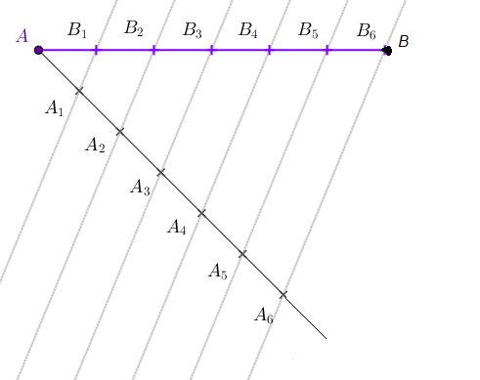

4. a)
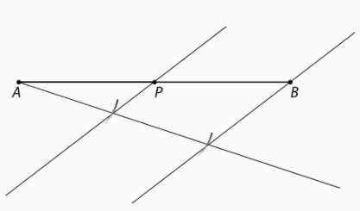

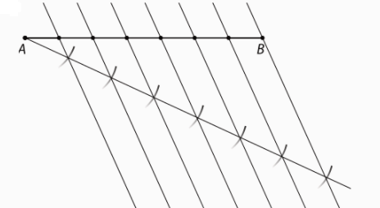
b)

5.
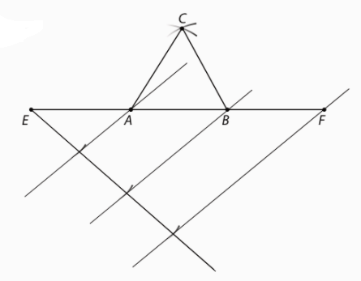
6. a)
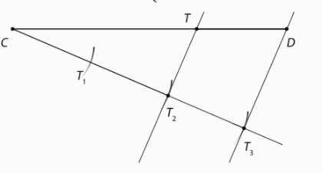

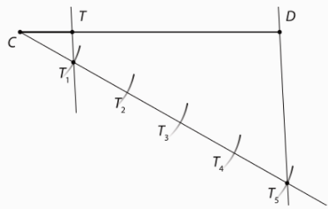
b)

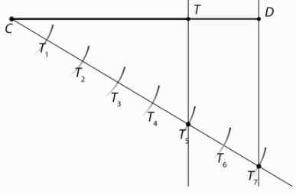
c)

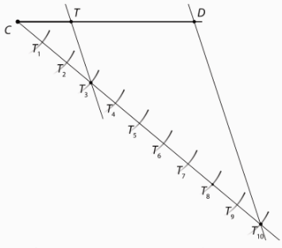
d)

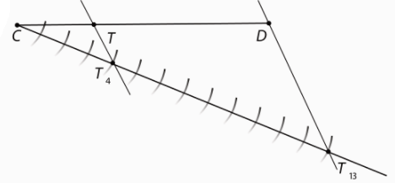
7.

$$\left|CT\right|=\frac{4}{13}∙\left|CD\right|=\frac{4}{13}∙117 mm=36 mm$$
$$\left|TD\right|=\frac{9}{13}∙\left|CD\right|=\frac{9}{13}∙117 mm=81 mm$$

8.
a) A
b) B
c) G
d) D
e) F
f) H
g) C
h) E

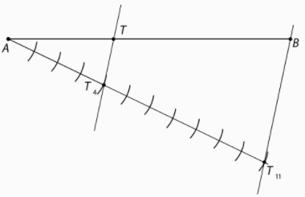
9.

10. a)
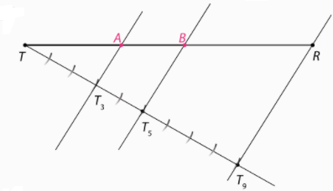
b)
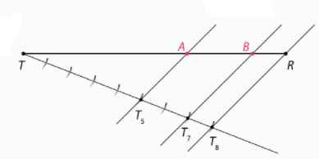
c)
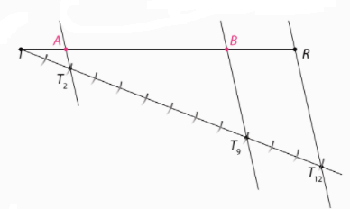

11.a) $1 :\frac{1}{2}:\frac{1}{3}$ /·6
$6:3:2$
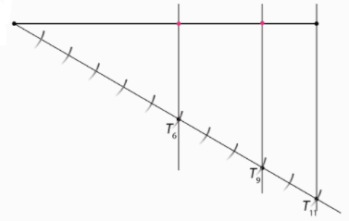
b) $1 :\frac{1}{3}:\frac{1}{9}$ /·9
$9:3:1$
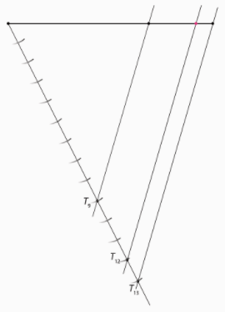

12. a)
$$a:b:c=3:3:5$$
3+3+5 = 11
Dužinu duljine 15.1 treba podijeliti na 11 jednakih dijelova.
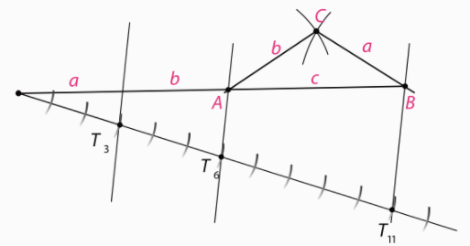
Trokut je jednakokračan i tupokutan.
b) $$a:b:c=3:4:5$$
3+4+5 = 12
Dužinu duljine 15.1 treba podijeliti na 12 jednakih dijelova.
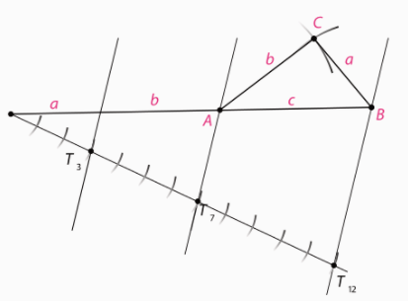
Trokut je raznostraničan i pravokutan,

c) $$a:b:c=2:5:6$$
2+5+6 = 13
Dužinu duljine 15.1 treba podijeliti na 13 jednakih dijelova.

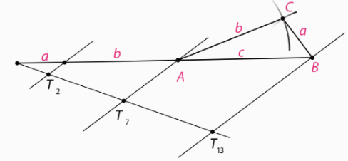
Trokut je raznostraničan i tupokutan.

13.
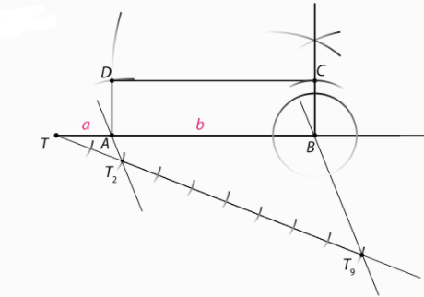

14.
$$a :b :c=3+4+6$$
3+4+6=13 Dužinu duljine 11.7 cm treba razdijeliti na 13 jednakih dijelova.
$$a=\frac{3}{13}o=\frac{3}{13}∙11.7=2.7 cm$$
$$b=\frac{4}{13}o=\frac{4}{13}∙11.7=3.6 cm$$
$$c=\frac{6}{13}o=\frac{6}{13}∙11.7=5.4 cm$$

15.
$$\frac{\left|AD\right|}{\left|DB\right|}=\frac{2}{3}$$
$$\left|AE\right|=3.7 cm$$
$$\frac{\left|AD\right|}{\left|DB\right|}=\frac{|AE|}{|EC|}$$
$$\frac{2}{3}=\frac{3.7}{\left|EC\right|}$$
$2\left|EC\right|=11.1$ /:2
$$\left|EC\right|=5.55 cm$$

16.
$$\frac{\left|PS\right|}{\left|SQ\right|}=\frac{3}{5}$$
$$\left|PR\right|=5.6 cm$$
$$\frac{\left|PS\right|}{\left|SQ\right|}=\frac{|PT|}{|TR|}$$
$$\frac{3}{5}=\frac{x}{5.6-x}$$
$5x=3(5.6-x)$
$$5x=16.8-3x$$
$$5x+3x=16.8$$
$8x=16.8$/:8
$x=2.1$ cm
$|PT|=2.1$ cm

17.
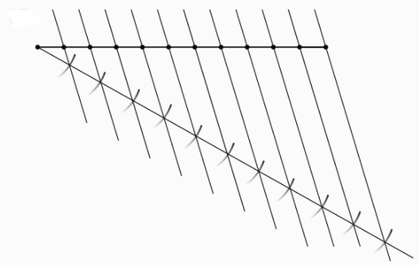
18.
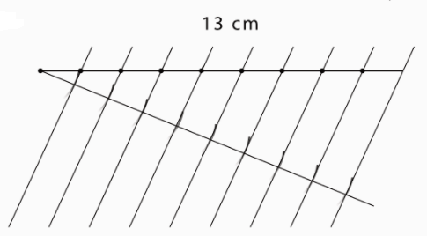
19.
Dužinu duljine 12.3 cm trebamo podijeliti na 3 jednaka dijela.

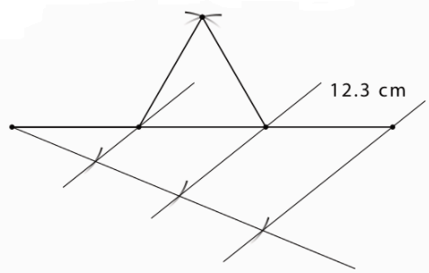
20. Dužinu duljine 13.7 cm trebamo podijeliti na 4 jednaka dijela.
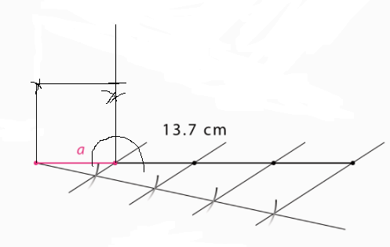

21.
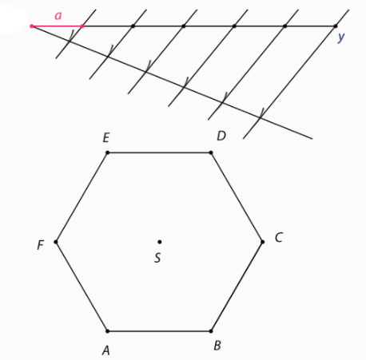

22.
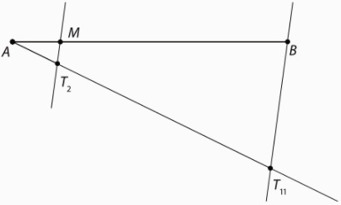

23.
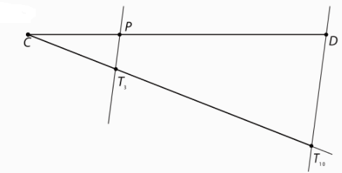
$$\left|CP\right|=\frac{3}{10}∙\left|CD\right|=\frac{3}{10}∙12 Cm=3.6 cm$$
$$\left|PD\right|=\frac{7}{10}∙\left|PD\right|=\frac{7}{10}∙12 cm=8.4 cm$$

24.
a) A
b) B
c) F
d) D
e) E
f) G
g) C

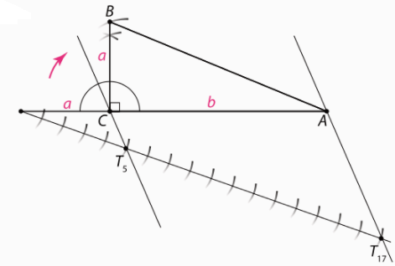
25.

26.
osnovica : krak = 2:3
Dužinu duljine 10.4 treba podijeliti na 2+3+3=8 jednakih dijelova.
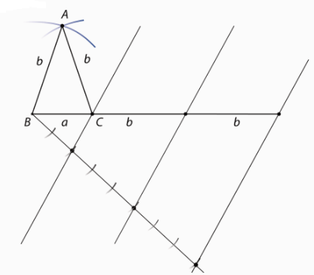
27.
a : b = 1:3
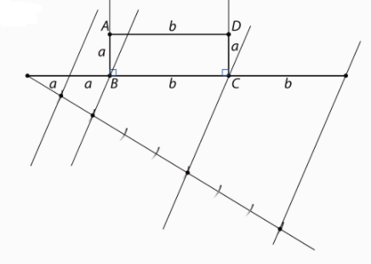

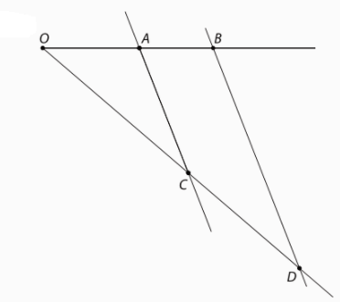
28.
$$a:b=c:d$$
$$4.8 :3.6=9.6 :d$$
$$4.8d=3.6∙9.6$$
$4.8d=34.56$ /:4.8
$d=7.2 cm$

29.
$$a:b=c:d$$
$$6.9 :4.8=c :12$$
$$4.8c=6.9∙12$$
$4.8d=82.5$ /:4.8
$d=17.25 cm$
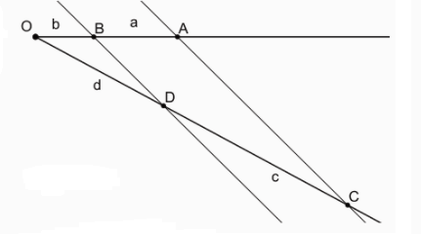

30.
a : e = 4 : 5
$5a=4e$ :/5
$$a=\frac{4}{5}e=6.22 cm$$
a + e=14 cm
$$\frac{4}{5}e+e=14$$
$\frac{9}{5}e=14$/:9/5
$$e=14 :\frac{9}{5}=14∙\frac{5}{9}=7.78 cm$$

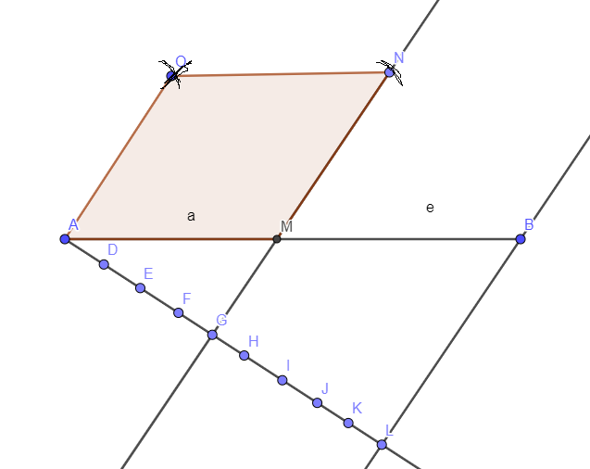

31.
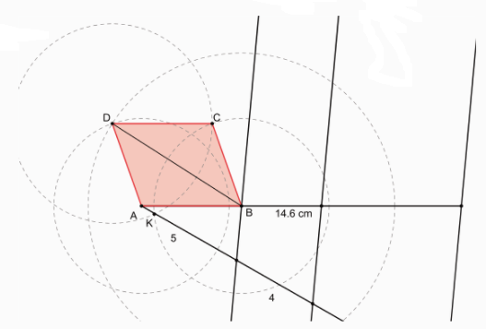

32.
b : a =1.618
a) o = 2m
b=1.618a
2a+2b=o
$$2a+2∙1.618a=o$$
$5.236a=2 m$ /:5,236
$$a=0.382 m=38.2 cm$$
b=1.618a = 0.618 m = 61.8 cm

b) 1 : 10 000
1 cm na karti je 10 000 cm u prirodi, tj. 100 m u prirodi.
2a+2b= 2000 m
$$2a+2∙1.618a=o$$
$5.236a=2000 m$ /:5,236
$$a=382 m$$
b=1.618a = 618 m
$$\frac{1}{100}=\frac{x}{382}$$
$100x=382$ /:100
$x=3.82$ cm

$$\frac{1}{100}=\frac{x}{618}$$
$100x=618$ /:100
$x=6.18$ cm

34.
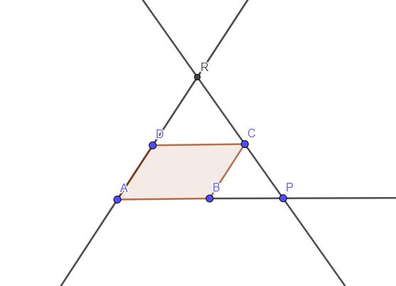

Pravci AP i DC su paralelni, pa možemo primijeniti Talesov poučak o proporcionalnim dužinama.
$$\frac{|DR|}{|AR|}=\frac{|DC|}{|AP|}$$
$$\frac{|DR|}{\left|DR\right|+9}=\frac{15}{21}$$
$$21|DR|=15(\left|DR\right|+9)$$
$$21\left|DR\right|-15\left|DR\right|=135$$
$6\left|DR\right|=135$ /:6
$$\left|DR\right|=22.5 cm$$

35.
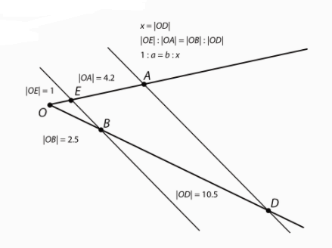
36.
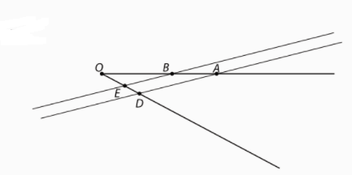

37.
a) h = 5.4 m = 540 cm
540 podijelimo sa 30 da dobijemo broj stuba
540 : 30 = 18
18 stuba, svaka je duga 40 cm, pa slijedi da je
$$d=18∙40=720 cm=7.2 m$$

b) 18 stuba

38.
$$h_{1}=24 m$$
$$h_{2}=36 m$$
$$x :48=h :24$$
24x=48h
$$(48-x) :48=h :36$$
$$48∙36-36x=48h$$
1726 – 36 x =24x
60x = 1726 / : 60
x=28.8 m
h = (24·28.8) : 48
h = 14.4 m

39.
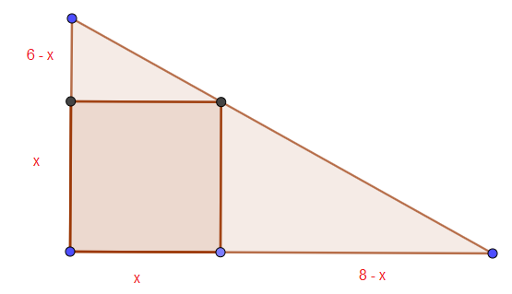
$$\frac{8-x}{x}=\frac{8}{6}$$
$$8x=6(8-x)$$
$$8x=48-6x$$
$$8x+6x=48$$
$$14x=48$$
$x=\frac{48}{14}=\frac{24}{7}$ cm

$P_{k}=x^{2}={\left(\frac{24}{7}\right)}^{2}=\frac{576}{49} cm^{2}$
$$P_{t}=\frac{6∙8}{2}=\frac{48}{2}=24 cm^{2}$$

Razlika $P_{t}-P_{k}=24-\frac{576}{49}=\frac{1176-576}{49}=\frac{600}{49} cm^{2}$
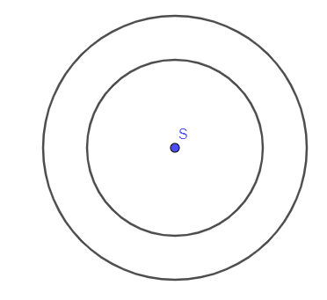
102.

103.
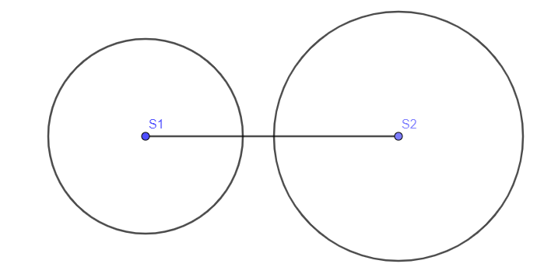

104.
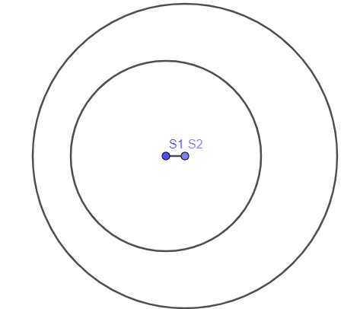
105.
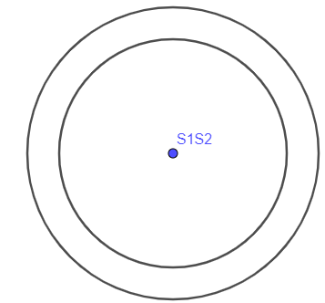

106.
a) $\left|S_{1}S_{2}\right|=3-2=1 cm$
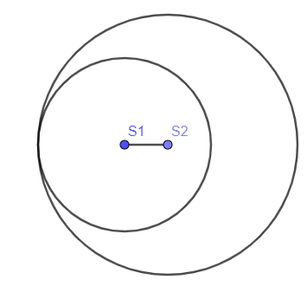
b) $\left|S_{1}S_{2}\right|=3+2=5 cm$
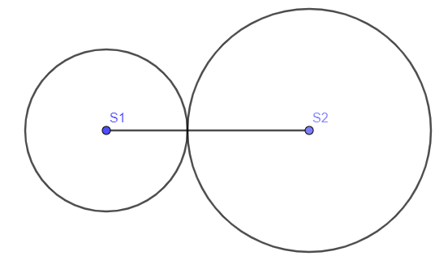
107.
$$\left|S_{1}S_{2}\right|=2.5+3.2=5.7 cm$$

108.
$$\left|S_{1}S_{2}\right|=4+2.5=6.5 cm$$

109.
a)
$$\left|S_{1}S_{2}\right|>3.5-2=1.5 cm$$

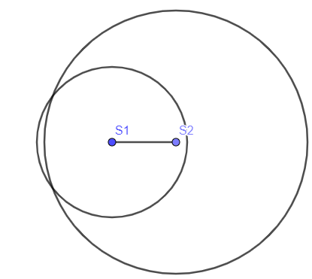
b) $\left|S_{1}S_{2}\right|<3.5+2=5.5 cm$
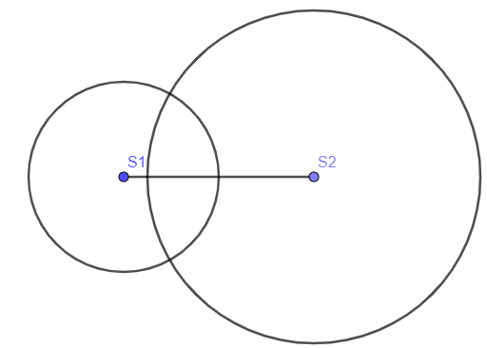

110. $1cm<\left|S_{1}S_{2}\right|<7cm$
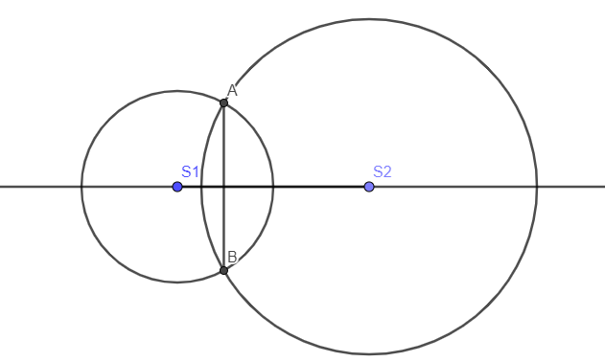
111.
a) $\left|S_{1}S_{2}\right|=4 cm$
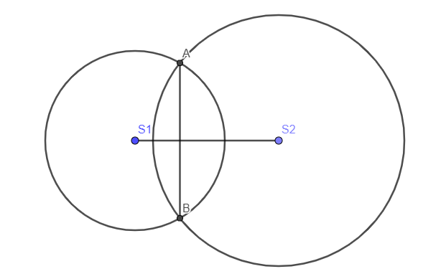
$$3.5-2.5=1 cm<\left|S_{1}S_{2}\right|<3.5+2.5=6 cm$$

b) $\left|S_{1}S_{2}\right|=1.5 cm$
$$3.5-2.5=1 cm<\left|S_{1}S_{2}\right|<3.5+2.5=6 cm$$
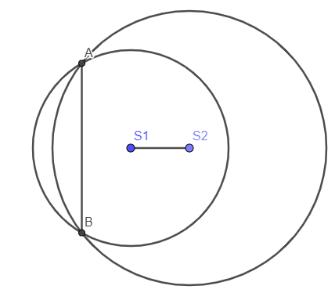
112.
a)

b)

113.
a)

b)

c)

114.
a) sijeku se u dvije točke
b) nemaju zajedničkih točaka
c) imaju 1 zajedničku točku
d) sijeku se u dvije točke
e) imaju jednu zajedničku točku
f) nemaju zajedničkih točaka
g)nemaju zajedničkih točaka

115.
a) izvana dodir $\left|S_{1}S_{2}\right|=5 cm$
iznutra dodir $\left|S_{1}S_{2}\right|=1 cm$

b) sijeku $1cm<\left|S_{1}S_{2}\right|<5 cm$

c) središte manje izvan veće $\left|S_{1}S_{2}\right|>5 cm$
središte manje unutar veće $\left|S_{1}S_{2}\right|<1 cm$

116.
a) dvije
b) jednu
c) jednu
d) nula
e) nijednu
f) nijednu
g) dvije

117.
a) nemaju zajedničkih točaka
b) sijeku se u 2 točke
c) sijeku se u 2 točke
d) dodiruju se izvana
e) nemaju zajedničkih točaka
f) nemaju zajedničkih točaka
g) dodiruju se iznutra

118.
nemaju zajedničkih točaka
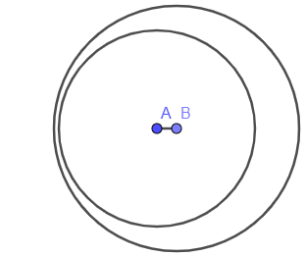

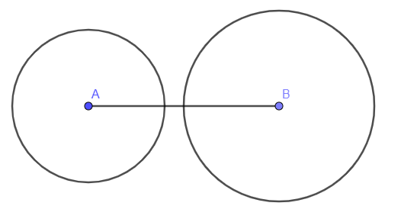

jedna zajednička točka
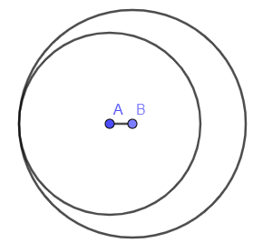
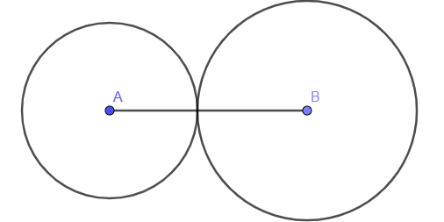
dvije zajedničke točke
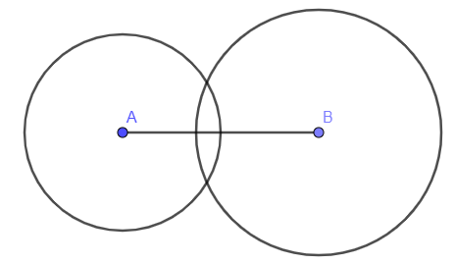

119.
120.
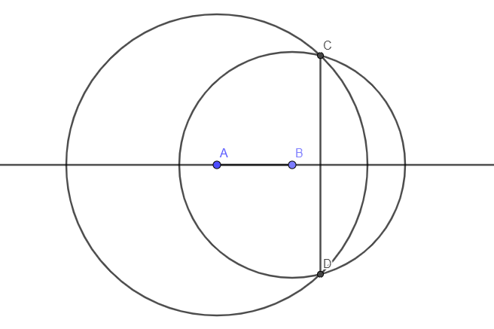
Simetrala tetive je pravac $S_{1}S_{2}$

121.
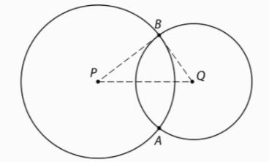
122.
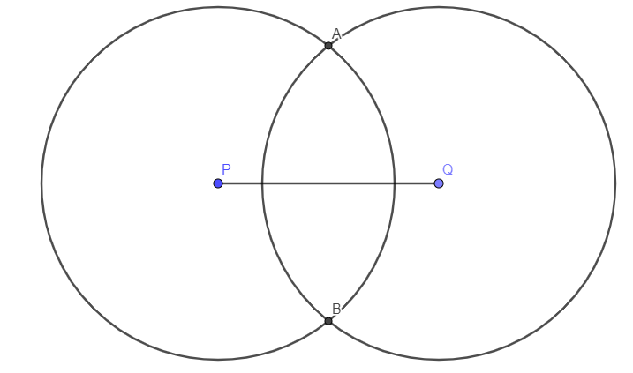
123.
a) r = 1cm
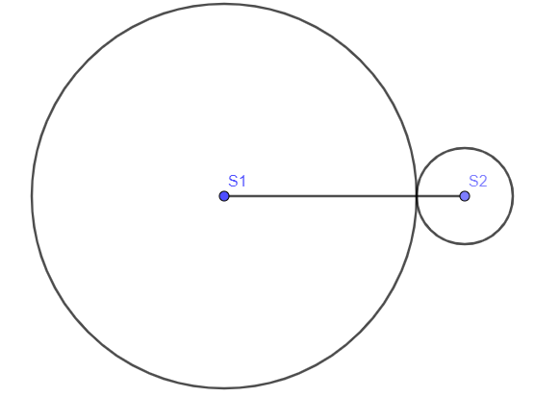
b) r=9 cm
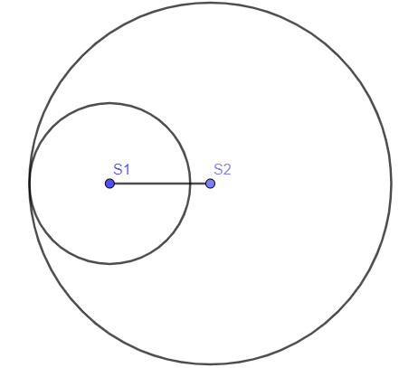
c) r između 1cm i 9 cm
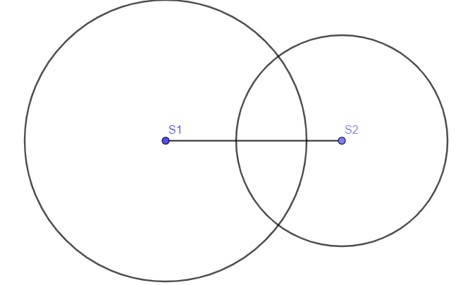
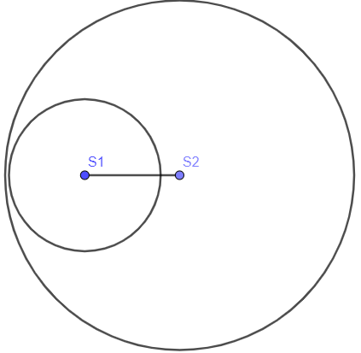
d) r mora biti veći od 9 cm

124.
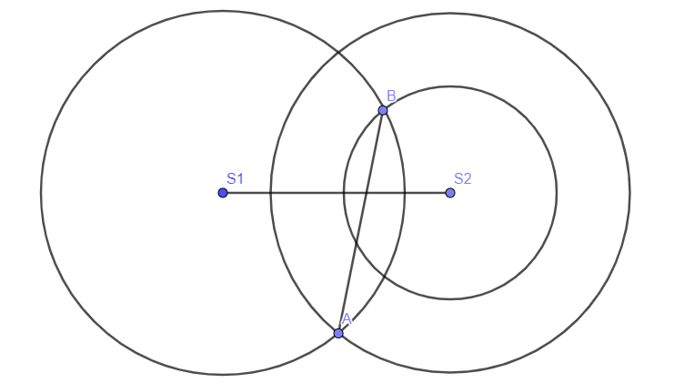
125.
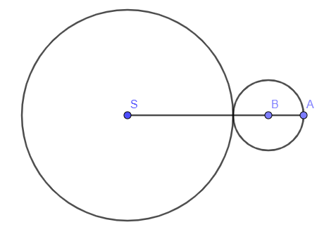
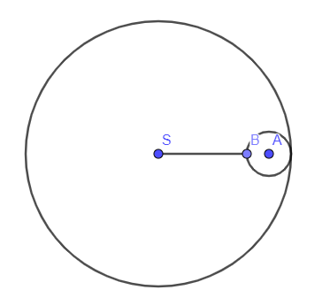
126.

128.
a)

b)
129.
a)

b)

131.
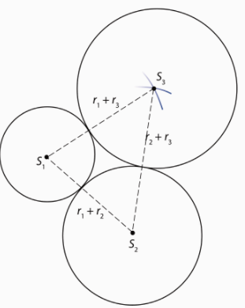
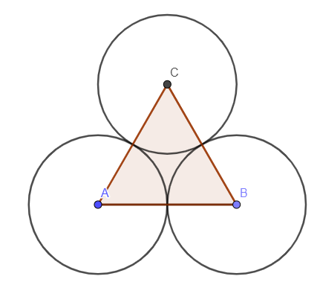
132.

133.
d=2m => r= 1 m =100 cm
$$\frac{1}{100}=\frac{r_{1}}{100}$$
$$r_{1}=1 cm$$
d=3m => r= 1.5 m =150 cm
$$\frac{1}{100}=\frac{r_{2}}{150}$$
$$r_{2}=1.5 cm$$
d=4m => r= 2 m =200 cm
$$\frac{1}{100}=\frac{r_{3}}{200}$$
$$r_{3}=2 cm$$

134.
a) translacija ΔSDE za vektor $\vec{BS}$
b) translacija romba ABCS za vektor $\vec{FA}$

135.
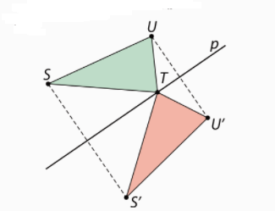
136.
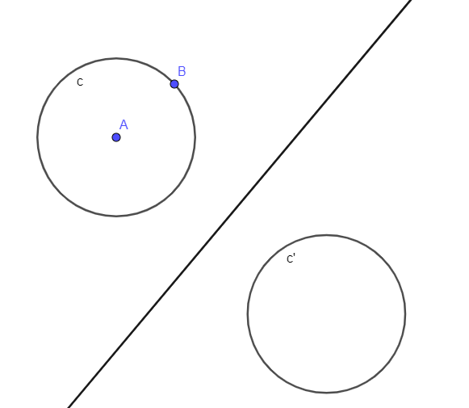

b)
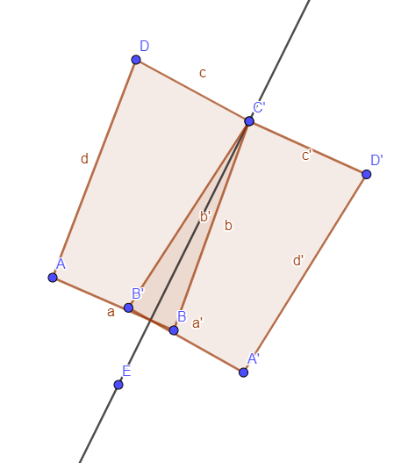
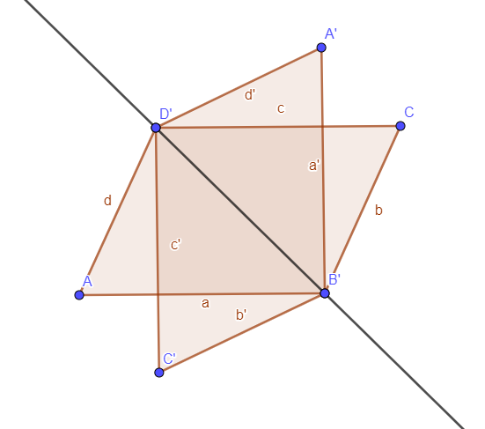
137.

138.
Je, os simetrije je simetrala kuta.
139.
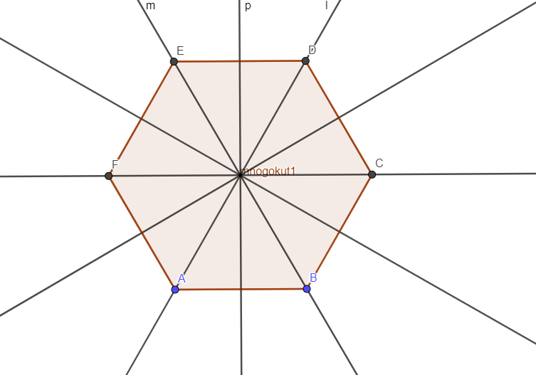
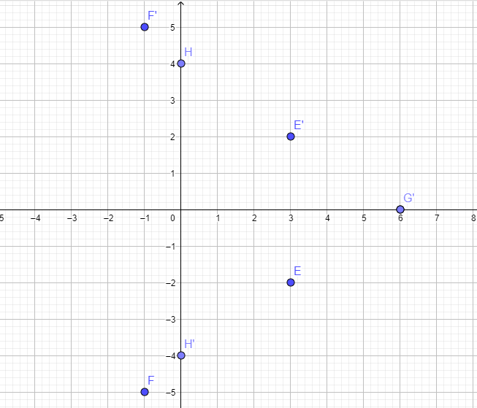
140. a)

b)
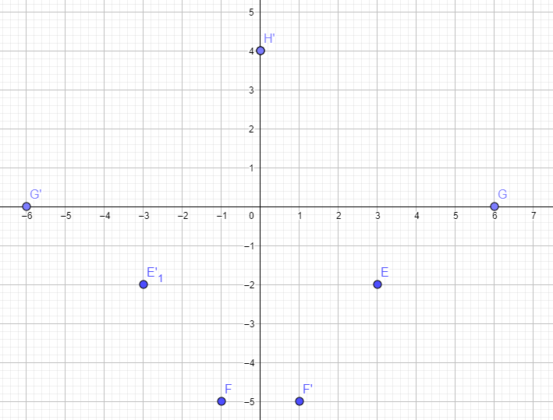
141.
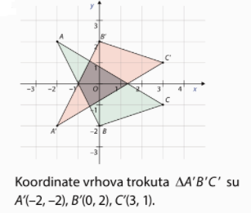

142.
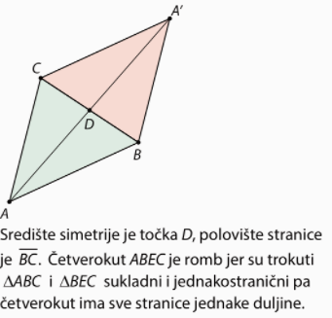
143.
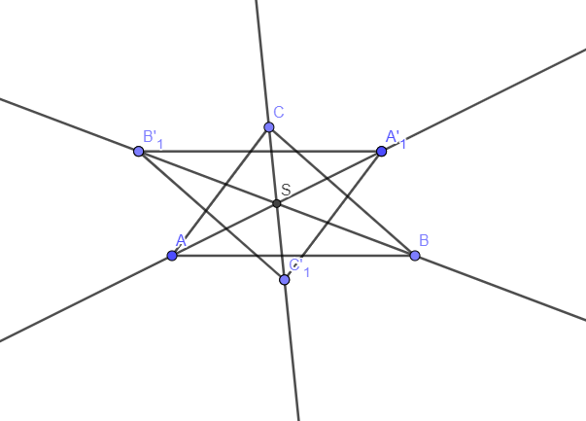

144.
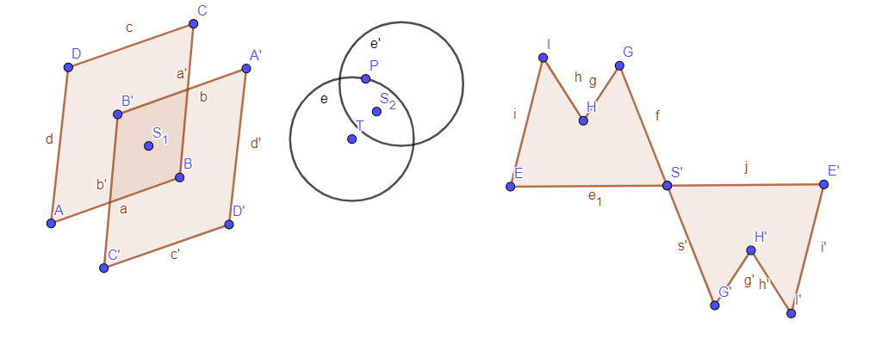
145.
a)
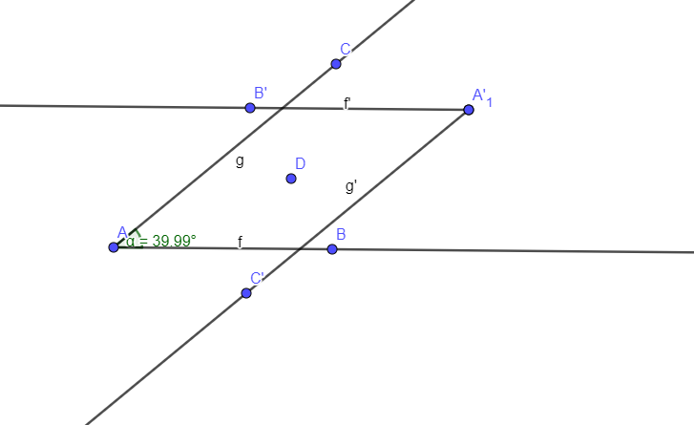
b)
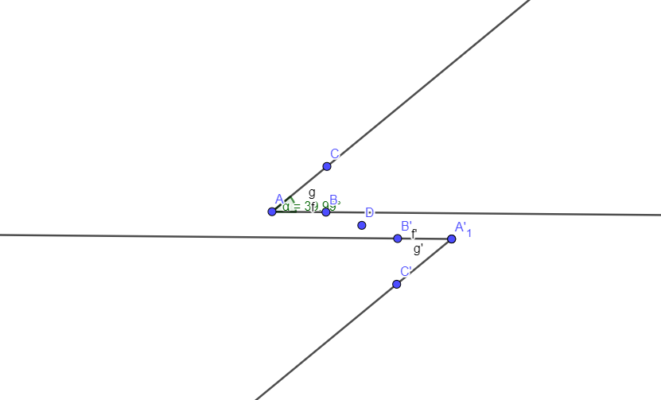
c)
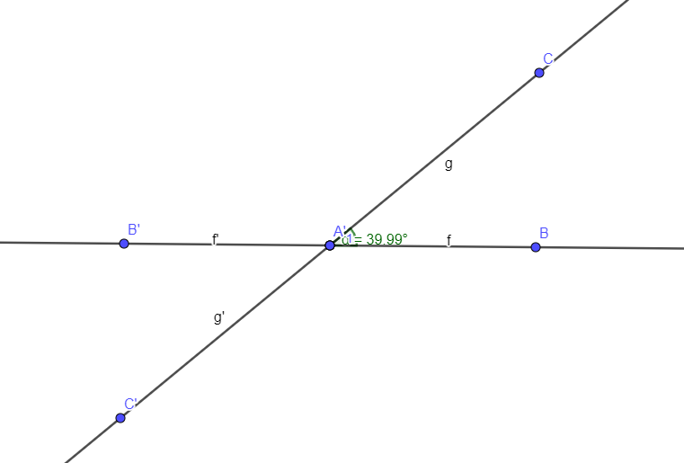
146.
a) III. kvadrant
b) IV. kvadrant
c) I. kvadrant
d) II. kvadrant

147.
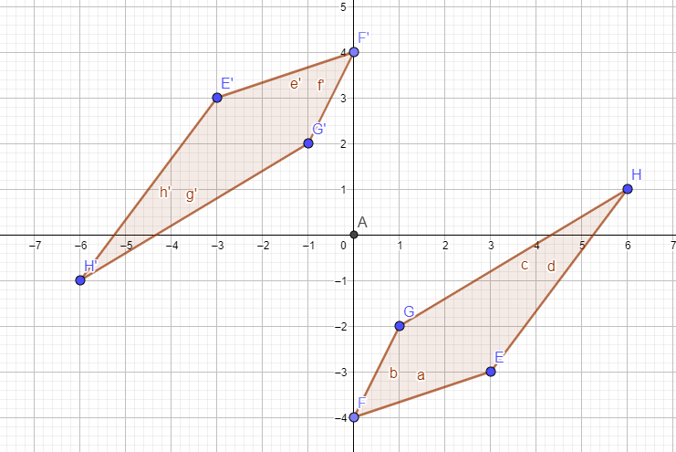

148.
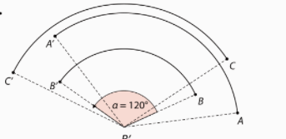
149.
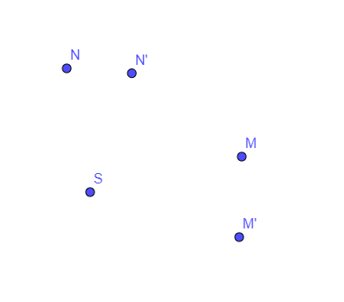
150.
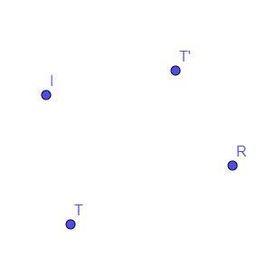
151.
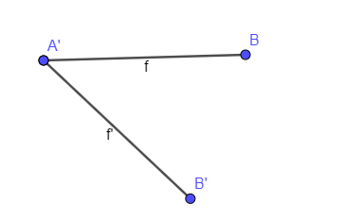
152.
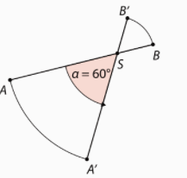
153.
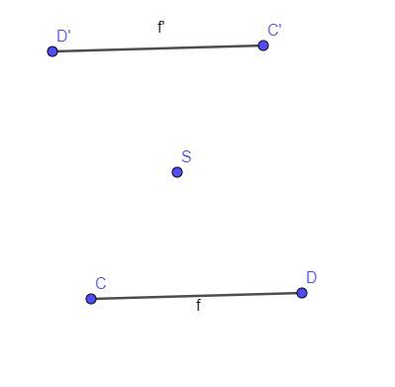

154.
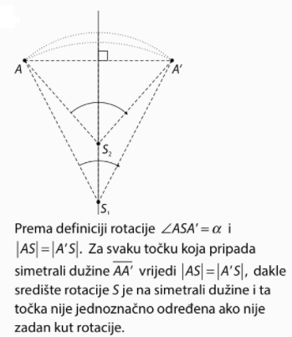
155.
a) ne
b) ne

156.
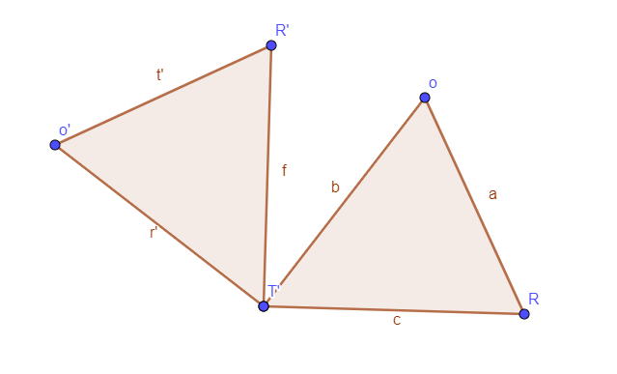

157.
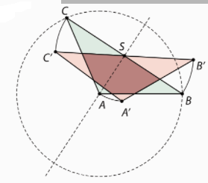
158.
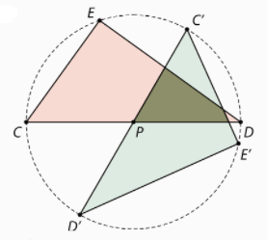
159.
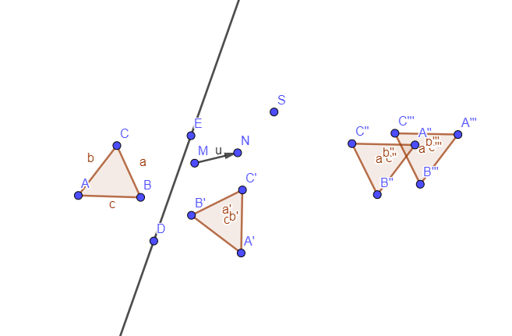
160.
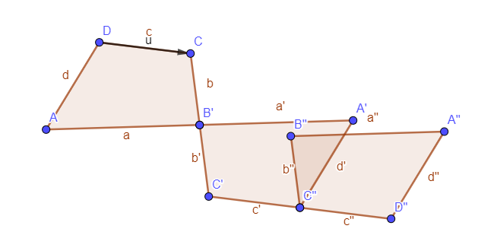
161.
a)
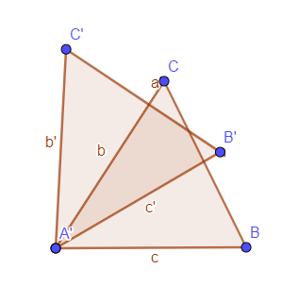
b)
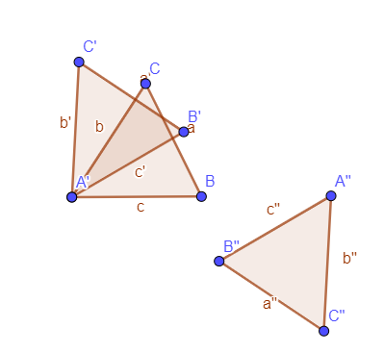

c)
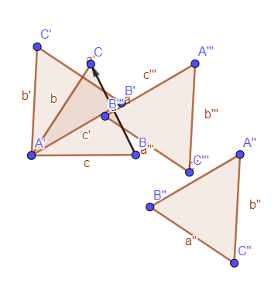
162.
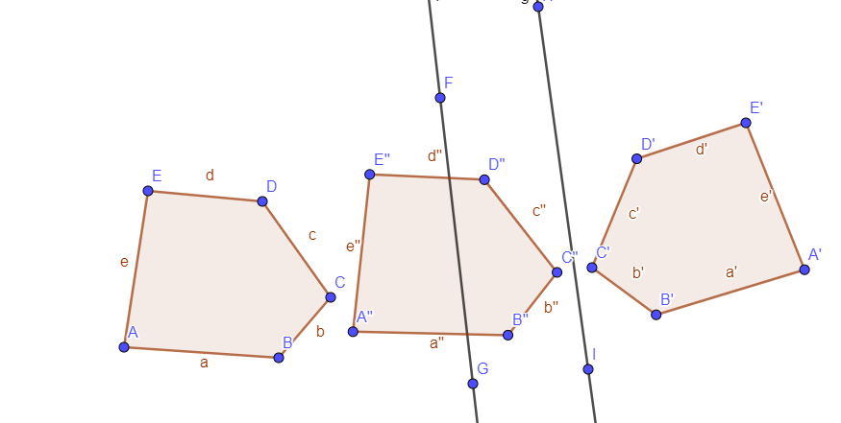
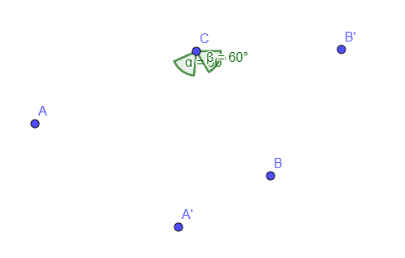
165.

166.
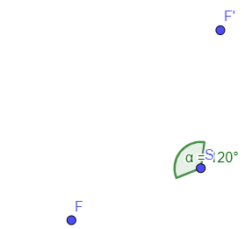
167.
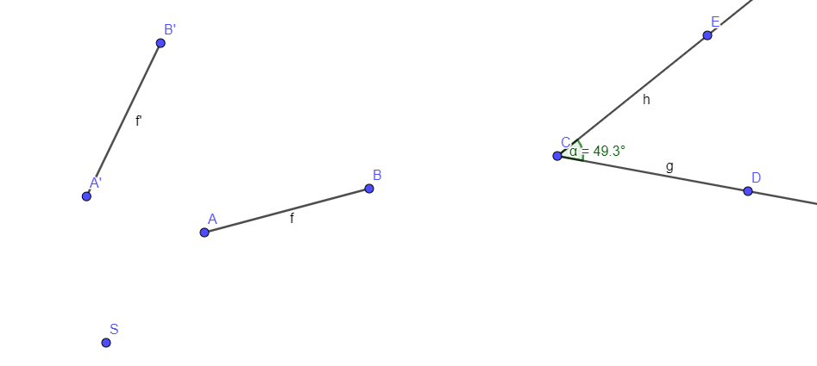
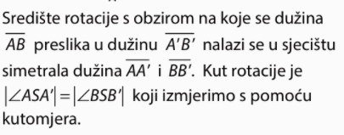
168.
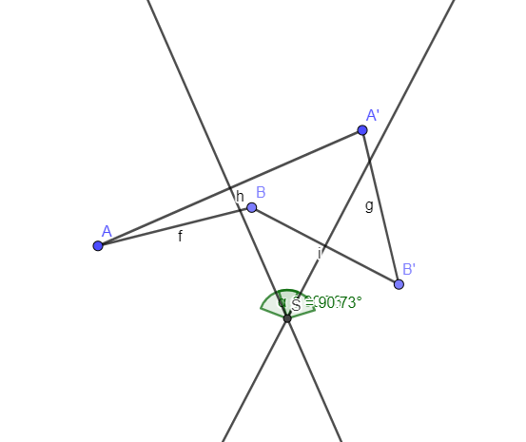

169.
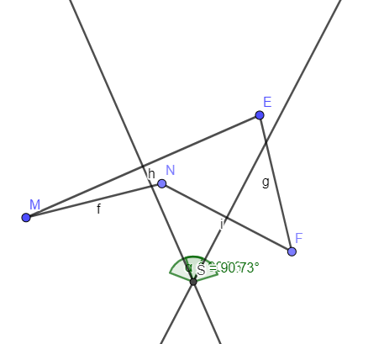
170.
a) translacija za vektor $\vec{SB}$
rotacija oko točke S za kut -60°
b) translacija za vektor $\vec{AF}$
centralna simetrija s obzirom na točku S

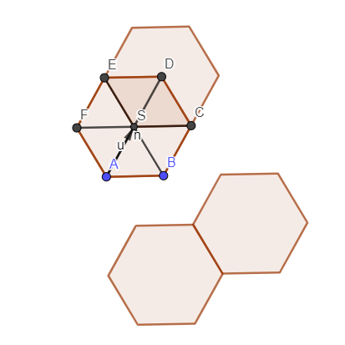
171.

172.
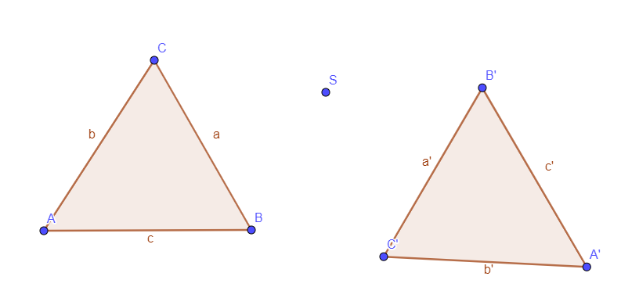
173.
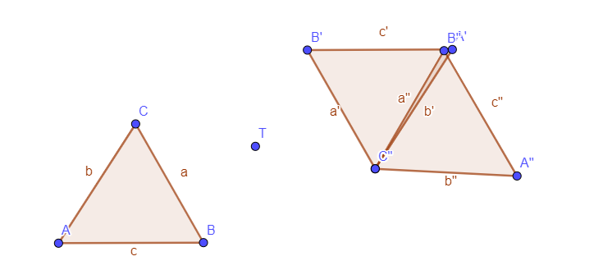
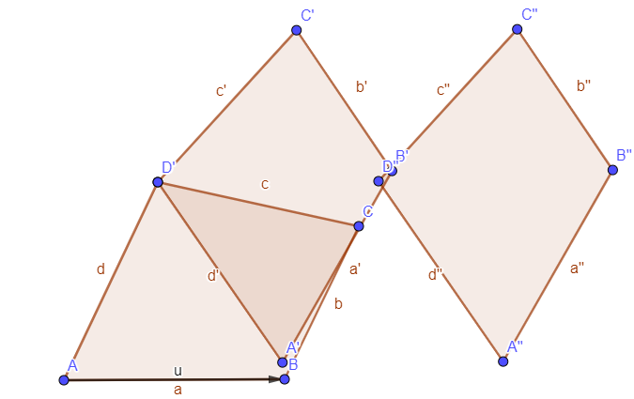
174.

175.
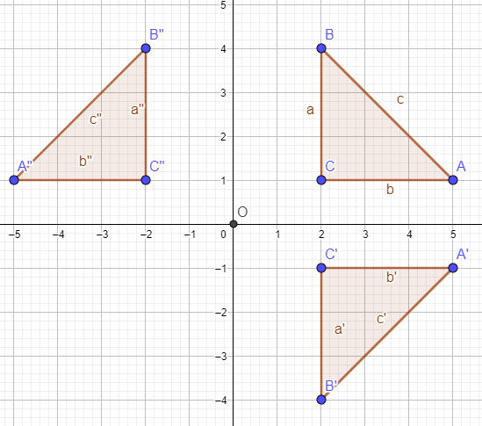
176.
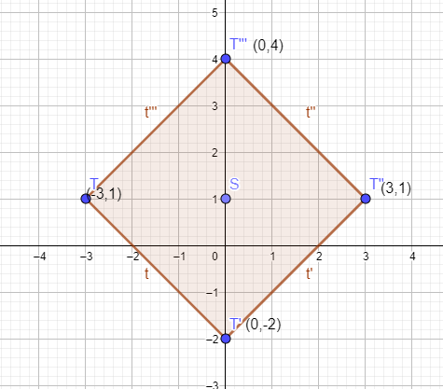
Dobiveni četverokut je kvadrat.

180.
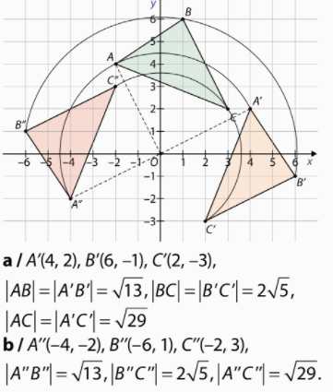
181.

182. a)
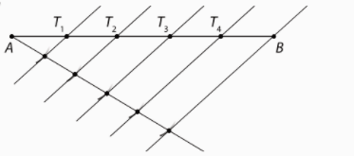
b)
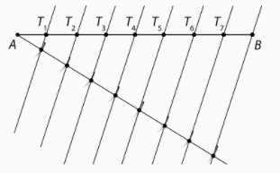
183. a)
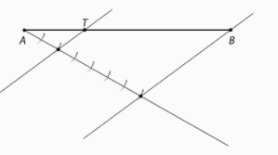
b)
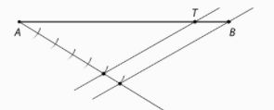

184.
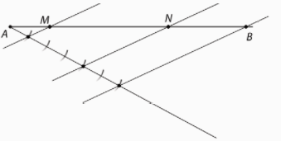
185.
a) $\frac{\left|AB\right|}{\left|CD\right|}=\frac{9}{13.5}=\frac{\frac{\frac{9}{1}}{27}}{2}=\frac{2}{3}$
b) $\frac{\left|CD\right|}{\left|AB\right|}=\frac{13.5}{9}=\frac{\frac{\frac{27}{2}}{9}}{1}=\frac{3}{2}$

186.
a) $\frac{\left|AD\right|}{\left|AE\right|}=\frac{|AB|}{|AC|}$
$\frac{3}{8}=\frac{9}{|AC|}$
$3\left|AC\right|=72$ /:3
$\left|AC\right|=24$ cm

b) $\frac{\left|AD\right|}{\left|AE\right|}=\frac{|AB|}{|AC|}$
$\frac{8}{12}=\frac{12}{|AC|}$
$8\left|AC\right|=144$ /:8
$\left|AC\right|=18$ cm
$\left|CE\right|=\left|AC\right|-\left|AE\right|=18-12=6 cm$

187.
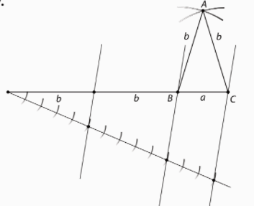
188.
$$a=8 cm, b=12 cm, c=10 cm$$
a) najkraća 12 cm
$$\frac{a}{a^{'}}=\frac{8}{12}=\frac{2}{3}$$
$$\frac{12}{b^{'}}=\frac{2}{3}$$
$$b^{'}=36:2=18 cm$$

$$\frac{10}{c^{'}}=\frac{2}{3}$$
$$c^{'}=30:2=15 cm$$

b) najdulja 36 cm
$$\frac{b}{c^{'}}=\frac{12}{36}=\frac{1}{3}$$
$$\frac{8}{a^{'}}=\frac{1}{3}$$
$a^{'}=8∙3=24 cm$
$$\frac{10}{c^{'}}=\frac{1}{3}$$
$$c^{'}=3∙10=30 cm$$

189.
a) $o=p+q+r=9+16+20=45 cm$
$\frac{o}{o^{'}}=\frac{45}{30}=\frac{3}{2}$
$\frac{9}{p^{'}}=\frac{3}{2}$
$p^{'}=18:3=6 cm$
$\frac{16}{q^{'}}=\frac{3}{2}$
$q^{'}=32:3=10\frac{2}{3} cm$
$\frac{20}{r^{'}}=\frac{3}{2}$
$r^{'}=40:3=13\frac{1}{3} cm$

b) $o=p+q+r=9+16+20=45 cm$
$\frac{o}{o^{'}}=\frac{45}{135}=\frac{1}{3}$
$\frac{9}{p^{'}}=\frac{1}{3}$
$p^{'}=27 cm$
$\frac{16}{q^{'}}=\frac{1}{3}$
$q^{'}=48 cm$
$\frac{20}{r^{'}}=\frac{1}{3}$
$r^{'}=60 cm$

190.
$∆CIG, ∆ICH,∆AIH, ∆BIG,∆ACI$

191.
Stavljamo u omjer odgovarajuće stranice u danim trokutima.
$\frac{11}{44}=\frac{9}{36}=\frac{13}{52}=\frac{1}{4}=k$
Trokuti su slični.

192. Jesu jer su odgovarajući kutovi jednake veličine.
$\frac{5}{2}=\frac{x}{6}$
$2x=30$ /:2
$x=15$

193.
Jesu jer su kutovi uz presječnicu usporednih pravaca jednake veličine, a kut pri vrhu A je zajednički.

194.
a) Jesu jer su kutovi uz presječnicu usporednih pravaca jednake veličine, a kut pri vrhu A je zajednički.
$\frac{3}{7}=\frac{4.5}{4.5+x}$
$13.5+3x=31.5$
$3x=31.5-13.5$
$x=6 cm$

b) $\frac{3.5}{7.5}=\frac{5.25}{5.25+x}$
$18.375+3.5x=39.375$
$3.5x=39.375-18.375$
$x=6 cm$

195.
a) $\frac{100}{20}=\frac{80}{x}$
$100x=1600$ /:100
$x=16$

b) $\frac{24}{x}=\frac{20}{8}$
$20x=192$ /:20
$x=9.6$

196.
$\frac{258}{232.2}=\frac{248}{|GF|}$
$258|GF|=232.2∙248$ /:258
$|GF|=223.2 m$

197.
$\frac{8.4}{2.8}=\frac{6}{h}$
$8.4h=6∙2.8$ /:8.4
$h=2 m$
Ljestve mogu dosegnuti visinu 2 m.

198.
$\frac{x}{6.7}=\frac{51.5}{9.4}$
$9.4h=6.7∙51.5$ /:9.4
$h≈36.71 m$
Visina zgrade je približno 36.71 m.

199.
$\frac{x}{3}=\frac{240}{12}$
$12h=240∙3$ /:12
$h=60m$
Visina zgrade je 60 m.

201.
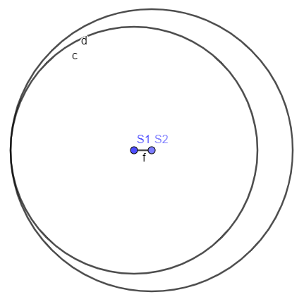
202.

Dodiruju se iznutra.
203.
a)
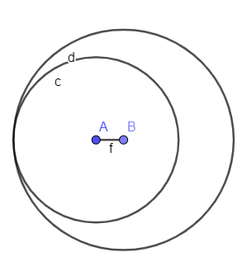
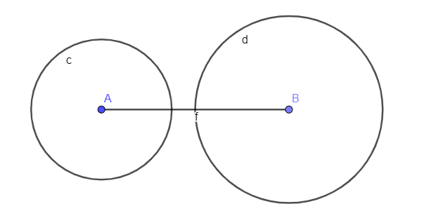
b)

c)
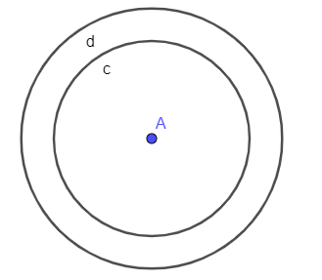

d)
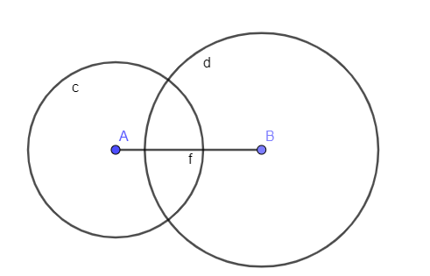
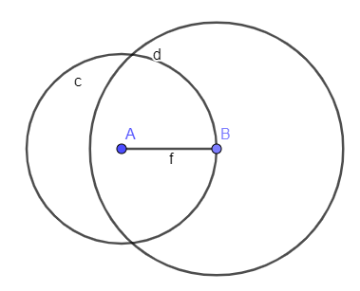
e)

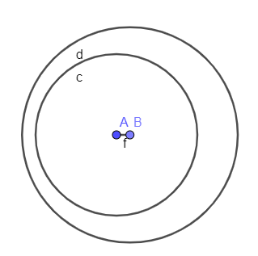

f)

Priprema za ispit znanja
1.
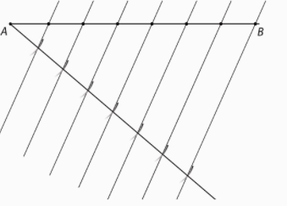
2.
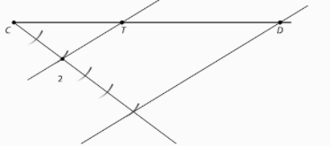
2k + 3 k = 5k
5k=9.9 cm /:5
k=1.98
|CT|=2·1.98 cm = 3.96 cm
|TD|=3·1.98 cm = 5.94 cm

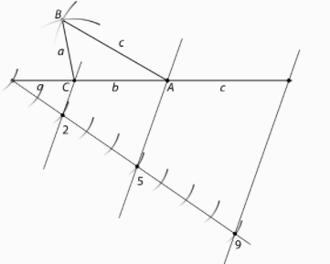
3.

4.
$\frac{c}{c^{'}}=\frac{3.6}{9.6}=0.375$
$\frac{4.2}{a^{'}}=0.375$
$0.375a'=4.2$ /:0.375
$a^{'}=11.2cm$
$\frac{b}{14.4}=0.375$
$b=0.375∙14.4=5.4 cm$
$o=a+b+c=4.2+5.4+3.6=13.2 cm$
$o'=a'+b'+c'=11.2+14.4+9.6=35.2 cm$

5.
$\frac{2.5}{4}=\frac{4}{4+x}$
$10+2.5x=16$ /:2.5
$2.5x=16-10$
$2.5x=6$ /:2.5
$x=0.96$cm

6.
$\frac{0.7}{1.2}=\frac{x}{3}$
$1.2x=0.7∙3$
$x=1.75$m
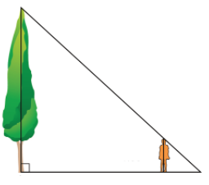
7.
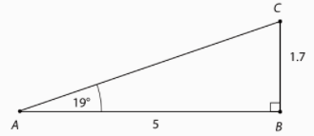
$\frac{50}{5}=\frac{h}{1.7}$
$5h=1.7∙50$
$h=17$m

8.
$r_{2}=\left|S_{1}S_{2}\right|+r_{1}=5 cm+3 cm=8 cm$
Radijus druge kružnice mora biti 8 cm.

1.
3x – 5y = 13 (1 , - 2)
$$3∙1-5∙\left(-2\right)=13$$
$$3+10=13$$
$$13=13$$

7x + y = 12 (3 , - 9)
$$7∙3-9=12$$
$$21-9=12$$
$$12=12$$

-2x – 6y =- 18 (-3 , 4)
$$-2∙\left(-3\right)-6∙4=-18$$
$$6-24=-18$$
$$-18=-18$$

-8x +9y = -2 (7, 6)
$$-8∙7+9∙6=-2$$
$$-56+54=2$$
$$2=2$$

2. a) $-4x+9y=1$
$3x-y=5$
$$-4∙8+9∙\frac{3}{2}=1$$
$-32+\frac{27}{2}=1$
$-18.5≠1$ Nije rješenje sustava.
b) $-5x+10y=-25$
$3x-6y=15$
$$-5∙8+10∙\frac{3}{2}=-25$$
$$-40+15=-25$$
$$-25=-25$$

$$3∙8-6∙\frac{3}{2}=15$$
$$24-9=15$$
$$15=15$$
Uređeni par je rješenje sustava.

3.a) $2x-y=3$
$-6x+3y=-9$
$$2∙\left(-0.5\right)-(-4)=3$$
$$-1+4=3$$
$$3=3$$

$$-6∙\left(-0.5\right)+3∙\left(-4\right)=-9$$
$$3-12=-9$$
$$-9=-9$$
Uređeni par je rješenje sustava.

b) $- 5x+7y=-20$
$4x-2y=6$
$$-5∙\left(-0.5\right)+7∙\left(-4\right)=-20$$
$$2.5-28=-20$$
$$-25.5≠-20$$
Uređeni par nije rješenje sustava.

4. a) 12x – 5y = 8
$$12∙x-5∙(-1.2)=8$$
$$12x+6=8$$
$$12x=8-6$$
$12x=2$ /:12
$x=\frac{1}{6}$

b) 12x – 5y = 8
$$12∙\frac{3}{8}-5∙y=8$$
$$\frac{9}{2}-5y=8$$
$-5y=8-\frac{9}{2}$
$-5x=\frac{7}{2}$ /: (-5)
$$x=\frac{-7}{10}=-0.7$$

5. a) 2x – y = 7
(1, -5)
(2, -3)
(3,-1)

b) x+4y=6
(2,1)
(-2,2)
(6,0)

c) 3x – 2y =1
(1,1)
(3,4)
(5, 7)

d) 4x – 5y = -2
(2,2)
(-3, -2)
($-\frac{1}{2},$ 0)

6.
a) $3x+y=-4$ $y=-3x-4$
$8x+5y=1$
$$8x+5\left(-3x-4\right)=1$$
$$8x-15x-20=1$$
$$-7x=1+20$$
$-7x=21$ /: (-7)
$$x=-3$$
$$y=-3x-4$$
$$y=-3∙\left(-3\right)-4$$
$$y=9-4$$
$y=5$
provjera
$$3∙(-3)+5=-4$$
$$-9+5=-4$$
$$-4=-4$$
$$8∙(-3)+5∙5=1$$
$$-24+25=1$$
$$1=1$$

Rješenje sustava je (-3,5).

b) $x+2y=-6$ $x=-2y-6$
$4x+3y=1$
$$4(-2y-6)+3y=1$$
$$-8y-24+3y=1$$
$$-5y=1+24$$
$-5y=25$ /: (-5)
$$y=-5$$
$$x=-2y-6$$
$$x=-2∙\left(-5\right)-6$$
$$x=10-6$$
$x=4$
provjera
$$4+2∙(-5)=-6$$
$$4-10=-6$$
$$-6=-6$$
$$4∙4+3∙(-5)=1$$
$$16-15=1$$
$$1=1$$

Rješenje sustava je (4,-5).

c) $2x-5y=-3$
$x+3y=15 x=-3y+15$
$$2\left(-3y+15\right)-5y=-3$$
$$-6y+30-5y=-3$$
$$-11y=-3-30$$
$-11y=-33$ /: (-11)
$$y=3$$
$$x=-3y+15$$
$$x=-3∙3+15$$
$$x=-9+15$$
$x=6$
provjera
$$2∙\left(6\right)-5∙3=-3$$
$$12-15=-3$$
$$-3=-3$$
$$6+3∙3=15$$
$$15=15$$

Rješenje sustava je (6,3).

d) $3x-2y=-8$
$x+y=-11 y=-x-11$
$$3x-2\left(-x-11\right)=-8$$
$$3x+2x+22=-8$$
$$5x=-8-22$$
$5x=-30$ /:5
$$x=-6$$
$$y=-x-11$$
$$y=-(-6)-11$$
$$y=6-11$$
$y=-5$
provjera
$$3∙\left(-6\right)-2∙(-5)=-8$$
$$-18+10=-8$$
$$-8=-8$$
$$-6-5=-11$$
$$-11=-11$$

Rješenje sustava je (-6,-5).

e) $-7x-9y=1$
$x+y=1 y=-x+1$
$$-7x-9\left(-x+1\right)=1$$
$$-7x+9x-9=1$$
$$2x=1+9$$
$2x=10$ /:2
$$x=5$$
$$y=-x+1$$
$$y=-5+1$$
$$y=-4$$

provjera
$$-7∙5-9∙(-4)=1$$
$$-35+36=1$$
$$1=1$$
$$5+(-4)=1$$
$$1=1$$

Rješenje sustava je (5,-4).

f) $-2x+y=14$
$x-9y=10 x=9y+10$
$$-2\left(9y+10\right)+y=14$$
$$-18y-20+y=14$$
$$-17y=14+20$$
$-17y=34$ /: (-17)
$$y=-2$$
$$x=9y+10$$
$$x=9∙\left(-2\right)+10$$
$$x=-18+10$$
$x=-8$
provjera
$$-2∙\left(-8\right)+(-2)=14$$
$$16-2=14$$
$$14=14$$
$$-8-9∙(-2)=10$$
$$10=10$$

Rješenje sustava je (-8,-2).

g) $x+4y=8$
$3x+y=-9 y=-3x-9$
$$x+4\left(-3x-9\right)=8$$
$$x-12x-36=-9$$
$$-11x=8+36$$
$-11x=44$ /: (-11)
$$x=-4$$
$$y=-3x-9$$
$$y=-3(-4)-9$$
$$y=12-9$$
$y=3$
provjera
$$-4+4∙3=8$$
$$-4+12=8$$
$$8=8$$
$$3∙\left(-4\right)+3=-9$$
$$-9=-9$$
Rješenje sustava je (-4,3).

h) $x+y=-10$ $x=-y-10$
$-2x+6y=4$
$$-2(-y-10)+6y=4$$
$$2y+20+6y=4$$
$$8y=4-20$$
$8y=-16$ /: 8
$$y=-2$$
$$x=-y-10$$
$$x=-\left(-2\right)-10$$
$$x=2-10$$
$x=-8$
provjera
$$-8-2=-10$$
$$-10=-10$$
$$-2∙(-8)+6∙(-2)=4$$
$$16-12=4$$
$$4=4$$

Rješenje sustava je (-8,-2).
7. a) $3x-y=7$ $y=3x-7$
$2x+3y=1$
$$2x+3(3x-7)=1$$
$$2x+9x-21=1$$
$$11x=1+21$$
$11x=22$ /: 11
$$x=2$$
$$y=3x-7$$
$$y=3∙2-7$$
$$y=6-7$$
$y=-1$

Rješenje sustava je (2,-1).

b) $-x-8y=6$ $x=-8y-6$
$5x+4y=6$
$$5\left(-8y-6\right)+4y=6$$
$$-40y-30+4y=6$$
$$-36y=6+30$$
$-36y=36$ /: (-36)
$$y=-1$$
$$x=-8y-6$$
$$x=-8∙(-1)-6$$
$$y=8-6$$
$y=2$

Rješenje sustava je (2,-1).
c) $2x+5y=-1$
$-x+6y=-8$ $x=6y+8$
$$2\left(6y+8\right)+5y=-1$$
$$12y+16+5y=-1$$
$$17y=-1-16$$
$17y=-17$ /: 17
$$y=-1$$
$$x=6y+8$$
$$x=6∙\left(-1\right)+8$$
$$x=-6+8$$
$x=2$

Rješenje sustava je (2,-1).

d) $3x+9y=-3$
$7x-y=15$ $y=7x-15$
$$3x+9\left(7x-15\right)=-3$$
$$3x+63x-135=-3$$
$$66x=-3+135$$
$66x=132$ /: 66
$$x=2$$
$$y=7x-15$$
$$y=7∙2-15$$
$$y=14-15$$
$y=-1$

Rješenje sustava je (2,-1).
8. a) $2x+4y=2$ $2x=-4y+2$ /:2 $x=-2y+1$
$8x+5y=-3$
$$8\left(-2y+1\right)+5y=-3$$
$$-16y+8+5y=-3$$
$$-11y=-3-8$$
$-11y=-11$ /: -11
$$y=1$$
$$x=-2∙1+1$$
$$x=-2+1$$
$$x=-1$$

Rješenje sustava je (-1,1).

b) $3x+2y=0$ $2y=-3x$ /:2 $y=-\frac{3}{2}x$
$5x+3y=1$
$5x+3∙\left(-\frac{3}{2}x\right)=1$
$$5x-4.5x=1$$
$0.5x=1$ /:0.5
$$x=2$$
$$y=-\frac{3}{2}∙2$$
$$y=-3$$

Rješenje sustava je (2,-3).

c) $4x-2y=8$ $-2y=-4x+8$ /: -2 $y=2x-4$
$2x+5y=16$
$$2x+5\left(2x-4\right)=16$$
$$2x+10x-20=16$$
$$12x=16+20$$
$12x=36$ /: 12
$$x=3$$
$$y=2∙3-4$$
$$y=6-4$$
$$y=2$$

Rješenje sustava je (3,2).

d) $-9x-7y=-5$
$3x-6y=-15 3x=6y-15 x=2y-5$
$$-9\left(2y-5\right)-7y=-5$$
$$-18y+45-7y=-5$$
$$-25y=-5-45$$
$-25y=-50$ /: -25
$$y=2$$
$$x=2∙2-5$$
$$x=4-5$$
$$x=-1$$

Rješenje sustava je (-1,2).

9. a) $3x+y=2$ $y=-3x+2$
$4x-3y=-6$
$$4x-3\left(-3x+2\right)=-6$$
$$4x+9x-6=-6$$
$$13x=-6+6$$
$13x=0$ /: 13
$$x=0$$
$$y=-3∙0+2$$
$$y=0+2$$
$$y=2$$

Rješenje sustava je (0,2).

b) $3x-7y=2$
$x+2y=5$ $x=-2y+5$
$$3\left(-2y+5\right)-7y=2$$
$$-6y+15-7y=2$$
$$-13y=2-15$$
$-13y=-13$ /: -13
$$y=1$$
$$x=-2∙1+5$$
$$x=-2+5$$
$$x=3$$

Rješenje sustava je (3,1).

c) $x+6y=5$ $x=-6y+5$
$7x+3y=-4$
$$7\left(-6y+5\right)+3y=-4$$
$$-42y+35+3y=-4$$
$$-39y=-4-35$$
$-39y=-39$ /: -39
$$y=1$$
$$x=-6∙1+5$$
$$x=-6+5$$
$$x=-1$$

Rješenje sustava je (-1,1).

d) $2x-4y=22$
$3x+y=12$ $y=-3x+12$
$$2x-4\left(-3x+12\right)=22$$
$$2x+12x-48=22$$
$$14x=22+48$$
$14x=70$ /: 14
$$x=5$$
$$y=-3∙5+12$$
$$y=-15+12$$
$$y=-3$$

Rješenje sustava je (5,-3).

e) $2x+8y=-6$
$x-y=7$ $x=y+7$
$$2\left(y+7\right)+8y=-6$$
$$2y+14+8y=-6$$
$$10y=-6-14$$
$10y=-20$ /: 10
$$y=-2$$
$$x=-2+7$$
$$x=5$$
Rješenje sustava je (5,-2).

f) $x+y=-7$
$x-2y=2$ $x=2y+2$
$$2y+2+y=-7$$
$$3y=-7-2$$
$3y=-9$ /: 3
$$y=-3$$
$$x=2∙(-3)+2$$
$$x=-6+2$$
$$x=-4$$

Rješenje sustava je (-4,-3).

g) $x+y=1$
$x-y=5$ $x=y+5$
$$y+5+y=1$$
$2y=-4$ /:2
$$y=-2$$
$$x=-2+5$$
$$x=3$$

Rješenje sustava je (3,-2).

h) $2x-5y=31$
$x+5y=-7$ $x=-5y-7$
$$2\left(-5y-7\right)-5y=31$$
$$-10y-14-5y=31$$
$$-15y=31+14$$
$-15y=45$ /: -15
$$y=-3$$
$$x=-5∙\left(-3\right)-7$$
$$x=15-7$$
$$x=8$$

Rješenje sustava je (8,-3).

10. a) $4x+2y=-2$
$2x-y=-11$ $y=2x+11$
$$4x+2\left(2x+11\right)=-2$$
$$4x+4x+22=-2$$
$$8x=-2-22$$
$8x=-24$ /: 8
$$x=-3$$
$$y=2∙(-3)+11$$
$$y=-6+11$$
$$y=5$$
Rješenje sustava je (-3,5).
b) $5x-8y=-9$
$-x+4y=9$ $x=4y-9$
$$5\left(4y-9\right)-8y=-9$$
$$20y-45-8y=-9$$
$$14y=-9+45$$
$12y=36$ /: 12
$$y=3$$
$$x=4∙\left(3\right)-9$$
$$x=12-9$$
$$x=3$$
Rješenje sustava je (3,3).

c) $-x-y=0$ $x=-y$
$2x+3y=-5$
$$2\left(-y\right)+3y=-5$$
$$-2y+3y=-5$$
$$y=-5$$
$$x=-(-5)$$
$$x=5$$
Rješenje sustava je (5,-5).

d) $3x+7y=-6$
$3x-y=18$ $y=3x-18$
$$3x+7\left(3x-18\right)=-6$$
$$3x+21x-126=-6$$
$$24x=-6+126$$
$24x=120$ /: 24
$$x=5$$
$$y=3∙5-18$$
$$y=15-18$$
$$y=-3$$
Rješenje sustava je (5,-3).

e) $-x-2y=-5$ $x=-2y+5$
$-2x+4y=30$
$$-2\left(-2y+5\right)+4y=30$$
$$4y-10+4y=30$$
$$8y=40$$
$$y=5$$
$$x=-2∙5+5$$
$$x=-5$$
Rješenje sustava je (-5,5).

f) $3x-6y=9$ 3$x=6y+9$ / : 3 $x=2y+3$
$2x+4y=-18$
$$2\left(2y+3\right)+4y=-18$$
$$4y+6+4y=-18$$
$$8y=-24$$
$$y=-3$$
$$x=2∙(-3)+3$$
$$x=-3$$
Rješenje sustava je (-3,-3).

g) $2x-2y=-16$ 2$x=2y-16$ / : 2 $x=y-8$
$3x+5y=0$
$$3\left(y-8\right)+5y=0$$
$$3y-24+5y=0$$
$$8y=24$$
$$y=3$$
$$x=3-8$$
$$x=-5$$
Rješenje sustava je (-5,3).

h) $4x+5y=-3$
$2x-3y=15$ 2$x=3y+15$ /:2 $x=1.5y+7.5$
$$4\left(1.5y+7.5\right)+5y=-3$$
$$6y+30+5y=-3$$
$$11y=-33$$
$$y=-3$$
$$x=1.5∙\left(-3\right)+7.5$$
$$x=3$$
Rješenje sustava je (3,-3).

11. 3x = 18 x = 6
2x + y = 15
$$2∙6+y=15$$
$$y=15-12$$
$$y=3$$
Rješenje sustava je (6,3).

12. a) x = 3
3x + 5y = 4
$$3∙3+5y=4$$
$$5y=4-9$$
$$5y=-5$$
$$y=-1$$
Rješenje sustava je (3,-1).

b) 3x+4y = 32
5x = 20 /:5 x=4
$$3∙4+4y=32$$
$$4y=32-12$$
$$4y=20$$
$$y=5$$
Rješenje sustava je (4,5).

c) y =14- 4x
2x - 3y = 14
$$2x-3(14-4x)=14$$
$$2x-42+12x=14$$
$$14x=56$$
$$x=4$$
y =14- 4x = 14 – 16 = - 2
Rješenje sustava je (4,-2).

d) x+3y=9
x =y – 5
$$y-5+3y=9$$
$$4y=14$$
$$y=3.5$$
$$x=3.5-5$$
x= - 1.5
Rješenje sustava je (-1.5,3.5).

13.
a) $\frac{2}{3}x+y=-\frac{1}{3}$
$x+\frac{1}{2}=-\frac{3}{2}$ $x=-\frac{1}{2}-\frac{3}{2}=-2$
$\frac{2}{3}∙(-2)+y=-\frac{1}{3}$
$\frac{-4}{3}+y=-\frac{1}{3}$
$y=\frac{3}{3}=1$
Rješenje sustava je (-2,1).

b) $-x+2y=11$ x = 2y – 11
$\frac{2}{3}x+y=9$
$\frac{2}{3}(2y-11)+y=9$
$\frac{4}{3}y-\frac{22}{3}+y=9$
$\frac{7}{3}y=\frac{22}{3}+\frac{27}{3}$ / : $\frac{7}{3}$
$y=7$
$$x=2∙7-11$$
$$x=3$$
Rješenje sustava je (3,7).
c) $4x+3y=-\frac{1}{6}$
$\frac{9}{5}x-y=\frac{11}{10}$ $y=\frac{9}{5}x-\frac{11}{10}$
$4x+3\left(\frac{9}{5}x-\frac{11}{10}\right)=-\frac{1}{6}$
$\frac{47}{5}x=-\frac{1}{6}+\frac{33}{10}$ 2
$x=\frac{1}{3}$
$y=\frac{9}{5}∙\frac{1}{3}-\frac{11}{10}$
$y=-\frac{1}{2}$
Rješenje sustava je ($\frac{1}{3},-\frac{1}{2}$).

7).
d) $4x-y=7$ y = 4x – 7
$\frac{1}{2}x-\frac{1}{3}y=\frac{2}{3}$
$\frac{1}{2}x-\frac{1}{3}(4x-7)=\frac{2}{3}$
$-\frac{5}{6}x=\frac{2}{3}-\frac{7}{3}$
$x=-\frac{5}{3}∙\frac{6}{-5}=2$
$y=4∙2-7$
$y=1$
Rješenje sustava je (2,1).

14. a)
$$\left.\begin{aligned}5x-2y=7 \\ 3x+2y=17 \end{aligned}\right\}+$$
$$8x=24$$
$x=3$
$$3∙3+2y=17$$
$$2y=17-9$$
$$y=4$$
Rješenje sustava je (3,4).

b)
$$\left.\begin{aligned}6x-2y=-8 \\ -6x-3y=3 \end{aligned}\right\}+$$
$$-5y=-5$$
$y=1$
$$6x-2∙1=-8$$
$$6x=-6$$
$$x=-1$$
Rješenje sustava je (-1,1).

c)
$$\left.\begin{aligned}2x-y=11 \\ 5x+y=3 \end{aligned}\right\}+$$
$$7x=14$$
$x=2$
$$5∙2+y=3$$
$$y=3-10$$
$$y=-7$$
Rješenje sustava je (2,-7).
d)
$$\left.\begin{aligned}-x+4y=2 \\ x-2y=-6 \end{aligned}\right\}+$$
$$2y=-4$$
$y=-2$
$$x-2∙\left(-2\right)=-6$$
$$x=-6-4$$
$$y=-10$$
Rješenje sustava je (-10,-2).

15.
a) $\begin{aligned}5x+3y=7 /∙2 \\ 2x-6y=10 \end{aligned}$
$$\left.\begin{aligned}10x+6y=14 \\ 2x-6y=10 \end{aligned}\right\}+$$
$$12x=24$$
$x=2$
$$5∙2+3y=7$$
$$3y=-3$$
$$y=-1$$
Rješenje sustava je (2,-1).

b) $\begin{aligned}4x-2y=-8 /∙2 \\ -3x+4y=9 \end{aligned}$
$$\left.\begin{aligned}8x-4y=-16 \\ -3x+4y=9 \end{aligned}\right\}+$$
$$5x=-7$$
$x=-1.4$
$$-3∙(-1.4)+4y=9$$
$$4y=9-4.2$$
$$y=1.2$$
Rješenje sustava je (-1.4,1.2).

c) $\begin{aligned}5x+3y=5 /∙2 \\ -10x-7y=-15 \end{aligned}$
$$\left.\begin{aligned}10x+6y=10 \\ -10x-7y=-15 \end{aligned}\right\}+$$
$$-y=-5$$
$y=5$
$$5x+3∙5=5$$
$$5x=-10$$
$$x=-2$$
Rješenje sustava je (-2,5).

d) $\begin{aligned}4x+2y=-10 \\ 2x-3y=7 /∙(-2)\end{aligned}$
$$\left.\begin{aligned}4x+2y=-10 \\ -4x+6y=-14 \end{aligned}\right\}+$$
$$8y=-24$$
$y=-3$
$$4x+2∙\left(-3\right)=-10$$
$$4x=-4$$
$$x=-1$$
Rješenje sustava je (-1,-3).

e) $\begin{aligned}6x-3y=6 \\ 5x-y=8 /∙(-3)\end{aligned}$
$$\left.\begin{aligned}6x-3y=6 \\ -15x+3y=-24 \end{aligned}\right\}+$$
$$-9x=-18$$
$x=2$
$$5∙2-y=8$$
$$-y=-2$$
$$y=2$$
Rješenje sustava je (2,2).

f) $\begin{aligned}2x-6y=0 \\ 4x-3y=9 /∙(-2)\end{aligned}$
$$\left.\begin{aligned}2x-6y=0 \\ -8x+6y=-18 \end{aligned}\right\}+$$
$$-6x=-18$$
$x=3$
$$2∙3-6y=0$$
$$-6y=-6$$
$$y=1$$
Rješenje sustava je (3,1).

16. a) $\begin{aligned}3x-2y=-8 /∙3 \\ 4x+3y=-5 /∙2\end{aligned}$
$$\left.\begin{aligned}9x-6y=-24 \\ 8x+6y=-10 \end{aligned}\right\}+$$
$$17x=-34$$
$x=-2$
$$3∙\left(-2\right)-2y=-8$$
$$-2y=-2$$
$$y=1$$
Rješenje sustava je (-2,1).

b) $\begin{aligned}5x+9y=-1 /∙(-4) \\ 4x+8y=0 /∙5\end{aligned}$
$$\left.\begin{aligned}-20x-36y=4 \\ 20x+40y=0 \end{aligned}\right\}+$$
$$4y=4$$
$y=1$
$$5x+9∙1=-1$$
$$5x=-10$$
$$x=-2$$
Rješenje sustava je (-2,1).

c) $\begin{aligned}2x+5y=1 /∙(-2) \\ 5x+2y=-8 /∙5\end{aligned}$
$$\left.\begin{aligned}-4x-10y=-2 \\ 25x+10y=-40 \end{aligned}\right\}+$$
$$21x=-42$$
$x=-2$
$$2∙\left(-2\right)+5y=1$$
$$5y=5$$
$$y=1$$
Rješenje sustava je (-2,1).

d) $\begin{aligned}6x+10y=2 /∙2 \\ 4x-4y=12 /∙5\end{aligned}$
$$\left.\begin{aligned}12x+20y=4 \\ 20x-20y=60 \end{aligned}\right\}+$$
$$32x=64$$
$x=2$
$$6∙2+10y=2$$
$$10y=-10$$
$$y=-1$$
Rješenje sustava je (2,-1).

e) $\begin{aligned}3x+7y=-1 /∙6 \\ 2x-6y=10 /∙7\end{aligned}$
$$\left.\begin{aligned}18x+42y=-6 \\ 14x-42y=70\end{aligned}\right\}+$$
$$32x=64$$
$x=2$
$$3∙2+7y=-1$$
$$7y=-7$$
$$y=-1$$
Rješenje sustava je (2,-1).

f) $\begin{aligned}4x+5y=3 /∙4 \\ 5x-4y=14 /∙5\end{aligned}$
$$\left.\begin{aligned}16x+20y=12 \\ 25x-20y=70 \end{aligned}\right\}+$$
$$41x=82$$
$x=2$
$$4∙2+5y=3$$
$$5y=-5$$
$$y=-1$$
Rješenje sustava je (2,-1).

17. a) $\left.\begin{aligned}2x-3y=9 \\ x+3y=18 \end{aligned}\right\}+$
$$3x=27$$
$x=9$
$$9+3y=18$$
$$3y=18-9$$
$$y=3$$
Rješenje sustava je (9,3).
b)
$$\left.\begin{aligned}5x+3y=2 \\ -5x+8y=3 \end{aligned}\right\}+$$
$$11y=5$$
$y=\frac{5}{11}$
$$5x+3∙\frac{5}{11}=2$$
$$5x=\frac{15}{11}-2$$
$x=\frac{7}{55}$
Rješenje sustava je ($\frac{7}{55}, \frac{5}{11}$).

c) $\begin{aligned}5x+3y=7 \\ 5x-4y=14 /∙(-1)\end{aligned}$
$$\left.\begin{aligned}5x+3y=7 \\ -5x+4y=-14 \end{aligned}\right\}+$$
$$7y=-7$$
$y=-1$
$$5x+3∙(-1)=7$$
$$5x=10$$
$$x=2$$
Rješenje sustava je (2,-1).

d) $\begin{aligned}3x-2y=10 \\ 4x-2y=12 /∙(-1)\end{aligned}$
$$\left.\begin{aligned}3x-2y=10 \\ -4x+2y=-12 \end{aligned}\right\}+$$
$$-x=-2$$
$x=2$
$$3∙2-2y=10$$
$$-2y=4$$
$$y=-2$$
Rješenje sustava je (2,-2).

e) $\begin{aligned}2x+y=5 \\ 2x-2y=4 /∙(-1)\end{aligned}$
$$\left.\begin{aligned}2x+y=5 \\ -2x+2y=-4 \end{aligned}\right\}+$$
$$3y=1$$
$y=\frac{1}{3}$
$$2x+\frac{1}{3}=5$$
$2x=\frac{14}{3}$
$x=\frac{7}{3}$
Rješenje sustava je ($\frac{7}{3},\frac{1}{3}$).

f) $\begin{aligned}2x+3y=7 \\ x-y=1 /∙3\end{aligned}$
$$\left.\begin{aligned}2x+3y=7 \\ 3x-3y=3 \end{aligned}\right\}+$$
$$5x=10$$
$x=2$
$$2∙2+3y=7$$
$$3y=3$$
$$y=1$$
Rješenje sustava je (2,1).

g) $\begin{aligned}x+7y=15 \\ 3x-y=1 /∙7\end{aligned}$
$$\left.\begin{aligned}x+7y=15 \\ 21x-7y=7 \end{aligned}\right\}+$$
$$22x=22$$
$x=1$
$$1+7y=15$$
$$7y=14$$
$$y=2$$
Rješenje sustava je (1,2).

h) $\begin{aligned}3x+y=11 \\ x-4y=-5 /∙(-3)\end{aligned}$
$$\left.\begin{aligned}3x+y=11 \\ -3x+12y=15 \end{aligned}\right\}+$$
$$13y=26$$
$y=2$
$$x-4∙2=-5$$
$$x=-5+8$$
$$x=3$$
Rješenje sustava je (3,2).

18. a) $\begin{aligned}x-3y=10 /∙(-5) \\ 5x-4y=28\end{aligned}$
$$\left.\begin{aligned}-5x+15y=-50 \\ 5x-4y=28 \end{aligned}\right\}+$$
$$11y=-22$$
$y=-2$
$$x-3∙(-2)=10$$
$$x=4$$
Rješenje sustava je (4,-2).

b) $\begin{aligned}x-2y=11 /∙(-3) \\ 3x+3y=6 \end{aligned}$
$$\left.\begin{aligned}-3x+6y=-33 \\ 3x+3y=6\end{aligned}\right\}+$$
$$9y=-27$$
$y=-3$
$$x-2∙(-3)=11$$
$$x=5$$
Rješenje sustava je (5,-3).

c) $\begin{aligned}2x+y=7 /∙(-5) \\ -3x+5y=-4\end{aligned}$
$$\left.\begin{aligned}-10x-5y=-35 \\ -3x+5y=-4\end{aligned}\right\}+$$
$$-13x=-39$$
$x=3$
$$2∙3+y=7$$
$$y=1$$
Rješenje sustava je (3,1).

d) $\begin{aligned}2x-7y=13 \\ x-2y=2 /∙(-2)\end{aligned}$
$$\left.\begin{aligned}2x-7y=13 \\ -2x+4y=-4\end{aligned}\right\}+$$
$$-3y=9$$
$y=-3$
$$x-2∙(-3)=2$$
$$x=-4$$
Rješenje sustava je (-4,-3).

e) $\begin{aligned}15x+8y=16 \\ 12x-4y=5 /∙2\end{aligned}$
$$\left.\begin{aligned}15x+8y=16 \\ 24x-8y=10\end{aligned}\right\}+$$
$$39x=26$$
$x=\frac{2}{3}$
$$15∙\frac{2}{3}+8y=16$$
$$8y=16-10$$
$y=\frac{4}{3}$
Rješenje sustava je ($\frac{2}{3},\frac{4}{3}$).

f) $\begin{aligned}5x-4y=14 \\ 3x+2y=4 /∙2\end{aligned}$
$$\left.\begin{aligned}5x-4y=14 \\ 6x+4y=8\end{aligned}\right\}+$$
$$11x=22$$
$x=2$
$$3∙2+2y=4$$
$$2y=4-6$$
$y=-1$
Rješenje sustava je (2,-1).

g) $\begin{aligned}2x-3y=1 /∙2 \\ 5x+6y=16 \end{aligned}$
$$\left.\begin{aligned}4x-6y=2 \\ 5x+6y=16\end{aligned}\right\}+$$
$$9x=18$$
$x=2$
$$5∙2+6y=16$$
$$6y=16-10$$
$y=1$
Rješenje sustava je (2,1).

h) $\begin{aligned}5x-7y=3 /∙(2) \\ -10x+14y=-3\end{aligned}$
$$\left.\begin{aligned}10x-14y=6 \\ -10x+14y=-3\end{aligned}\right\}+$$
$$0=3$$
Sustav je nemoguć.

19. a) a) $\begin{aligned}2x-3y=2 /∙4 \\ 5x+4y=28 /∙3\end{aligned}$
$$\left.\begin{aligned}8x-12y=8 \\ 15x+12y=84 \end{aligned}\right\}+$$
$$23x=92$$
$x=4$
$$2∙4-3y=2$$
$$-3y=-6$$
$$y=2$$
Rješenje sustava je (4,2).

b) $\begin{aligned}3x+2y=2 /∙5 \\ 2x-5y=14 /∙2\end{aligned}$
$$\left.\begin{aligned}15x+10y=10 \\ 4x-10y=28\end{aligned}\right\}+$$
$$19x=38$$
$x=2$
$$3∙2+2y=2$$
$$2y=-4$$
$$y=-2$$
Rješenje sustava je (2,-2).

c) a) $\begin{aligned}3x+2y=5 /∙(-3) \\ 2x+3y=5 /∙2\end{aligned}$
$$\left.\begin{aligned}-9x-6y=-15 \\ 4x+6y=10 \end{aligned}\right\}+$$
$$-5x=-5$$
$x=1$
$$3∙1+2y=5$$
$$2y=2$$
$$y=1$$
Rješenje sustava je (1,1).

d) $\begin{aligned}5x-7y=13 /∙5 \\ 7x-5y=-1 /∙(-7)\end{aligned}$
$$\left.\begin{aligned}25x-35y=65 \\ -49x+35y=7 \end{aligned}\right\}+$$
$$-24x=72$$
$x=-3$
$$5∙\left(-3\right)-7y=13$$
$$-7y=28$$
$$y=-4$$
Rješenje sustava je (-3,-4).

e) $\begin{aligned}5x+4y=7 /∙3 \\ 3x+7y=-5 /∙(-5)\end{aligned}$
$$\left.\begin{aligned}15x+12y=21 \\ -15x-35y=25 \end{aligned}\right\}+$$
$$-23y=46$$
$y=-2$
$$5x+4∙\left(-2\right)=7$$
$$5x=15$$
$$x=3$$
Rješenje sustava je (3,-2).

f) $\begin{aligned}5x+2y=16 /∙3 \\ -3x+3y=3 /∙5\end{aligned}$
$$\left.\begin{aligned}15x+6y=48 \\ -15x+15y=15 \end{aligned}\right\}+$$
$$21y=63$$
$y=3$
$$5x+2∙3=16$$
$$5x=10$$
$$x=2$$
Rješenje sustava je (2,3).

g) $\begin{aligned}3x+5y=9 /∙2 \\ -6x+4y=10 \end{aligned}$
$$\left.\begin{aligned}6x+10y=18 \\ -6x+4y=10 \end{aligned}\right\}+$$
$$14y=28$$
$y=2$
$$3x+5∙2=9$$
$$3x=-1$$
$$x=-\frac{1}{3}$$
Rješenje sustava je ($-\frac{1}{3}$,2).

h) $\begin{aligned}10x+7y=-2 /∙3 \\ 4x-3y=5 /∙7\end{aligned}$
$$\left.\begin{aligned}30x+21y=-6 \\ 28x-21y=35\end{aligned}\right\}+$$
$$58x=29$$
$x=\frac{1}{2}$
$$10∙\frac{1}{2}+7y=-2$$
$$7y=-7$$
$$y=-1$$
Rješenje sustava je ($\frac{1}{2},-1).$

20.
a) $6x+4y-6+4y=3+3x+2y$
$$2-2x+6y=9-4y+x$$
$$3x+6y=9$$
$$-3x+10y=7$$
$$16y=16$$
$$y=1$$
$$3x+6∙1=9$$
$$3x=3$$
$$x=1$$
Rješenje sustava je (1,1).

b) $6y-4x+4=-24$
$$3y+3-x=-10$$
$$-4x+6y=-20$$
$$-x+3y=-13 /∙(-2)$$

$$-4x+6y=-28$$
$$2x-6y=26$$
$$-2x=-2$$
$$x=1$$
$$-1+3y=-13$$
$$3y=-12$$
$$y=-4$$

Rješenje sustava je (1,-4).

c) $2x+4-3y+9=24$
$$5x-5-4y-8=4$$
$$2x-3y=11 /∙(-4)$$
$5x-4y=17$ $/∙3$
$$-8x+12y=-44$$
$$15x-12y=51$$
$$7x=7$$
$$x=1$$
$$2-3y=11$$
$$-3y=9$$
$$y=-3$$

Rješenje sustava je (1,-3).

d) $6x-2-12x+3y=13$
$$2x-6y-5x+10y=10$$

$$-6x+3y=15$$
$$-3x+4y=10 /∙(-2)$$
$$-6x+3y=15$$
$$6x-8y=-20$$
$$-5y=-5$$
$$y=1$$
$$6x-8=-20$$
$$6x=-12$$
$$x=-2$$
Rješenje sustava je (-2,1).

21.
a) $2x+4y+6-3x-6y+6=y$
$$4x+8y-20-4y-6=x$$
$$-x-3y=-12 / 3$$
$$3x+4y=26$$
$$-3x-9y=-36$$
$$3x+4y=26$$
$$-5y=-10$$
$$y=2$$
$$-x-6=-12$$
$$x=6$$
Rješenje sustava je (6,2).

b) $7x-24-16x-8y=30-14x+8-6y$
$$8x-20+8y+2=34-12+6x+9y$$

$$5x-2y=62$$
$2x-y=40$ y=2x-40
$$5x-4x+80=62$$
$$x=-18$$
$$y=2∙\left(-18\right)-40=-36-40=-76$$
Rješenje sustava je (-18,-76).

c) $8x+10=9y+9$
$$9x+15=36y-12$$
$8x-9y=-1$
$9x-36y=-27$ /:9
$$8x-9y=-1$$
$x-4y=-3$ x=4y-3
$$8\left(4y-3\right)-9y=-1$$
$$32y-24-9y=-1$$
$$23y=23$$
$$y=1$$
$$x=4y-3=4-3=1$$
Rješenje sustava je (1,1).

d) $21x-56=4y+8$
$$6x+21=15y-30$$
$$21x-4y=64$$
$6x-15y=-51$ /:3
$21x-4y=64$ /·5
$2x-5y=-17$ /·(-4)

$$105x-20y=320$$
$$-8x+20y=68$$
$97x=388$ /:97
x = 4
84 – 4y = 64
-4y = -20 /: (-4)
y=5
Rješenje sustava je (4,5).

22.
a)$\begin{aligned}3x-5y=6.5 \\ 3x-9y=4.5 /∙(-1)\end{aligned}$
$$\left.\begin{aligned}3x-5y=6.5 \\ -3x+9y=-4.5\end{aligned}\right\}+$$
$$4y=2$$
$y=\frac{1}{2}$
$3x-5∙\frac{1}{2}=6.5$
$$3x=9$$
$x=3$
Rješenje sustava je (3,$\frac{1}{2}$).

b) $\begin{aligned}5x-4y=-7 /∙3 \\ 4x+6y=-7.9 /∙2\end{aligned}$
$$\left.\begin{aligned}15x-12y=-21 \\ 8x+12y=-15.8\end{aligned}\right\}+$$
$$23x=-36.8$$
$x=\frac{-8}{5}$
$5∙\frac{-8}{5}-4y=-7$
$$-4y=1$$
$y=-\frac{1}{4}$
Rješenje sustava je ($\frac{-8}{5},-\frac{1}{4}$).

c) $\begin{aligned}4x-2y=-2 \\ x-1.5y=-2.5 /∙(-4)\end{aligned}$
$$\left.\begin{aligned}4x-2y=-2 \\ -4x+6y=10\end{aligned}\right\}+$$
$$4y=8$$
$y=2$
$4x-2∙2=-2$
$$4x=2$$
$x=0.5$
Rješenje sustava je ($0.5,2$).

d) $\begin{aligned}0.4x+0.3y=2.3 /∙50 \\ 0.6x-0.5y=-1.3 /∙30\end{aligned}$
$$\left.\begin{aligned}20x+15y=115 \\ 18x-15y=-39\end{aligned}\right\}+$$
$$38x=76$$
$x=2$
$36-15y=-39$
$$-15y=-75$$
$y=5$
Rješenje sustava je ($2,5$).

e) $\begin{aligned}0.2x+0.5y=0.6 /∙30 \\ 0.03x-0.003y=0.09 /∙500\end{aligned}$
$$\left.\begin{aligned}6x+15y=18 \\ 15x+15y=45\end{aligned}\right\}+$$
$$21x=63$$
$x=3$
$18+15y=18$
$$15y=0$$
$y=0$
Rješenje sustava je ($3,0$).

f) $\begin{aligned}0.25x+0.6y=-1 \\ 0.3x+0.3y=-1.2 /∙(-2)\end{aligned}$
$$\left.\begin{aligned}0.25x+0.6y=-1 \\ -0.6x-0.6y=2.4\end{aligned}\right\}+$$
$$-0.35x=1.4$$
$x=-4$
$-1+0.6y=-1$
$$0.6y=0$$
$y=0$
Rješenje sustava je ($-4,0$).

23.
a) $\begin{aligned}\frac{1}{4}x-y=1 /∙(-1) \\ \frac{3}{7}x-y=1 \end{aligned}$
$$\left.\begin{aligned}-\frac{1}{4}x+y=-1 \\ \frac{3}{7}x+y=1\end{aligned}\right\}+$$
$\frac{5}{28}x=0$
$x=0$
$y=-1$
Rješenje sustava je ($0,-1$).
b) $3x-2y=7/∙2$
$\frac{1}{3}x+\frac{4}{3}y=7/∙3$
$$\left.\begin{aligned}6x-4y=14 \\ x+4y=21\end{aligned}\right\}+$$
$$7x=35$$
$x=5$
$15-2y=7$
$$-2y=-8$$
$y=4$
Rješenje sustava je ($5,4$).

c) $\frac{1}{2}x-y=-1$
$\frac{3}{2}x+\frac{1}{2}y=4$
$$\left.\begin{aligned}x-2y=-2 \\ 6x+2y=16\end{aligned}\right\}+$$
$$7x=14$$
$x=2$
$12+2y=16$
$$2y=4$$
$y=2$
Rješenje sustava je ($2,2$).

d) $3x-2y=-7/∙5$
$\frac{1}{2}x+\frac{5}{2}y=1/∙(-4)$
$$\left.\begin{aligned}15x-10y=-35 \\ -2x+10y=-4\end{aligned}\right\}+$$
$$13x=-39$$
$x=-3$
$-9-2y=-7$
$$-2y=2$$
$y=-1$
Rješenje sustava je ($-3,-1$).

e) $\frac{2}{3}x-\frac{5}{6}y=-15/∙12$
$\frac{2}{5}x-\frac{2}{3}y=-14/∙15$
$$\left.\begin{aligned}8x-10y=-180 \\ -6x+10y=210\end{aligned}\right\}+$$
$$2x=30$$
$x=15$
$-90+10y=210$
$$10y=300$$
$y=30$
Rješenje sustava je ($15,30$).

f) $\frac{5}{4}x-\frac{5}{6}y=0/∙12$
$\frac{1}{2}x-\frac{1}{3}y=0/∙(-30)$
$$\left.\begin{aligned}15x-10y=0 \\ -15x+10y=0\end{aligned}\right\}+$$
$$0=0$$
Sustav je neodređen.

24.
a) $\frac{3x+2y+7}{2x+3y+5}=-\frac{1}{2}$
$\frac{5x-y-3}{6x+3y+6}=\frac{4}{1}$

$$6x+4y+14=-2x-3y-5$$
$$5x-y-3=24x+12y+24$$
$$8x+7y=-19 /∙19$$
$$-19x-13y=27/∙8$$
$$152x+133y=-361$$
$$-152x-104y=216$$
$$29y=-145$$
$$y=-5$$
$$8x-35=-19$$
$$x=2$$
Rješenje sustava je (2,-5).

b) $\frac{5x+y+9}{4x-2y}=\frac{1}{2}$
$\frac{7x-5y-3}{6x-y+8}=\frac{1}{1}$
$$10x+2y+18=4x-2y$$
$$7x-5y-3=6x-y+8$$
$$6x+4y=-18$$
$$x-4y=11$$
$$7x=-7$$
$$x=-1$$
$$-1-4y=11$$
$$-4y=12$$
$$y=-3$$
Rješenje sustava je (-1,-3).

c) $\frac{4x-8y+6}{6x+4y-5}=2$
$\frac{2x-y}{3x+2y-2}=\frac{1}{4}$
$$4x-8y+6=12x+8y-10$$
$$8x-4y=3x+2y-2$$
$-8x-16y=-16$ /:8
$$5x-6y=-2$$
$$-x-2y=-2$$
$$5x-6y=-2$$
$$-5x-10y=-10$$
$$5x-6y=-2$$
$$-16y=-12$$
$y=\frac{3}{4}$
$$-x-\frac{3}{2}=-2$$
$x=\frac{1}{2}$
Rješenje sustava je ($\frac{1}{2},\frac{3}{4}).$

25.
a) $\frac{x-1}{3}+\frac{x+y}{2}=4$
$\frac{5y-x}{3}+\frac{3y-2x}{2}=1$
$$2x-2+3x+3y=24$$
$10y-2x+9y-6x=6$
$5x+3y=26$
$-8x+19y=6$

$40x+24y=208$
$-40x+95y=30$
119y = 238
y = 2
5x + 6 = 26
5x = 20
x = 4
Rješenje sustava je (4,2).

b) $\frac{6-y}{2}+\frac{6-2x}{3}=1$
$\frac{2+2y}{5}-\frac{3+5x}{6}=-1$
$$18-3y+12-4x=6$$
$$12+12y-15-25x=-30$$
$$-4x-3y=-24$$
$$-25x+12y=-27$$
$$-16x-12y=-96$$
$$-25x+12y=-27$$
$$-41x=-123$$
$$x=3$$
-12 -3y = -24
-3y=-12
y=4
Rješenje sustava je (3,4).

c) $\frac{2x-1}{2}-\frac{3y-1}{3}=\frac{5}{6}$
$\frac{x+2}{2}-\frac{y+6}{3}=0$
$$6x-3-6y+2=5$$
$$3x+6-2y-12=0$$
$6x-6y=6$ x = y + 1
$$3x-2y=6$$
3(y+1)-2y = 6
3y+3-2y=6
y=3
x = 3+1 = 4
Rješenje sustava je (4,3).

26.
a) $x+\frac{2x-y+1}{3}=-\frac{8}{3}$
$\frac{x-3y+1}{2}-\frac{x-2y}{3}=1$
$$3x+2x-y+1=-8$$
$$3x-9y+3-2x+4y=6$$
$$5x-y=-9$$
$x-5y=3$ x = 5y+3
25y + 15 – y = -9
24y=-24
y = -1
x = - 5 +3 = -2
Rješenje sustava je (-2,-1).

b) $\frac{2x-7y-5}{2}-\frac{3x+5y+2}{4}=y+10$
$\frac{3x-5y}{4}-\frac{2x+3y}{3}=1-2y$

$$4x-14y-10-3x-5y-2=4y+40$$
$$9x-15y-8x-12y=12-24y$$
$$x-23y=52$$
$$x-3y=12$$
$$x-23y=52$$
$$-x+3y=-12$$
-20y = 40
y = -2
x + 6 = 12
x = 6
Rješenje sustava je (6,-2).

c)
$\frac{8x-5y+1}{12}+\frac{7y-5-4x}{6}=\frac{6y-5x-4}{9}$
$\frac{3x-y}{2}-\frac{8x+y+1}{3}=\frac{2x-y+1}{6}$
$24x-15y+3+42y-30-24x=24y-20x-16$
$$9x-3y-16x-2y-2=2x-y+1$$
$$20x+3y=11$$
$$-9x-4y=3$$
$$80x+12y=44$$
$$-27x-12y=9$$
53x = 53
x = 1
20+3y=11
3y = - 9
y = -3
Rješenje sustava je (1,-3).
d) $\frac{13-y+2x}{10}=\frac{2x+3-3y}{5}-\frac{x+2y+4}{2}$
$\frac{6y-4x+4}{5}=\frac{3+x-2y}{5}-\frac{5x-y+1}{2}$
$$13-y+2x=4x+6-6y-5x-10y-40$$
$$12y-8x+8=6+2x-4y-25x+5y-5$$
$3x+15y=-27$ x = -5y - 9
$$15x+11y=-7$$
$$15\left(-5y-9\right)+11y=-7$$
$$-75y-135+11y=-7$$
$$-64y=128$$
$$y=-2$$
$x=10-9=1$
Rješenje sustava je (1,-2).

27.
a) $\frac{x+3}{2}-1+\frac{3x+4}{4}=\frac{5x+2y}{8}$
$\frac{2}{5}x-\frac{1}{5}y=-1$
$4x+12-8+6x+8=5x+2y$
$2x-y=-5$
$5x-2y=-12$
$-4x+2y=10$
$x=-2$
$-4-y=-5$
$y=1$
Rješenje sustava je (-2,1).

b) $\frac{5}{2}x-\frac{5}{2}y-3x+\frac{33}{2}=4$
$\frac{1}{2}x-\frac{23}{30}y=2.7$
$5x-5y-6x+33=8$
$15x-23y=81$
$-x-5y=-25$ / 15
$15x-23y=81$
$-15x-75y=-375$
$15x-23y=81$
$-98y=-294$
$y=3$
$-x-15=-25$
$x=10$
Rješenje sustava je (10,3).

c) $\frac{7x+5y+2}{4}-2x+2=\frac{25}{8}$
$4x-\frac{1}{6}+\frac{3}{4}y=\frac{1}{3}-\frac{6y-2x-9}{2}$
$14x+10y+4-16x+16=25$
$48x-2+9y=4-36y+12x+54$
$-2x+10y=5$
$36x+45y=60$
$-36x+180y=90$
$36x+45y=60$
$225y=150$
$y=\frac{2}{3}$
$-2x+\frac{20}{3}=5$
$x=\frac{5}{6}$
Rješenje sustava je $\left(\frac{5}{6},\frac{2}{3}\right).$

d) $x-2-\frac{1}{4}-\frac{3}{4}x+\frac{5}{4}y=\frac{5y-3}{3}$
$\frac{6-2x}{3}-\frac{3+2y}{3}=\frac{1}{2}-\frac{1}{4}y+\frac{5}{4}x+\frac{7}{4}$
$$12x-24-3-9x+15y=20y-12$$
$$24-8x-12-8y=6-3y+15x+21$$
$3x-5y=15$
$$23x+5y=-15$$
$$26x=0$$
$$x=0$$
$$-5y=15$$
$$y=-3$$
Rješenje sustava je (0,-3).

28.
3x = 30
x+2y=16 / -3
3x=30
-3x – 6y = - 48
-6y = -18
y=3
x + 6=16
x = 16 – 6 = 10
Rješenje sustava je (10,3).

29.
a)
$$\left.\begin{aligned}x+y=4 \\ 2x-y=5 \end{aligned}\right\}+$$
$$3x=9$$
$x=3$
$$3+y=4$$
$$y=1$$
Rješenje sustava je (3,1).

b)
$$\left.\begin{aligned}3x+y=6 \\ 2x-y=4 \end{aligned}\right\}+$$
$$5x=10$$
$x=2$
$$3∙2+y=6$$
$$2y=6-6$$
$$y=0$$
Rješenje sustava je (2,0).

c)
$$\left.\begin{aligned}7x-2y=13 \\ 4x+2y=20\end{aligned}\right\}+$$
$$11x=33$$
$x=3$
$$4∙3+2y=20$$
$$2y=20-12$$
$$y=4$$
Rješenje sustava je (3,4).
d)
$$\left.\begin{aligned}7x-2y=15 \\ 5x+2y=-3\end{aligned}\right\}+$$
$$12x=12$$
$x=1$
$$5∙1+2y=-3$$
$$2y=-3-5$$
$$y=-4$$
Rješenje sustava je (1,-4).

e)
$$\left.\begin{aligned}2x+5y=4 \\ 3x-5y=31 \end{aligned}\right\}+$$
$$5x=35$$
$x=7$
$$2∙7+5y=4$$
$$5y=4-14$$
$$y=-2$$
Rješenje sustava je (7,-2).

f)
$$\left.\begin{aligned}5x-3y=1 \\ x+3y=11 \end{aligned}\right\}+$$
$$6x=12$$
$x=2$
$$2+3y=11$$
$$3y=11-2$$
$$y=3$$
Rješenje sustava je (2,3).
g)
$$\left.\begin{aligned}4x+7y=6 \\ 3x-7y=29 \end{aligned}\right\}+$$
$$7x=35$$
$x=5$
$$4∙5+7y=6$$
$$y=6-20$$
$$y=-2$$
Rješenje sustava je (5,-2).

h) $2x+3y=-1$
$-x+4y=17$ / ·2
$$\left.\begin{aligned}2x+3y=-1 \\ -2x+8y=34 \end{aligned}\right\}+$$
$$11y=33$$
$y=3$
$$2x+3∙3=-1$$
$$2x=-1-9$$
$$x=-5$$
Rješenje sustava je (-5,3).

30. a) pomnožimo vanjske i unutarnje članove proporcije
$20y-\frac{25x-35}{2}=\frac{42y-14x+7}{3}$ / 6
$7x+14y-7=3y-8+16x$
$47x-36y=91$ / ·11
$9x-11y=1$ / ·(-36)

$$517x-396y=1001$$
$$-324x+396y=-36$$
$$193x=965$$
$$x=5$$
$$45-11y=1$$
$$-11y=-44$$
$$y=4$$
Rješenje sustava je (5,4).

b) $3-4x+2y+\frac{4x-2y}{3}=\frac{1}{3}-\frac{5}{6}x+2y=-\frac{7}{6}$ /6
$x+\frac{5}{3}+x=\frac{5y-7}{6}-\frac{3}{2}x-\frac{15}{4}y-\frac{x}{2}-\frac{1}{2}$ / 6
$11x+4y=23$ / 35
$48x+35y=-40$ / -4
$$385x+140y=805$$
$$-192x-140y=160$$
$193x=965$ /:193
$$x=5$$
$$55+4y=23$$
$$4y=23-55$$
$$y=-8$$
Rješenje sustava je (5,-8).

c) $2-\frac{3}{2}x+\frac{3}{2}+\frac{5x-3}{2}=1-\frac{3y-4x}{2}+y$
$3+\frac{1}{3}x-\frac{1}{2}y-3x+1+3=1-x-\frac{2}{3}y-\frac{2}{3}$
$2x-y=2$ / - 1
$$10x-y=40$$
$$-2x+y=-2$$
$$10x-y=40$$
$$8x=38$$
$x=\frac{19}{4}$
$\frac{19}{2}-y=2$
$y=\frac{19}{2}-2$
$y=\frac{15}{2}$
Rješenje sustava je ($\frac{19}{4},\frac{15}{2}) .$

31. x – prvi broj
y – drugi broj
$x+y=200$
$\frac{2}{3}x=0.4y$ / $\frac{3}{2}$
$x+y=200$
$x=\frac{3}{5}y$
$\frac{3}{5}y+y=200$
$\frac{8}{5}y=200$
$y=125$
$x=200-125=75$
Prvi broje je 75, a drugi 125.

32.
x – prvi broj
y – drugi broj
$x+y=570$ x = 570 – y
$0.95x+0.92y=534$
$0.95\left(570-y\right)+0.92y=534$
$$541.5-0.95y+0.92y=534$$
$$-0.03y=-7.5$$
$$y=250$$
$$x=570-250=320$$
Prvi broje je 320, a drugi 250.

33.x – znamenka desetice
y – znamenka jedinice
$10x+y+10y+x=110$
$x-y=2$
$11x+11y=110$/:11
$x-y=2$
$$x+y=10$$
$$x-y=2$$
$$2x=12$$
$$x=6$$
$$y=10-6=4$$
Broj je 64.

34. x – znamenka desetice
y – znamenka jedinice
$\left(10x+y\right):\left(10y+x\right)=7:4$
$x-y=4$ x= y + 4
$$40x+4y=70y+7x$$
$33x-66y=0$ /:33
$$x-2y=0$$
$$y+4-2y=0$$
$y=4$
$$x=4+4=8$$
Broj je 84.

35.
$$x+y=88$$
$$x=3y+12$$
$$3y+12+y=88$$
$$4y=76$$
$$y=19$$
$x=88-19=69$
To su 69 i 19.

36.
$x :y=4:5$
$\left(x-2\right):\left(y+2\right)=3:4$
$5x=4y$
$4x-8=3y+6$
$5x-4y=0$
$4x-3y=14$
$-15x+12y=0$
$16x-12y=56$
$x=56$
$$4y=280$$
$$y=70$$
To su brojevi 56 i 70.

37. a + 2b = 21
b – a = 3
a+2b=21
-2+b=3
3b=24 /:3
b = 8 cm
a= 8 – 3 = 5 cm
Osnovica je 5 cm, a krakovi 8 cm.
38. x – veličina prvog kuta, y – veličina drugog kuta
$x+y=104°18'$
$$x-y=48°52'$$
$2x=152° 70'$ /:2
$$x=76°35'$$
$$y=104°{18}^{'}-76°{35}^{'}=103°{78}^{'}-76°{35}^{'}=23°43'$$

39.
x – količina bakra
y – količina srebra
$$x+y=1000$$
$$0.088x+0.105y=0.1016·1000$$
$$x+y=1000 x = 1000 – y$$
$$0.088x+0.105y=101.6$$
$0.088\left(1000-y\right)+0.105y=101.6$
$$88-0.088y+0.105y=101.6$$
$0.017y=13.6$ /:0.017
$$y=800$$
$$x=1000-800=200$$
Količina bakra je 200 g, a količina srebra 800 g.

40. x, y – brojevi
$$x+y=505$$
$$x-y=101$$
$$2x=606$$
$$x=303$$
$y=505-303=202$ To su 303 i 202.
41. x, y – dva pribrojnika
$$x+y=90$$
$$5x=2y+9$$
$x+y=90$ x = 90 – y
$$5x-2y=9$$
$$5\left(90-y\right)-2y=9$$
$$450-5y-2y=9$$
$$-7y=-441$$
$$y=63$$
$$x=90-63=27$$
To su 27 i 63.

42.
x – znamenka desetice, y – znamenka jedinice
$$10x+y=6y$$
$$10x+y=12x$$
$$10x-5y=0$$
$-2x+y=0$ y = 2x
$$10x-5·2x=0$$
$0x=0$ Neodređen sustav.
S obzirom na konačan broj znamenki imamo rješenja
12,24,36 i 48. (znamenka jedinice je dvostruko veća od znamenke desetice).

43. x,y – brojevi
$$x-y=16$$
$$x:y=7:5$$
$x-y=16$ $x=y+16$
$$5x=7y$$
$$5\left(y+16\right)=7y$$
$$5y+80=7y$$
$$-2y=-80$$
$$y=40$$
$$x=40+16=56$$

44. x, y – brojevi
$$x-y=17$$
$$\left(x-100\right):\left(y-90\right)=5:6$$
$$x-y=17$$
$$6x-600=5y-450$$
$x-y=17$ x = y+17
$$6x-5y=150$$
$$6\left(y+17\right)-5y=150$$
$$6y-5y=150-102$$
$$y=48$$
$$x=48+17=65$$
Brojevi 65 i 48.

45. x, y – brojevi
$$x+y=230$$
$$0.15x=0.2y+3$$
$x+y=230$ x=230 – y
$$0.15x-0.2y=3$$
$$0.15\left(230-y\right)-0.2y=3$$
$$-0.15y-0.2y=3-34.5$$
$$-0.35y=-31.5$$
$$y=90$$
$$x=230-90=140$$

46. x, y – znamenke broja
$$x+y=9$$
$$10x+y+9=10y+x$$
$$x+y=9$$
$9x-9y=-9$ /:9
$$x+y=9$$
$$x-y=-1$$
$$2x=8$$
$$x=4$$
$$y=9-4=5$$
To je broj 45.

47. x, y – znamenke broja
$$x=2y$$
$$10x+y=10y+x+36$$
$$x=2y$$
$9x-9y=36$ /:9
$$x=2y$$
$$x-y=4$$
$$2y-y=4$$
$$y=4$$
$$x=2∙4=8$$
To je broj 84.
48. x – tečaj dolara, y – tečaj funte
$80x+15y=631.5$ /·(-3)
$$60x+45y=760.5$$
$$-240x-45y=-1894.5$$
$$60x+45y=760.5$$
$$-180x=-1134$$
$$x=6.3$$
$$15y=631.5-80·6.3$$
$$15y=127.5$$
$$y=8.5$$
Tečaj dolara je 6.3 kn, a funte 8.5 kn.

49.
x – tečaj na rođendan
y – cijena rola
60x = y + 3
60(x – 0.1) = y – 3
0=0
Neodređen sustav, beskonačno rješenja.

50.
x – znamenka desetice
y – znamenka jedinice
$10x+y=6y+5$
$$10x+y=11x+3$$
$10x-5y=5$ /:5
$$-x+y=3$$
$2x-y=1$
$-x+y=3$
$$x=4$$
$$y=4+3=7$$
Broj 47.

51.
a – osnovica
b – krak
a + 2b = 39
a : b = 3 : 5
a+2b=39 a = 39 – 2b
5a = 3b
5(39-2b)=3b
-10b – 3b = - 195
-13b=-195
b=15 cm
a = 39 – 30 = 9 cm

52.
$r_{1},r_{2}--$radijusi kružnica
$r_{1}+r_{2}=12.4$
$$r_{1}-r_{2}=2.8$$
$$2r_{1}=15.2$$
$r_{1}=7.6$cm
$r_{2}=12.4-7.6=4.8$cm

53.
$$α+β=90°$$
$$α=2β+12°$$
$$2β+12°+β=90°$$
$$3β=78°$$
$$β=26°$$
$$α=90°-26°=64°$$

54.
x – broj točnih, y – broj netočnih
$x+y=20$ /3
$$4x-3y=38$$
$$3x+3y=60$$
$$4x-3y=38$$
$$7x=98$$
$$x=14$$
$$y=20-14=6$$
Točnih je 14, a netočnih 6.
p% od 20 =14
p%=(14:20)*100=70%

55.
x – broj vreća magarca, y – broj vreća konja
x + 1 = 2(y-1)
x – 1 = y + 1
x+1=2y – 2 x =2y – 3
2y – 3 – 1 = y +1
y = 5
x = 10 – 3 = 7
Magarac nosi 7, a konj 5 vreće.
56.
x – pilići, y – zečići
x+y=11 / ·(-2)
2x+4y=28
-2x-2y=-22
2x+4y=28
2y=6
y=3
x = 11-3=8
Pilića je 8, a zečića 3.

57.
x – broj soba za dječake, y – broj soba za djevojčice
x+y=15 / ·(-3)
4x+3y=52
-3x-3y=-45
4x+3y=52
x = 7
y=15-7=8
Dječaka ima 4·7=28.
Djevojčica ima 3·8=24.

58.
x – Anini novci, y – Martinini novci
$$x+y = 255$$
$\frac{3}{4}x=\frac{2}{3}y$ /12
$x+y=255$ /8
$$9x-8y=0$$
$8x+8y=20$
$$9x-8y=0$$
$$17x=2040$$
$x=$120
$$y=255-120=135$$
Ana ima 120, a Martina 135 kn.

59.
x – Ivini novci, y – Franini novci
$$x+y = 242$$
$x-\frac{5}{6}x=y-\frac{4}{5}y$ /30
$x+y=242$ /6
$$5x-6y=0$$
$6x+6y=1452$
$$5x-6y=0$$
$$11x=1452$$
$x=$132
$$y=242-132=110$$
Ivo ima 132, a Frano 110 kn.

60.
x – cijena kg zelja, y – cijena kg kelja
2.5x + 0.5y = 27 /·(-3)
2x + 1.5y = 37
-7.5x-1.5y=-81
2x+1.5y=37
5.5x = 44
x= 8
1.5y = 37-16
1.5y=21
y = 14
Cijena zelja je 8, a cijena kelja 14 kn.

61.
x – ulje u prvoj bačvi, y – ulje u drugoj bačvi
x+y=165
(x – 25)·3 = y + 20
x + y= 165
3x – 75 =y+20
x + y=165
3x – y = 95
4x = 260
x = 65
y = 165 – 65 = 100
U 1. bačvi ima 65, a u drugoj 100 L.

62.
x – kobasice na 1. gredi, y – kobasice na 2. gredi
x + y = 255
(x – 0.15x)·2 = y + 0.15x
x + y=255
2x - 0.3x = y + 0.15x

x + y = 255
1.55x -y = 0
2.55x = 255
x = 100
y = 255 – 100 = 155
Na prvoj gredi je bilo 100, a na drugoj 155.

63.
x – Ivin uložen novac, y – Anin uložen novac
y = 1.05x
10·0.02·(x + y) = 110700
y = 1.05x
0.2x + 0.21x = 110700
0.41x = 110700
x = 270 000
y = 1.05·270 000=283 500
x + y + k = 664 500 kn.
Imaju dovoljno za stan.

64.
x – broj djevojčica, y – broj dječaka
x = 2y
(x – 4) : (y – 1) = 5 : 3
x=2y
3x – 12 = 5y – 5
6y – 5y = 12 -5
y = 7
x = 14
Broj djevojčica je 14, a broj dječaka 7.

65.
x – broj knjiga u 1. knjižnici
y – broj knjiga u 2. knjižnici
$x + y = 80000$
$x-0.2x=\frac{3}{2}(y+0.2x)$
$x + y = 80000$
$0.5x-1.5y=0$ /: (-2)
$$x+y=80000$$
$$-x+3y=0$$
$$4y=80000$$
$$y=20000$$
$$x=80000-20000=60000$$

66.
x – masa jabuka, y – masa kutije
$x+y=50$ y = 50 - x
$$0.75x+2y=40$$
$$0.75x+100-2x=40$$
$$-1.25x=-60$$
$$x=48$$
$$y=50-48=2$$
Masa jabuka je bila 48kn, a masa kutije 2 kg.

67.
x – majka
y – kći
$$x-8=4(y-8)$$
$$x+8=2(y+8)$$
$x-4y=-24$ / (-1)
$$x-2y=8$$
$$-x+4y=24$$
$$x-2y=8$$
$$2y=32$$
$$y=16$$
$$x=2y+8=32+8=40$$
Majka ima 40 g, a kći 16 godina.

68.
x – otac
y – kći
$$x-5=5(y-5)$$
$$x+3=3(y+3)$$
$x-5y=-20$ / (-1)
$$x-3y=6$$
$$-x+5y=20$$
$$x-3y=6$$
$$2y=26$$
$$y=13$$
$$x=3y+6=39+6=45$$
Otac ima 45, a kći 13 godina.
69.
x – temp topla voda
y – temp hladna voda
$$20x+10y=30∙60$$
$$8x+2y=10∙68$$
$20x+10y=1800$ /:10
$8x+2y=680$ / :2
$2x+y=180$ y = 180-2x
$$4x+y=340$$
$$4x+180-2x=340$$
$$2x=160$$
$$x=80$$
$$y=180-160=20$$
Temperatura tople vode je 80°C, a hladne 20°C.

70.
x broj ivančica
y broj ruža
$x+y=13$ x = 13 - y
$$3x+7y=55$$
$$39-3y+7y=55$$
$$4y=16$$
$$y=4$$
$$x=13-4=9$$
Može uzeti 9 ivančica i 4 ruže.

71. x,y - brojevi
$$x+y=33$$
$$x-y=3$$
$$2x=36$$
$$x=18$$
$$y=33-18=15$$
To su 18 i 15.

72.
x,y - brojevi
$$x+y=48$$
$$x-y=12$$
$$2x=60$$
$$x=30$$
$$y=48-30=18$$
To su 30 i 18.

73.
x -cijena reketa, y – cijena loptica
$x+6y=37$ x = 37 – 6y
$$2x+10y=70$$
$$2\left(37-6y\right)+10y=70$$
$$74-12y+10y=70$$
$$-2y=-4$$
$$y=2$$
$$x=37-12=25$$
Reket košta 25 kn, a loptica 2 kn.
74.
a , b stranice pravokutnika
2a+2b=68 /:2
a – b = 8
a + b = 34
a – b = 8
2a=42
a=21 cm
b = 34 – 21 = 13 cm
Stranice su 21 i 13 cm.

75.
x – znamenka stotice i desetice, y znamenka jednice
2x+y=11
110x+y + 45 = 101x + 10y
2x + y = 11
9x – 9y = - 45 /:9
2x+y=11
x – y = - 5
3x = 6
x = 2
4 + y = 11
y = 11-4 = 7
Broj je 227.
76.
x – znamenka desetice, y – znamenka jednice
x – y= 5
10x + y=2(10y+x) + 18
x – y =5
10x + y – 20y – 2x = 18
x – y = 5 x = y+5
8x – 19y = 18
8(y+5)-19y = 18
8y + 40 – 19 y = 18
-11y = -22
y = 2
x =2+5 = 7
Broj je 72.

77.
x, y – broj stranica u 1. i 2. mnogokutu
$$x :y=2 :3$$
$\left(\frac{(x-2)∙180°}{x}\right):\left(\frac{\left(y-2\right)∙180°}{y}\right)=12 :13$
$3x=2y$ –> y = 1.5x
$\left(\frac{(x-2)∙180°}{x}\right):\left(\frac{\left(1.5x-2\right)∙180°}{1.5x}\right)=12 :13$
$\frac{(x-2)∙13}{x}=\frac{\left(1.5x-2\right)∙12}{1.5x}$
$\frac{(x-2)∙13}{1}=\frac{\left(1.5x-2\right)∙12}{1.5}$
$13x-26=12x-16$
$$13x-12x=26-16$$
$$x=10$$
$$y=1.5∙10=15$$
Deseterokut i petnaesterokut.

78.
x – brzina broda, y – brzina rijeke
vrijeme · brzina = put
2.5·(x-y)=45
1.5(x+y)=45
2.5x – 2.5y = 45 /:2.5
1.5x + 1.5y = 45 /:1.5
x – y = 18
x + y= 30
2x =48
x = 24 km/h
y = 30 – 24 = 6 km/h

79.
0.2 min = 12 sekundi
Vrijeme koje trči bez oraha – x
vrijeme koje trči sa orahom - y
x + y = 12 -> y = 12 – x
5x = 3y
5x = 3(12-x)
5x +3x=36
8x = 36
x = 4.5
Udaljenost između stabla i duplje je 4.5·5=22.5 m.
80.
x – kruške 1. vrste
y – kruške 2. vrste

12x + 15y = 690
18·0.88x + 25·0.84y=690+256.80
12x+15y=690 x = 57.5 – 1.25y
15.84x + 21y =946.80
15.84(57.5-1.25y)+21y = 946.80
y = 30
x = 57.5 – 1.25·30 = 20
Prve kruške koštaju 20kn, a druge 30 kn.

81.
x – Lanin uloženi novac
y – Pavlov uloženi novac

$\frac{1}{3}∙0.03∙x=\frac{5}{6}∙0.04∙y$
$\frac{1}{3}∙0.03∙\left(x-4000\right): \frac{5}{6}∙0.04∙\left(y-4000\right)=12:5$
$0.01∙x=\frac{1}{30}y$ $x=\frac{10}{3}y$
$0.05\left(x-4000\right)=0.4(y-4000)$
$0.05x+200=0.4y+1600$
$\frac{1}{6}y-\frac{2}{5}y=1600-200$
$$y=6000$$
$$x=\frac{10}{3}∙6000=20000$$

82.
x – uloženo na početku
$x∙0.055∙3.5+\left(x+1000\right)∙0.05∙4.5=6120$
$$0.1925x+0.225x+225=6120$$
$$0.4175x=5895$$
$$x=14119.76$$
Uloženo je 14119.76 kn.

83.
a) $5x-2y=1$
$x+y=10$ x = 10 – y
$$5\left(10-y\right)-2y=1$$
$$50-5y-2y=1$$
$$-7y=-49$$
$$y=7$$
$$x=10-7=3$$
Rješenje sustava je (3,7).

b) $3x-4y=9$
$x-y=3$ –> x = y+3
$$3\left(y+3\right)-4y=9$$
$$3y+9-4y=9$$
$$-y=0$$
$$y=0$$
$$x=0+3=3$$
Rješenje sustava je (3,0).

c) $x-3y=9$ x = 3y+9
$$3x-y=27$$
$$3\left(3y+9\right)-y=27$$
$$9y+27-y=27$$
$$8y=0$$
$$y=0$$
x =0+9=9
Rješenje sustava je (9,0).
d) $3x-y=20$ y = 3x – 20
$$-2x+3y=3$$
$$-2x+3\left(3x-20\right)=3$$
$$-2x+9x-60=3$$
$$7x=63$$
$$x=9$$
y =27-20=7
Rješenje sustava je (9,7).

e) $6x-2y=4$
$-x+2y=11$ x = 2y – 11
$$6\left(2y-11\right)-2y=4$$
$$12y-66-2y=4$$
$$10y=70$$
$$y=7$$
$$x=14-11=3$$
Rješenje sustava je (3,7).

f) $-x+y=4$ y = x+4
$$4x-3y=-6$$
$$4x-3\left(x+4\right)=-6$$
$$4x-3x-12=-6$$
$$x=6$$
$$y=6+4=10$$
Rješenje sustava je (6,10).

g) $3x-2y=13$
$4x-2y=22$ –> 2y = 4x – 22 y = 2x – 11
$$3x-2\left(2x-11\right)=13$$
$$3x-4x+22=13$$
$$-x=-9$$
$$x=9$$
$$y=18-11=7$$
Rješenje sustava je (9,7).

h) $2x-y=4$ y = 2x – 4
$$3x-2y=1$$
$$3x-2\left(2x-4\right)=1$$
$$3x-4x+8=1$$
$$-x=-7$$
$$x=7$$
$$y=14-4=10$$
Rješenje sustava je (7,10).

84.
$x+2y=4$ x =4 – 2y
$$3x+4y=11$$
$$3\left(4-2y\right)+4y=11$$
$$12-6y+4y=11$$
$$-2y=-1$$
$y=\frac{1}{2}$
$$x=4-1=3$$
Rješenje sustava je $\left(3,\frac{1}{2}\right).$
b) $5x-y=5$
$x-5y=1$ x = 5y+1
$$5\left(5y+1\right)-y=5$$
$$25y+5-y=5$$
$$24y=0$$
$$y=0$$
$$x=0+1=1$$
Rješenje sustava je (1,0).

c) $2x+3y=9$
$$2x=y+1$$
$$y+1+3y=9$$
$$4y=8$$
$$y=2$$
$$x=\left(2+1\right):2=1.5$$
Rješenje sustava je (1.5,2).

d) $3x-2y=3$
$3x-y=5$ –> y = 3x – 5
$$3x-2\left(3x-5\right)=3$$
$$3x-6x+10=3$$
$$-3x=-7$$
$$x=\frac{7}{3}$$
$$y=7-5=2$$
Rješenje sustava je $\left(\frac{7}{3},2\right).$

85.
a) $3x+4y=10$
$$2x-4y=0$$
$$5x=10$$
$$x=2$$
$$3∙2+4y=10$$
$$4y=4$$
$$y=1$$
Rješenje sustava je (2,1).

b) $-2x+2y=10$
$$2x-3y=-17$$
$$-y=7$$
$$y=7$$
$$2x-3∙7=-17$$
$$2x=4$$
$$x=2$$
Rješenje sustava je (2,7).

c) $5x-y=8$
$$3x+y=16$$
$$8x=24$$
$$x=3$$
$$3∙3+y=16$$
$$y=16-9$$
$$y=7$$
Rješenje sustava je (3,7).
d) $4x-3y=5$
$2x+y=15$ /3
$$4x-3y=5$$
$6x+3y=45$
$$10x=50$$
$$x=5$$
$$2∙5+y=15$$
$$y=15-10$$
$$y=5$$
Rješenje sustava je (5,5).

e) $3x-3y=0$
$$4x+3y=7$$
$$7x=7$$
$$x=1$$
$$4+3y=7$$
$$3y=3$$
$$y=1$$
Rješenje sustava je (1,1).

f) $-x+2y=6$ /·(-2)
$$-2x+3y=5$$
$$2x-4y=-12$$
$$-2x+3y=5$$
$$-y=-7$$
$$y=7$$
$$-x+14=6$$
$$-x=-8$$
$$x=8$$
Rješenje sustava je (8,7).

g) $x-5y=3$ /·(-1)
$$x+2y=10$$
$$-x+5y=-3$$
$$x+2y=10$$
$$7y=7$$
$$y=1$$
$$x-5=3$$
$$x=8$$
Rješenje sustava (8,1).

h) $2x-9y=5$
$x-y=6$ /·(-2)
$$2x-9y=5$$
$$-2x+2y=-12$$
$$-7y=-7$$
$$y=1$$
$$x-1=6$$
$$x=7$$
Rješenje sustava je (7,1).

i) $2x-3y=-1$ /·(-2)
$$4x-4y=8$$

$$-4x+6y=2$$
$$4x-4y=8$$
$$2y=10$$
$$y=5$$
$$2x-15=-1$$
$$2x=14$$
$$x=7$$
Rješenje sustava je (7,5).

j) $2x-5y=-5$ /·(-2)
$3x-2y=9$ /·5
$$-4x+10y=10$$
$$15x-10y=45$$
$$11x=55$$
$$x=5$$
$$15-2y=9$$
$$-2y=-6$$
$$y=3$$
Rješenje sustava je (5,3).

k) $7x-4y=1$ /·3
$5x-3y=0$ /·(-4)
$$21x-12y=3$$
$$-20x+12y=0$$
$$x=3$$
$$21-4y=1$$
$$-4y=-20$$
$$y=5$$
Rješenje sustava je (3,5).

l) $2x-6y=0$ /·5
$3x+5y=14$ /·6
$$10x-30y=0$$
$$18x+30y=84$$
$$28x=84$$
$$x=3$$
$$6-6y=0$$
$$-6y=-6$$
$$y=1$$
Rješenje sustava je (3,1).

86.
a) $2x+y=-1$
$-x+y=2$ /·(-1)
$$2x+y=-1$$
$$x-y=-2$$
$$3x=-3$$
$$x=-1$$
$$-2+y=-1$$
$$y=1$$
Rješenje sustava je (-1,1).

b) $x-2y=10$
$3x+y=9$ /·2
$$x-2y=10$$
$$6x+2y=18$$
$$7x=28$$
$$x=4$$
$$12+y=9$$
$$y=-3$$
Rješenje sustava je (4,-3).

c) $3x+y=5$ /·5
$$2x-5y=9$$
$$15x+5y=25$$
$$2x-5y=9$$
$$17x=34$$
$$x=2$$
$$6+y=5$$
$$y=-1$$
Rješenje sustava je (2,-1).

d) $4x-3y=-16$/·(-1)
$$4x+5y=16$$
$$-4x+3y=16$$
$$4x+5y=16$$
$$8y=32$$
$$y=4$$
$$4x=16-20$$
$$x=-1$$
Rješenje sustava je (-1,4).
e) $4x-3y=7$ /·2
$$7x+6y=1$$
$$8x-6y=14$$
$$7x+6y=1$$
$$15x=15$$
$$x=1$$
$$7+6y=1$$
$$6y=-6$$
$$y=-1$$
Rješenje sustava je (1,-1).

f) $5x-4y=8$
$3x+2y=18$ /·2
$$5x-4y=8$$
$$6x+4y=36$$
$$11x=44$$
$$x=4$$
$$12+2y=18$$
$$2y=18-12$$
$$2y=6$$
$y=3$
Rješenje sustava je (4,3).

g) $2x+3y=5$ /·2
$5x-6y=8$
$$4x+6y=10$$
$$5x-6y=8$$
$$9x=18$$
$$x=2$$
$$4+3y=5$$
$$3y=1$$
$y=\frac{1}{3}$
Rješenje sustava je ($2,\frac{1}{3}).$

h) $9x-6y=3$ /·(-2)
$6x-4y=2$ /·3
$$-18x+12y=-6$$
$$18x-12y=6$$
0=0
neodređen sustav

87.
a) $5x+3y=-11$
$x-4y=7$ x = 4y+7
$$5\left(4y+7\right)+3y=-11$$
$$20y+35+3y=-11$$
$$23y=-46$$
$$y=-2$$
$$x=-8+7=-1$$
Rješenje (-1,-2)

b) $3x-2y=12$
$4x-y=11$ y = 4x-11
$$3x-2\left(4x-11\right)=12$$
$$3x-8x+22=12$$
$$-5x=-10$$
$$x=2$$
$$y=8-11=-3$$
Rješenje (2,-3)

c) $2x-5y=13$ /·(-3)
$$6x+11y=13$$
$$-6x+15y=-39$$
$$6x+11y=13$$
$$26y=-26$$
$$y=-1$$
$$2x+5=13$$
$$2x=8$$
$$x=4$$
Rješenje (4,-1)

d) $9x+2y=-3$
$3x-5y=33$ /(-3)
$$9x+2y=-3$$
$$-9x+15y=-99$$
$$17y=-102$$
$$y=-6$$
$$3x+30=33$$
$$3x=3$$
$$x=1$$
Rješenje (1,-6)
e) $4x+3y=1$
$2x-5y=7$ /2
$4x+3y=1$
$-4x+10y=-14$
$13y=-13$
$y=-1$
$2x+5=7$
$2x=2$
$x=1$
Rješenje (1,-1)

f) $5x+6y=-2$
$-4x+3y=25$ /(-2)
$5x+6y=-2$
$8x-6y=-50$
$13x=-52$
$x=-4$
$-20+6y=-2$
$6y=18$
$y=3$
rješenje (-4,3)

g) $7x+2y=15$ / (-3)
$3x+6y=9$
$-21x-6x=-45$
$3x+6y=9$
$-18x=-36$
$x=2$
$14+2y=15$
$2y=1$
$y=\frac{1}{2}$
Rješenje ($2,\frac{1}{2}).$

h) $4x-9y=-1$
$10x-3y=4$ /·(-3)
$4x-9y=-1$
$-30x+9y=-12$
$-26x=-13$
$x=\frac{1}{2}$
$2-9y=-1$
$-9y=-3$
$y=\frac{1}{3}$
Rješenje ($\frac{1}{2},\frac{1}{3}).$

88.
a) $5x-3y=17$ /2
$6x+2y=26$ /3
$$10x-6y=34$$
$$18x+6y=78$$
$$28x=112$$
$$x=4$$
$$24+2y=26$$
$$2y=2$$
$$y=1$$
Rješenje (4,1)

b) $5x+9y=6$ /2
$-2x+5y=-11$ /5
$$10x+18y=12$$
$$-10x+25y=-55$$
$$43y=-43$$
$$y=-1$$
$$5x-9=6$$
$$5x=15$$
$$x=3$$
Rješenje (3,-1)

c) $2x+5y=25$ /2
$3x-2y=9$ /5
$$4x+10y=50$$
$$15x-10y=45$$
$$19x=95$$
$$x=5$$
$$10+5y=25$$
$$5y=15$$
$$y=3$$
Rješenje (5,3)

d) $3x-2y=2$ /(-3)
$4x-3y=4$ /2
$$-9x+6y=-6$$
$$8x-6y=8$$
$$-x=2$$
$$x=-2$$
$$-6-2y=2$$
$$-2y=8$$
$$y=-4$$
Rješenje (-2,-4)

e) $3x-4y=2$
$$5x-3y=7$$
$$-9x+12y=-6$$
$$20x-12y=28$$
$$11x=22$$
$$x=2$$
$$6-4y=2$$
$$-4y=-4$$
$$y=1$$
Rješenje (2,1)

f) $11x-3y=-5$
$$7x-2y=-4$$
$$-22x+6y=10$$
$$21x-6y=-12$$
$-x=-2$
$x=2$
$$22-3y=-5$$
$$-3y=-27$$
$$y=9$$
Rješenje (-2,9)

g) $7x+6y=12$
$$2x-9y=7$$
$$21x+18y=36$$
$$4x-18y=14$$
$$25x=50$$
$$x=2$$
$$14+6y=12$$
$$6y=-2$$
$y=-\frac{1}{3}$
Rješenje ($2, -\frac{1}{3}).$

h) $7x+4y=4$
$$5x+6y=-5$$
$$-21x-12y=-12$$
$$10x+12y=-10$$
$$-11x=-22$$
$$x=2$$
$$14+4y=4$$
$$4y=-10$$
$y=-\frac{5}{2}$
Rješenje ($2, -\frac{5}{2}).$

89.
a) $4x-2y-8+6=5+5x-5y$
$$3x-6y-24+26=10y-5x-30$$
$$x-3y=-7$$
$x-2y=-4$ x = 2y-4
$$2y-4-3y=-7$$
$$-y=-3$$
$$y=3$$
$$x=6-4=2$$
Rješenje (2,3)

b) $2y+6-5x-15=-2$
$$5y-15-3x+9=2$$
$-5x+2y=7$ /(-3)
$-3x+5y=8$ / 5
$$15x-6y=-21$$
$$-15x+25y=40$$
$$19y=19$$
$$y=1$$
$$-3x+5=8$$
$$-3x=3$$
$$x=-1$$
Rješenje (-1,1)

c) $3x-6y-24+26=10y-5x-30$
$$2x-6y-5x+10y=10$$
$x-2y=-4$ –> x = 2y – 4
$$-3x+4y=10$$
$$-3\left(2y-4\right)+4y=10$$
$$-6y+12+4y=10$$
$$-2y=-2$$
$$y=1$$
$$x=2-4=-2$$
Rješenje (-2,1)

d) $4x-2y+2+2x-2y+16=3x$
$$24x-6y-12-20+10y-25x=6$$
$3x-4y=-18$
$x-4y=-38$ /(-1)
$$3x-4y=-18$$
$$-x+4y=38$$
$$2x=20$$
$$x=10$$
$$10-4y=-38$$
$$-4y=-48$$
$$y=12$$
Rješenje (10,12)

e) $14-3x-6y-3=3+x-3y$
$$6y-2x-6x-6y+24=x-6y+57$$
$4x+3y=8$ /2
$3x-2y=-11$ /3
$$8x+6y=16$$
$$9x-6y=-33$$
$$17x=-17$$
$$x=-1$$
$$-4+3y=8$$
$$3y=12$$
$$y=4$$
Rješenje (-1,4)

f) $28x-4y-60x+10y=17-20x-5y$
$$12x-9y-2x-10y=36-14x-7y$$
$$12x-11y=-17$$
$2x-y=3$ y = 2x – 3
$$12x-11\left(2x-3\right)=-17$$
$$12x-22x+33=-17$$
$$-10x=-50$$
$$x=5$$
$$y=10-3=7$$
Rješenje je (5,7).

g) $15x+6-8x+20+24y=9$
$$5x+6-15y-6x=45-15x+10y$$
$7x+24y=-17$ /-2
$$14x-25y=39$$
$$-14x-48y=34$$
$$14x-25y=39$$
$$-73y=73$$
$$y=-1$$
$$7x-24=-17$$
$$7x=7$$
$$x=1$$
Rješenje (1,-1)

h) $10x-6-12+9y=7x+12y-2$
$$12-20+12x-8y=10x-20-6y$$
$$3x-3y=16$$
$x-y=-6$ /(-3)
$$3x-3y=16$$
$$-3x+3y=18$$
$$0=34$$
Nema rješenja.

90.
a) $6x-3y=-15.6$
$-3x+2y=7.9$ /2
$$6x-3y=-15.6$$
$$-6x+4y=15.8$$
$$y=0.2$$
$$6x-0.6=-15.6$$
$$6x=-15$$
$$x=-2.5$$
Rješenje (-2.5,0.2)

b) $3x-2y=-3$
$2.5x-y=0.5$ /(-2)

$$3x-2y=-3$$
$$-5x+2y=-1$$
$$-2x=-4$$
$$x=2$$
$$6-2y=-3$$
$$-2y=-9$$
$$y=4.5$$
Rješenje (2,4.5).

c) $0.9x+0.4y=-3$ /3
$0.8x-0.6y=0.2$ / 2
$$2.7x+1.2y=-9$$
$$1.6x-1.2y=0.4$$
$$4.3x=-8.6$$
$$x=-2$$
$$1.6∙\left(-2\right)-1.2y=0.4$$
$$-1.2y=3.6$$
$$y=-3$$
Rješenje (-2,-3)

d) $1.4x+0.75y=1$
$0.4x-0.5y=6$ x = 1.25y +15
$$1.4\left(1.25y+15\right)+0.75y=1$$
$$y=-8$$
$$x=1.25∙\left(-8\right)+15=5$$
Rješenje (5,-8)

91.
a) $3x-\frac{2}{3}y=8$ /3
$\frac{1}{2}x+2y=-5$
$$9x-2y=24$$
$$0.5x+2y=-5$$
$$9.5x=19$$
$$x=2$$
$$1+2y=-5$$
$$2y=-6$$
$$y=-3$$
Rješenje (2,-3)

b) $\frac{4}{5}x-y=6$ y = $\frac{4}{5}x-6$
$2x+\frac{3}{2}y=7$
$2x+\frac{3}{2}\left(\frac{4}{5}x-6\right)=7$
$2x+\frac{6}{5}x-9=7$
$\frac{16}{5}x=16$
$$x=5$$
$$y=4-6=-2$$
Rješenje (5,-2)

c) $\frac{3}{4}x-\frac{3}{2}y=-9$ /( $\frac{4}{3})$
$\frac{1}{2}x+\frac{1}{5}y=6$ /10
$$x-2y=-12$$
$$5x+2y=60$$
$$6x=48$$
$$x=8$$
$$8-2y=-12$$
$$-2y=-20$$
$$y=10$$
Rješenje (8,10)

d) $\frac{1}{7}x-\frac{1}{3}y=\frac{2}{3}$ /21
$\frac{5}{8}x-\frac{1}{2}y=1$ /8
$3x-7y=14$ /·4
$5x-4y=8$ /·(-7)
$$12x-28y=56$$
$$-35x+28y=-56$$
$$-23x=0$$
$$x=0$$
$$0-7y=14$$
$$y=-2$$
Rješenje (0,-2)

92.
a) $x+\frac{1}{2}y-\frac{1}{3}x-y=\frac{4}{3}$
$$\frac{3}{2}x+\frac{9}{4}y-\frac{1}{2}y+\frac{1}{2}x+\frac{1}{2}=4.5$$
$4x-3y=8$ /(-2)
$$8x+7y=16$$
$$-8x+6y=-16$$
$$8x+7y=16$$
$$13y=0$$
$$y=0$$
$$4x=8$$
$$x=2$$
Rješenje (2,0)

b) $\frac{4}{5}x+\frac{2}{5}y+\frac{2x-y}{3}=1$
$\frac{5x+8}{2}+\frac{2y-3x}{5}=3.1$
$$12x+6y+10x-5y=15$$
$$25x+40+4y-6x=31$$
$22x+y=15$ y=-22x+15
$$19x+4y=-9$$
$$19x+4\left(-22x+15\right)=-9$$
$$19x-88x+60=-9$$
$$-69x=-69$$
$$x=1$$
$$19+4y=-9$$
$$4y=-28$$
$$y=-7$$
Rješenje (1,-7)

c) $\frac{4}{3}x-y+\frac{1}{3}-\frac{4}{3}+\frac{4}{3}y+\frac{2}{3}x=\frac{6}{5}x+\frac{6}{5}-\frac{2}{5}$
$\frac{6}{5}x-2y+\frac{4}{5}=x+\frac{3}{2}y+\frac{1}{2}-10$
$$12x + 5y = 27 /7$$
$$2x – 35y = -103$$

$$84x+35y=189$$
$$2x-35y=-103$$
$$86x=86$$
$$x=1$$
$$12+5y=27$$
$$5y=15$$
$$y=3$$
Rješenje (1,3)

d) $\frac{15}{2}x-9y-12x-10y=1$
$$\frac{7}{3}x-\frac{8}{3}y-4x+\frac{16}{3}=\frac{8-2x-4y}{3}$$
$$9x+38y=-2$$
$3x+4y=8$ /(-3)
$$9x+38y=-2$$
$$-9x-12y=-24$$
$$26y=-26$$
$$y=-1$$
$$3x-4=8$$
$$3x=12$$
$$x=4$$
Rješenje (4,-1)

93.
a) $\frac{x+3}{5}+\frac{y-5}{4}=5$ /20
$\frac{x+5}{2}+\frac{8-y}{3}=3$ /6
$4x+12+5y-25=100$
$$3x+15+16-2y=18$$
$4x+5y=113$ /2
$3x-2y=-13$ /5
$$8x+10y=226$$
$$15x-10y=-65$$
$$23x=161$$
$$x=7$$
$$28+5y=113$$
$$5y=85$$
$$y=17$$
Rješenje (7,17)

b) $\frac{x}{3}-\frac{y}{2}=1$ /6
$\frac{3x-1}{3}-\frac{2y-1}{2}=\frac{7}{6}$ /6
$2x-3y=6$
$$6x-2-6y+3=7$$
$2x-3y=6$ /(-2)
$6x-6y=6$
$-4x+6y=-12$
$$6x-6y=6$$
$$2x=-6$$
$$x=-3$$
$$-6-3y=6$$
$$-3y=12$$
$$y=-4$$
Rješenje (-3,-4)

c) $\frac{3x-2y-1}{2}+\frac{5x-1}{3}=6$
$\frac{x+4y+5}{5}+\frac{4-6y}{7}=2$
$$9x-6y-3+10x-2=36$$
$$7x+28y+35+20-30y=70$$
$$19x-6y=41$$
$7x-2y=15$ /(-3)
$$19x-6y=41$$
$$-21x+6y=-45$$
$$-2x=-4$$
$$x=2$$
$$14-2y=15$$
$$-2y=1$$
$$y=-0.5$$
Rješenje (2,-0.5)

d) $\frac{5x-3y}{3}-\frac{2y-3x}{5}=x+1$ /15
$\frac{2x-3y}{3}-\frac{3y-4x}{2}=y+1$ /6
$$25x-15y-6y+9x=15x+15$$
$4x-6y-9y+12x=6y+6$
$$19x-21y=15$$
$16x-21y=6$ /(-1)
$$19x-21y=15$$
$$-16x+21y=-6$$
$$3x=9$$
$$x=3$$
$$48-21y=6$$
$$-21y=-42$$
$$y=2$$
Rješenje (3,2)

e) $\frac{2x+y}{4}-\frac{x-y}{12}=1+\frac{x-3}{3}$
$\frac{x+3y}{3}+\frac{2x-5y}{6}=1-\frac{x+y}{2}$
$$6x+3y-x+y=12+4x-12$$
$$2x+6y+2x-5y=6-3x-3y$$
$$x+4y=0$$
$$7x+4y=6$$
$$x+4y=0$$
$$-7x-4y=-6$$
$$-6x=-6$$
$$x=1$$
$$1+4y=0$$
$$4y=-1$$
$$y=-0.25$$
Rješenje (1,-0.25)

94.
x, y – brojevi
x+y =100
x- y = 50
2x = 150
x=75
75 + y =100
y = 100 – 75 = 25 Brojevi su 75 i 25.
95.
x, y – pribrojnici
$x+y=69$
$x=\frac{2}{3}y+4$
$\frac{2}{3}y+4+y=69$
$\frac{5}{3}y=65$
$y=39$
$x=\frac{2}{3}∙39+4=26+4=30$
Pribrojnici su 30 i 39.

96. x,y – brojevi
$x+y=85$
$\left(x-9\right):\left(y-11\right)=7:6$
$x+y=85$ x=85-y
$$6x-54=7y-77$$
$6\left(85-y\right)-7y=-23$
$510-6y-7y=-23$
$-13y=-533$
$y=41$
$x=85-41=44$
Brojevi su 44 i 41.

97. x – desetica, y – jedinica
$x=y-3$
$10x+y=12x$
$10\left(y-3\right)+y-12\left(y-3\right)=0$
$10y-30+y-12y+36=0$
$-y=-6$
$y=6$
$x=6-3=3$
Broj 36.

98.
x, y znamenke broja
$x+y=8$
$10x+y=10y+x+18$
$x+y=8$
$9x-9y=18$ /:9
$x+y=8$
$x-y=2$
$2x=10$
$x=5$
$5+y=8$
$y=3$
Broj 53.

99.
x,y – znamenke desetice i jedinice
$x-y=5$
$10x+y+10y+x=77$
$x-y=5$
$11x+11y=77$ /:11

$x-y=5$
$x+y=7$
$$2x=12$$
$$x=6$$
$$6-y=5$$
$$y=1$$
Broj 61.

100.
$$\left(10x+y\right):\left(10y+x\right)=5:17$$
$$10x+y+10y+x=66$$
$$170x+17y=50y+5x$$
$11x+11y=66$ /:11
$165x-33y=0$ /:33
$$x+y=6$$
$$5x-y=0$$
$$x+y=6$$
$$6x=6$$
$$x=1$$
$$1+y=6$$
$$y=5$$
Broj 15.

101.
x,y-brojevi
$$x+y=120$$
$\frac{x}{y}=4$ x=4y
$$4y+y=120$$
$5y=120$ /:5
$$y=24$$
$$x=4∙24=96$$
Brojevi 96 i 24.

102.
x, y – znamenke
$$10x+y=8y+7$$
$$10x+y=11x+2$$
$$10x-7y=7$$
$-x+y=2$ y=x+2
$10x-7\left(x+2\right)=7$
$10x-7x-14=7$
$3x=21$
$x=7$
$y=7+2=9$
Broj 79.

103.
a,b – stranice
2a + 2b=36 /:2
a = 1.25 b
a+b=18
1.25b+b=18
2.25b=18 /:2.25
b = 8 cm
a = 1.25·8= 10 cm

Stranice su 10 i 8 cm.

104.
α,β – šiljasti kutovi u pravokutnom trokutu
α+β=90°
α-β=16°
2α=106° /:2
α=53°
β=90°-53°=37°

105.
x – točni, y – netočni
$x+y=30$ /·2
$5x-2y=94$
$2x+2y=60$
$5x-2y=94$
$7x=154$ /:7
$x=22$
$y=30-22=8$
Točnih je 22, a netočnih 8.

106.
x -količina jabuka , y – količina kruške
$x+y=4$ x = 4-y
$5x+7y=23$
$5\left(4-y\right)+7y=23$
$20-5y+7y=23$
$2y=3$
$y=1.5$
$x=4-1.5=2.5$
Jabuka je 2.5 kg, a krušaka 1.5 kg.

107.
x – zarada prvog radnika
y – zarada drugog radnika
$x+y=1632$
$x-\frac{4}{7}x=y-\frac{2}{5}y$
$\frac{3}{7}x=\frac{3}{5}y$
$x=\frac{3}{5}·\frac{7}{3}y=\frac{7}{5}y$
$\frac{7}{5}y+y=1632$
$\frac{12}{5}y=1632$
$y=1632 ·\frac{5}{12}=680 kn$
$x=1632-680=952$ kn

108.
x – veći brojevi
y – manji brojevi
$x+y=7$ x = 7-y
$12x+9y=66$
$12\left(7-y\right)+9y=66$
$84-12y+9y=66$
$-3y=-18$
$y=6$
$x=7-6=1$
Većih brodova je 1, a manjih 6.

109.
x – bomboni
y – prijateljice
$x=7y+5$
$x=9y-1$
$7y+5=9y-1$
$-2y=-6$
$y=3$
$x=7·3+5=21+5=26$
Dijeli 26 bombona na 3 prijateljice.

110.
x – majka, y – kći
$x-3=9(y-3)$
$x+2=4\left(y+2\right)$
$x-9y=-24$
$x-4y=6$ x = 4y + 6
$4y+6-9y=-24$
$-5y=-30$
$y=6$
$x=24+6=30$
Majka ima 30, a kći 6 godina.
111.
x -količina 1. vrste soka
y – količina 2. vrste soka
$x+y=20$
$0.5x+0.3y=0.45·20$
$x+y=20$ x = 20 – y
$0.5x+0.3y=9$
$0.5\left(20-y\right)+0.3y=9$
$10-0.5y+0.3y=9$
$-0.2y=-1$
$y=5$
$x=20-5=15$
Prve vrste 15L, a druge 5 L.

Priprema za ispit znanja
1. 7x – 3y= - 5
x + 2y = -8 x = -2y – 8
$7\left(-2y-8\right)-3y=-5$
$-14y-56-3y=-5$
$-17y=51$
$y=-3$
$x=6-8=-2$
Rješenje (-2,-3).

2.
$5x-4y=-3$
$6x-2y=2$ /(-2)
$5x-4y=-3$
$-12x+4y=-4$
$-7x=-7$
$x=1$
$5-4y=-3$
$-4y=-8$
$y=2$
Rješenje (1,2)

3.
$6x-4y=-5$ /5
$4x+5y=-11$ /4
$$30x-20y=-25$$
$$16x-20y=-44$$
$$46x=-69$$
$x=-\frac{3}{2}$
$$-6+5y=-11$$
$$5y=-5$$
$$y=-1$$
Rješenje $(-\frac{3}{2}, -1)$

4.
$$3x-6-2y=1-6y+2$$
$$6x+8y-5=2x-12+9y$$
$$3x+4y=9$$
$4x-y=-7$ y = 4x+7
$$3x+4\left(4x+7\right)=9$$
$$3x+16x+28=9$$
$$19x=-19$$
$$x=-1$$
$$y=-4+7=3$$
Rješenje (-1,3)

5.
$\frac{3}{4}x+\frac{1}{2}-\frac{1}{2}y=\frac{1}{2}-\frac{3}{4}y+1$
$\frac{2}{3}y+\frac{1}{3}-\frac{15}{6}=\frac{1}{2}x-2$
$$3x+2-2y=2-3y+4$$
$$4y+2-15=3x-12$$
$$3x+y=4$$
$$-3x+4y=1$$
$$5y=5$$
$$y=1$$
$$3x+1=4$$
$$3x=3$$
$$x=1$$
Rješenje (1,1)

6.
$3x-\frac{15}{2}-\frac{1}{2}y-3=\frac{1}{2}x-4$
$\frac{8}{3}y+4+\frac{1}{3}x=\frac{7y+17}{3}$
$$6x-15-y-6=x-8$$
$$8y+12+x=7y+17$$
$$5x-y=13$$
$$x+y=5$$
$$6x=18$$
$$x=3$$
$$3+y=5$$
$$y=2$$
Rješenje (3,2)

7.
x,y brojevi
$$x:y=2:3$$
$$\left(x+5\right):\left(y-5\right)=3:2$$
$3x=2y$ y= $\frac{3}{2}x$
$$2x+10=3y-15$$
$$2x-3∙\frac{3}{2}x=-25$$
$$2x-\frac{9}{2}x=-25$$
$$-\frac{5}{2}x=-25$$
$$x=10$$
$$y=\frac{3}{2}∙10=15$$
Brojevi 10 i 15.

8.x – jabuke po 5.50 kn, y – jabuke po 4.80 kn
$x+y=100$ -> x = 100-y
$$5.50x+4.50y=480$$
$$5.50\left(100-y\right)+4.50y=480$$
$$550-5.50y+4.50y=480$$
$-1y=-70$
$$y=70$$
$$x=100-70=30$$

9. x – sobe za dječake, y –sobe za djevojčice
$x+y=32$ /(-2)
$3x+2y=78$
$$-2x-2y=-64$$
$$3x+2y=78$$
$$x=14$$
$$y=32-14=18$$
Dječaci $14∙3=42$
Djevojčice $18∙2=36$

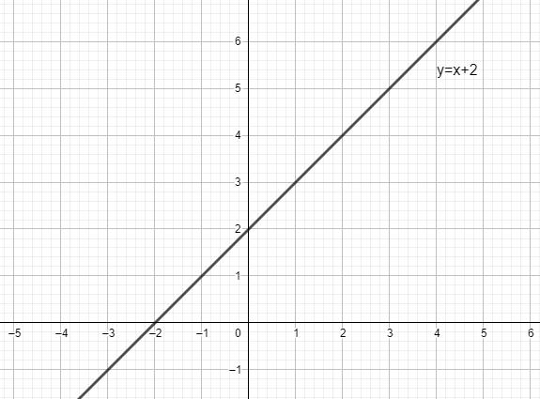
1. a)

b)
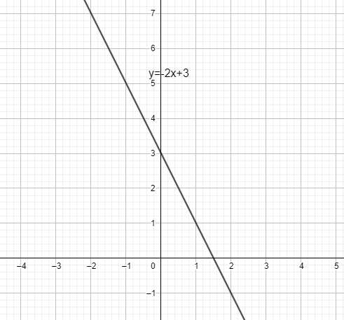

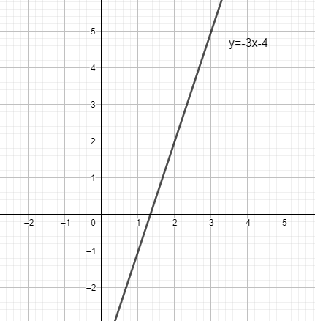
c)

d)
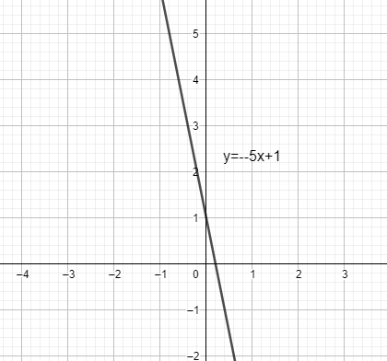
e)
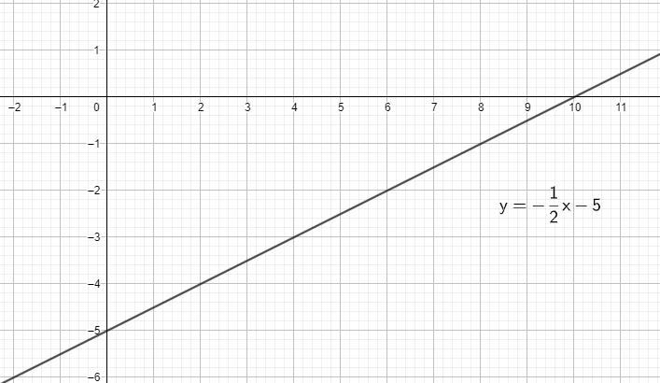

f)
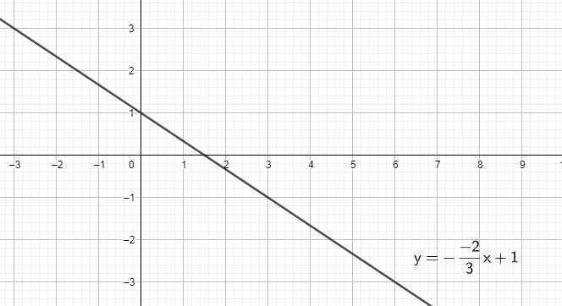
g)
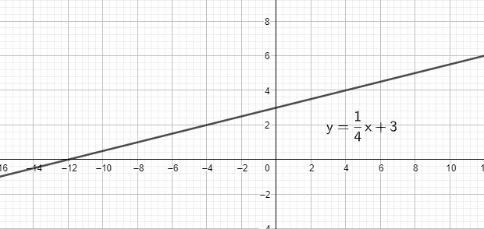
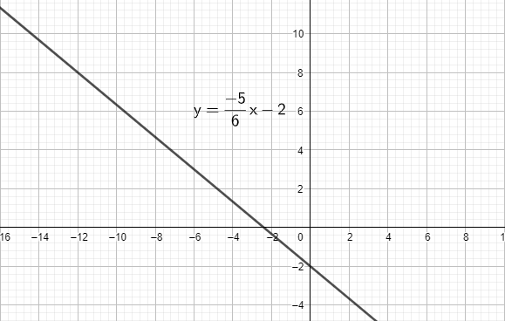
h)

2.
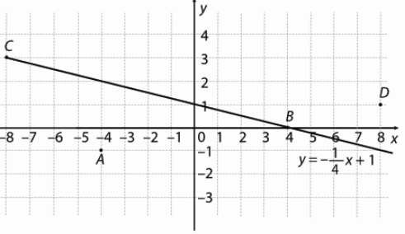
a) $1= -\frac{1}{4}∙\left(-4\right)+1$
$$1=1+1$$
$1≠2$ Ne pripada.

b) $0= -\frac{1}{4}∙4+1$
$$0=-1+1$$
$0=0$ Pripada.

c) $3= -\frac{1}{4}∙\left(-8\right)+1$
$$3=2+1$$
$3=3$ Pripada.

d) $1= -\frac{1}{4}∙8+1$
$$1=-2+1$$
$1≠-1$ Ne pripada.

3.
a) $2= 12∙1-10$
$$2=12-10$$
$2=2$ Pripada.

b) $110= 12∙(-10)-10$
$$110=-120-10$$
$110≠-130$ Ne pripada.

c)$12= 12∙0-10$
$$12=0-10$$
$12≠-10$ Ne pripada.

d) $2= 12∙1-10$
$$2=12-10$$
$2=2$ Pripada.

4.
a) A(0,y)
$$y= -x+5$$
$$y=0+5$$
$y=5$

B(3.5,y)
$$y= -x+5$$
$$y=-3.5+5$$
$y=1.5$
C(-2,y)
$$y= -x+5$$
$$y=-2+5$$
$y=3$

D(-2.3,y)
$$y= -x+5$$
$$y=-2.3+5$$
$y=2.7$

b)
A(x,1)
$$y= -x+5$$
$$1=-x+5$$
$x=5-1$
$$x=4$$

B(x,-3)
$$y= -x+5$$
$$-3=-x+5$$
$x=5+3$
$$x=8$$

C(x,2.5)
$$y= -x+5$$
$$2.5=-x+5$$
$x=5-2.5$
$$x=2.5$$
D(x,7)
$$y= -x+5$$
$$7=-x+5$$
$x=5-7$
$$x=-2$$

5.
a) A(-4,1) i a=-1
$$y= ax+b$$
$$y=-x+b$$
$1=-\left(-4\right)+b$
$$b=1-4$$
$$b=-3$$
$$y=-x-3$$

b) B(-3,-3) i a=2
$$y= ax+b$$
$$y=2x+b$$
$-3=2∙\left(-3\right)+b$
$$b=6-3$$
$$b=3$$
$$y=2x+3$$

c) A(10,-4) i a=-0.5
$$y= ax+b$$
$$y=-0.5x+b$$
$-4=-0.5∙10+b$
$$b=5-4$$
$$b=1$$
$$y=-0.5x+1$$

6.
a) A(1,-4) i b=-1
$$y= ax+b$$
$$y=ax-1$$
$-4=a∙1-1$
$$a=-4+1$$
$$a=-3$$
$$y=-3x-1$$

b) A(-3,3) i b=-3
$$y= ax+b$$
$$y=ax-3$$
$3=a∙(-3)-3$
$$-3a=3+3$$
$$-3a=6$$
$$a=-2$$
$$y=-2x-3$$

c) C(0.5,-3) i b=-0.5
$$y= ax+b$$
$$y=ax-0.5$$
$-3=a∙0.5-0.5$
$$0.5a=-3+0.5$$
$$0.5a=-2.5$$
$$a=-5$$
$$y=-5x-0.5$$

7.
a) A(-4,1), B(-6,3)
$$y= ax+b$$
$1=-4a+b$ /(-1)
$3=-6a+b$
$$-1=4a-b$$
$$3=-6a+b$$
$$2=-2a$$
$$a=-1$$
$$1=-4a+b$$
$$b=1+4∙\left(-1\right)=-3$$
$$y=-x-3$$

b) A(1,-1), B(-1,-7)
$$y= ax+b$$
$-1=1a+b$ /(-1)
$-7=-1a+b$
$$1=-a-b$$
$$-7=-a+b$$
$$-6=-2a$$
$$a=3$$
$$-1=a+b$$
$$b=-1-3=-4$$
$$y=3x-4$$

c) A(4,2), B(-4,8)
$$y= ax+b$$
$2=4a+b$
$8=-4a+b$
$$10=2b$$
$$b=5$$
$$2=4a+5$$
$$4a=-3$$
$$a=-\frac{3}{4}$$
$$y=-\frac{3}{4}x+5$$

8.
a) (4,-5), (1,1)
$$y= ax+b$$
$-5=4a+b$ /(-1)
$1=a+b$
$$5=-4a-b$$
$$1=a+b$$
$$6=-3a$$
$$a=-2$$
$$1=-2+b$$
$$b=1+2=3$$
$$y=-2x+3$$

(6,7)
$$7=-2∙6+3$$
$$7=-12+3$$
$$7≠-9$$
Ne pripada.

b) (-2,-3), (-4,2)
$$y= ax+b$$
$-3=-2a+b$ /(-1)
$2=-4a+b$
$$3=2a-b$$
$$2=-4a+b$$
$$5=-2a$$
$$a=-2.5$$
$$3=-5-b$$
$$b=-5-3=-8$$
$$y=-2.5x-8$$

(6,7)
$$7=-2.5∙7-8$$
$$7=-17.5-8$$
$$7≠-25.5$$
Ne pripada.

c) A(0,2), B(2,0)
$$y= ax+b$$
$2=b$
$0=2a+b$
$$0=2a+2$$
$$2a=-2$$
$$a=-1$$
$$y=-x+2$$

(6,7)
$$7=-6+2$$
$$7=-4$$
$$7≠-4$$
Ne pripada.

9.
a) $y=x$
i y i x os siječe u točki (0,0)

b) $y=-x+4.5$
y – os (0,4.5)

$$0=-x+4.5$$
$$x=4.5$$
x – os (4.5,0)

c) $y=5x-3$
y – os (0,-3)

$$0=5x-3$$
$$5x=3$$
$x=\frac{3}{5}$
x – os ($\frac{3}{5}$,0)

d) $y=-\frac{4}{5}x+2$
y – os (0,2)

$$0=-\frac{4}{5}x+2$$
$$\frac{4}{5}x=2$$
$x=\frac{5}{2}$
x – os ($\frac{5}{2}$,0)

10.
a) $y=-4x+0.5$
$$0=-4x+0.5$$
$$4x=0.5$$
$$x=0.125$$

b) $y=-0.8x-2.4$
$$0=-0.8x-2.4$$
$$0.8x=2.4$$
$$x=3$$

c) $y=\frac{3}{8}x+\frac{1}{4}$
$0=\frac{3}{8}x+\frac{1}{4}$
$-\frac{3}{8}x=\frac{1}{4}$
$x=-\frac{2}{3}$

d) $5x-2y-5=0$
$$5x-0-5=0$$
$$5x=5$$
$$x=1$$

11.
a) $y=-17x-2$
Ordinata je -2.

b) $y=2.25x$
Ordinata je 0.

c) $\frac{12}{5}x+\frac{2}{3}y-4=0$
$\frac{2}{3}y=-\frac{12}{5}+4$
$y=-\frac{18}{5}x+6$
Ordinata je 6.

d) $-2x-12y+15=0$
$12y=-2x+15$ /:12
$y=-\frac{1}{6}x+\frac{5}{4}$
Ordinata je $\frac{5}{4}.$
12.
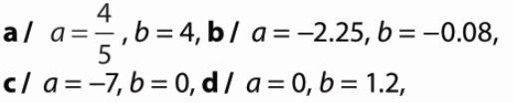
14.
a) b = 2
$$0=-2a+2$$
$$2a=2$$
$$a=1$$

b) $b=1$
$$0=2a+1$$
$$-2a=1$$
$$a=-0.5$$

c) b=0
$$1=a∙1+0$$
$$a=1$$

d) b= -2
$$0=-1a-2$$
$$a=-2$$

15.
a) $y=\frac{3}{4}x-2$
$$-5=\frac{3}{4}∙\left(-4\right)-2$$
$$-5=-3-2$$
$$-5=-5$$
Da.

b) $y=\frac{3}{4}x-2$
$$0=\frac{3}{4}∙\left(-2\right)-2$$
$$0=-\frac{3}{2}-2$$
$$0=-\frac{7}{2}$$
Ne.

c) $y=\frac{3}{4}x-2$
$$1=\frac{3}{4}∙4-2$$
$$1=3-2$$
$$1=1$$
Da.

d) $y=\frac{3}{4}x-2$
$$-2=\frac{3}{4}∙0-2$$
$$-2=-2$$
Da.

e) $y=\frac{3}{4}x-2$
$$-4=\frac{3}{4}∙2-2$$
$$-4=\frac{3}{2}-2$$
$$-4=-\frac{1}{2}$$
Ne.

f) $y=\frac{3}{4}x-2$
$$\frac{1}{4}=\frac{3}{4}∙3-2$$
$$\frac{1}{4}=\frac{9}{4}-2$$
$$\frac{1}{4}=\frac{1}{4}$$
Da.

g) $y=\frac{3}{4}x-2$
$$-7=\frac{3}{4}∙3-2$$
$$-5=\frac{9}{4}-2$$
$$-5=\frac{1}{4}$$
Ne.

h) $y=\frac{3}{4}x-2$
$8=\frac{3}{4}∙2-2$
$$-5=\frac{3}{2}-2$$
$-5=-\frac{1}{4}$
Ne.
16.
a) A, C, N
b) B, G
c) C, M
d) G

17.
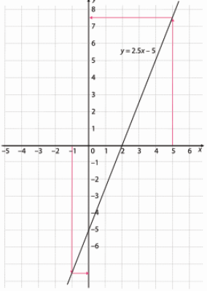
a) $y=2.5∙0-5=-5$
b) $y=2.5∙2-5=5-5=0$
c) $y=2.5∙5-5=12.5-5=7.5$
d) $y=2.5∙\left(-1\right)-5=-2.5-5=-7.5$

18.
a) $y=-\frac{2}{5}x+3 A(x,-5)$
$-5=-\frac{2}{5}x+3$
$\frac{2}{5}x=8$
$x=8∙\frac{5}{2}=20$

b) $y=-\frac{2}{5}x+3 B(-5,y)$
$y=-\frac{2}{5}∙(-5)+3$
$y=2+3$
$$y=5$$

c) $y=-\frac{2}{5}x+3 C(x,2.5)$
$2.5=-\frac{2}{5}x+3$
$\frac{2}{5}x=0.5$
$x=\frac{1}{2}∙\frac{5}{2}=\frac{5}{4}$

d) $y=-\frac{2}{5}x+3 D(2.5,y)$
$y=-\frac{2}{5}∙\frac{5}{2}+3$
$y=-1+3$
$$y=2$$

e) $y=-\frac{2}{5}x+3 P(x,\frac{3}{5})$
$\frac{3}{5}=-\frac{2}{5}x+3$
$\frac{2}{5}x=\frac{12}{5}$
$x=\frac{12}{5}∙\frac{5}{2}=6$

f) $y=-\frac{2}{5}x+3 R(7\frac{1}{2},y)$
$y=-\frac{2}{5}∙\frac{15}{2}+3$
$y=-3+3$
$$y=0$$

g) $y=-\frac{2}{5}x+3 G(x,-1\frac{7}{12})$
$-\frac{19}{12}=-\frac{2}{5}x+3$
$\frac{2}{5}x=\frac{55}{12}$
$x=\frac{55}{12}∙\frac{5}{2}=\frac{275}{24}$

h) $y=-\frac{2}{5}x+3 H(-1.2,y)$
$y=-\frac{2}{5}∙\left(-\frac{6}{5}\right)+3$
$y=\frac{12}{25}+3$
$y=\frac{87}{25}$

19.
a) A(-4, y)
$y=-\frac{1}{2}x-7$
$y=-\frac{1}{2}∙\left(-4\right)-7$
$y=2-7$
$y=-5$

b) $y=3.25x-12$
$y=3.25∙\left(-4\right)-12$
$y=-13-12$
$y=-25$

c) $y=-3x-22.5$
$y=-3∙\left(-4\right)-22.5$
$y=12-22.5$
$y=-10.5$

d) $y=-5.75x+23$
$y=-5.75∙\left(-4\right)+23$
$y=23+23$
$y=46$

20.
a) A(-5,1), B(0,0)
$$y= ax+b$$
$1=-5a+b$
$0=b$
$$1=-5a$$
$a=-\frac{1}{5}$
$y=-\frac{1}{5}x$

b) A(0,-6), B(-5,-5)
$$y= ax+b$$
$-6=b$
$-5=-5a+b$
$$-1=-5a-6$$
$$-5a=5$$
$$a=-1$$
$y=-x-6$

c) A(25,-2), B(-7,-2)
$$y= ax+b$$
$-2=25a+b$ /(-1)
$-2=-7a+b$
$$2=-25a-b$$
$$-2=-7a+b$$
$$0=-32a$$
$a=0$
$-2=0+b$
$b=-2$
$y=-2$

21.
a) A(-3,9), B(2,-1)
$$y= ax+b$$
$9=-3a+b$ /(-1)
$-1=2a+b$
$$-9=3a-b$$
$$-1=2a+b$$
$$-10=5a$$
$a=-2$
$-1=-4+b$
$b=3$
$y=-2x+3$
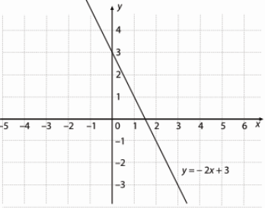

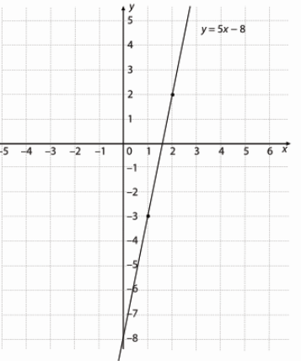
b) C(2,2), D(1,-3)
$$y= ax+b$$
$2=2a+b$ /(-1)
$-3=a+b$
$$-2=-2a-b$$
$$-3=a+b$$
$$-5=-a$$
$a=5$
$2=10+b$
$b=-8$
$y=5x-8$

c) M(3,1), N(-9,17)
$$y= ax+b$$
$1=3a+b$ /(-1)
$17=-9a+b$
$$-1=-3a-b$$
$$17=-9a+b$$
$$16=-12a$$
$a=-\frac{4}{3}$
$1=-4+b$
$b=5$
$y=-\frac{4}{3}x+5$
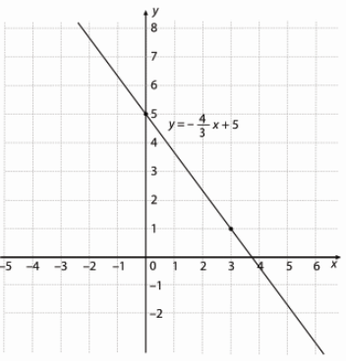
22.
a) (1,1), (-3,9)
$$y= ax+b$$
$1=a+b$ /(-1)
$9=-3a+b$
$$-1=-a-b$$
$$9=-3a+b$$
$$8=-4a$$
$a=-2$
$1=-2+b$
$b=3$
$y=-2x+3$
T(5,-7)
$-7=-2∙5+3$
$-7=-7$ Pripada.

b) (2,-3), (-1,9)
$$y= ax+b$$
$-3=2a+b$ /(-1)
$9=-a+b$
$$3=-2a-b$$
$$9=-a+b$$
$$12=-3a$$
$a=-4$
$9=4+b$
$b=5$
$y=-4x+5$
T(5,-7)
$-7=-4∙5+5$
$-7=-15$ Ne pripada.

c) (4,-6), (-12,10)
$$y= ax+b$$
$-6=4a+b$ /(-1)
$10=-12a+b$
$$6=-4a-b$$
$$10=-12a+b$$
$$16=-16a$$
$a=-1$
$-6=-4+b$
$b=-2$
$y=-x-2$
T(5,-7)
$-7=-1∙5-2$
$-7=-7$ Pripada.

23. a) (0,5), (3,3), (-3,7)
$$y= ax+b$$
$5=0+b$
$5=b$
$3=3a+5$
$$3a=-2$$
$a=-\frac{2}{3}$
$7=-\frac{2}{3}∙\left(-3\right)+5$
$7=2+5$
$7=7$
Pripadaju pravcu $y=-\frac{2}{3}x+5$
b) (4,4), (0,-2), (2,0)
$$y= ax+b$$
$-2=0+b$
$-2=b$
$4=4a-2$
$$4a=6$$
$a=\frac{3}{2}$
$0=\frac{3}{2}∙2-2$
$0=3-2$
$0=1$
Ne pripadaju.

c) (0,4), (-1,3), (3,1)
$$y= ax+b$$
$4=0+b$
$4=b$
$3=-a+4$
$$a=1$$
$1=3+4$
$1=7$
$Ne pripadaju.$

24.
a) A(-5, -2.5) a=0.2
$$y=0.2x+b$$
$$-2.5=0.2·(-5)+b$$
$$b=-2.5+1$$
$$b=-1.5$$
$$y=0.2x-1.5$$

b) B(-2, 0.4) a=1.8
$$y=1.8x+b$$
$$0.4=1.8·(-2)+b$$
$$b=0.4+3.6$$
$$b=4$$
$$y=1.8x+4$$

c) C(5, 1.2) a=1
$$y=x+b$$
$$1.2=1·5+b$$
$$b=1.2-5$$
$$b=-3.8$$
$$y=x-3.8$$

25.
a) A(3,2) b=-4
$$y=ax-4$$
$$2=a·3-4$$
$$3a=-6$$
$$a=-2$$
$$y=-2x-4$$

b) A(-5,-7) b=-3
$$y=ax-3$$
$$-7=a·(-5)-3$$
$$5a=4$$
$a=\frac{4}{5}$
$y=\frac{4}{5}x-3$

c) A(3,-3) b=-2
$$y=ax-4$$
$$-3=a·3-2$$
$$3a=-1$$
$a=-\frac{1}{3}$
$y=-\frac{1}{3}x-2$

26. a) A(7,7) a=12
$$y=ax+2$$
$$7=12·7+b$$
$$b=84-7$$
$a=77$
$y=12x+77$

b) A(7,7) b=2
$$y=ax+2$$
$$7=a·7+2$$
$$7a=5$$
$a=\frac{5}{7}$
$y=\frac{5}{7}x+2$

c) A(7,7) b=-10
$$y=ax-10$$
$$7=a·7-10$$
$$7a=17$$
$a=\frac{17}{7}$
$y=\frac{17}{7}x-10$

d) A(7,7) a=-2
$$y=-2x+b$$
$$7=-2·7+b$$
$$b=14+7$$
$a=21$
$y=-2x+21$

27.
a) $x – os$
$$0=-2x-10$$
$$2x=-10$$
$$x=-5$$
$$(-5,0)$$
$$y – os (0,-10)$$

b) $x – os$
$$0=\frac{3}{4}x-6$$
$$\frac{3}{4}x=6$$
$$x=8$$
$$(8,0)$$
$$y – os (0,-6)$$

c) $x – os$
$$0=-\frac{1}{3}x+1$$
$$\frac{1}{3}x=1$$
$$x=3$$
$$(3,0)$$
$$y – os (0,1)$$

d) $x – os$
$$0=-x+2.5$$
$$x=2.5$$
$$(2.5,0)$$
$$y – os (0,2.5)$$

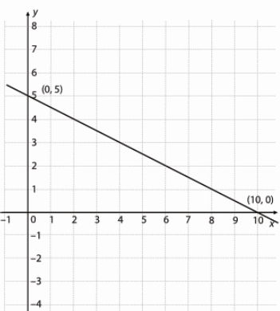
28.
a)

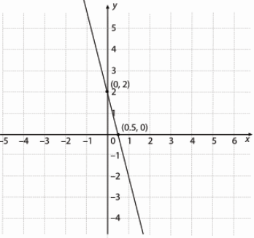
b)

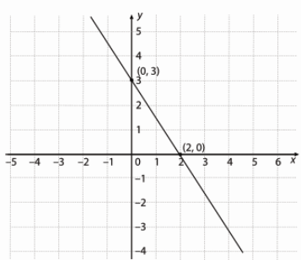
c)

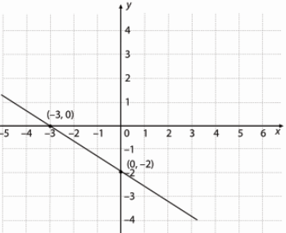
d)

29.
a) (-3,0) (0,2) b=2
$$0=-3a+2$$
$$3a=2$$
$a=\frac{2}{3}$
$y=\frac{2}{3}x+2$

b) (4,0) (0,-2) b=-2
$$0=4a-2$$
$$4a=2$$
$a=\frac{1}{2}$
$y=\frac{1}{2}x-2$

c) (-1,0) (0,5) b=5
$$0=-a+5$$
$a=5$
$y=5x+5$

d) (4,0) (0,3) b=3
$$0=4a+3$$
$$4a=-3$$
$a=-\frac{3}{4}$
$y=-\frac{3}{4}x+3$

30.
a) $P=\frac{3∙2}{2}=\frac{6}{2}=3$ kvadratne jedinične dužine
b) $P=\frac{4∙2}{2}=\frac{8}{2}=4$ kvadratne jedinične dužine
c) $P=\frac{1∙5}{2}=\frac{5}{2}=2.5$ kvadratne jedinične dužine
d) $P=\frac{3∙4}{2}=\frac{12}{2}=6$ kvadratnih jediničnih dužina

33.
a) y = x – 2
b) y = - 4.5x
c) $y = -\frac{1}{4}x –\frac{2}{5}$

34.
a) (0,-1)
b) (0,0)
c) (0, -2)
d) (0,4)

35.
a) 0 = 2x – 4
2x = 4
x = 2
(2,0)

b) 0= - 4x
x=0
(0,0)
c) 0=-x+1
x=1
(1,0)

d) $0=\frac{1}{2}x+2$
$\frac{1}{2}x=-2$
$x=-4$
(-4,0)

36.
a) $1=2∙3-5$
$1=1$
Pripada.

b) $1=-3-2$
$1=-5$
Ne pripada.

c) $1=-2∙3+7$
$1=1$
Pripada.

d) $3=1$
Ne pripada.

37.
a) y = -2x+b
$1=-2∙2+b$
$b=1+4$
$b=5$
$y=-2x+5$

b) $y=x+b$
$-3=2+b$
$b=-5$
$y=x-5$

c) $y=3x+b$
$-1=3∙\left(-1\right)+b$
$b=2$
$y=3x+2$

d) $y=-x+b$
$0=-\left(-2\right)+b$
$b=-2$
$y=-x-2$

38. a) A(3,-3), B(-1,1)
$$y= ax+b$$
$-3=3a+b$ /(-1)
$1=-a+b$
$$3=-3a-b$$
$$1=-a+b$$
$$4=-4a$$
$a=-1$
$1=1+b$
$b=0$
$y=-x$

b) M(1,3), N(-2,-3)
$$y= ax+b$$
$3=a+b$ /(-1)
$-3=-2a+b$
$$-3=-a-b$$
$$-3=-2a+b$$
$$-6=-3a$$
$a=2$
$3=2+b$
$b=1$
$y=2x+1$

c) K(2,-3), L(0,2)
$$y= ax+b$$
$-3=2a+b$
$2=0+b$ b=2
$$-3=2a+2$$
$$-5=2a$$
$a=-\frac{5}{2}$
$y=-\frac{5}{2}x+2$

39.
a) 40 km
b) 6 h
c) brzina=put : vrijeme = 40km : 8h = 5 km/h
d) y = 5x
e) brzinu

40.
a) y = 0.095x
b) x=70: 0.095=736.84 km
c) y=0.095·52=4.94 L Može.
d) 10% manje goriva
0.9 ·9.5=8.55 L
y=0.0855x
x = 70 : 0.0855=818.71 km

41.
a) m = gustoća ·volumen =7.8 · 25=195 g
b) m = 7.8V
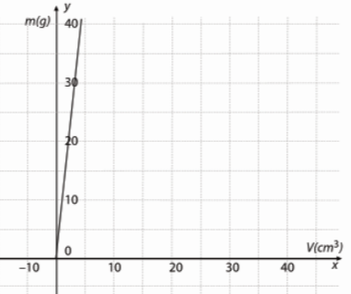
c)

d) m=7.8 ·12000000=93600000 g = 93600kg
e) V = m : 7.8 = 31.2:7.8 =4 cm³

42. x- sat, y - temperatura
(8,10), (16, 18)
10=8a+b /(-1)
18=16a+b
-10=-8a-b
18=16a+b
8=8a
a=1
b=18-16=2
y=x+2
y =13+2 = 15°C

43.
A(5,-3) B(-1,-4)
-3=5a+b
-4=-a + b /(-1)
-3=5a+b
4=a – b
1=6a
a = $\frac{1}{6}$
$-3=\frac{5}{6}+b$
$b=-\frac{23}{6}$
$y=\frac{1}{6}x-\frac{23}{6}$
B(-1,-4), C(-2,6)
-4=-a + b /(-1)
6=-2a+b
4= a – b
6=-2a+b
-a=10
a=-10
b=-20+6=-14
y = -10x-14

A(5,-3), C(-2,6)
-3 =5a +b
6=-2a+b
3=-5a-b
6=-2a+b
9=-7a
a= $-\frac{9}{7}$
b=$-\frac{18}{7}+6=\frac{24}{7}$
$y=-\frac{9}{7}x+\frac{24}{7}$

44.
a) Ne, jer se koeficijenti smjera razlikuju.
b) Je, jer su koeficijenti smjera jednaki.
c) Je, jer su koeficijenti smjera jednaki.
d) 4y=8x+12 /:4
y = 2x+3 Je, jer su koeficijenti smjera jednaki.

45.
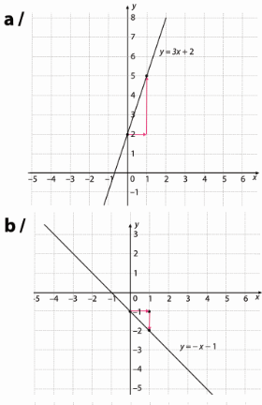
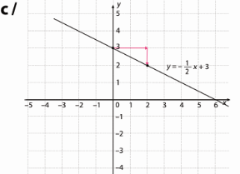
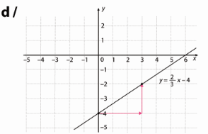
46.
a) y = x A(0,7) a=1, b=7
$y=x+7$

b) y = - x +4 a = -1, b = 7
$y=-x+7$

c) y = - ½ x +2 a = -1/2, b = 7
$y=-\frac{1}{2}x+7$

d) y = - 0.2x -0.6 a = -0.2, b = 7
$y=-0.2x+7$

47.
$$3x-2y=4$$
$2y=3x-4$ /:2
$y=\frac{3}{2}x-2$
$y=\frac{3}{2}x+b$
a)M(2,-2)
$-2=\frac{3}{2}∙2+b$
$b=-2-3=-5$
$y=\frac{3}{2}x-5$

b) M(3,0)
$0=\frac{3}{2}∙3+b$
$b=-\frac{9}{2}$
$y=\frac{3}{2}x-\frac{9}{2}$

c) P(-4,5)
$5=\frac{3}{2}∙(-4)+b$
$b=5+6=11$
$y=\frac{3}{2}x+11$

d) R(1,1)
$1=\frac{3}{2}∙1+b$
$b=1-\frac{3}{2}=-\frac{1}{2}$
$y=\frac{3}{2}x-\frac{1}{2}$

48.
a) 2
b) 1
c) 3

49.
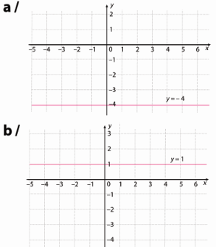
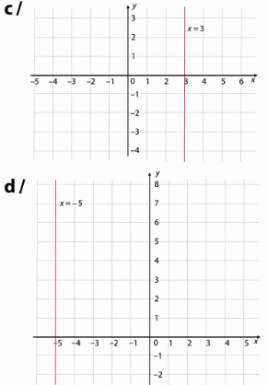

50.
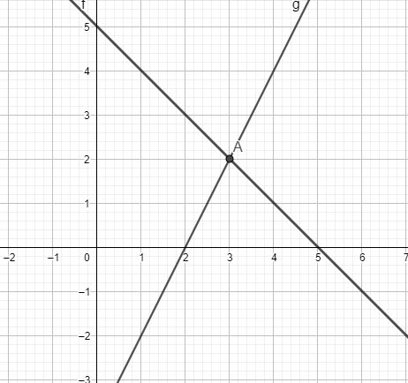
a)

Sjecište je A(3,2).
b)
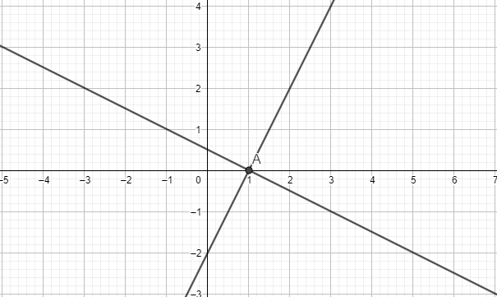
Sjecište je A(1,0).
51.
a) $2x-4y-5=0$
$4y=2x-5$
$y=\frac{1}{2}x-\frac{5}{4}$
$2y=4x-5$
$y=2x-\frac{5}{2}$
Nisu.

b) $y=-x+2$
$y=-x$
Jesu.

c) $y=-0.22x+2.2$
$y=-0.22$
Nisu.

52.
a) $y=-\frac{2}{3}x$
T(-6,2)
$2=-\frac{2}{3}∙(-6)+b$
$b=2-4=-2$
$y=-\frac{2}{3}x-2$

b) $y=-0.5x-16$
T(-6,2)
$2=-0.5∙(-6)+b$
$b=2-3=-1$
$y=-0.5x-1$

c) $y=\frac{3}{2}x+\frac{1}{2}$
T(-6,2)
$2=\frac{3}{2}∙(-6)+b$
$b=2+9=11$
$y=\frac{3}{2}x+11$

d) $y=-x$
T(-6,2)
$2=-6+b$
$b=2+6=8$
$y=-x+8$

e) $y=-\frac{1}{4}x+2$
T(-6,2)
$2=-\frac{1}{4}∙(-6)+b$
$b=2-\frac{3}{2}=\frac{1}{2}$
$y=-\frac{1}{4}x+\frac{1}{2}$

f) $y=2x$
T(-6,2)
$2=2∙(-6)+b$
$b=2+12=14$
$y=2x+14$

53.
a) y = 9
b) x = -17

54.
y = -1.5

55.
a) y = 2.5
b) x = -7

56.
a)
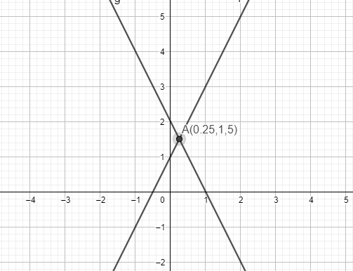

b)
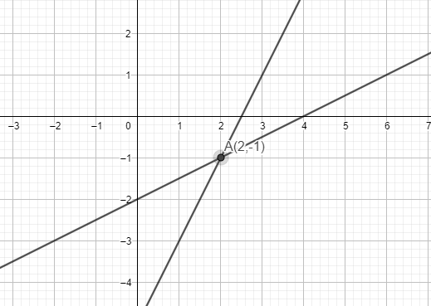
c)
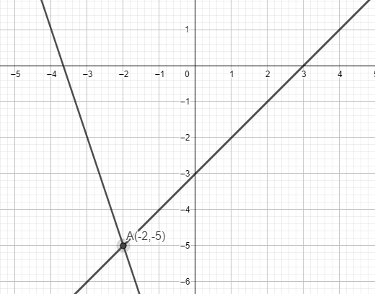

d)
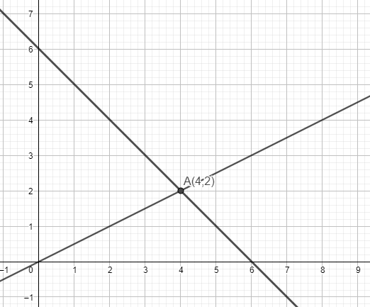
57.
a) Ne.
b) Da.
c) Ne.

58.
a) x=2
b) y=3

59. a)
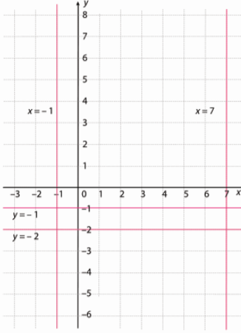
b)
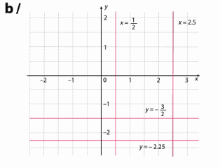
60.
a) karte 3·550=1650 kn
ostane 3000 – 1650 = 1350 kn
1350 : 90 = 15 dana
b) y – novac, x - dani
y = 3000 – 90x – 1650 = -90x +1350
c)
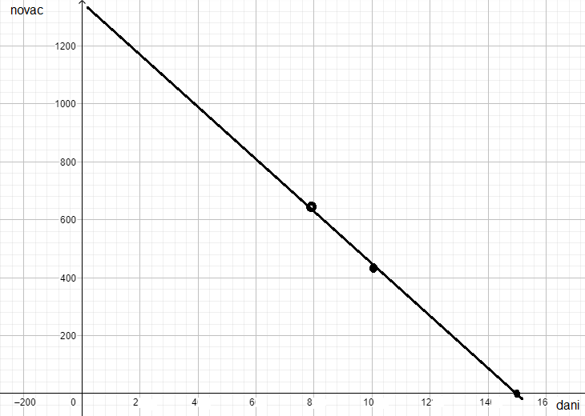
d) x = 8
y = -90·8+1350 = 630 kn
e) 450 = -90x +1350
90x =1350 – 450
90x=900
x =10

61.
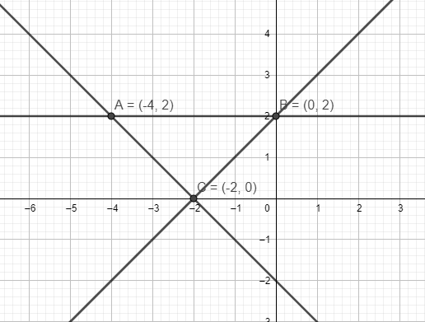
$P=\frac{|AB|∙v_{AB}}{2}=\frac{4∙2}{2}=4$ kvadratne jedinične dužine
62.
a) $2x+y=7$ /5
$$3x-5y=4$$
$$10x+5y=35$$
$$3x-5y=4$$
$$13x=39$$
$$x=3$$
$$6+y=7$$
$$y=7-6=1$$
Rješenje (3,1)

b) $4x-2y=-2$
$2x-3y=-5$ /(-2)
$$4x-2y=-2$$
$$-4x+6y=10$$
$$4y=8$$
$$y=2$$
$$4x-4=-2$$
$$4x=2$$
$x=\frac{1}{2}$
Rješenje ($\frac{1}{2},2)$

c) $6x-10y=11$
$\frac{1}{3}x-2y=1$/(-5)
$$6x-10y=11$$
$-\frac{5}{3}x+10y=-5$
$$\frac{13}{3}x=6$$
$x=\frac{18}{13}$
$\frac{6}{13}-2y=1$
$-2y=\frac{7}{13}$
$y=-\frac{7}{26}$

d) $12x-4y-9x+6=-5$
$25y+10x-14-6y=-15x-1$
$3x-4y=-11$ /19
$25x+19y=13$ /4
$57x-76y=-209$
$100x+76y=52$
$157x=-157$
$x=-1$
$-3-4y=-11$
$-4y=-8$
$y=2$
Rješenje (-1,2)

63. a) y =x – 3
y = -3x -11 (-1)
y = x- 3
-y=3x+11
0=4x+8
4x=-8
x=-2
y=-2-3 = - 5
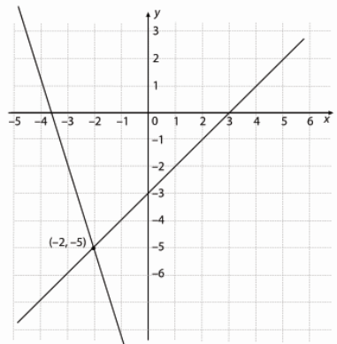
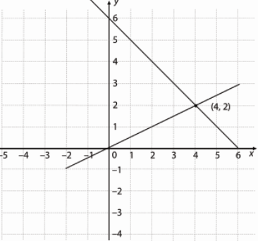
b) $y=\frac{1}{2}x$
$y=-x+6$ /(-1)
$y=\frac{1}{2}x$
$-y=x-6$
$0=\frac{3}{2}x-6$
$\frac{3}{2}x=6$
$$x=4$$
$$y=-4+6=2$$

63.
a) x+y=7
2x-y=2
3x=9
x=3
y = 7-x=7-3=4
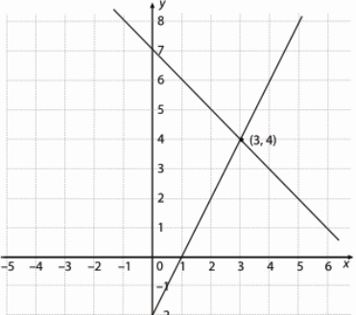
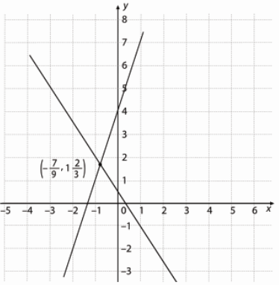
b) -3x+y=4
3x+2y=1
3y=5
$y=\frac{5}{3}$
$3x+\frac{10}{3}=1$
$3x=-\frac{7}{3}$
$x=-\frac{7}{9}$

65.
a) -2x+y= -3
2x+y =3
2y=0
y=0
x=1.5
(1.5,0)
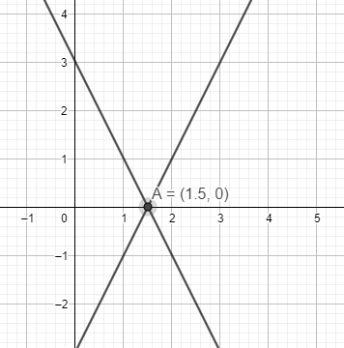
b) y=-x+3
x+y-1=0
y=-x+1
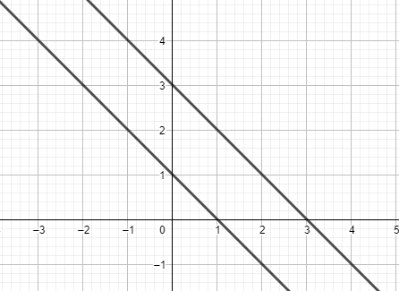
Nema rješenja.

c) $y=\frac{3}{4}x-1$
$8y=6x-8$
$y=\frac{3}{4}x-1$
Beskonačno rješenja.
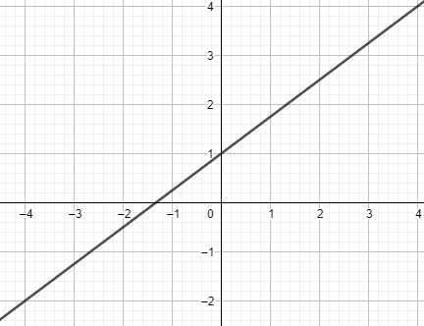
66.
a)1 rješenje
b) 1 rješenje
c) nema rješenja
d) 1 rješenje
e) 1 rješenje
f) beskonačno rješenja
g) nema rješenja
h) beskonačno rješenja

67.
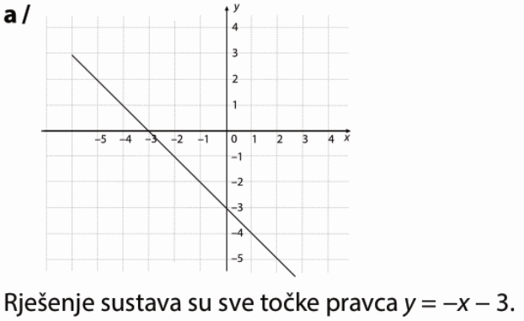
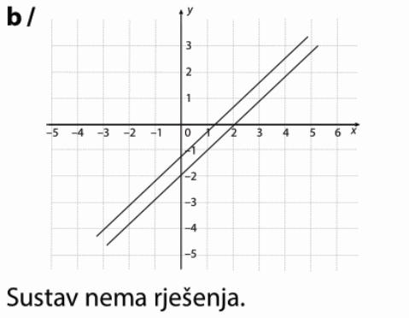

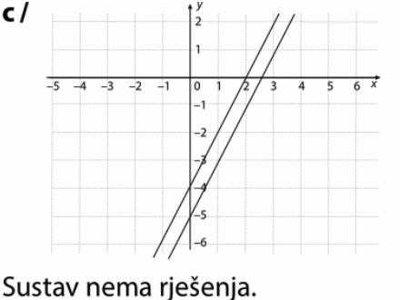

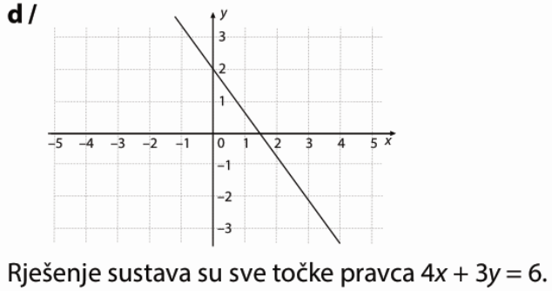

68.
a)
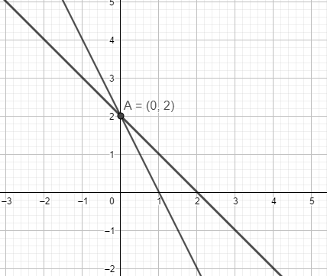

b)
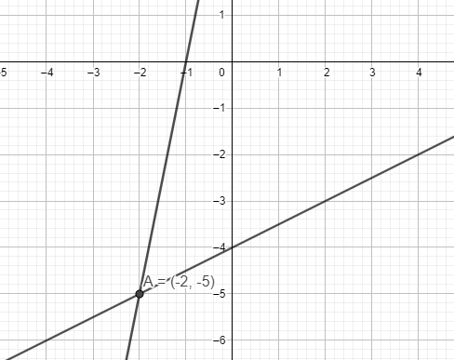
c)
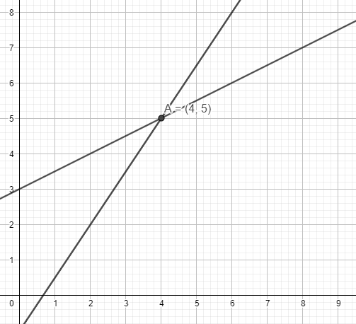
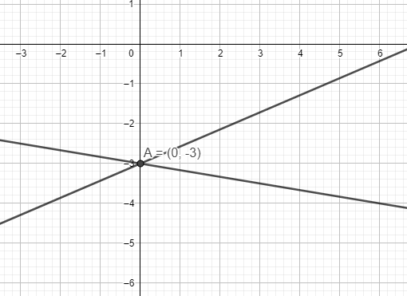
d)

69.
a) 1 rješenje
b) nema rješenja
c) beskonačno rješenja
d) beskonačno rješenja

70.
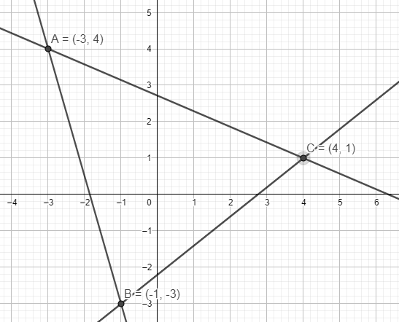
71.
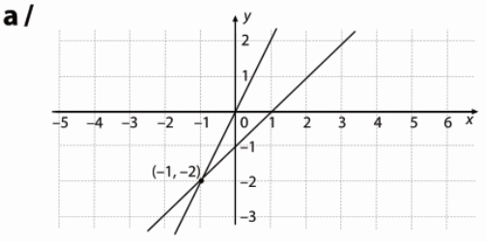
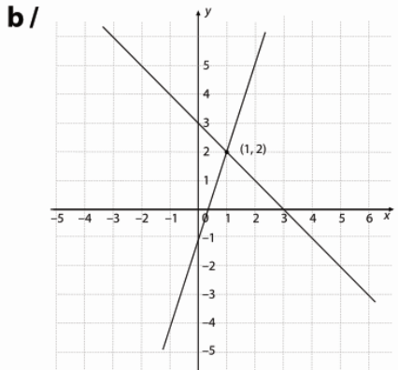
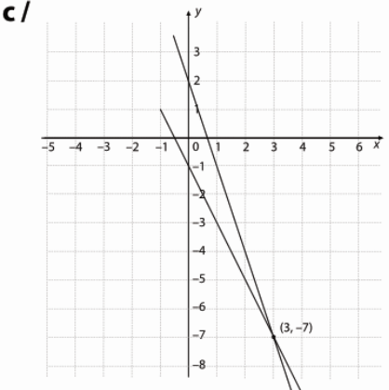
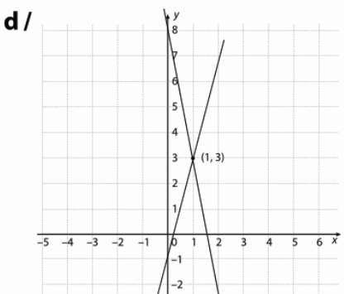
72.
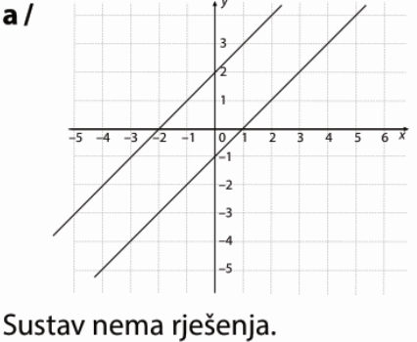
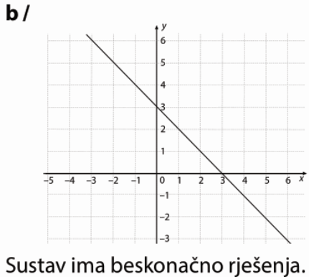
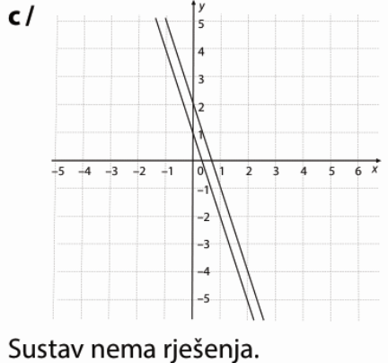

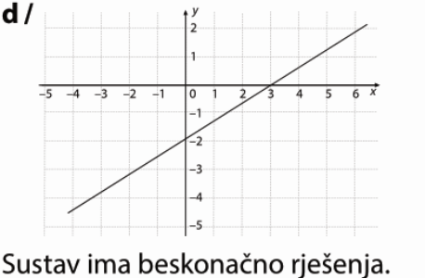
73.
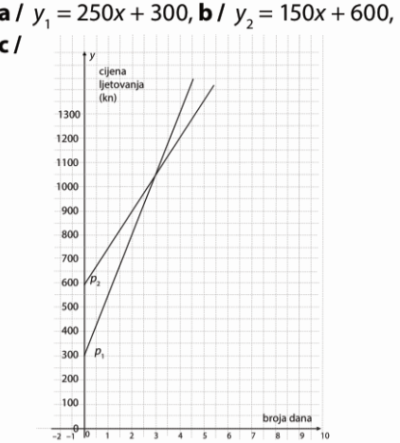
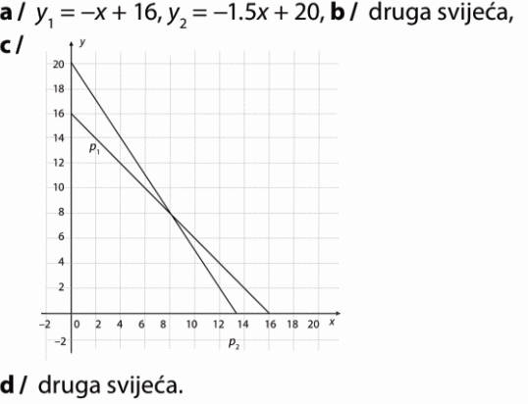
74.

d) $y_{1}=250∙2+300=500+300=800$
$$y_{2}=150∙2+600=300+600=900$$
Prva je povoljnija.

e) $y_{1}=250∙6+300=1500+300=1800$
$$y_{2}=150∙6+600=900+600=1500$$
Druga.

f) 250x+300=150x+600
250x-150x=600-300
100x=300
x=3
Tri dana.

75.
a) G=g · m=10N/kg · m
b) $G_{m}=\frac{1}{6}g_{Z}∙m$
e) $G_{m}=\frac{1}{6}∙695N=115.83 N$

76.
a) $y_{M}=50x+600$
$$y_{I}=100x+400$$

c) 50x+600=100x+400
50x =200
x = 4
Nakon 4 mjeseca.
78.
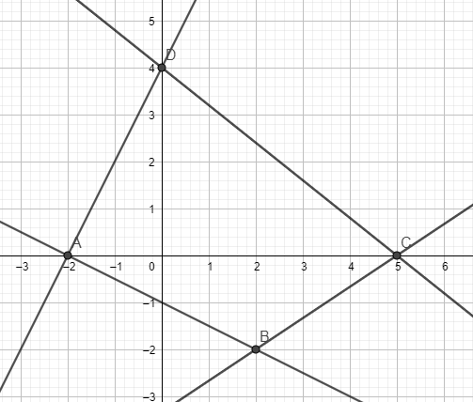
$P=P_{∆ABC}+P_{∆CDA}=\frac{7∙2}{2}+\frac{7∙4}{2}=7+14=21$ kvadratnih jediničnih dužina

79.
a) $y = -2x + 3$
$$a = -2$$
$$b=3$$

b) $y = x$
$$a = 1$$
$$b=0$$

c) $y = 5$
$$a = 0$$
$$b=5$$

d)
$$y = -\frac{1}{3}x + 0.2$$
$a = -\frac{1}{3}$
$$b=0.2$$

e)
$y = -\frac{2}{3}x + 3$
$a = -\frac{2}{3}$
$b=3$

f)
$$y = x + 12$$
$$a = 1$$
$$b=12$$
g)
$y =\frac{1}{4}x +\frac{1}{20}$
$a =\frac{1}{4}$
$b=\frac{1}{20}$

h)
$$y = -\frac{8}{9}x +\frac{1}{4}$$
$a = -\frac{8}{9}$
$b=\frac{1}{4}$

80.
a)
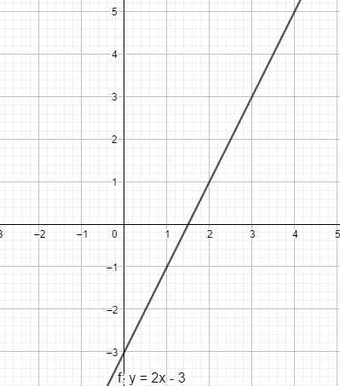
b)
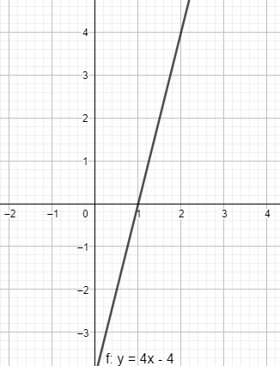
c)
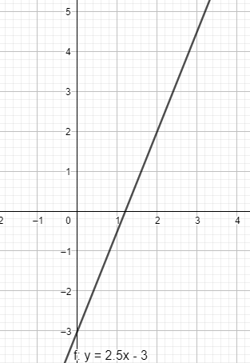

d)
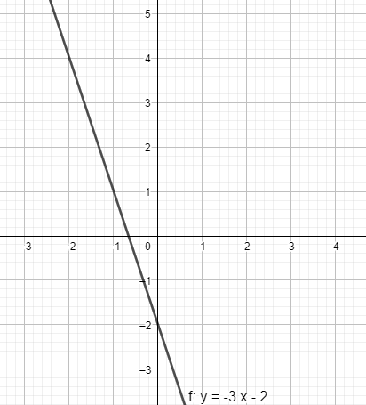
81.
a) y = 2x-2
b) y = -5x
c) $y=-\frac{2}{3}x+1$
d) y=4

82.
a) y – os (0,2)
0=x-2
x=2
x – os (2,0)

b) y – os (0,4)
0=-2x+4
2x=4
x=2
x – os (2,0)

c) y – os (0,0.25)
0=-x+0.25
x=0.25
x – os (0.25,0)

d) y – os (0,2)
$$0=\frac{1}{2}x+2$$
$\frac{1}{2}x=-2$
x=-4
x – os (-4,0)

83.
a) y = 2, y = -3
b) x = 2, x = - 3

84.
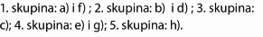
85.
a) $a=-\frac{3}{4}$
b) b=2
c)
$$0=-\frac{3}{4}x+2$$
$\frac{3}{4}x=2$
$x=\frac{8}{3}$ $(\frac{8}{3},0)$

d) (0,2)
e) $-5=-\frac{3}{4}∙4+2$
$-5=-3+2$
$-5=-1$
Ne pripada.

f) $5=-\frac{3}{4}∙(-4)+2$
$5=3+2$
$5=5$
Pripada.

86.
a) y = -3
$$y=\frac{1}{2}x+3$$
$-3=\frac{1}{2}x+3$
$\frac{1}{2}x=-6$
$x=-12$

b) $y=1.75x-2$
$-3=1.75x-2$
$1.75x=-1$
$x=-\frac{4}{7}$

c) $y=-3x-\frac{3}{2}$
$-3=-3x-\frac{3}{2}$
$3x=\frac{3}{2}$
$x=\frac{1}{2}$

d) $y=-20x+17$
$-3=-20x+17$
$-20x=-20$
$x=1$

87.a) $y=-3.7x+b$
$5.2=-3.7∙2+b$
$b=5.2+7.4=12.6$
$y=-3.7x+12.6$

b) $y=\frac{2}{3}x+b$
$0=\frac{2}{3}∙\frac{3}{2}+b$
$b=0-1=-1$
$y=\frac{2}{3}x-1$

c) $y=-\frac{1}{4}x+b$
$-4=-\frac{1}{4}∙(-16)+b$
$b=-4-4=-8$
$y=-\frac{1}{4}x-8$
88.
a) $y=ax-2$
$12=a∙4-2$
$4a=14$
$a=\frac{7}{2}$
$y=\frac{7}{2}x-2$

b) $y=ax+2$
$-1=a∙7+2$
$7a=-3$
$a=-\frac{3}{7}$
$y=-\frac{3}{7}x+2$

c) $y=ax-5$
$-3=a∙(-9)-5$
$9a=2$
$a=\frac{2}{9}$
$y=\frac{2}{9}x-5$

89.
a) (0,-18)
0=-2.4x-18
2.4x=-18 /:2.4
x =7.5
(7,5,0)

b) (0,0.2)
0=-0.3x+0.2
0.3x=0.2 /:0.3
x =$\frac{2}{3}$
($\frac{2}{3}$,0)

c) $\left(0,-\frac{1}{2}\right)$
$0=-\frac{4}{5}x-\frac{1}{2}$
$\frac{4}{5}x=-\frac{1}{2}$
$x=-\frac{5}{8}$
$\left(-\frac{5}{8},0\right)$

d) $15y=6x+12$ /:15
$y=\frac{2}{5}x+\frac{4}{5}$
$\left(0,\frac{4}{5}\right)$
$0=\frac{2}{5}x+\frac{4}{5}$
$-\frac{2}{5}x=\frac{4}{5}$
$x=-2$
(-2,0)

90.
a) y=ax+3
0=2a+3
-2a=3
a=-1.5
$y=-1.5x+3$

b) $y=ax-3$
$0=-2a-3$
$2a=-3$
$a=-1.5$
$y=-1.5x-3$

c) $y=ax+1$
$0=-4a+1$
$4a=1$
$a=0.25$
$y=0.25x+1$

d) $y=-2$

91.
a) (0,6.8)
0=-5.1x+6.8
5.1x=6.8
x=$\frac{4}{3}$
($\frac{4}{3},0)$

b) $P=\frac{\frac{4}{3}∙6.8}{2}=\frac{68}{15}$

92.
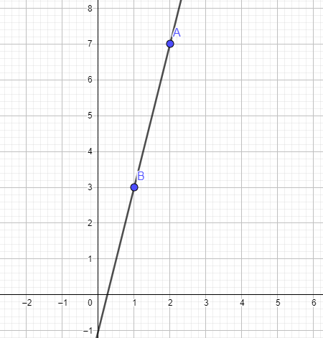
y =ax-1
3=a-1
a=4
y=4x-1
b) (0,-1)
0=4x-1
$4x=1$
$x=\frac{1}{4}$
$\left(\frac{1}{4}, 0\right)$

93.
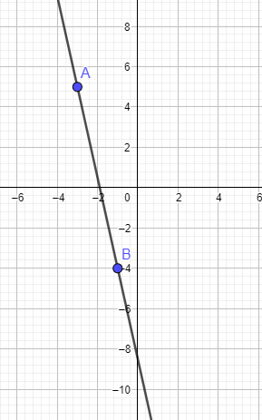
5=-3a+b
-4=-a+b /(-1)
5=-3a+b
4=a-b
9=-2a
a=$-\frac{9}{2}$
$-4=\frac{9}{2}+b$
$b=-\frac{17}{2}$
$y=-\frac{9}{2}x-\frac{17}{2}$

Priprema za ispit znanja
1.
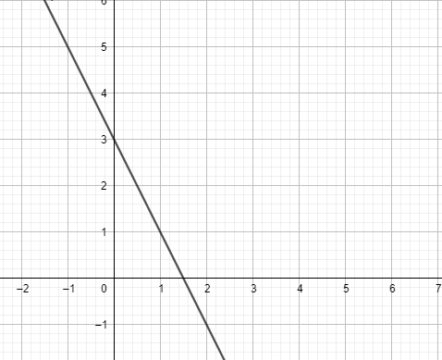
2.
y=2x-1
$3=2∙\left(-2\right)-1$
$3=-5$
A ne pripada.

$-5=2∙\left(-2\right)-1$
$-5=-5$
B pripada.

$3=2∙0-1$
$3=-1$
C ne pripada.
$-1=2∙1-1$
$-1=1$
D ne pripada.

3.
a) y = -4x + b
4=20 + b
b = -16
y = -4x – 16

b) y = ax+5
4=-5a+5
5a=1
$a=\frac{1}{5}$
$y=\frac{1}{5}x+5$

4.
a) $a=\frac{1}{2}$
b) (0,-1)
c) $0=\frac{1}{2}x-1$
$\frac{1}{2}x=1$
$x=2$
(2,0)

5.
a = -2
y=-2x+b
-5=-6+b
b=6-5=1

y=-2x+1

6.
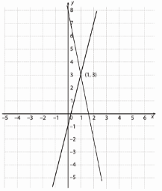
y=4x-1
y=-5x + 8 /(-1)
y=4x-1
-y=5x-8
0=9x-9
9x=9
x=1
y = 4-1 = 3
Rješenje je (1,3).

SKUP PRIRODNIH, CIJELIH I RACIONALNIH BROJEVA
1. a) Skup prirodnih brojeva je pravi podskup skupa racionalnih brojeva.
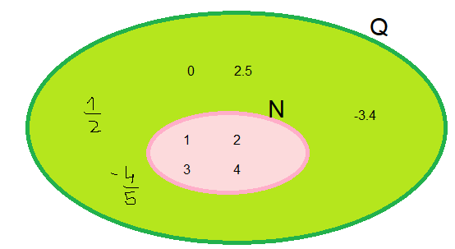
b) $N \bigcup{Q}=Q$ i $Q\bigcap{N}=N$

2. a) $\frac{10}{2}=10 :2=5=5.0$
$$-\frac{24}{6}=-24 :6=-4=-4.0$$
$$\frac{63}{9}=63 :9=7=7.0$$
$$\frac{125}{5}=125 :5=25=25.0$$
$$-\frac{156}{12}=-156 :12=-13=-13.0$$

b) $-\frac{12}{2}=-12 :2=-6=-6.0$
$$\frac{21}{7}=21 :7=3=3.0$$
$$\frac{32}{8}=32 :8=4=4.0$$
$$-\frac{132}{22}=-132 :22=-6=-6.0$$
$$\frac{224}{32}=224 :32=7=7.0$$

3.a)
$$\frac{7}{2}=7 :2=3.5$$
$$\frac{3}{4}=3 :4=0.75$$
$$-\frac{5}{8}=-5 :8=-0.625$$
$$\frac{9}{10}=9 :10=0.9$$
$$-\frac{4}{25}=-4 :25=-0.16$$

b) $$-\frac{7}{4}=-7 :4=-1.75$$
$$\frac{6}{5}=6 :5=1.2$$
$$\frac{9}{8}=9 :8=1.125$$
$$-\frac{13}{50}=-13 :50=-0.26$$
$$\frac{5}{100}=5 :100=0.05$$

4. a)
$$\frac{2}{3}=2 :3=0.666…=0.\dot{6}$$
$$-\frac{4}{7}=-4 :7= -0.571428571428…=-0.\dot{5}7142\dot{8}$$
$$\frac{5}{9}=5:9=0.555…=0.\dot{5}$$
$$-\frac{3}{11}=-3:11=-0.272727…=-0.\dot{2}\dot{7}$$
$$\frac{6}{13}=6:13=0.461538461538…=0.\dot{4}6153\dot{8}$$

b)
$$\frac{4}{3}=4 :3=1.333…=1.\dot{3}$$
$$\frac{8}{7}=8 :7=1.142857142857…=1.\dot{1}4285\dot{7}$$
$-\frac{5}{17}=-5:17=-0.2941176470588235294117647…=0.\dot{2}94117647058823\dot{5}$
$$\frac{3}{19}=3:19=0.15789473684210526315789…=0.\dot{1}5789473684210526\dot{3}$$
$$-\frac{4}{21}=-4:21=-0.190476190476=-0.\dot{1}9047\dot{6}$$

5.a)
$$\frac{7}{6}=7 :6=1.16666…=1.1\dot{6}$$
$$\frac{3}{14}=0.2142857142857…=0.2\dot{1}4285\dot{7}$$
$$-\frac{11}{15}=-11:15=-0.73333…=-0.7\dot{3}$$
$$-\frac{5}{18}=-5:18=-0.2777…=-0.2\dot{7}$$
$$\frac{9}{22}=9:22=0.40909…=0.4\dot{0}\dot{9}$$

b)
$$\frac{5}{12}=5:12=0.416666…=0.41\dot{6}$$
$$-\frac{11}{18}=-11:18=-0.61111…=-0.6\dot{1}$$
$$\frac{7}{24}=7:24=0.2916666…=0.291\dot{6}$$
$$\frac{11}{30}=11:30=0.3666…=0.3\dot{6}$$
$$-\frac{7}{55}=-7:55=-0.1272727…=-0.1\dot{2}\dot{7}$$

6. a) $0.9=\frac{9}{10}$
b) $1.4=\frac{14}{10}=\frac{7}{5}$
c) $-5.36=-\frac{536}{100}=-\frac{134}{25}$
d) $8.209=\frac{8209}{1000}$
e) $0.097341=\frac{97341}{100000}$

7.a) $0.\dot{3}=x$ / $∙10$
$$3.\dot{3}=10x$$
$$3+0.\dot{3}=10x$$
$$3+x=10x$$
$9x=3$ /:9
$$x=\frac{1}{3}$$
b) $1.\dot{5}=x$ / $∙10$
$$15.\dot{5}=10x$$
$$14+1.\dot{5}=10x$$
$$14+x=10x$$
$9x=14$ /:9
$$x=\frac{14}{9}$$

c) $7.\dot{8}=x$ / $∙10$
$$78.\dot{8}=10x$$
$$71+7.\dot{8}=10x$$
$$71+x=10x$$
$9x=71$ /:9
$$x=\frac{71}{9}$$

d) $0.\dot{5}\dot{7}=x$ / $∙10$0
$$57.\dot{5}\dot{7}=100x$$
$$57+0.\dot{5}\dot{7}=100x$$
$$57+x=100x$$
$99x=57$ /:99
$$x=\frac{57}{99}=\frac{19}{33}$$

e) $-4.\dot{7}\dot{2}=x$ / $∙10$0
$$-472.\dot{7}\dot{2}=100x$$
$$-468-4.\dot{7}\dot{2}=100x$$
$$-468+x=100x$$
$99x=-468$ /:99
$$x=-\frac{468}{99}=-\frac{52}{11}$$

8.
a) $-\frac{14}{2}=-14 :2=-7=-7.0$
$$\frac{24}{8}=24 :8=3=3.0$$
$$\frac{72}{9}=72 :9=8=8.0$$
$$-\frac{55}{5}=-55 :5=-11=-11.0$$
$$\frac{78}{6}=78 :6=13=13.0$$

b) $-\frac{36}{4}=-36 :4=-9=-9.0$
$$\frac{49}{7}=49 :7=7=7.0$$
$$-\frac{56}{8}=-56 :8=-7=-7.0$$
$$\frac{121}{11}=121 :11=11=11.0$$
$$\frac{221}{13}=221 :13=17=17.0$$

9.a)
$$\frac{11}{4}=11 :4=2.75$$
$$\frac{25}{8}=25 :8=3.125$$
$$-\frac{7}{16}=-7 :16=-0.4375$$
$$-\frac{9}{40}=-9 :40=-0.225$$
$$\frac{3}{200}=3 :200=0.015$$

b) $$-\frac{5}{2}=-5 :2=-2.5$$
$$\frac{9}{5}=9 :5=1.8$$
$$\frac{11}{20}=11 :20=0.55$$
$$\frac{17}{25}=17 :25=0.68$$
$$-\frac{23}{400}=-23 :400=-0.0575$$

10.a) $$\frac{8}{3}=8 :3=2.666…=2.\dot{6}$$
$$-\frac{11}{7}=-11 :7= -1.571428571428…=-1.\dot{5}7142\dot{8}$$
$$-\frac{13}{9}=-13:9=1.444…=1.\dot{4}$$
$$\frac{9}{11}=9:11=0.81818181…=0.\dot{8}\dot{1}$$
$$\frac{25}{13}=25:13=1.923076923076…=1.\dot{9}2307\dot{6}$$

b)
$$\frac{25}{9}=25 :9=2.7777…=2.\dot{7}$$
$$\frac{24}{11}=24:11=2.181818…=2.\dot{1}\dot{8}$$
$$-\frac{8}{21}=-8:21=-0.380952380952…=0.\dot{3}8095\dot{2}$$
$$\frac{13}{37}=13 :37=0.351351351…=0.\dot{3}5\dot{1}$$
$$-\frac{20}{41}=-20 :41=-0.4878048780…=-0.\dot{4}878\dot{0}$$

11. a)
$$\frac{17}{6}=17 :6=2.83333…=2.8\dot{3}$$
$$-\frac{5}{12}=-5:12=0.416666…=0.41\dot{6}$$
$$\frac{19}{15}=19:15=1.26666…=1.2\dot{6}$$
$$-\frac{13}{24}=-13:24=-0.541666…=-0.541\dot{6}$$
$$\frac{11}{30}=11:30=0.36666…=0.3\dot{6}$$

b)
$$-\frac{11}{12}=-11:12=0.916666…=0.91\dot{6}$$
$$\frac{13}{28}=13:28=0.46428571428571…=0.46\dot{4}2857\dot{1}$$
$$\frac{19}{44}=19:44=0.43181818…=0.43\dot{1}\dot{8}$$
$$-\frac{73}{66}=-73:66=-1.106060606…=-1.1\dot{0}\dot{6}$$
$$\frac{41}{75}=41:75=0.5466666…=0.54\dot{6}$$

12. a)
$\frac{44}{4}=44 :4=11=11.0$
$$\frac{91}{7}=91 :7=13=13.0$$
$$-\frac{104}{13}=-104 :13=8=8.0$$
$$\frac{322}{14}=322 :14=23=23.0$$

b)
$$\frac{9}{4}=9 :4=2.25$$
$$-\frac{18}{5}=-18 :5=-3.6$$
$$-\frac{13}{40}=-13 :40=-0.325$$
$$\frac{37}{250}=37 :250=0.148$$

c)
$$-\frac{5}{3}=-5 :3=-1.666…=-1.\dot{6}$$
$$\frac{18}{7}=18 :7= 2.571428571428…=2.\dot{5}7142\dot{8}$$
$$\frac{17}{13}=17:13=1.307692307692…=1.\dot{3}0769\dot{2}$$
$$-\frac{11}{27}=-11:27=-0.407407…=-0.\dot{4}0\dot{7}$$

d)
$$\frac{25}{22}=25:22=1.136363636…=1.1\dot{3}\dot{6}$$
$$\frac{13}{36}=13:36=0.361111…=0.36\dot{1}$$
$$-\frac{17}{24}=-17:24=-0.7083333…=0.708\dot{3}$$
$$\frac{23}{65}=23:65=0.353846153846153…=0.3\dot{5}3846\dot{1}$$

13.
a) $0.\dot{8}=0.8888…>0.8$
b) $-0.\dot{6}=-\frac{2}{3}$
$$-\frac{2}{3}=-2:3=-0.6666…=0.\dot{6}$$
c) $-4\frac{1}{6}=-4.166666…=-4.1\dot{6}>-4.17$
d) $4.5>0.8$
$$\frac{4}{5}=4:5=0.8$$
e) $5.\dot{4}=5.44444…<5.4545$

14.
a) $1.6=1.6$
b) $-\frac{5}{6}=-5:6=-0.83333…=-0.8\dot{3}$
$-\frac{5}{6}=-0.8\dot{3}$
c) $8.3>\frac{8}{3}$
$$\frac{8}{3}=8:3=2.6666…$$
d) $7.5858>7.\dot{5}=7.5555…$

15.
a) $0.7=\frac{7}{10}$
b) $3.47=\frac{347}{100}$
c) $-12.508=-\frac{12508}{1000}=-\frac{3127}{250}$
d) $59.15=\frac{5915}{100}=\frac{1183}{20}$
e) $-107.003=-\frac{107003}{1000}$

16.
a)$0.3=\frac{3}{10}$
b) $1.25=\frac{125}{100}=\frac{5}{4}$
c) $-24.306=-\frac{24306}{1000}=-\frac{6079}{250}$
d) $200.008=\frac{200008}{1000}=\frac{25001}{125}$
e)$-0.3572=-\frac{3572}{10000}=-\frac{893}{2500}$
f)$0.00036=\frac{36}{100000}=\frac{9}{25000}$
g)$-5892.3208=-\frac{58923208}{10000}=-\frac{7365401}{1250}$
h)$520.005=\frac{520005}{1000}=\frac{104001}{200}$

17.
duljina promjera jednog cvjetnjaka je $\frac{5}{4}m=5:4=1.25 m$
Konačan decimalni zapis jer je rastav nazivnika na proste faktore $4=2∙2$
$$1.25 m=125 cm$$

18.
a) $\frac{7}{11}=7:11=0.636363…=0.\dot{6}\dot{3}$
Period čine 2 znamenke.
45 : 2 = 22
1
45. decimala je 6.
83 : 2 = 41
1
83. decimala je 6.

b) $\frac{5}{13}=5:13=0.384615384615…=0.\dot{3}8461\dot{5}$
Period čini 6 znamenki.
45 : 6 = 7
3
45. decimala je 4.
83 : 6 = 13
5
83. decimala je 1.

c) $-\frac{13}{21}=-13:21=-0.619047619047…=-0.\dot{6}1904\dot{7}$
Period čini 6 znamenki.
45 : 6 = 7
3
45. decimala je 9.
83 : 6 = 13
5
83. decimala je 4.
d) $\frac{17}{41}=17:41=0.4146341463…=0.\dot{4}146\dot{3}$
Period čini 5 znamenki.
45 : 5 = 9
0
45. decimala je 3.
83 : 5 = 16
3
83. decimala je 4.

19.
a) $\frac{7}{45}=7:45=0.155555…=0.1\dot{5}$
Pretperiod čini 1 znamenki te period također 1 znamenka.
S obzir da je period samo 1 znamenka 68. i 571. decimala je 5.

b) $-\frac{5}{39}=-5:39=-0.128205128205…=-0.\dot{1}2820\dot{5}$
Period čini 6 znamenki.
68 : 6 = 11
2
68. decimala je 2.
571 : 6 = 95
1
571. decimala je 1.

c) $\frac{11}{91}=11:91=0.120879120879…=0.\dot{1}2087\dot{9}$
Period čini 6 znamenki.
68 : 6 = 11
2
68. decimala je 2.
571 : 6 = 95
1
571. decimala je 1.

